Fig. S1 The chromatogram of (a) raw and (b) fermented grains under different storage conditions

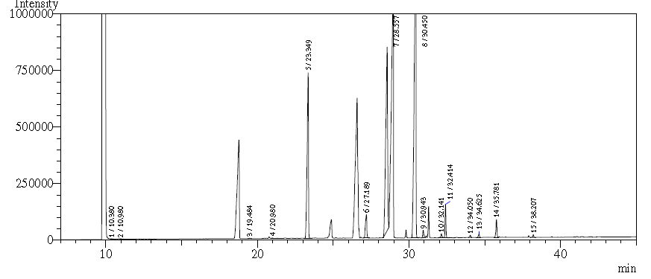
(a)
Raw pearl millet grains
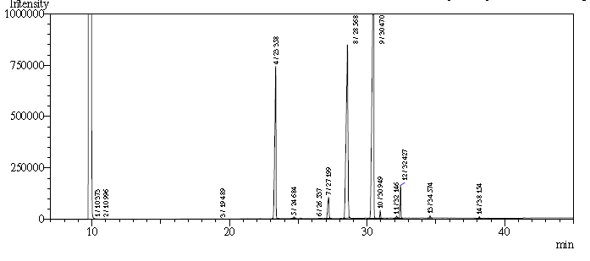
(b)
Fermented pearl millet grains

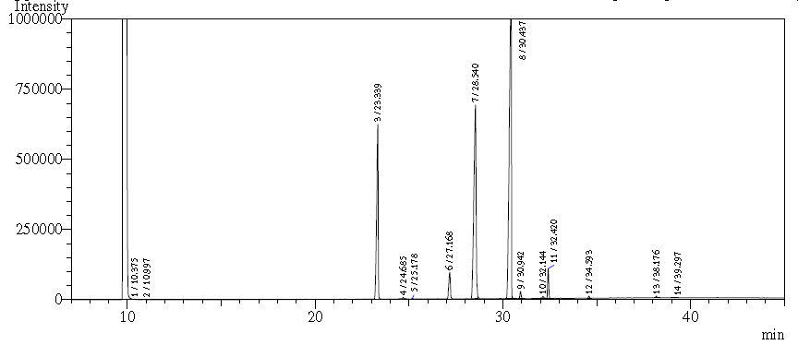
Raw pearl millet grains stored at 5 °C on the 60th day

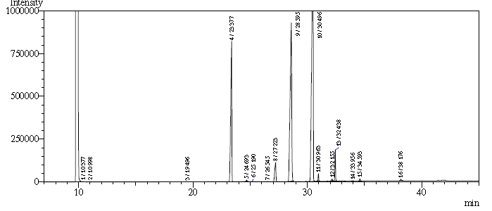
Fermented pearl millet grains stored at 5 °C on the 60th day

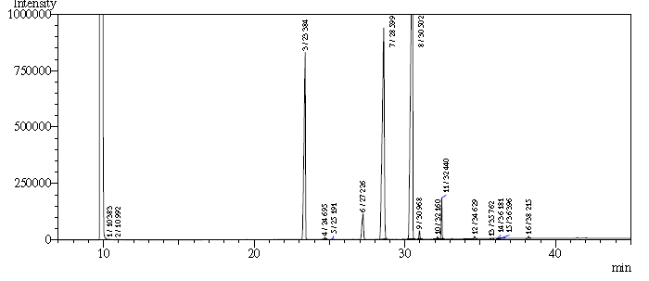
Raw pearl millet grains stored at 25 °C on the 60th day

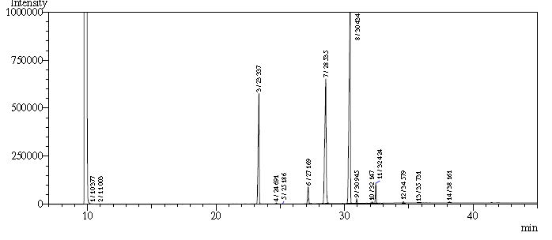
Fermented pearl millet grains stored at 25 °C on the 60th day

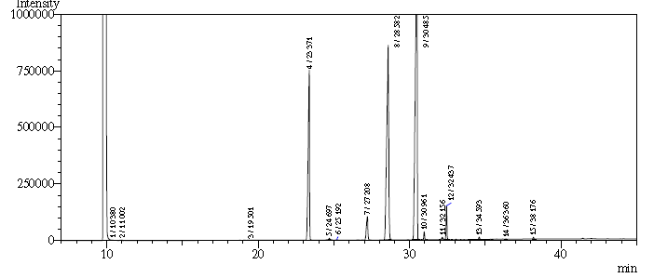
Raw pearl millet grains stored at 45 °C on the 60th day

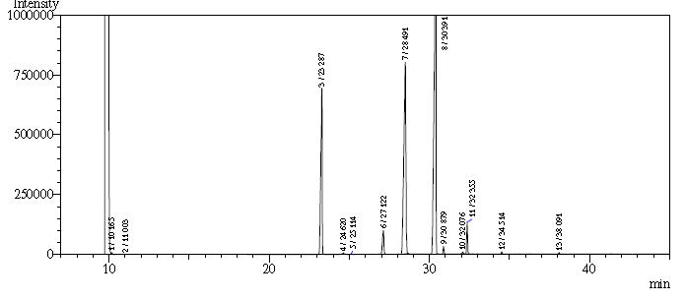
Fermented pearl millet grains stored at 45 °C on the 60th day

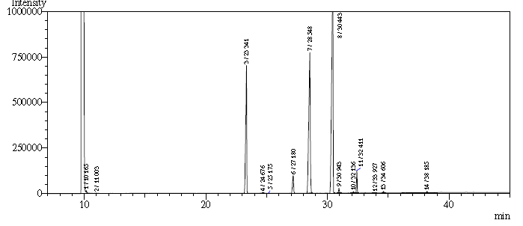
Raw pearl millet grains stored at 5 °C on the 120th day

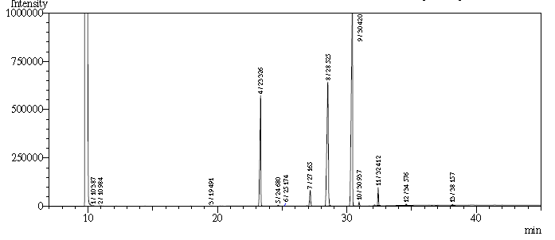
Fermented pearl millet grains stored at 5 °C on the 120th day

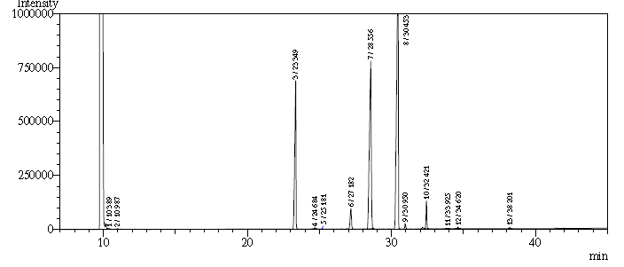
Raw pearl millet grains stored at 25 °C on the 120th day

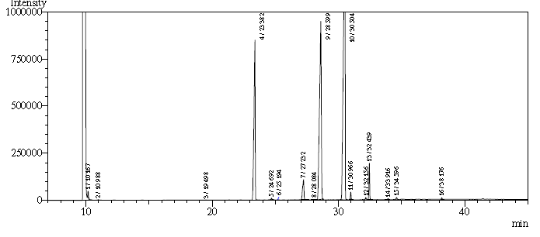
Fermented pearl millet grains stored at 25 °C on the 120th day

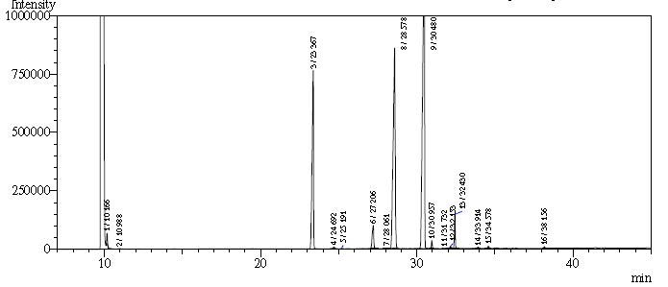
Raw pearl millet grains stored at 45 °C on the 120th day

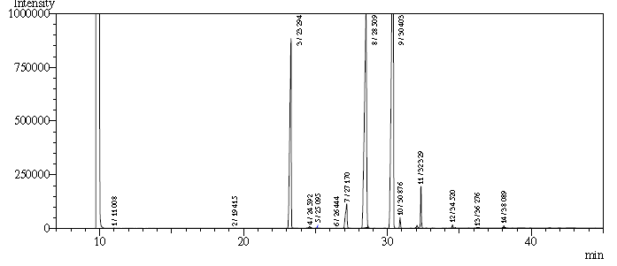

Fermented pearl millet grains stored at 45 °C on the 120th day

