Supplementary materials for
Proteomic Analysis Reveals Lipid Metabolism Disruption and Key Targets in ARPE-19 Cells after RNF13 Knockdown
Liyin Wang^{a, c}, Xin Yu^{a, b}, Chen Xie^{a, b}
a Clinical Research Center, First Affiliated Hospital, College of Medicine, Zhejiang University, Hangzhou, Zhejiang 311003, China
b Department of Ophthalmology, First Affiliated Hospital, College of Medicine, Zhejiang University, Hangzhou, Zhejiang 311003, China
c Department of Ophthalmology and Vision Science, Eye and ENT Hospital, Fudan University, Shanghai, China; NHC Key Laboratory of Myopia (Fudan University), Shanghai, China

Corresponding author: Chen Xie, xiechenzju@163.com, Department of Ophthalmology, First Affiliated Hospital, College of Medicine, Zhejiang University, Hangzhou, Zhejiang, 310003, China

Methods
Parallel reaction monitoring analysis (PRM)
The protein samples were prepared as descripted before. Specifically, 200 μg of proteins per sample were combined with 30 μl of SDT buffer (4% SDS, 100 mM DTT, 150 mM Tris-HCl at pH 8.0) and were repeatedly ultrafiltrated using UA buffer (8 M Urea, 150 mM Tris-HCl at pH 8.5). Subsequently, 100 μl of iodoacetamide (100 mM IAA in UA buffer) was used to block reduced cysteine residues, and the samples were left to incubate in darkness for 30 minutes. The filters were rinsed thrice with 100 μl of UA buffer followed by two washes with 100 μl of 0.1M TEAB buffer. Finally, digestion of the protein suspensions were performed overnight at 37 °C with 4 μg of trypsin (Promega) in 40 μl of 0.1M TEAB buffer, and the resulting peptides were collected as a filtrate. The peptide content was assessed by UV light spectral density (OD 280nm). The peptide mixture was introduced to the C18-reversed phase analytical column (Thermo Fisher Scientific, Acclaim PepMap RSLC 50um X 15cm, nano viper, P/N164943) using buffer A (0.1% Formic acid) and subjected to a non-linear gradient employing buffer B (80% acetonitrile and 0.1% Formic acid) at a flow rate of 300 nl/min. The gradient consisted of the following steps: 3% buffer B for 5 minutes, 3-28% buffer B for 40 minutes, 28-38% buffer B for 5 minutes, 38-100% buffer B for 5 minutes, followed by a 5-minute hold in 100% buffer B. Subsequently, LC-MS/MS analysis was conducted using a Q Exactive HFX mass spectrometer (Thermo Fisher Scientific) coupled to Easy nLC (Thermo Fisher Scientific) in positive ion mode. The MS/MS spectra were analyzed using the MASCOT engine (Matrix Science, London, UK; version 2.6) integrated into Proteome Discoverer 2.1. The MS data acquisition settings were as follows: (1) Full-MS: scan range (m/z)=350-1800; resolution=60000; Automatic gain control (AGC) target=3e6; maximum injection time=50 ms; (2) PRM: resolution=30000; AGC target=2e5; maximum injection time=50ms; Isolation window=2m/z; NCE=27eV.
PRM data were analyzed using the Skyline 3.6. Set the enzyme as trypsin [KR/P], the maximal missed cleavage as 2 and variable modifications as carbamidomethylation of Cys and oxidation of Met. Use 2, 3, 4 as precursor charges, 1, 2 as ion charges and b, y, p as ion types. Quantification was prformed by peak area of precursors and spectras. Statistical analysis was performed by Student’s t test.

Fig S1. Results of STR analysis.

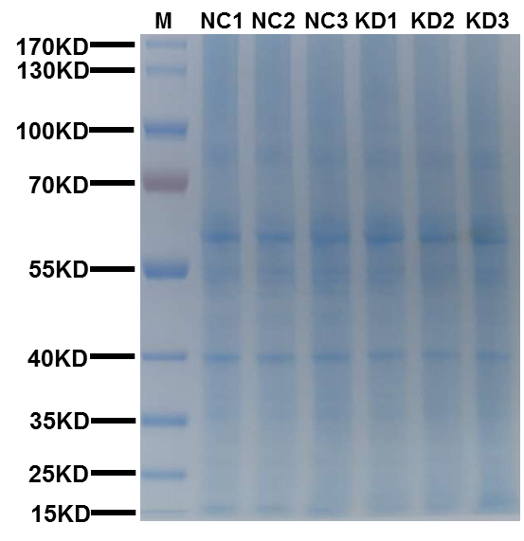
Fig. S2. Coomassie Blue R-250 of proteomic sample.

Table S1. The sequence of the primers used in qRT-PCR.
Gene name | Sequence (5’ to 3’)
Plin2 | Forward: | ATGGCATCCGTTGCAGTTGAT
Plin2 | Reverse: | GGACATGAGGTCATACGTGGAG
CPT1α | Forward: | ATCAATCGGACTCTGGAAACGG
CPT1α | Reverse: | TCAGGGAGTAGCGCATGGT
SCD | Forward: | TCTAGCTCCTATACCACCACCA
SCD | Reverse: | TCGTCTCCAACTTATCTCCTCC
FADS2 | Forward: | TGACCGCAAGGTTTACAACAT
FADS2 | Reverse: | AGGCATCCGTTGCATCTTCTC
HMGCS1 | Forward: | CATTAGACCGCTGCTATTCTGTC
HMGCS1 | Reverse: | TTCAGCAACATCCGAGCTAGA
GAPDH | Forward: | GGAGCGAGATCCCTCCAAAAT
GAPDH | Reverse: | GGCTGTTGTCATACTTCTCATGG

Table S2. The sequences of peptides used in PRM to detect HMGCS1.
Master Protein Accessions | Gene Name | Annotated  Sequence | Charge | m/z | RT
Q01581 | HMGCS1 | NNLSYDCIGR | 2 | 606.277 | 26.275
Q01581 | HMGCS1 | MLLNDFLNDQNR | 2 | 746.864 | 45.746
Q01581 | HMGCS1 | TGVAPDVFAENMK | 2 | 689.837 | 35.339
Q01581 | HMGCS1 | YTIGLGQAK | 2 | 475.769 | 25.277
Q01581 | HMGCS1 | PGSLPLNAEACWPK | 2 | 770.385 | 38.901

