SUPPLEMENT S1
Table S1. Species (65) used for the phylogenetic analyses of the Psathyrella s.s. main tree including GenBank accession numbers of the ITS regions.
Organism | GenBank accession No. | Organism | GenBank accession No.
Coprinellus micaceus | HM240519 | P. luteopallida | KC992884
C. silvaticus | KC992943 | P. lutulenta | KC992875
C. xanthothrix | HF543673 | P. magnispora | KC992863
Psathyrella aberdarensis | MH880928 | P. magnispora | KC992864
P. aff. casca BRNM 705627 | AM712278 | P. marquana | MF668178
P. almerensis | KC992873 | P. microrhiza | DQ389684
P. almerensis | KC992874 | P. multipedata | AM712279
P. amarescens | KC992852 | P. multipedata | KC992888
P. ammophila | KC992871 | P. obtusata | DQ389711
P. ammophila | KC992872 | P. orbitarum | DQ389673
P. atomata | DQ389665 | P. phegophila | AM712277
P. badhyzensis | KC992883 | P. piluliformis | DQ389699
P. bipellis | DQ389679 | P. pratensis | DQ389678
P. bipellis | DQ389680 | P. prona | DQ389666
P. bipellis | KC992865 | P. pseudogracilis | DQ389675
P. calcarea | DQ389671 | P. pseudogracilis | KC992853
P. candolleana | DQ389720 | P. romellii | KC992859
P. carminei | KC992880 | P. senex | AM712273
P. cf. longicauda LO382-89 | DQ389667 | P. sp. 10 EL-2013 | KC992877
P. clivensis | DQ389683 | P. sp. 5 EL-2013 | KC992851
P. corrugis | DQ389674 | P. sp. 9 EL-2013 | KC992868
P. cotonea | AM712283 | P. spadiceogrisea | DQ389682
P. cotonea | KC992870 | P. spadiceogrisea | KC992878
P. duchesnayensis | KC992869 | P. stercoraria | DQ389669
P. effibulata | DQ389672 | P. sulcatotuberculosa | KJ138422
P. euryospora | MT651560 | P. supernula | KC992867
P. fatua | DQ389681 | P. thujina | KC992876
P. fatua | KC992879 | P. trinitatensis | KC992882
P. gordonii | KC992925 | P. tuberculata | KC992886
P. lacuum | KC992887 | P. tuberculata | KC992934
P. leucotephra | KC992885 | P. typhae | DQ389721
P. longicauda | KC992889 | P. vinosofulva | KC992861
P. lutensis | DQ389685

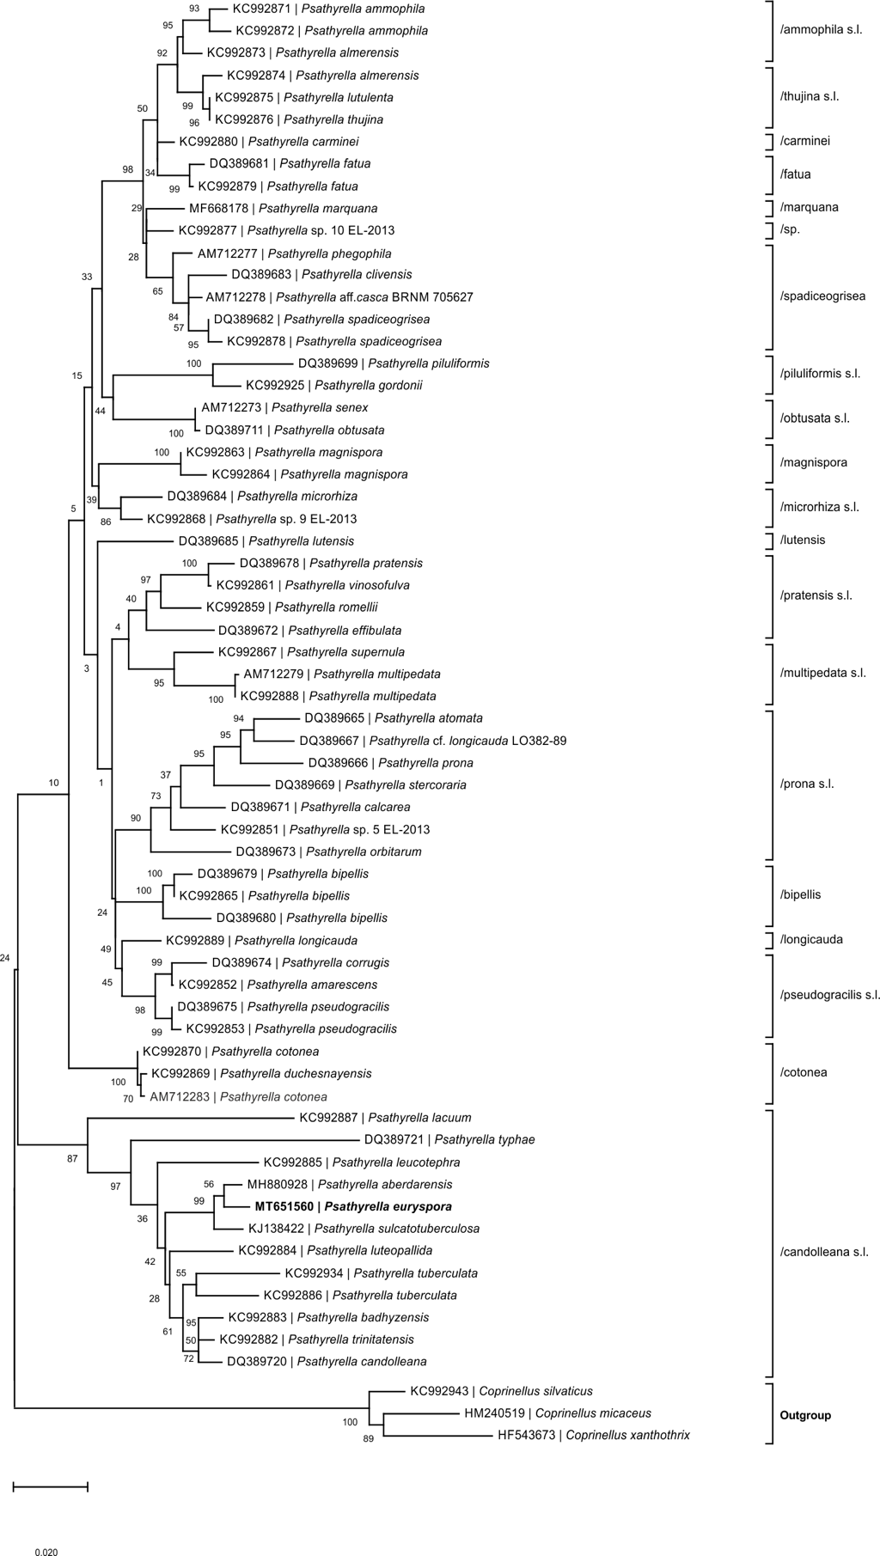
Figure S1. Maximum Likelihood tree inferred from an alignment including ITS and 28s rRNA gene sequences of P. euryspora (bold) and 64 reference sequences. Support of branches were calculated using a maximum likelihood bootstrap (MCL) approach (1,000 replicates, values >80 below branches; Kumar et al., 2018; Nei and Kumar, 2000). Gamma distribution was used to model evolutionary rate differences among sites (5 categories; +G, parameter = 0.1676). The tree is rooted using Coprinellus spp. as outgroup.

