APPENDICES

Appendix 1: Below are snippets of steps of configurations (set-up, training and test scenarios) used in building the chatbot.
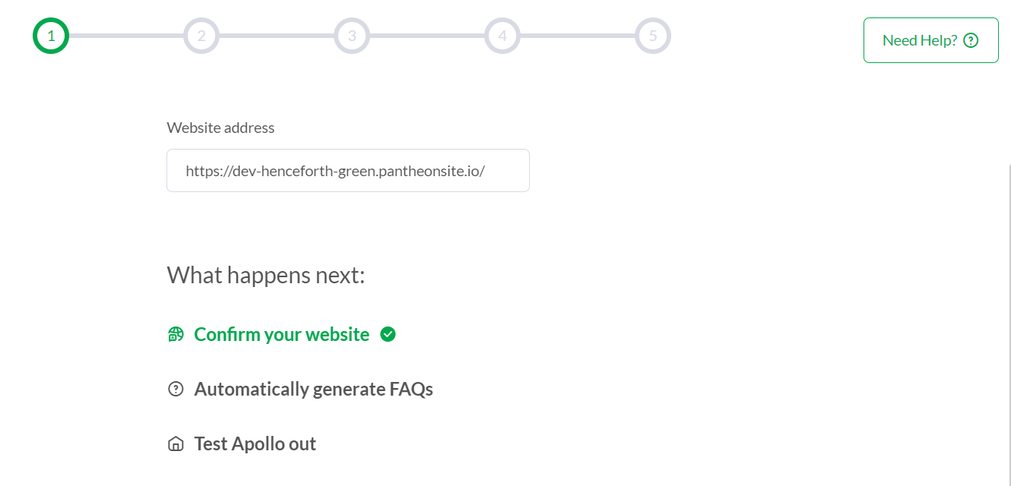
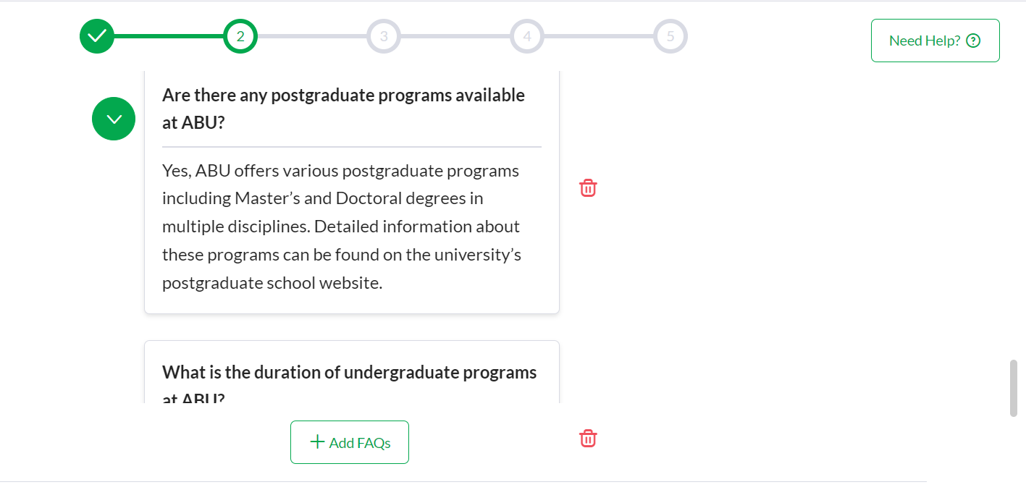

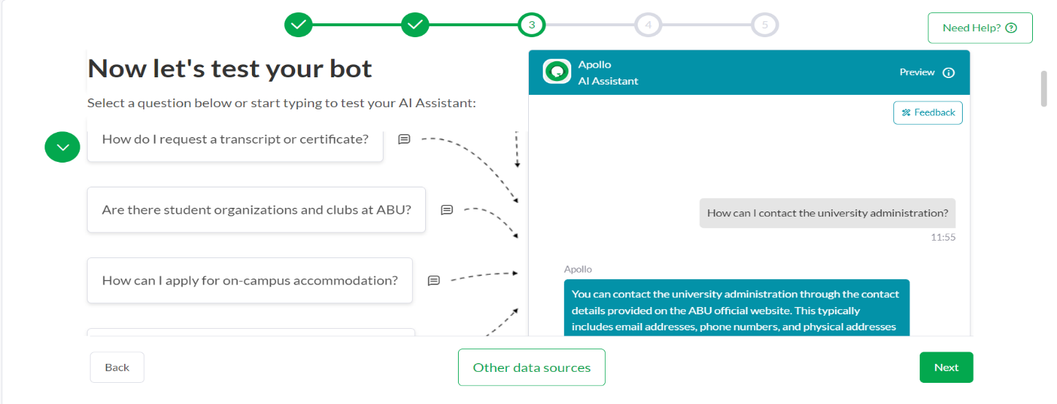
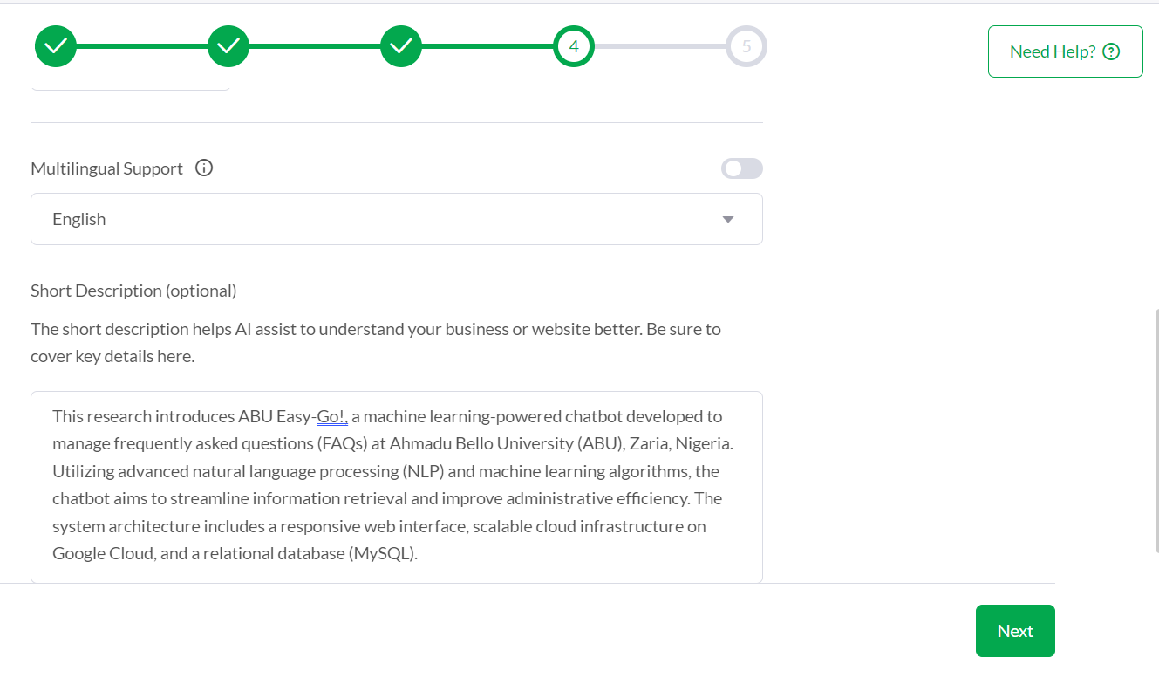

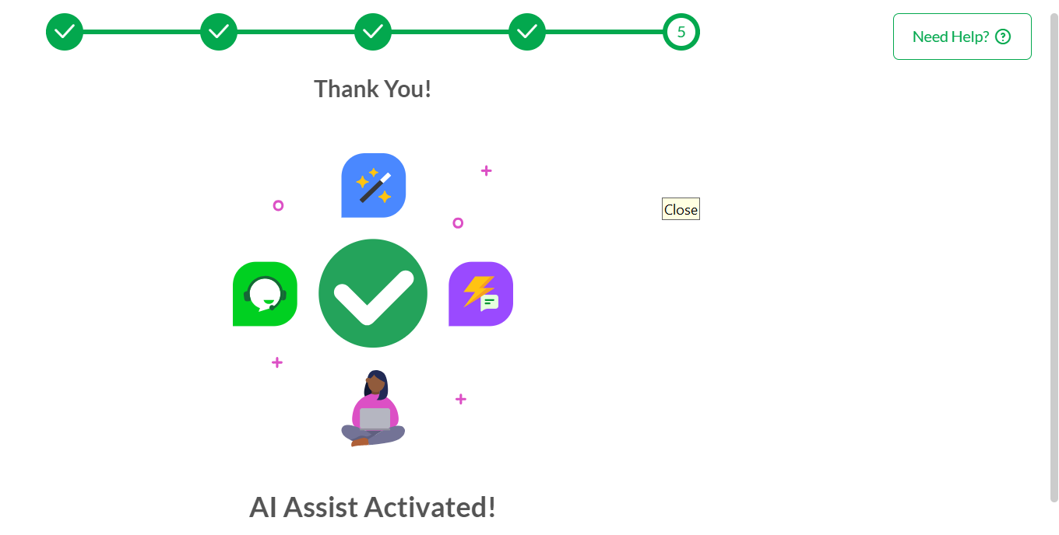

Appendix 2: Examples of FAQs and Answers that was used in training the chatbot

General Information
1. What is Ahmadu Bello University (ABU)?
- Answer: Ahmadu Bello University (ABU) is a prestigious public university located in Zaria, Nigeria. It is named after the Sardauna of Sokoto, Alhaji Ahmadu Bello, and is one of the largest and oldest degree-awarding institutions in Nigeria, offering a wide range of undergraduate and postgraduate programs.
2. Where is Ahmadu Bello University located?
- Answer: Ahmadu Bello University is located in Zaria, Kaduna State, Nigeria. The main campus is situated in Samaru, Zaria.
3. What are the main faculties at ABU?
- Answer: ABU has several faculties including the Faculty of Science, Faculty of Arts, Faculty of Engineering, Faculty of Social Sciences, Faculty of Medicine, and many others. Each faculty offers various undergraduate and postgraduate programs.

Admissions
4. How can I apply for admission to ABU?
- Answer: To apply for admission to ABU, you need to visit the university's official website and follow the instructions for the online application process. Ensure you meet the admission requirements and deadlines for your chosen program.
5. What are the admission requirements for undergraduate programs?
- Answer Admission requirements for undergraduate programs at ABU typically include having a minimum of five credits in relevant subjects at the Senior Secondary School Certificate Examination (SSCE) or equivalent, meeting the program-specific criteria, and passing the Unified Tertiary Matriculation Examination (UTME).
6. How do I check my admission status?
- Answer: You can check your admission status by visiting the ABU admission portal on the university’s website and entering your application details. Admission status updates are also communicated via email or SMS.

Academic Programs
7. What undergraduate programs are offered at ABU?
- Answer: ABU offers a wide range of undergraduate programs in fields such as Engineering, Medicine, Social Sciences, Arts, Science, Agriculture, Education, and many others. For a complete list, visit the university’s official website or contact the admissions office.
8. Are there any postgraduate programs available at ABU?
- Answer: Yes, ABU offers various postgraduate programs including Master’s and Doctoral degrees in multiple disciplines. Detailed information about these programs can be found on the university’s postgraduate school website.
9. What is the duration of undergraduate programs at ABU?
- Answer: The duration of undergraduate programs at ABU generally ranges from 4 to 6 years depending on the program and the student’s academic progress.

Campus Life
10. What facilities are available on the ABU campus?
- Answer ABU’s campus provides various facilities including lecture halls, laboratories, libraries, hostels, sports complexes, and recreational centers. There are also medical facilities and eateries available for students and staff.
11. How can I apply for on-campus accommodation?
- Answer: To apply for on-campus accommodation, you need to fill out the hostel application form available on the university’s website or through the student affairs office. Accommodation is typically assigned based on availability and eligibility.
12. Are there student organizations and clubs at ABU?
- Answer: Yes, ABU has numerous student organizations and clubs covering academic, cultural, social, and recreational interests. Students are encouraged to join and participate in activities that align with their interests.

Administrative Procedures
13. How do I request a transcript or certificate?
- Answer: To request a transcript or certificate, you should submit a request through the university’s registrar’s office or online portal, providing necessary details such as your student ID and program information. There may be a processing fee involved.
14. What is the procedure for applying for a leave of absence?
- Answer: To apply for a leave of absence, you need to submit a formal application to the university’s academic office or student affairs office, stating the reason for the leave and the duration. Approval is subject to university policies.
15. How can I contact the university administration?
- Answer: You can contact the university administration through the contact details provided on the ABU official website. This typically includes email addresses, phone numbers, and physical addresses for various administrative offices.

Appendix 3: Examples of Testing Scenarios that was used in building the chatbot

Scenario 1:
- User: "I need information about the admission requirements for undergraduate programs at ABU."
- Chatbot: "The admission requirements for undergraduate programs at ABU include having a minimum of five credits in relevant subjects at the Senior Secondary School Certificate Examination (SSCE) or equivalent, meeting the program-specific criteria, and passing the Unified Tertiary Matriculation Examination (UTME)."

Scenario 2:
- User: "What facilities are available on the ABU campus?"
- Chatbot: "ABU’s campus provides various facilities including lecture halls, laboratories, libraries, hostels, sports complexes, and recreational centers. There are also medical facilities and eateries available for students and staff."

Scenario 3:
- User: "How do I check my admission status?"
- Chatbot: "You can check your admission status by visiting the ABU admission portal on the university’s website and entering your application details. Admission status updates are also communicated via email or SMS."

Appendix 4: Code Editor: Below is a snippet of the Footer Code Editor of the website where the Chatbot JavaScript snippet was embedded.
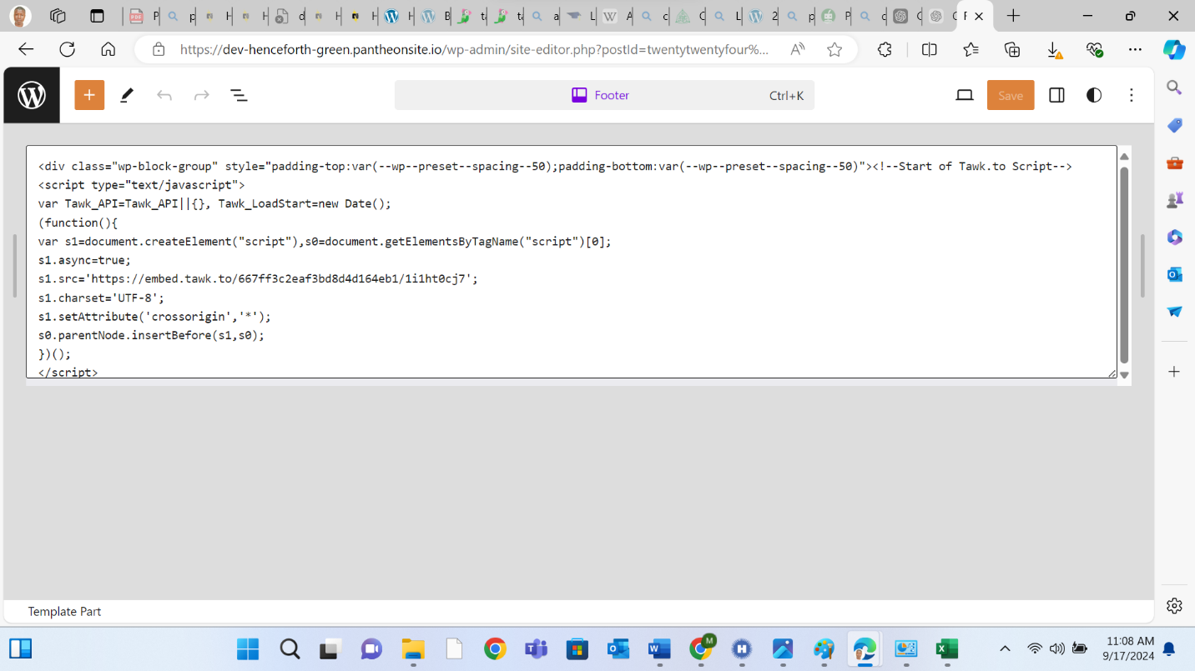

Appendix 5: Below is a snippet of the site visit displaying the integrated chatbot and confirmation of its function-ability.


