Supplementary information for
Opportunities to mitigate PM_{2.5} and nitrogen deposition through agricultural ammonia control strategies in China’s Beijing-Tianjin-Hebei region
Lu Li, Yixin Guo, and Lin Zhang et al.
This file includes:
Supplementary Tables S1–S7
Supplementary Text S1
Supplementary Figures S1–S11

Table S1 Information on emission reduction measures for livestock breeding.

Measure |  | Description of measures
Housing | Adsorbent | Substances with adsorption properties to NH₃ are used to reduce NH₃ emissions, and commonly used exogenous adsorbents such as Ca(H₂PO₄)₂·H₂O, molecular sieve, bentonite, zeolite, etc.
Housing | Mechanical | Installing ventilation systems to reduce NH₃ emissions or using scraping manure board machinery
Housing | Floor | Using slatted floor or add straw to the floor
Feeding | Crude protein content | Synthetic amino acids were added to replace partial of the crude protein
Feeding | Dietary bacteria | Probiotics such as bacillus are added to feed to improve intestinal flora of livestock and poultry and reduce fecal NH₃ emissions
Feeding | Dietary acidifier | Adding acid such as slow-release compound acidifiers to feed to reduce NH₃ emissions
Feeding | Dietary additives | Adding additives such as cinnamon extract to feed to reduce NH₃ emissions
Feeding | Dietary yucca extracts | Adding yucca to feed to reduce NH₃ emissions
Storage | Cover | Mulch is added manually to reduce NH₃ volatilization during storage
Storage | Additives | Using additives such as microbial additives, inorganic additives (zeolite), chemical additives (urease inhibitors)
Storage | Acidifier | Acidifiers are used to adjust the ratio of NH₃ and NH₄⁺ in feces to reduce NH₃ volatilization
Storage | Adsorbent | Substances with adsorption properties to NH₃ are used to reduce NH₃ emissions, and commonly used exogenous adsorbents such as Ca(H₂PO₄)₂·H₂O, molecular sieve, bentonite, etc.
Storage | Compaction and covering | Compaction and covering
Field application | Separated | Separating solid and liquid
Field application | Digested | The feces and urine were digested or fermented before applied
Field application | Irrigated | Water immediately after fertilization
Field application | Band-spread | Using Band-spreading instead of surface application
Field application | Techniques | Settling-decantation or mechanically aerating
Field application | Deep placement | Deep application can reduce the contact between fertilizer and air, and reduce the NH₃ volatilization loss of fertilizers.
Field application | Injected | Using Injection instead of surface application
Field application | Incorporation | Improve the method of manure and urine application, using mulch instead of surface application

 | Measure | Description of measures
crop management | crop density manipulation | Adopt higher (+27%-+43%) planting density
crop management | newer crop variety | Planting new varieties of crops (e.g. wheat, maize and rice)
tillage management | ridge tillage | Tillage with high and low ridges
water management | Intermittent irrigation | Improving irrigation method
water management | drip irrigation | Improving irrigation method
water management | enhanced irrigation rate | Increasing irrigation (+13%-+83%)
surface mulching | plastic film | Using different surface mulching in the field
surface mulching | rice bran | Using different surface mulching in the field
surface mulching | molecular film | Using different surface mulching in the field
surface mulching | vegetative film | Using different surface mulching in the field
soil management | bentonite | Using amendments such as crop straw, straw biochar (only including biochar made using the crop residue as feedstock), bentonite, zeolite, or lime applications as treatments
soil management | zeolite
soil management | straw returning
soil management | straw biochar returning
Table S2 Information on emission reduction measures for crop planting in field management.

Table S3 Information on emission reduction measures for crop planting in N fertilizer management.
 | Measure | Description of measures
fertilizer application | split application | Use optimal fertilization method by splitting the N application in several times
fertilizer application | deep placement | Replace surface by deep application
fertilizer application | irrigation | Water immediately after fertilization
chemical N replacement |  | Substitution with other chemical N fertilizer. Urea and compound fertilizer (CF) were considered low NH3 loss risk fertilizers to replace ABC. Calcium ammonium nitrate (CAN), urea ammonium nitrate (UAN), urea ammonium (UA), ammonium sulfate (AS), and compound fertilizer (CF) were considered as low NH3 loss risk fertilizers to replace urea.
organic N substitution |  | Substitution with organic N sources. N input from solid manure (including raw manure, composted manure, and commercial organic fertilizer derived from animal excretion), slurry (raw slurry and anaerobically-digested slurry), rape-seed cake, straw, and green manure were considered as organic N sources.
enhanced-efficiency fertilizer | urease inhibitor | Add stabilized N fertilizer, controlled-release fertilizer, slow-release fertilizer, and biofertilizer as enhanced-efficiency fertilizer treatments to the fertilizer. The stabilized N fertilizers include urease inhibitors, and dual inhibitors (urease inhibitor plus nitrification inhibitor).
enhanced-efficiency fertilizer | double inhibitor
enhanced-efficiency fertilizer | control-released fertilizer
enhanced-efficiency fertilizer | slow-released fertilizer
enhanced-efficiency fertilizer | bio-fertilizer

Table S4 Information on emission reduction measures for crop planting in diversified crop systems.
Measure | Description of measures
integration | Agriculture-husbandry integration refers to raising ducks or fish in the cropland,  generally, only applicable to rice paddy systems with rice-duck and rice-fish options.
inter-cropping | Inter-cropping regimes such as crop-legume, crop-tree, and crop-grass as the improved treatment.
rotation | Crop-crop rotation as the improved treatment.

Table S5 Classification of emission reduction measures in crop planting.
Crop sub-types | Fertilizer types | application methods
- early rice  - late rice  - spring wheat  - winter wheat  - spring maize  - summer maize  - cotton  - sweet potato  - potato  - rapeseed  - soybean  - groundnut  - tobacco  - apple  - banana  - pear  - grape  - citrus  - other crops  - other fruits  - vegetables&melons | - urea  - ammonium bicarbonate  - ammonium sulfate  - ammonium nitrate  - npk compound fertilizer  - other fertilizer | - deep placement  - spread

Table S6 Classification of emission reduction measures in livestock breeding.
Animal sub-types | Manure handling systems | Breeding systems
- beef＜1year  - beef＞1year  - diary＜1year  - dairy＞1year  - goat＜1year  - goat>1year  - sheep＜1year  - sheep＞1year  - sow  - weaner  - fattening pig  - poultry | - feeding  - housing  - storage  - field application | - intensive  - grazing  - free

Table S7 Site locations for ground-level observations.
Province | Sampling site | Geographical coordinates
 |  | longitude（E°） | latitude（N°）
Beijing | Agricultural university^{1,2} | 116.28 | 40.02
Beijing | Shangzhuang^{1,2} | 116.20 | 40.11
Beijing | Yanqing^{1,2} | 116.00 | 40.50
Beijing | Fangshan | 116.10 | 39.72
Beijing | Beijing Normal university | 116.37 | 39.96
Henan | Zhenzhou^{1,2} | 113.63 | 34.75
Hebei | Quzhou² | 114.96 | 36.78
Shandong | Yucheng^{1,2} | 116.63 | 36.94
Shandong | Changdao^{1,2} | 120.75 | 37.93
Shandong | Lingshandao² | 120.18 | 35.77
Shandong | Qingdao | 120.40 | 36.32
Shanxi | Yangqu^{1,2} | 112.89 | 38.05
Shanxi | Dongyang | 112.69 | 37.56
Shaanxi | Baoji | 107.15 | 34.38
Shaanxi | Yangling² | 108.01 | 34.31
All sites include NH₃ ground-level data, among them sites¹ have wet N deposition data, sites² have main PM_{2.5} components (pNH₄⁺ and pNO₃⁻) data.

Text S1 The abbreviation NMSE stands for normalized mean square errors, which is calculated as follows: $NMSE=\frac{1}{n}\sum{({\left(P-O\right)}^{2}}/O^{2})$, $n$ is the number of samples, $O$ is the observation value, $P$ is the predicted value. The value of $NMSE$ is between 0 and 1. The closer to 0, the better the predictive value of the model.
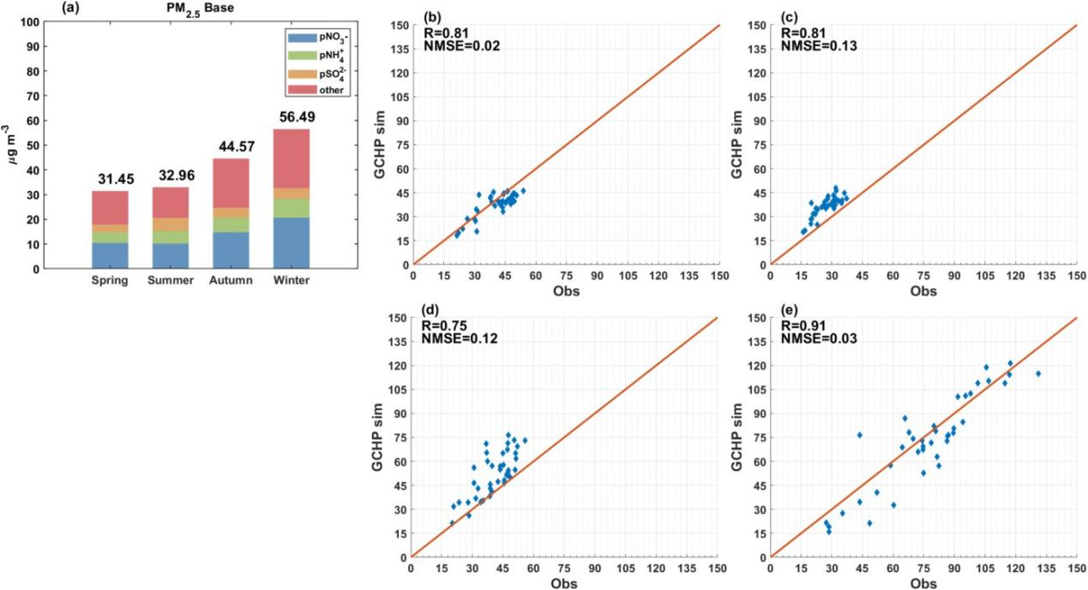
Fig. S1 (a) Seasonal variation of PM_{2.5} concentration and its main components in BTH region. (b–e) Comparison of PM_{2.5} concentration observation and model simulation. The comparison between observations and simulations in (b) spring, (c) summer, (d) autumn, and (e) winter.

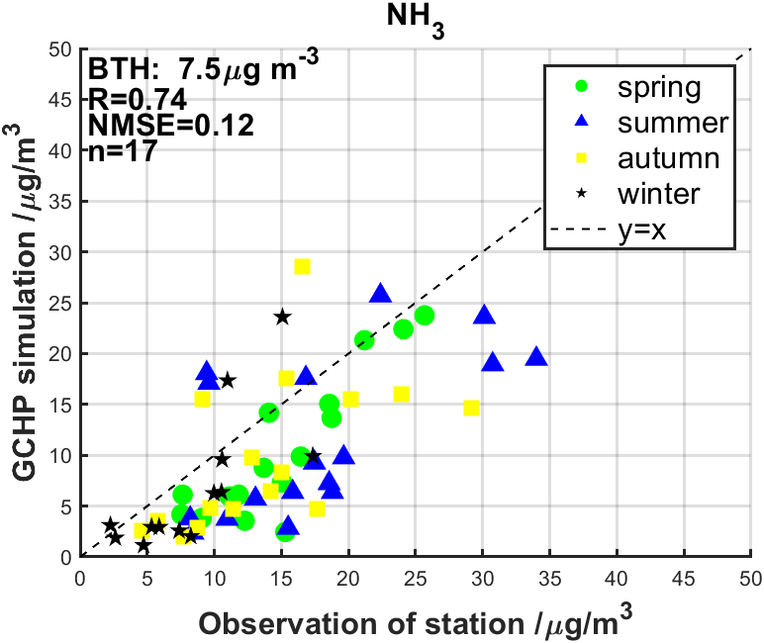
Fig. S2 Ground observation and GCHP simulation of surface concentration of NH₃ for different seasons.

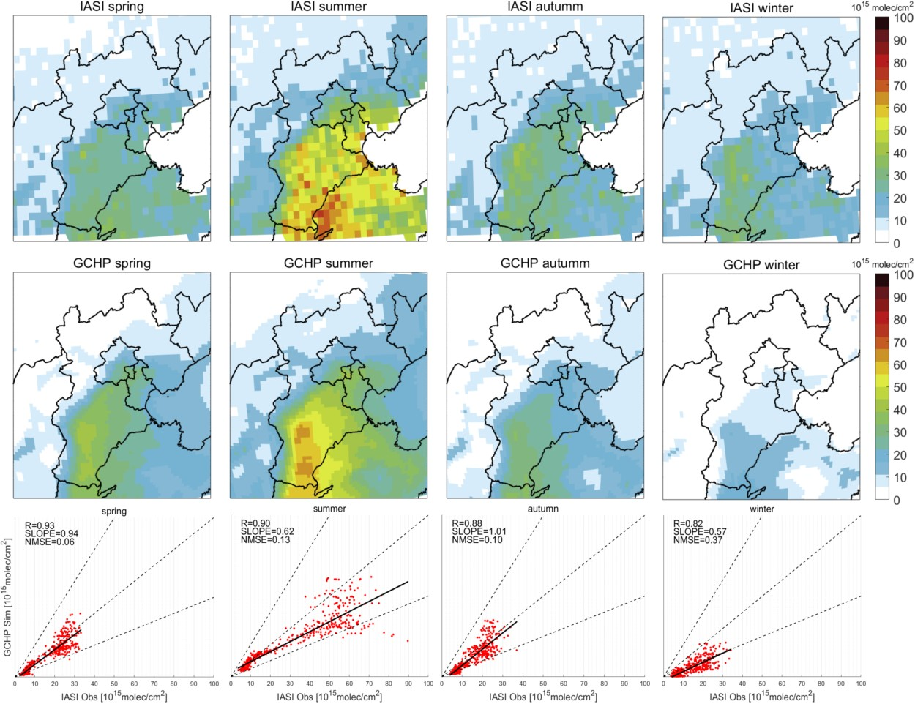Fig. S3 IASI satellite observation and GCHP simulation of total column concentration of NH₃ for different seasons.
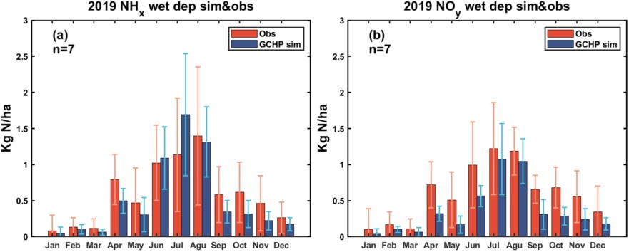Fig. S4 Comparison of site observation and GCHP model simulation. (a) and (b) refer to the monthly average variation of observations and simulations of wet deposition of NH_{X} and NO_{y} respectively.
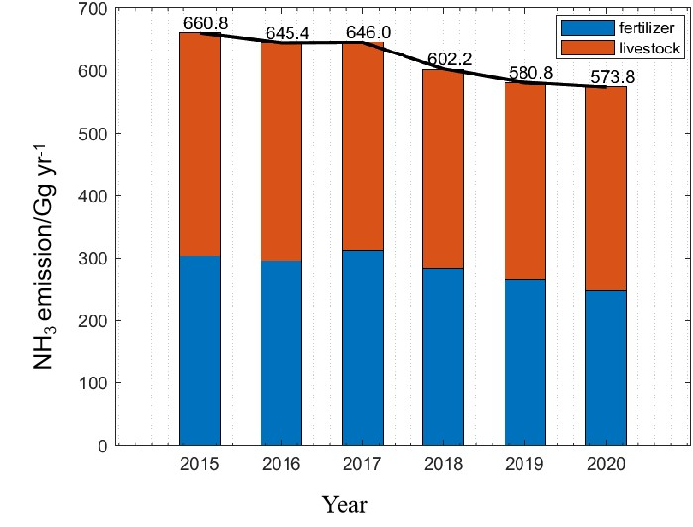
Fig. S5 Agricultural NH₃ emission in BTH region changes by years.

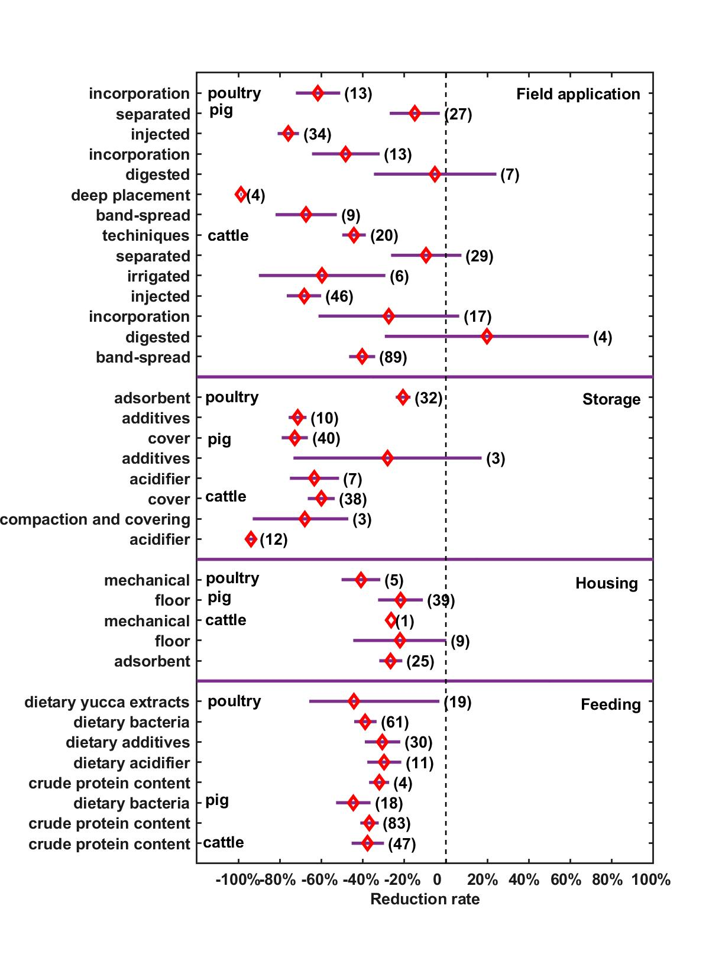
Fig. S6 Effect of manure measures on NH₃ volatilization ($TF$)
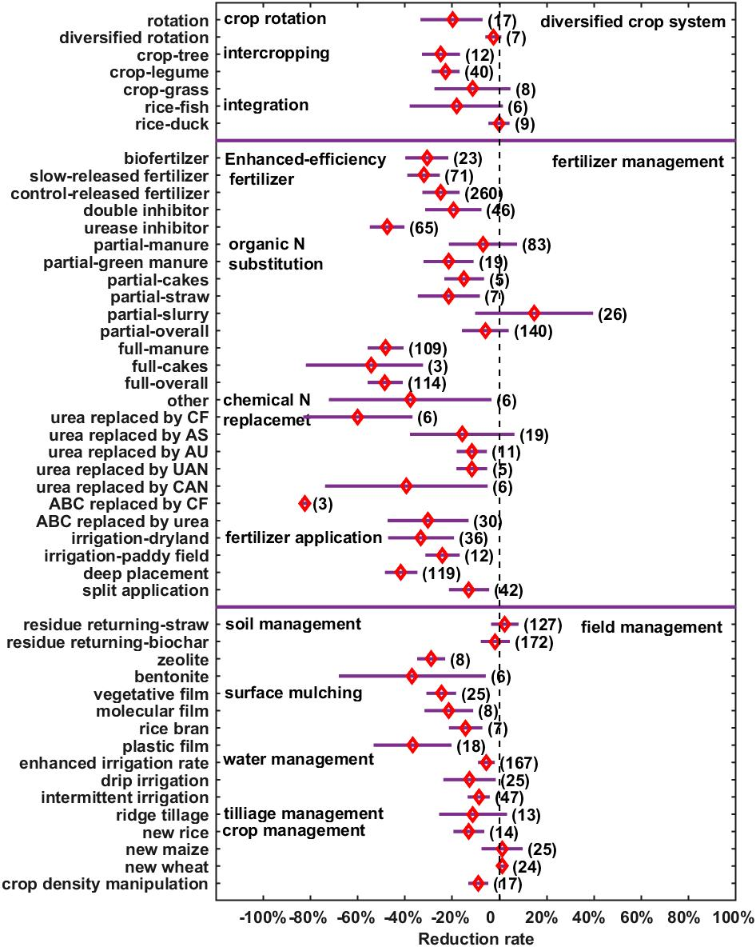Fig. S7 Effect of crop planting measures on NH₃ volatilization ($TF$) in field management, N fertilizer management part and diverse crop systems.

BTH
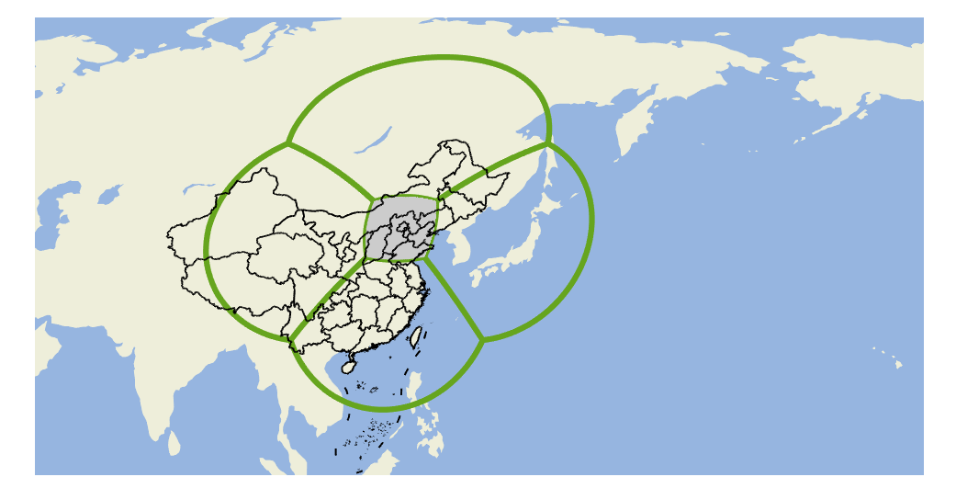
Fig. S8 Stretched grids used in GCHP. The target latitude and longitude are 40°N, 116°E. There are six faces (bounded by green lines) in the model, each containing 90×90 grids.

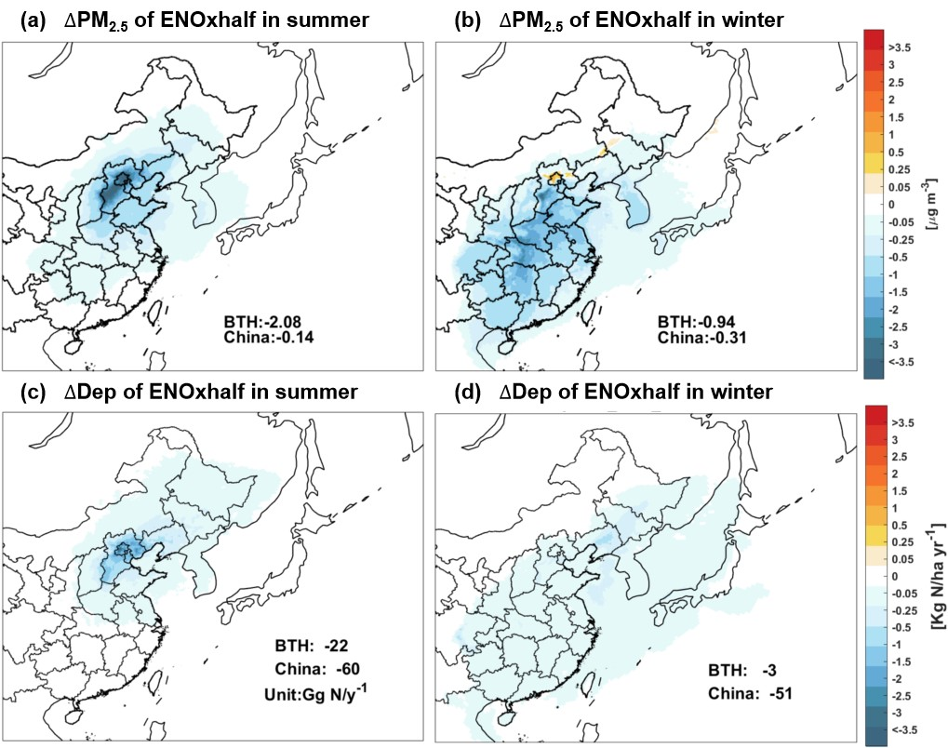
Fig. S9 The spatial distribution of PM_{2.5} concentration (a–b) and nitrogen deposition (c–d) decrease in summer and winter under ENOxhalf scenario. Lifetime of NO_{x} is longer in winter than in summer.

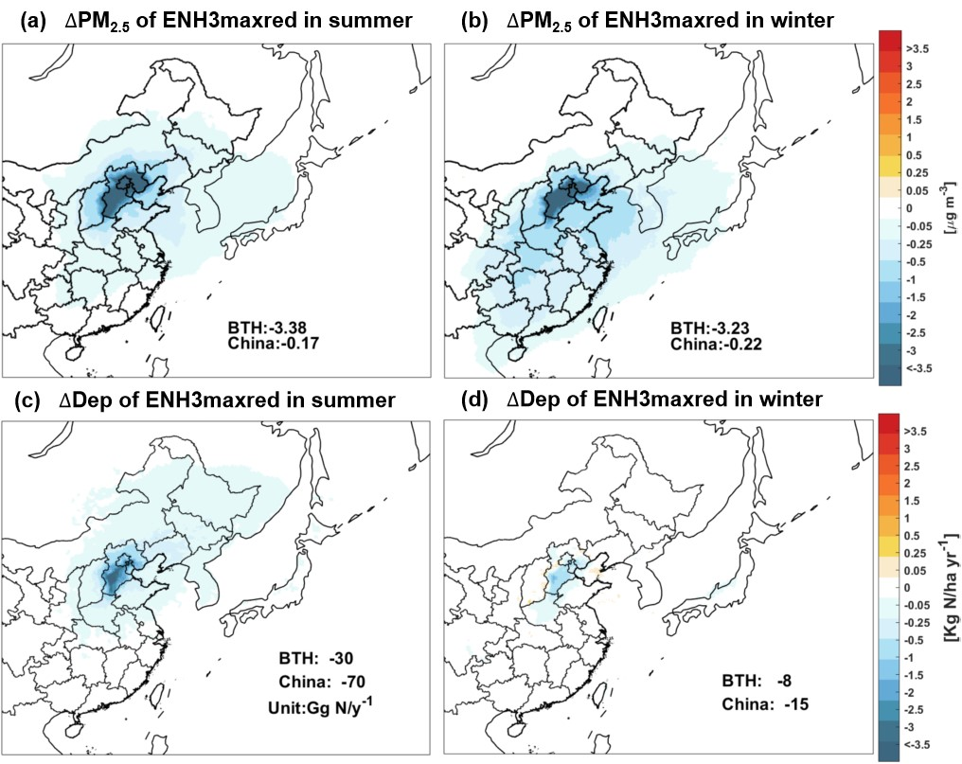
Fig. S10 The spatial distribution of PM_{2.5} concentration decrease in (a) summer and (b) winter under ENH3maxred scenario.

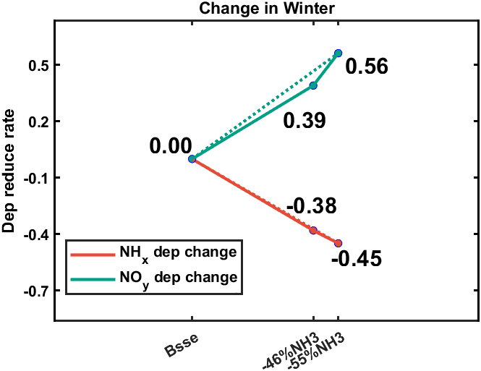
Fig. S11 Relative changes of nitrogen deposition and emissions in winter in BTH region.

