Supplementary
Synthesis, Characterization, DNA-Interaction, and Anticancer Activity of Cu⁺² Coordinated with Dipicolinic Acid. Experimental and Computational Studies

Ameneh Heidari*ª, Effat Dehghanian^{b}, Somaye Shahrakiª, Zohreh Razmaraª, Mostafa Heidari Majd^{c}, Hamid Ahmarª, Mansoureh Rakhshanipourª, Srikanta Goswami^{d}
ªDepartment of Chemistry, Faculty of Science, University of Zabol, P.O. Box 98615-538, Zabol, Iran
^{b}Department of Chemistry, University of Sistan and Baluchestan, Zahedan, Iran
^{c}Faculty of Pharmacy, Zabol University of Medical Sciences, Zabol, Iran
^{d}Institute of Physics ASCR, Prague, Czech Republic

* Corresponding author, Ameneh Heidari, E-mail addresses: Amheidari@uoz.ac.ir, Heidaria544@gmail.com

Abbreviation:
DPA: dipicolinic acid
dmpn: 2,2׳-dimethyl-1,3-diaminepropane
CT-DNA: Calf Thymus Deoxyribonucleic Acid
EB: Ethidium Bromide
TMS: Tetra methyl silane
UV-Vis: ultraviolet visible spectrophotometer
TGA: thermal gravimetric analysis
DFT: density functional theory
K_{app}: apparent binding constant
K_{b}: binding constant
K_{sv}: Stern-Volmer constant
k_{q}: biomolecular quenching constant
n: number of binding sites
ΔS°: entropy changes
ΔH°: Enthalpy changes
ΔG°: Free energy changes

Materials and apparatus
All chemicals were applied without further purification and achieved from the Chemical Company of Merck (chemical purities 98+) but the sodium salt of calf thymus DNA (CT-DNA) which purchased from Sigma-Aldrich (CAS 73049-39-5). Double distilled water was used in all stages. Complex (1) information was obtained at 298 K on a SuperNova diffractometer of Rigaku Oxford Diffraction equipped with a CCD detector Atlas S2 using graphite-monochromated MoKa radiation (0.71073) Gemini ultra. The crystal structure was solved by charge flipping using the Super flip program and refined using full-matrix least-squares on F² with the program Jana2006 [1, 2]. Conductivity measurements were carried out on a Systronics conductivity bridge, model 305, with a cell constant of 0.59, using conductivity water as a solvent. The UV–Vis absorption analysis data was measured by a double-beam spectrophotometer (JASCO UV/Vis-7850) utilizing quartz cells with a path length of 1.0 cm from 200 to 400 nm. All fluorescence measurements were accomplished by an Agilent Cary Eclipse Fluorescence Spectrophotometer equipped with a 1 cm path-length quartz cell. The emission and excitation slit widths were regulated to 5 nm. The selected excitation wavelengths were 471 and the emission spectra range was used between 500 and 750 nm. Ostwald micro viscometer (SCHOT-geräte, Germany) was carried out for viscosity experiments in a water bath of 27±1 °C. The data of partition coefficient was achieved by employing the shake-flask system for determining of lipophilicity of the metal complex. Gel electrophoresis was applied on CCD-5 Gel Documentation System utilizing Maxi HD 15 × 15 Tank, Ladder 50bp, Iran. Thermogravimetric-differential thermal analysis (TG-DTA) was carried out using a thermal gravimetric analysis instrument (TG/DTA6300 Japan) with a heating rate of 10 °C/min in the air atmosphere from ambient temperature to 700 °C.
Cyclic voltammetry measurements were performed using a cyclic voltammetry instrument (AutolabPGSTAT204 from Metrohm Company-Netherlands). In this method, glassy carbon, platinum wire and Ag/AgCl/KCl 3M were used as working, auxiliary and reference electrodes, respectively.

Experimental

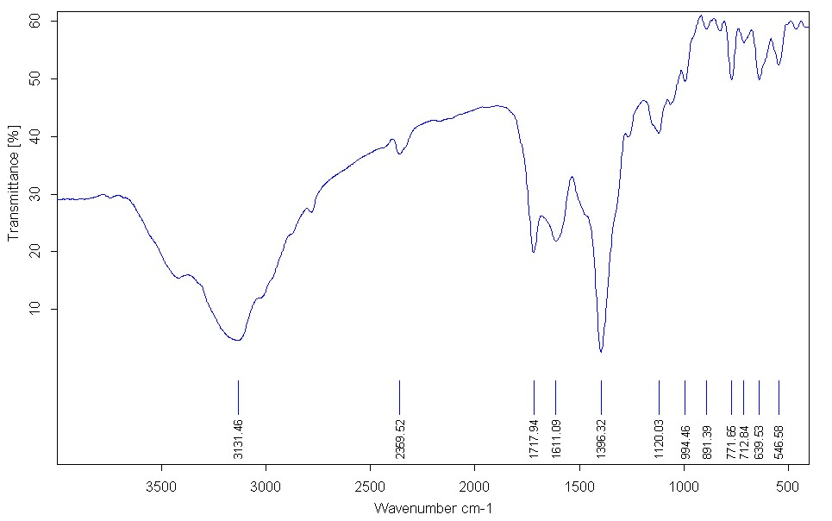
Figure 1S. FT-IR spectrum of complex (1)

Figure 2S. UV-Vis spectrum of complex (1) in water as solvent

Figure 3S. The plot of stability of complex (1) in time

Table 1S. Crystal and structure refinement data
Identification code | 1
Empirical formula | C₂₄H₃₄Cu₂N₆O_{9.5}
Formula weight | 685.7
T, K | 100
λ, Å | 0.71073
Crystal system | orthorhombic
Space group | Pnma
a, Å | 18.462(4)
b, Å | 37.218(7)
c, Å | 8.315(2)
α, ° | 90
β, ° | 90
γ, ° | 90
V, Å³ | 5714(2)
Z | 8
ρ_{max}, g cm⁻³ | 1.5942
μ, mm | 1.552
F(000) | 2832
Crystal size, mm | 0.95x0.29x 0.156
θ min, θ max, | 2.19, 28.44
Index ranges | -24<=h<=24, -48<=k<=48, -10<=l<=11,
Reflections collected | 68789
Independent reflections, | 6927
Reflections with I > 3σ(I) | 5135
R_{int} | 0.156
Data/restraints/parameters | 6927/0/188
Goodness-of-fit on F² ¹⁾ | 5.2292
R₁ [I>3σ(I)] | 0.2186
wR₂ [I>3σ(I)] | 0.3685
Δρ_{min}, Δρ_{max}, e Å⁻³ | -2.57, 2.96

¹⁾The used refinement program JANA2020 calculates true goodness of fit, which is based on experimental weighting scheme. The only factor introduced to the weighting scheme by user is the instability factor, which is however a parameter of the instrument (and to some extent of the data processing software) and cannot be arbitrarily changed. The CCDC number is 2361945.

Table 2S. Selected geometrical parameters from single crystal X-Ray diffraction data.
Angles | degree
N2—Cu1—N5 | 177.9 (5)
N3—Cu2—N3^{i} | 180
N3—Cu2—N4 | 86.7 (4)
N3—Cu2—N4^{i} | 93.3 (4)
N3^{i} —Cu2—N4 | 93.3 (4)
N3^{i} —Cu2—N4^{i} | 86.7 (4)
N4—Cu2—N4^{i} | 180
N1—Cu3—N1^{ii} | 96.7 (4)
N1—Cu3—N6 | 84.8 (4)
N1—Cu3—N6^{ii} | 170.3 (5)
N1^{ii} —Cu3—N6 | 170.3 (5)
N1^{ii} —Cu3—N6^{ii} | 84.8 (4)
N6—Cu3—N6^{ii} | 92.2 (4)
Cu3—N1—C7 | 122.6 (8)
Cu1—N2—C6 | 119.4 (9)
Cu1—N2—C19 | 119.7 (9)
Cu2—N3—C22 | 116.3 (8)
Cu2—N4—C20 | 117.4 (8)
Cu1—N5—C1 | 119.4 (9)
Cu1—N5—C9 | 120.3 (9)
Cu3—N6—C23 | 123.4 (8)

Symmetry codes: (i) −x+1, −y+1, −z; (ii) x, −y+3/2, z.

In-vitro cytotoxicity studies
This procedure is based on the changing of color of the yellow (MTT) to the purple formazan. The phenomenon of color alteration is attributed to the function of the mitochondrial enzyme which is succinate dehydrogenase in living cells [3]. In this assay, HCT116 cells were kept for three weeks in cell culture flasks containing RPMI-1640 growth medium with 10% FBS and 1% penicillin G-streptomycin to reach the desired number for MTT assay [4, 5]. Cells were transferred to 96-well culture plates with a density of 1.5×10⁴ cells per well and then kept for 24 h in a CO₂ incubator under standard conditions. Five different concentrations of compound (I) (31.25 µM to 500 µM) were prepared in the growth medium to treat the cells for 48 and 72 h. Each concentration was repeated three independent times (n=3, ±SD) to reduce the error. Also, three wells were considered as the negative control in each period. For comparison, five similar concentrations of the routine anticancer drug, cisplatin, were added to the cells as a positive control under the same conditions. At the right times, the solution inside each well was then carefully removed and replaced with 150 µL RPMI-1640 and 50 µL MTT in PBS and incubated for another 4 h in the dark at 37 °C. After that, the solution was taken meticulously so that the formazan crystals had been dissolved by means of 200 µL of DMSO and prepared for spectroscopic analysis at 570 nm with an ELISA reader.

determination of L_{1/2}
Another experiment was carried out to obtain an important parameter, L_{1/2}, which is the concentration of each complex at the midpoint of the refolding or unfolding of native CT-DNA. Thus, similar experiments as above (in measuring K_{app}) were performed and data achieved were used here. These data include:
[L]_{t}: total concentration of each Cu(II) complex injected into CT-DNA solution after each step of titration.
a: dilution coefficient which is the ratio of V₂/V₁ (where, V₁ is the initial volume of the solution in the cell before starting the titration i.e. 2 mL, and V₂ is the volume of the solution in the cell after each injection of any Cu(II) complex solution).
A: the absorption reading after each injection of any Cu(II) complex at 260 nm for CT-DNA.
A₆₄₀: the absorption reading after each injection of any Cu(II) complex at 640 nm.
The value of L_{1/2} can be determined from a plot of (A–A₆₄₀) vs [L]_{t} at 300 K for the interaction of complex (I) with CT-DNA.

Figure 4S. This plot represents the degree of cooperativity using slope of the line

Cyclic voltammetric measurements
All the electrochemical measurements were done in a 25 mL electrolytic cell at room temperature (298 k) by utilizing 15 mM Tris–HCl/50 mM NaCl buffer, pH 7.1, acting as the supporting electrolyte. For each test, Al₂O₃-paste was utilized and the glassy carbon cathode (GCE) surface was to begin with crisply cleaned to a reflect, and after that cleaned in water [6]. In this experiment, the cyclic voltammogram of a solution of the Cu(II) complex (1× 10⁻³M) was recorded in absence of DNA within the potential range of −1.2 to 0.8 V at the scan rate of 50 mV s⁻¹. Keeping all the parameters constant, the voltammograms of a series of solutions containing the same concentration of the Cu(II) complex (1× 10⁻³M) and different concentrations of DNA (4.8 mM) ranging from 8 to 24 µl were recorded.
Figure 5S. CVs of (a) complex (1) and (b) blank in 15 mM Tris–HCl/50 mM NaCl buffer (pH = 7.1) at a scan rate of 50 mVs⁻¹.

Figure 6S. TG curves of complex (1)

Reference:
[1] L. Palatinus, G. Chapuis, SUPERFLIP–a computer program for the solution of crystal structures by charge flipping in arbitrary dimensions, Journal of Applied Crystallography, 40 (2007) 786-790.
[2] V. Petříček, M. Dušek, L. Palatinus, Crystallographic computing system JANA2006: general features, Zeitschrift für Kristallographie-Crystalline Materials, 229 (2014) 345-352.
[3] A.R. Jassbi, M. Vafapour, A. Shokrollahi, O. Firuzi, M. Zare, J.N. Chandran, B. Schneider, I.T. Baldwin, Cytotoxic Activity of Two Cembranoid Diterpenes from Against Three Human Cancer Cell Lines, The Open Bioactive Compounds Journal, 5 (2017).
[4] Z. Sorinezami, H. Mansouri-Torshizi, M. Aminzadeh, A. Ghahghaei, N. Jamgohari, M. Heidari Majd, Synthesis of new ultrasonic-assisted palladium oxide nanoparticles: an in vitro evaluation on cytotoxicity and DNA/BSA binding properties, Journal of Biomolecular Structure and Dynamics, 37 (2019) 4238-4250.
[5] C. He, M.H. Majd, F. Shiri, S. Shahraki, Palladium and platinum complexes of folic acid as new drug delivery systems for treatment of breast cancer cells, Journal of Molecular Structure, 1229 (2021) 129806.
[6] K. Abdi, H. Hadadzadeh, M. Salimi, J. Simpson, A.D. Khalaji, A mononuclear copper (II) complex based on the polypyridyl ligand 2, 4, 6-tris (2-pyridyl)-1, 3, 5-triazine (tptz),[Cu (tptz) 2] 2+: X-ray crystal structure, DNA binding and in vitro cell cytotoxicity, Polyhedron, 44 (2012) 101-112.

