Supporting Information for:
Mass Production of Gradient Perovskite Nanowires via Microscale Thermal Engineering

Jianliang Li^{1,#}, Jing Li^{1,2,#}, Jiao Xu^{1,#}, Weili Liu^{1,#}, Conghui Tan¹, Meiqi An¹,
Shuai Yang¹, Han Bao¹,Yanan Bao¹, Huayi Tang¹, Yingmin Luo¹, Yurui Fang ², and Yiming Yang^{1,*}

¹School of Integrated Circuits, Dalian University of Technology, Dalian 116620, China

²Key Laboratory of Materials Modification by Laser, Ion, and Electron Beams (Ministry of Education), School of Physics, Dalian University of Technology, Dalian 116024, China

*Corresponding author, e-mail: ymyang@dlut.edu.cn
#These authors contributed equally to this work.

1. Bottom-up anion exchange method
The bottom-up exchange reaction of as-grown CsPbBr₃ NW array was carried out in a 20-mL glass vial (Figure 2a in the main text). Iodine source of 20 mg n-C₄H₉NH₃I (n-Butylammonium iodide) powder was placed at the bottom of the vial. The NW substrate was placed in the center of the vial, and separated from the bottom of vial by spacers with thickness of 2 to 10 mm. The vial was then placed on a hotplate heated above 175 °C. Typical reaction time of 30 minutes was set for exchange between the NWs and n-C₄H₉NH₃I vapor. The reaction was terminated by removing the vials from the hotplate and immediately taking out the NW substrate. All the above procedures were conducted in a nitrogen-filled glovebox.

2. Top-down anion exchange methods
The top-down anion exchange was conducted in a home-built chemical vapor deposition system¹ . Ground powders of 20 mg BAI (n-Butylammonium iodide) was used as precursor and placed at the center of a quartz tube. The NW substrate was placed downstream in the low-temperature zone. Argon gas was used as the carrier gas with a flow rate of 10 sccm and the pressure inside the quartz tube was maintained at 170 mTorr during the exchange. The center of the heating zone was set to 150 °C for the I-exchange reaction (130 °C for chlorine exchange). The temperature at the substrate was estimated about 40 °C lower than that at the center, as measured by a thermocouple. The exchange reaction was carried out for 20 min, and the furnace was allowed to cool down naturally.

Reference
1. Y. Bao, et al. Defect-modulated synthesis and optoelectronic properties in chemical vapor deposited CsPbBr3 microplates. Nano Res. 17, 4610-4615 (2023).

3. Thermal simulation. The temperature distribution along the nanowires was simulated using the solid heat transfer module in the COMSOL6.1 software package. The simulation parameters are summarized in Table S1.
Table S1. Parameters for the nanowire thermal simulation
Parameter Configurations
Materials FTO、CsPbBr₃ NW、Silicon NW
Geometry Hexahedron: CsPbBr₃、Silicon
Cuboid: Glass
Temperature Initial temperature: 293.15 K
Heating temperature: 450 K
Thermal conductivity FTO: 1.4 W·m⁻¹·K⁻
CsPbBr₃ NW: 0.38 W·m⁻¹·K⁻
Silicon NW:150 W·m⁻¹·K⁻
Heat flux type: Convective heat flux (External natural convection)
Feature length (area/perimeter): 2.5 mm
Fluid: air
Absolute pressure: 1 atm
External temperature: 293 K
Mesh Cell size: Extreme miniaturization
Research type Steady-state
Note that other parameters of the material were derived from the software itself.

4. Modeling of temperature distribution along a nanowire
We analyze the temperature distribution along a single NW with diameter of d and length of L, as shown in the graph below.
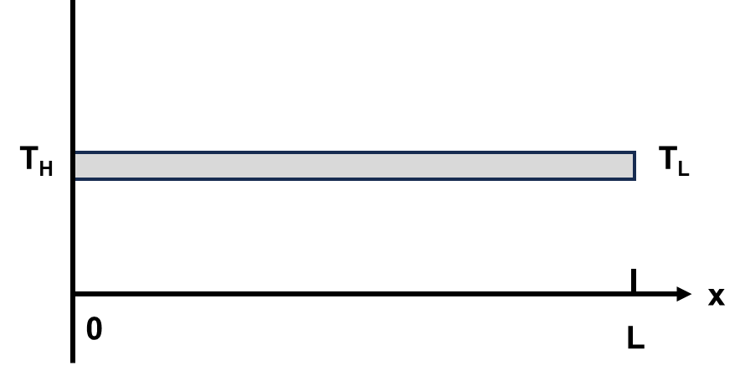
Assume that the left end of NW is in contact with the substrate, where a constant temperature T_{H} is maintained. The right end of the NW is free in the air with temperature of T_{L}. Thus, the temperature distribution T(x,t) along the NW can be obtained from the 1D heat transport equation²:
(1)
where ρ is the mass density, C is the specific heat capacity, κ is the thermal conductivity, and λ is heat dissipation into the air. At steady state, the solution to equation (1) takes the form of:
(2)
where L_{T} is the temperature decay length, defined as:
(3)

Note that the thermal conductivity κ is an intrinsic property of the material, while the heat dissipation λ is dependent on the specific geometry of the nanostructure. For the NW geometry, the heat dissipation is given by:
(4)
where h is heat transfer coefficient and D = 2ab/(a+b), a and b are the widths of the NW cross section. In this scenario, the NWs have square cross-section, so that D equals the NW diameter d. Hence, the temperature decay length can be expressed as:
(5)
For NWs with small diameters, the temperature decay length is reduced, resulting in enhanced thermal inhomogeneity in the microenvironment.

Reference
2. C. Cheng, et al. Heat Transfer across the Interface between Nanoscale Solids and Gas. Acs Nano 5, 10102-10107 (2011).

5. Calculation of detectivity (D) and responsivity (R).
The responsivity (R) and detectivity (D) are defined by the following two equations:
(6)

(7)
where I_{light} and I_{dark} are the photocurrent and dark current, respectively. P is the illuminated optical power. S is the effective area of the device, and q is unit charge, J_{dark} is the density of dark current.

6. Supporting Figures

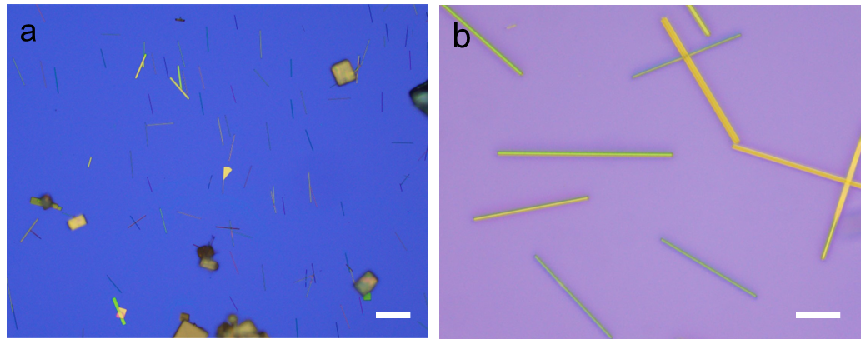

Figure S1. (a) Optical microscope image of NWs and nanoplates growing on a SiO₂/Si substrate. Scale bar: 30 μm. (b) Zoom-in image of (a). Scale bar: 10 μm.

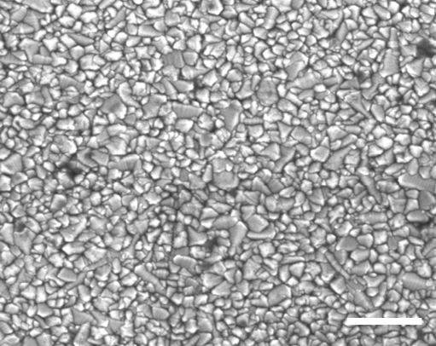

Figure S2. SEM image of typical surface morphology from an FTO substrate. Scale bar: 500 nm.

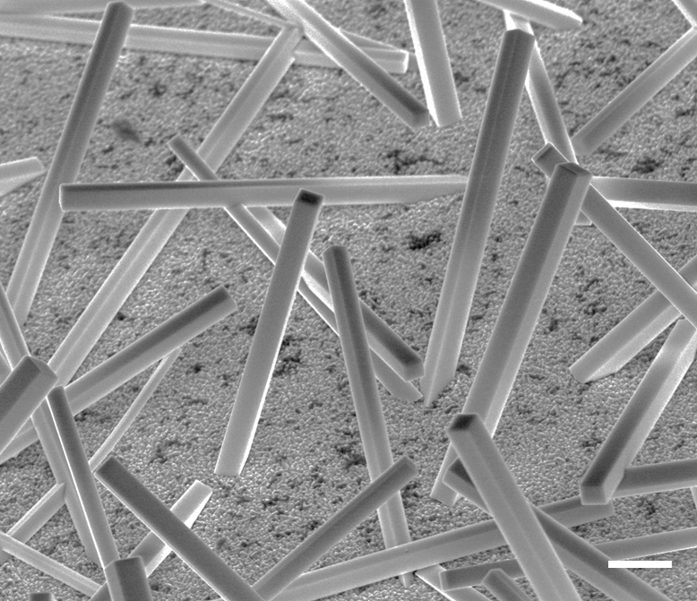

Figure S3. SEM image of as-grown NW array on FTO substrate captured at tilted view of 45°. Scale bar: 3 µm.

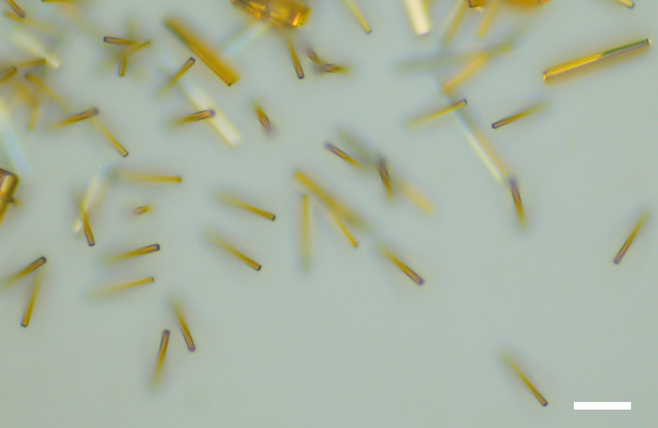

Figure S4. Optical microscope image of pristine NWs compared to that of exchanged NWs in Figure 2b. Scale bar: 20 µm.

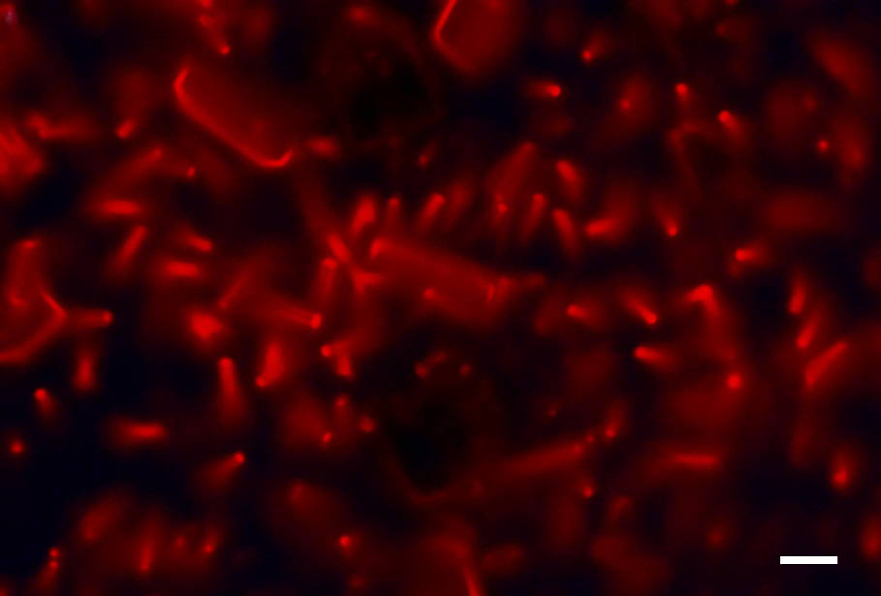

Figure S5. Micro-PL image of a fully exchanged NW array. Scale bar: 20 µm.

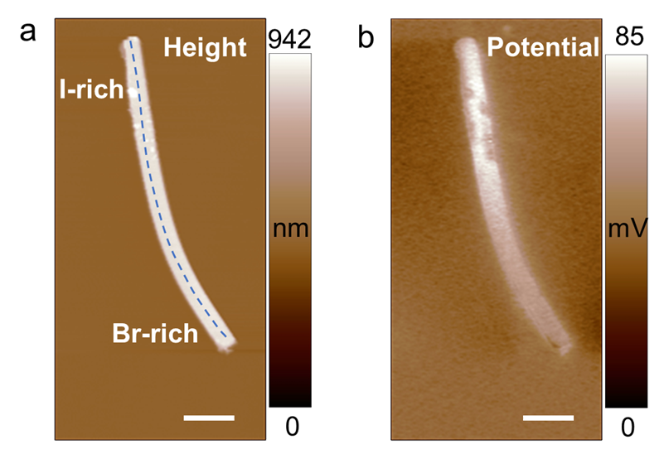

Figure S6. AFM (a) and corresponding KPFM (b) images of a gradient NW on SiO₂/Si substrate. The height and CPD profiles in Figure 3a were measured along the dashed line in (a). Scale bars: 3 µm.

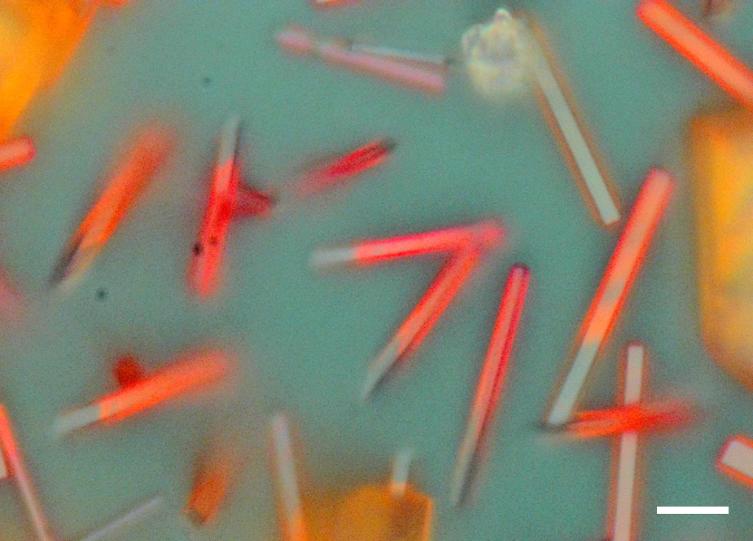

Figure S7. Optical microscope image of an I-exchanged NW array from the top-down exchange setup. Scale bar: 10 µm.

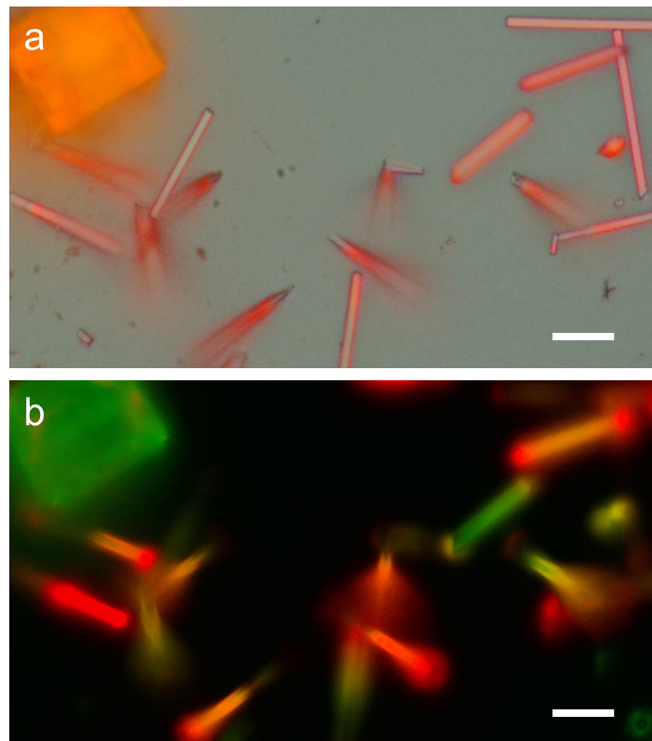

Figure S8. Optical microscope (a) and corresponding micro-PL (b) images of I-exchanged NW array. Scale bar: 10 µm.

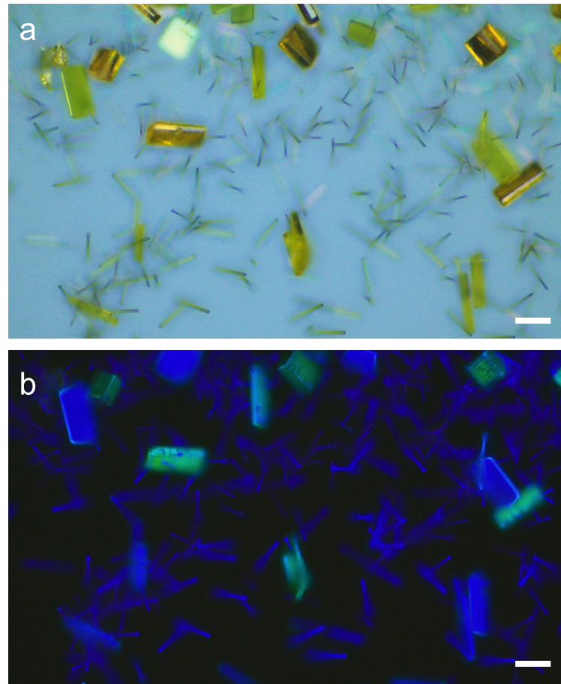
Figure S9. The optical microscope (a) and micro-PL (b) images of uniformly Cl-exchanged NW. Scale bar: 20 µm.

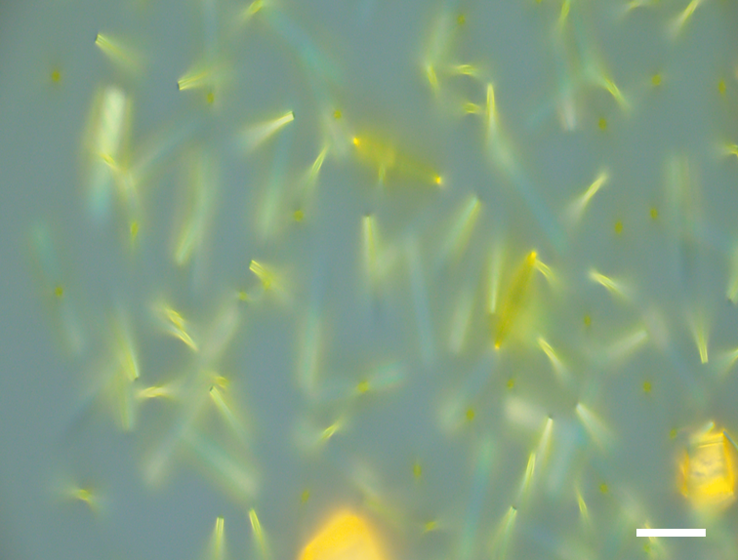

Figure S10. Optical microscope image of the Cl-exchanged NW array. Scale bar: 20 µm.

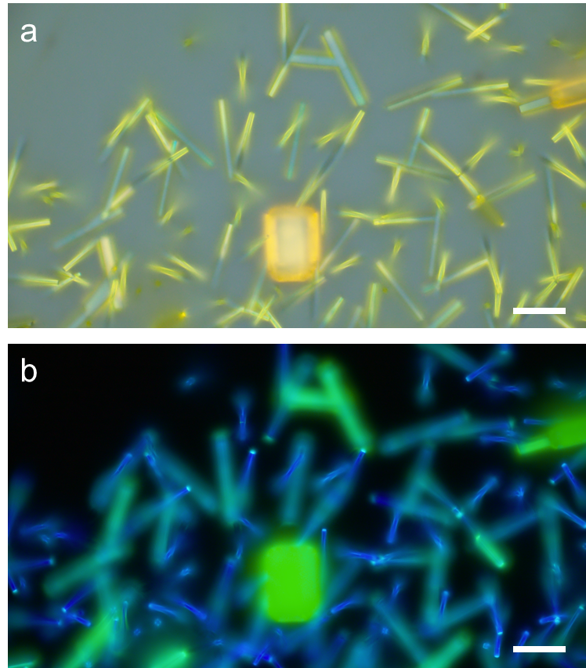

Figure S11. Optical microscope (a) and corresponding micro-PL (b) images of the Cl-exchanged NW array. Scale bars: 20 µm.

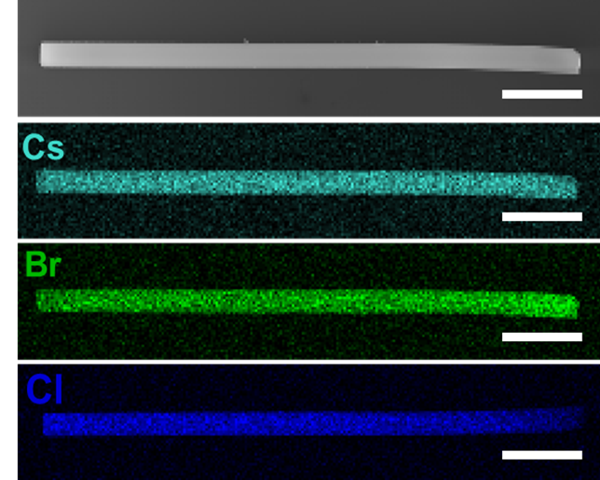

Figure S12. SEM and corresponding elemental mapping of Cs, Br, and Cl along the Cl-exchanged of NW. Scale bar: 5 µm.

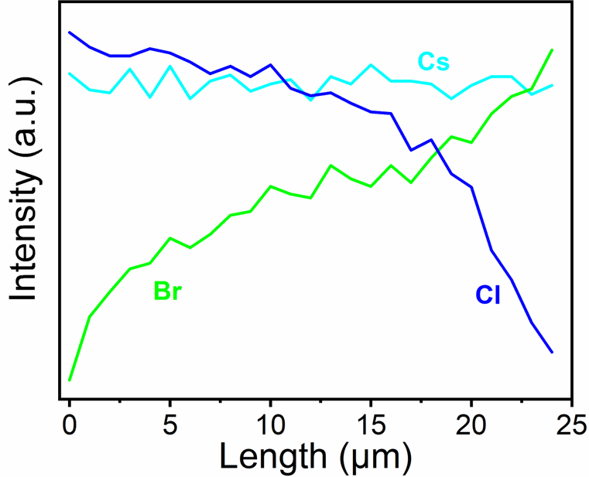

Figure S13. EDS line-scans of Cs, Br, and Cl along the NW in Figure S12.

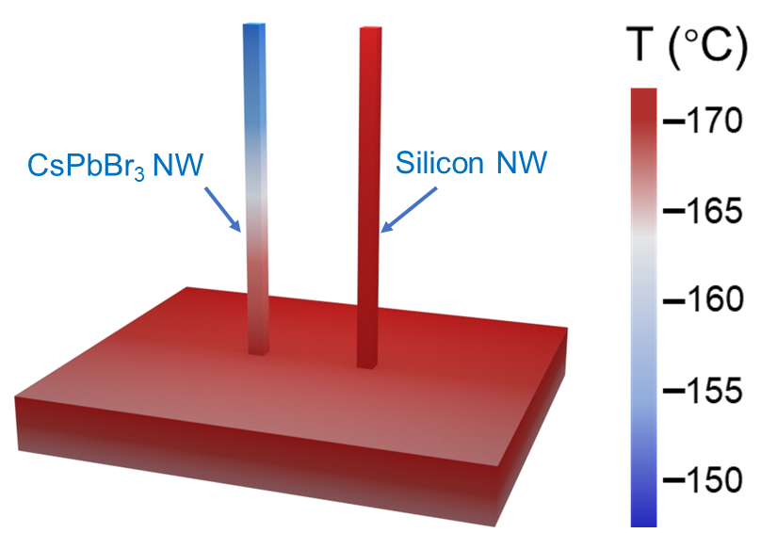

Figure S14. Comparison of temperature profiles between single vertical CsPbBr₃ and silicon NWs with the same diameter of 500 nm and length of 25 μm.

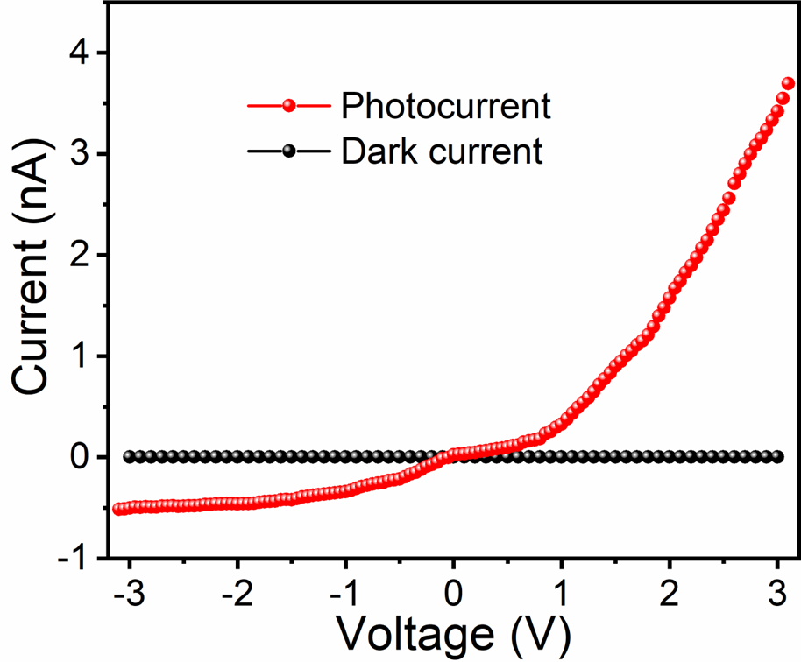

Figure S15. I-V curves of the Br-Cl gradient NW device in dark and under illumination from a 405 nm laser with intensity of 77.4 mW/cm².

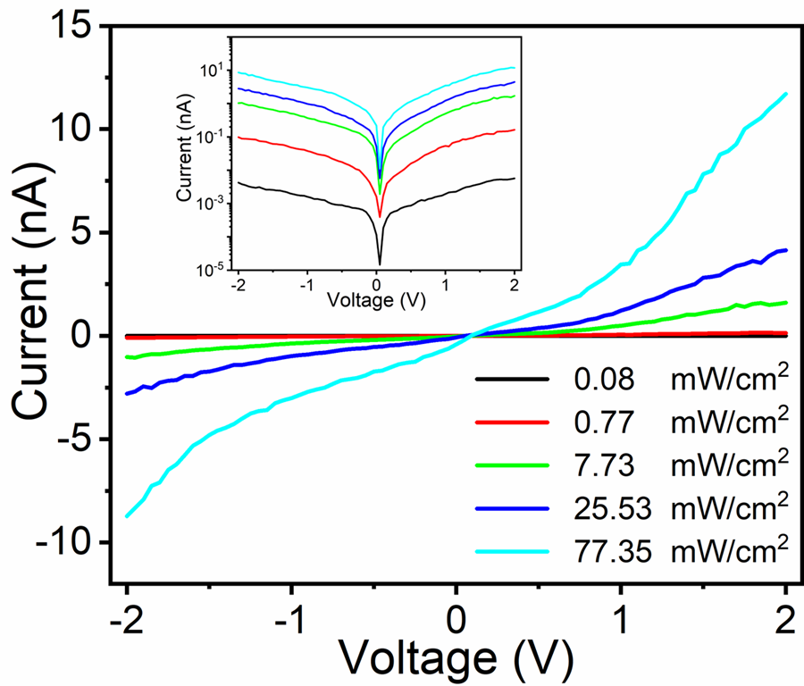

Figure S16. Current-voltage (I-V) characteristics of a pure CsPbBr₃ NW device at various light intensity from irradiation of a 405nm diode laser. The inset shows semi-log plot of the I-V curve.

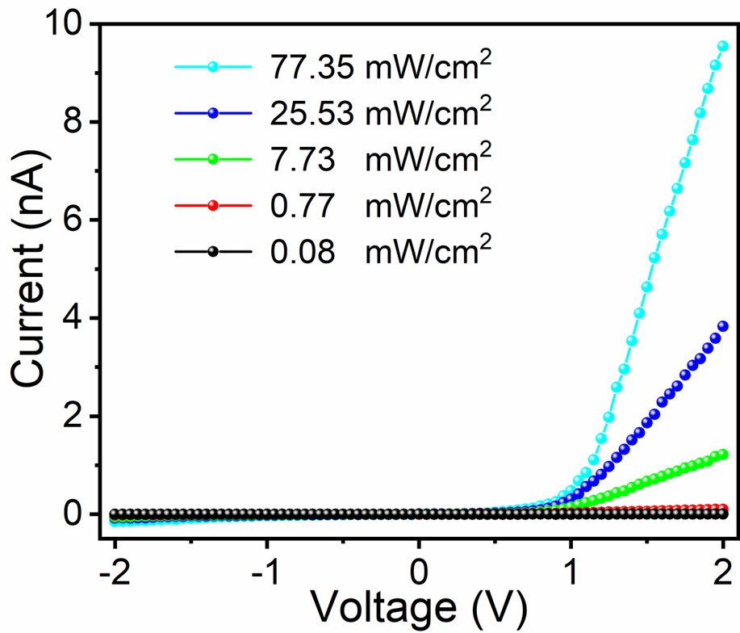

Figure S17. I-V curves of the Br-I gradient NW device in Figure 5f under various light intensity.

Figure S18. I-V curves of the Br-Cl gradient NW device under various light intensity.

Figure S19. Photoresponse of the Br-Cl device under various light intensity and at bias of 3 V.

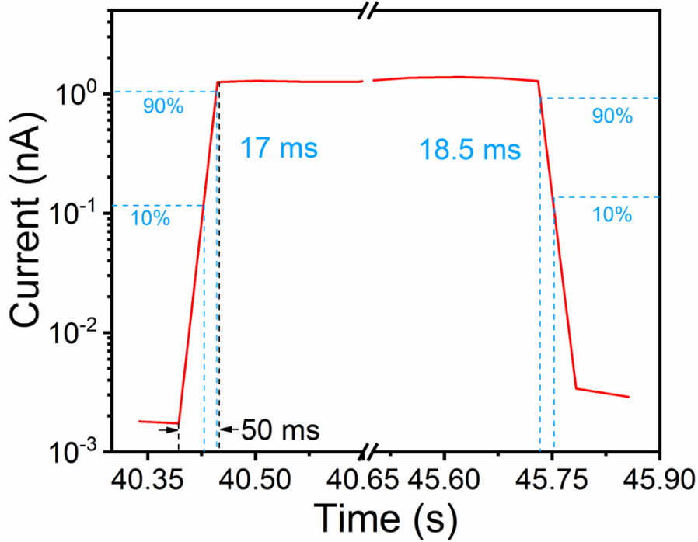

Figure S20. Rise and fall time of the Br-I gradient NW device at bias of 2V and light intensity of 7.73 mW/cm⁻². The rise and fall time were calculated based on the 10% to 90% of photoresponse magnitude.

