Appendix. Supplementary materials
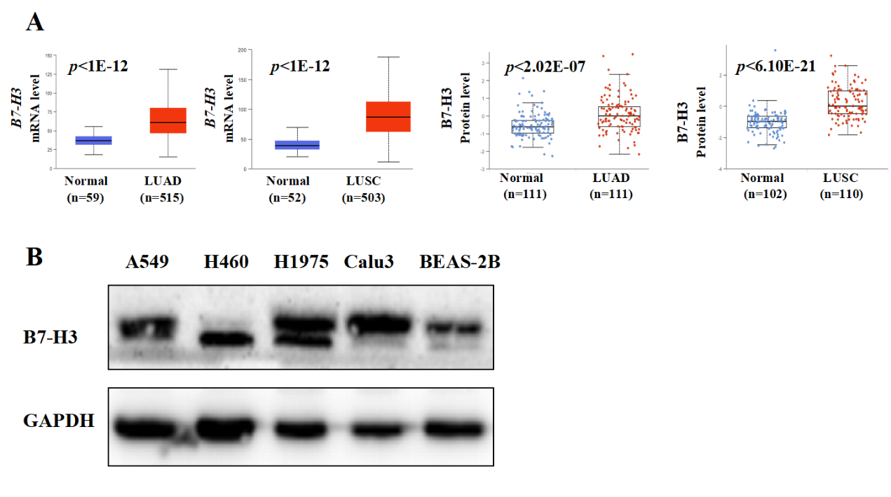

Figure S1. Expression of B7-H3 in lung cancer
A: The differential expression of B7-H3 between tumour tissues and normal tissues was differential expression through bioinformatics analysis of mRNA and protein expression data obtained from the TCGA and CPTAC databases. B: The protein levels of the B7-H3 were evaluated by western blotting in lung cancer lines cells.

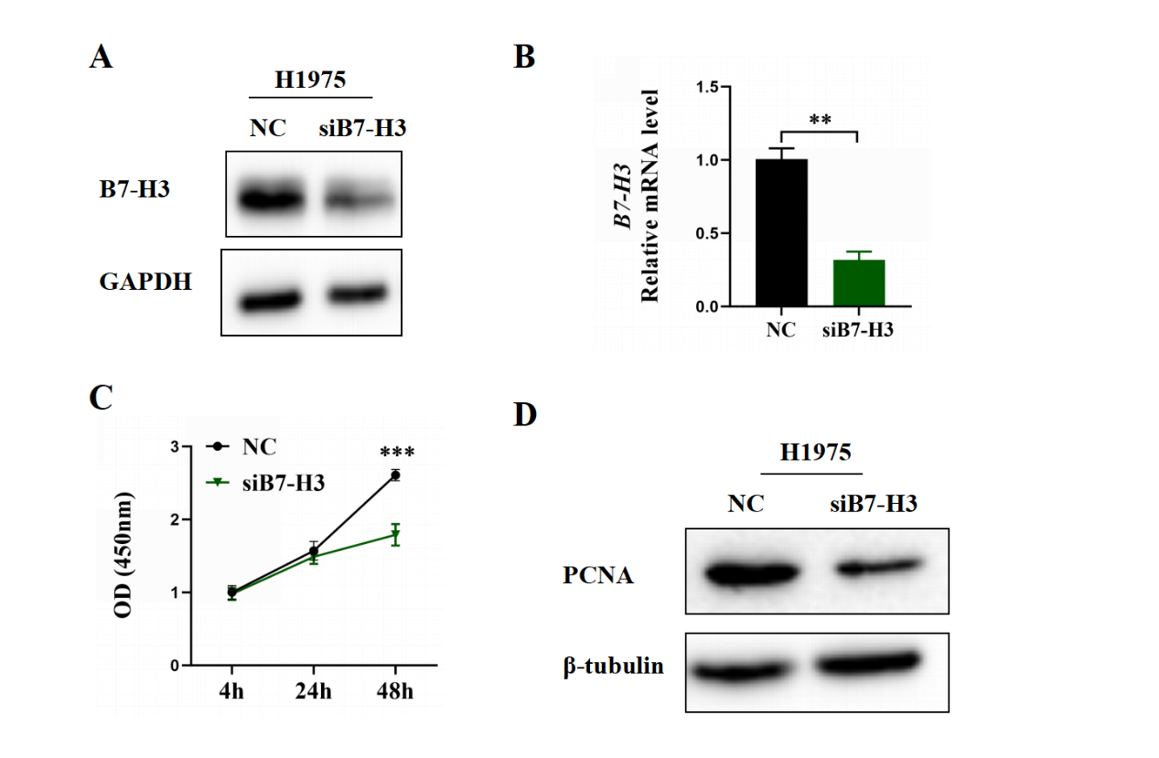
Figure S2. Knockdown of B7-H3 inhibited lung cancer cell proliferation proteins
A-B: Western blot and RT-PCR were used to verify the efficiency of siB7-H3 in H1975 cells. C: Cell proliferation was assessed using the CCK-8 assay. D: The expression of PCNA, E-Cadherin, N-Cadherin, and Vimentin in H1975 cells was detected by western blotting.

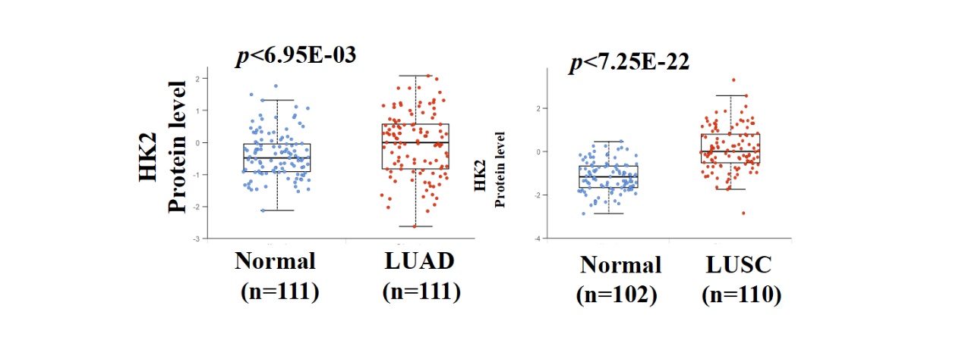
Figure S3. The expression of HK2 in lung cancer in CPTAC databases

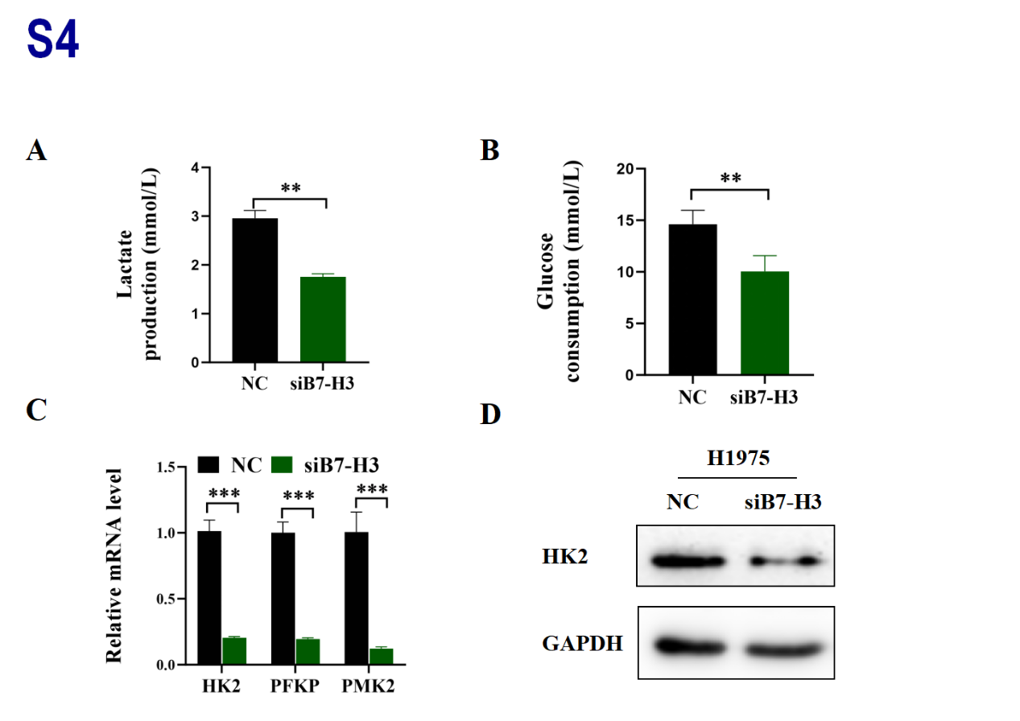
Figure S4. Knockdown of B7-H3 inhibits key glycolytic enzymes and products
A-B: Glucose consumption and lactate production were measured in H1975 cells transfected with siB7-H3. C: The expression of glycolysis-related genes was detected by RT-qPCR in H1975 cells transfected with siB7-H3. D: The HK2 protein levels in H1975 cells transfected with siB7-H3 were measured by Western blot.

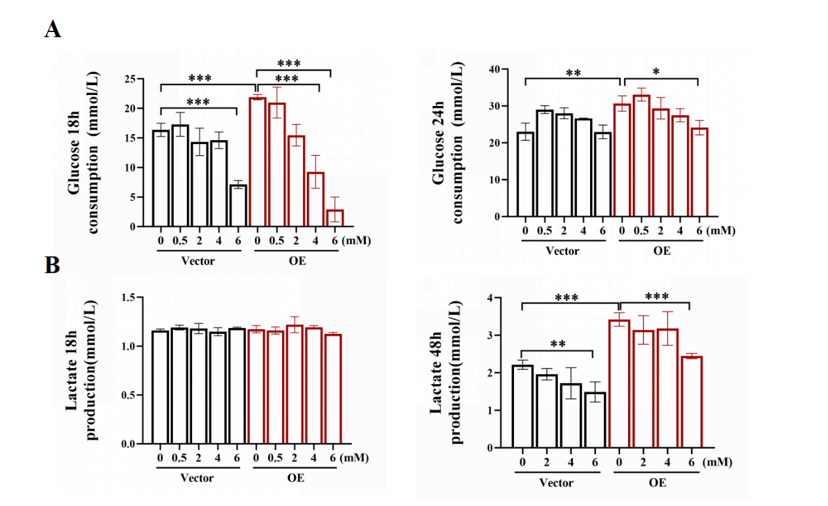
Figure S5. Duration and concentration of 2-DG treatment
A-B: Lactate production, along with glucose consumption (A) and glucose consumption (B), was assessed in A549 cells overexpressing B7-H3, which were treated with PBS or various concentrations of 2-DG. Glucose was measured at 18 hours, and lactate was measured at 48 hours. The concentration of 2DG was 6 mM.

Suppl table 1. Sequences of the oligonucleotides for sgRNA, siRNA, and qRT-PCR
Assay |  |  | Sequence
sgRNA | B7-H3 sg | oligo1 | 5′-CACCGACCCAGTGGTGGCACTGGT-3′
 |  | oligo2 | 5′-AAACACCAGTGCC-ACCACTGGGTC-3′
 | Control sg | oligo1 | 5′-CACCG GCGAGGTATTCGGCTCCGCG-3′
 |  | oligo2 | 5′-AAAC CGCGGAGCCGAATACCTCGC C-3′
siRNA | HK2 | sense | 5′-CACGAUGAAAUUGAACCUGGU-3′
 |  | antisense | 5′-ACCAGGUUCAAUUUCAUCGUG-3′
 | B7-H3 | sense | 5′-GCUGUCUGUCUGUCUCAUUTT-3′
 |  | antisense | 5′-CGACAGACAGACAGAGUAATT-3′
 | Negative | sense | 5’-UUC UCC GAA CGU GUC ACG UUU-3’
 |  | antisense | 5’-UGCACUGUGCAAGCCUCUUGG-3’
qRT-PCR | B7-H3 | Forward | 5’-TGTCTCATTGCACTGCTGGT-3’
 |  | Reverse | 5’-CCTCAGCTCCT GCATTCTCC-3’
 | HK2 | Forward | 5’-GAGCCACCACTCACCCTACT-3’
 |  | Reverse | 5’-CCAGGCATTCGGCAATGTG -3’
 | PKM2 | Forward | 5’-ATGTCGAAGCCCCATAGTGAA-3’
 |  | Reverse | 5’-TGGGTGGTGAATCAATGTCCA-3’
 | PFKP | Forward | 5’-GCATGGGTATCTACGTGGGG -3’
 |  | Reverse | 5’-CTCTGCGATGTTTGAGCCTC-3’
 | β-actin | Forward | 5’-CTCCATCCTGGCCTCGCTGT-3’
 |  | Reverse | 5’-GCTGTCACCTTCACCGTTCC-3’

Suppl table 2. Antibodies used for western blotting
Name | Lot. | Company
anti-β-tubulin | AC030 | ABclonal
anti-GAPDH | AC002 | ABclonal
anti-B7-H3 | 14058S | Cell Signaling Technology
anti-PCNA | A12427 | ABclonal
anti-Hexokinase Ⅱ | A22319 | ABclonal
anti-AKT | A18675 | ABclonal
anti-phospho-AKT S473 | AP0140 | ABclonal
anti-PI3K | A22996 | ABclonal
anti-phospho-PI3K P85 α/γ/β/-Y467/Y199/Y464 | AP0854 | ABclonal
anti-mTOR 7C10 | 2983S | Cell Signaling Technology
anti-phospho-mTOR Ser2448 | 5336S | Cell Signaling Technology

Suppl table 3. The relationship between the levels of sB7-H3 in plasma of patients with LC and clinicopathological characteristics
 |  | sB7-H3 High |  |  |  |  | sB7-H3 Low
Characteristics | N | Median (Min-Max) | P25~P75 | U | P |  | N | Median (Min-Max) | P25~P75 | U | P
Gender |  |  |  | 412 | 0.4985 |  |  |  |  | 705 | 0.8796
Male | 40 | 18.09（15.16-32.36） | 16.27-20.29 |  |  |  | 45 | 12.09（5.415-15.00） | 9.913-13.31
Female | 23 | 18.55（15.37-32.08） | 16.17-22.25 |  |  |  | 32 | 12.36（7.130-14.83） | 9.948-14.83
Age |  |  |  | 317.5 | 0.6788 |  |  |  |  | 450 | 0.1655
≤ 60 | 14 | 19.52（15.16-32.08） | 15.88-24.52 |  |  |  | 20 | 11.24（5.415-14.71） | 9.778-12.68
＞60 | 49 | 18.27（15.27-32.36） | 16.45-20.69 |  |  |  | 57 | 12.40（7.130-15.00） | 10.13-13.50
TNM |  |  |  | 313 | 0.2313 |  |  |  |  | 454.5 | 0.018
Ⅰ＋Ⅱ | 17 | 17.32（15.37-24.33） | 16.06-20.20 |  |  |  | 27 | 10.63(5.415-14.71) | 9.701-12.73
Ⅲ＋Ⅳ | 46 | 18.43（15.16-32.36） | 16.71-21.56 |  |  |  | 50 | 12.49(7.427-15.00) | 10.73-13.62
Metastasis |  |  |  | 205 | 0.078 |  |  |  |  | 430.5 | 0.0719
No | 12 | 16.77（15.37-22.25） | 16.06-18.90 |  |  |  | 21 | 10.72(5.415-14.71) | 9.658-12.60
Yes | 51 | 18.44（15.16-32.36） | 16.53-21.94 |  |  |  | 56 | 12.44(7.340-15.00) | 10.16-13.50
Type of pathology |  |  |  |  | 0.5455 |  |  |  |  |  | 0.0386
Adenocarcinoma | 39 | 18.3（15.2-32.4） | 16.9-21.4 |  |  |  | 47 | 11.4(5.415-14.7) | 9.7-13.00
Squamous carcinoma | 14 | 19.2（15.3-27.1） | 16.4-22.0 |  |  |  | 21 | 13.1(7.43-15.00) | 12.2-15.00
Small cell lung cancer | 8 | 18.2（15.5-23） | 16.2-21.7 |  |  |  | 8 | 11.2(7.9-13.1) | 10.4-13.1
Other | 2 | 16.0（15.9-16.1） | 15.9-16.1 |  |  |  | 1 | 13.5 | 13.5

