Supplemental Figure 1: Scatterplot of Predicted e19-9 Values and Real CA19-9 Values

(a) 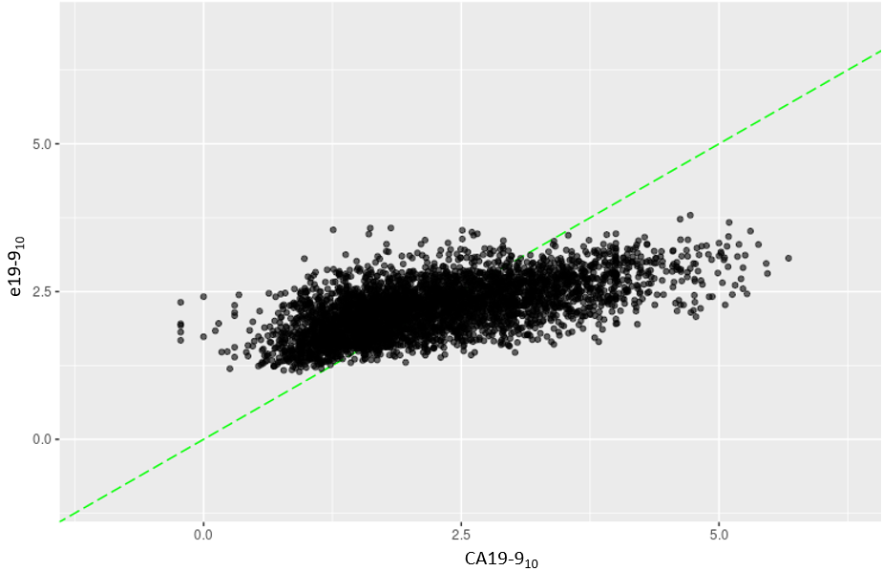(b) 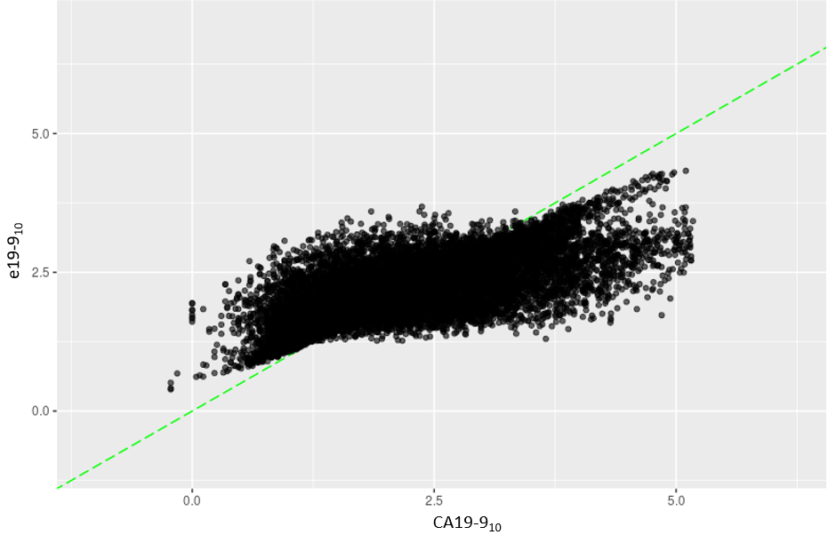
The CA19-9 values among patients in the internal and external datasets compared to predicted e19-9 values. Values are Log₁₀ transformed. (a) Performance metrics for the trained e19-9 model on the internally withheld test set (75/25 split) were RMSE 0.752 and R² 0.383. (b) Performance metrics for the trained e19-9 model on the external dataset were RMSE 0.667 and R² 0.496.

SUPPLEMENTAL TABLE 1. Demographics for Internal Cohort and External Validation Set
 | Internal Cohort  (n=3,239) | External Cohort  (n=4,384)
Age in years, median (IQR) | 67 (15) | 64 (16)
Gender (female), n (%) | 1,522 (47.0) | 2,117 (48.3)
Race, n (%)
White | 2,850 (88.0) | 3,095 (70.6)
Black | 259 (8.0) | 504 (11.5)
Other/Unknown | 130 (4.0) | 785 (17.9)
Ethnicity, n (%)
Hispanic | 58 (1.8) | 215 (4.9)
Non-Hispanic | 3,142 (97.0) | 3,161 (72.1)
Unknown | 39 (1.2) | 1,008 (23.0)

SUPPLEMENTAL TABLE 2. Median Covariate Values for Internal Cohort and External Validation Set
Covariate (median, IQR) | Units | Internal Cohort | External Cohort
WHITEBLOODCELLCOUNT | 10e3/uL | 6.0 (3.60) | 6.2 (4.0)
REDBLOODCELLCOUNT | 10e6/uL | 3.8 (0.80) | 3.8 (0.86)
HEMOGLOBIN | g/dL | 11.3 (2.4) | 11.3 (2.4)
HEMATOCRIT | % | 35.0 (6.2) | 34.5 (7.0)
MEANCORPUSCULARHEMOGLOBIN | pg | 30.2 (2.8) | 30.4 (3.1)
MEANCORPUSCULARHEMOGLOBINCONCENTRATION | g/dL | 33.0 (1.2) | 33.0 (1.7)
MEANCORPUSCULARVOLUME | fl (US femtoliter) | 93.0 (8.0) | 92.3 (8.6)
REDCELLDISTRIBUTIONWIDTH | % | 15.2 (3.2) | 15.6 (3.5)
PLATELETCOUNT | 10e3/uL | 208.0 (131.0) | 210.0 (137.0)
MEANPLATELETVOLUME | fl (US femtoliter) | 9.5 (1.5) | 9.6 (1.8)
NEUTROPHILPERCENT | % | 67.0 (15) | 66.0 (17.0)
LYMPHOCYTEPERCENT | % | 18.0 (12) | 19.7 (14.5)
MONOCYTEPERCENT | % | 10.0 (5.0) | 9.4 (5.1)
EOSINOPHILPERCENT | % | 2.0 (3.0) | 2.0 (2.2)
BASOPHILPERCENT | % | 1.0 (1.0) | 0.6 (0.8)
IMMATUREGRANULOCYTEPERCENT | % | 0.0 (1.0) | 0.4 (0.9)
NEUTROPHILABSOLUTE | 10e3/uL | 3.8 (2.6) | 4.2 (3.6)
LYMPHOCYTEABSOLUTE | 10e3/uL | 1.1 (0.8) | 1.2 (1.0)
MONOCYTEABSOLUTE | 10e3/uL | 0.5 (0.5) | 0.6 (0.5)
EOSINOPHILABSOLUTE | 10e3/uL | 0.12 (0.1) | 0.11 (0.1)
BASOPHILABSOLUTE | 10e3/uL | 0.03 (0.0) | 0.03 (0.1)
BLOODUREANITROGEN | mg/dL | 13.9 (5.1) | 13.0 (8.0)
SODIUM | mmol/L | 138 (4.0) | 139 (5.0)
POTASSIUM | mmol/L | 4.1 (0.5) | 4.0 (0.6)
CHLORIDE | mmol/L | 102 (4.0) | 103 (5.0)
BICARBONATE | mmol/L | 26 (3.0) | 26 (4.0)
ANIONGAP | mmol/L | 11 (3.0) | 10 (4.0)
GLUCOSE | mg/dL | 124 (60.3) | 122 (59.0)
CREATININE | mg/dL | 0.80 (0.30) | 0.80 (0.40)
EGFR | mL/min/1.73 sqm | 60 (0) | 60 (10)
CALCIUM | mg/dL | 9.1 (0.6) | 9.0 (0.7)
ALBUMIN | g/dL | 3.8 (0.6) | 3.6 (0.9)
ALKALINEPHOSPHATASE | U/L | 128 (111.0) | 129 (123.0)
ALTSGPT | U/L | 26 (25.0) | 28 (29.0)
ASTSGOT | U/L | 27 (20.0) | 29 (23.0)
TOTALPROTEIN | g/dL | 6.7 (0.8) | 6.5 (1.0)
BILIRUBINTOTAL | mg/dL | 0.4 (0.4) | 0.5 (0.5)
CARCINOEMBRYONICANTIGEN | ng/mL | 3.9 (5.1) | 4.2 (7.3)
CA199 | U/mL | 109.0 (624.7) | 171.0 (1103.0)
EGFR, Estimated Glomerular Filtration Rate

SUPPLEMENTAL TABLE 3. Cox Proportional Hazards Models for Survival
 | Univariable |  |  |  | Multivariable
Covariate | HR | 95% CI | p value |  | HR | 95% CI | p value
Age (continuous) | 1.02 | 0.99-1.05 | 0.15 |  | 1.05 | 1.01-1.11 | 0.04
Gender (ref: female) | 1.05 | 0.64-1.71 | 0.86 |  | - | - | -
Race
White | Ref
Black | 3.75 | 1.79-7.86 | <0.001 |  | 4.36 | 1.89-10.07 | 0.001
Other | 0.87 | 0.12-6.31 | 0.89 |  | 1.96 | 0.25-15.10 | 0.52
BMI (continuous) | 1.03 | 0.98-1.09 | 0.23 |  | - | - | -
Charlson comorbidity index | 1.14 | 00.99-1.31 | 0.07 |  | 0.96 | 0.74-1.25 | 0.76
Clinical Stage
Resectable | ref
Borderline Resectable | 1.61 | 0.98-2.65 | 0.06 |  | 1.13 | 0.63-2.03 | 0.68
Tumor Size on Diagnostic Imaging (continuous) | 1.15 | 0.95-1.39 | 0.14 |  | 0.99 | 0.82-1.19 | 0.90
Neoadjuvant Therapy
Both | ref
Chemotherapy alone | 0.69 | 0.27-1.76 | 0.43 |  | - | - | -
Radiotherapy alone | 0.75 | 0.43-1.31 | 0.31 |  | - | - | -
e19-9 at Diagnosis (continuous) | 1.00 | 1.00-1.00 | 0.57 |  | - | - | -
Proportional Change in e19-9 over Treatment (continuous) | 0.99 | 0.99-0.99 | <0.001 |  | 0.99 | 0.99-0.99 | 0.003
Completion of all Treatment and Surgery | 0.16 | 0.09-0.28 | <0.001 |  | 0.23 | 0.11-0.49 | <0.001

SUPPLEMENTAL TABLE 4. Cox Proportional Hazards Models for Survival
 | Univariable |  |  |  | Multivariable
Covariate | HR | 95% CI | p value |  | HR | 95% CI | p value
Age (continuous) | 1.02 | 0.99-1.05 | 0.15 |  | 1.05 | 1.00-1.10 | 0.05
Gender (ref: female) | 1.05 | 0.64-1.71 | 0.86 |  | - | - | -
Race
White | Ref
Black | 3.75 | 1.79-7.86 | <0.001 |  | 4.34 | 1.88-10.00 | 0.001
Other | 0.87 | 0.12-6.31 | 0.89 |  | 1.65 | 0.21-12.65 | 0.63
BMI (continuous) | 1.03 | 0.98-1.09 | 0.23 |  | - | - | -
Charlson comorbidity index | 1.14 | 00.99-1.31 | 0.07 |  | 0.97 | 0.76-1.23 | 0.78
Clinical Stage
Resectable | ref
Borderline Resectable | 1.61 | 0.98-2.65 | 0.06 |  | 1.12 | 0.61-2.03 | 0.72
Tumor Size on Diagnostic Imaging (continuous) | 1.15 | 0.95-1.39 | 0.14 |  | 0.98 | 0.81-1.19 | 0.87
Neoadjuvant Therapy
Both | ref
Chemotherapy alone | 0.69 | 0.27-1.76 | 0.43 |  | - | - | -
Radiotherapy alone | 0.75 | 0.43-1.31 | 0.31 |  | - | - | -
e19-9 at Diagnosis (continuous) | 1.00 | 1.00-1.00 | 0.57 |  | - | - | -
Post-Treatment e19-9 value (continuous) | 1.01 | 1.01-1.01 | <0.001 |  | 1.01 | 1.01-1.01 | 0.03
Completion of all Treatment and Surgery | 0.16 | 0.09-0.28 | <0.001 |  | 0.17 | 0.08-0.34 | <0.001

