Supplementary Information for
Anomalous CO Saturation at 26% on Cu(111) Governed by Long-range Collective Quantum Compression
The PDF file includes:
Experimental Method
Sample Preparation
Tip Preparation
CO Manipulation
Computational Method
CO Identification
Monte Carlo Simulation
Statistical Analysis
Density Functional Theory (DFT) Calculations
Issues with the DFT Description of CO Adsorption
Orbital Analysis
Indirect Elastic Interaction Estimation
CO Stretching Frequency
GitHub Repository
Figs. S1 to S8
References

Experimental Method
Sample Preparation
Our experiments were performed with a CreaTecTM STM/AFM system under ultrahigh vacuum conditions. All images were taken at 4.8 K. The pattern formed at 77.6 K was checked by STM first and then cooled to 4.8 K for STM and AFM measurements. The bias voltages referred to the sample in both STM and AFM images. The STM images were recorded in constant-current mode. The AFM images were recorded in constant-height frequency modulation mode using a qPlus sensor. The sensor has a resonance frequency of 30 kHz with a spring constant k = 1,800 N/m. In our measurements, the quality factor of the sensor is about 20,000. The oscillation amplitude was set to 100 pm. The Cu(111) surfaces were cleaned by repeated cycles of sputtering and annealing. CO molecules were dosed onto the surfaces through a leaking valve.

Tip Preparation
The AFM Cu tip apex was functionalized by controlled pickup of a CO molecule from the substrate¹ with the C atom towards the metal tip at 4.8 K. All the experiments were conducted using either a pure Cu tip or a CO-functionalized tip.

CO Manipulation
Figure S1 demonstrates a CO manipulation procedure – from its original position to an empty site in two steps. As shown in Fig. S1A, the initial CO (marked by a yellow dot) is first "pushed" by the AFM probe tip towards the up-right direction. This results in the initial CO being moved to the site between two neighboring COs (marked by two red dots) while these two COs move to the empty sites nearby (marked by two dashed red circles). Figure S1B shows that these two COs (red dots in Fig. S1A) now occupy the previous empty sites and the originally "pushed" CO sites in the middle between three newly created empty sites (yellow arrow). Then this CO was pushed again upwards. Figure S1C displays the final state after the two-step CO manipulation. The original CO and two other COs in Fig. S1C are relocated to their new positions, respectively, leaving two original CO-occupied sites to appear empty. Therefore, we confirm that the vacancies are indeed empty sites.

Computational Method
CO Identification
We employed a MATLAB code (available on GitHub) to efficiently analyze the number of CO molecules, $n_{CO}$, and the corresponding number of surface Cu atoms, $n_{Cu}$, in large experimental images. Since the distance between nearest COs on Cu(111) is 4.4 Å, we utilized the identified coordinates of COs to estimate the actual size of the images. Once we obtained the image area, dividing it by the area per surface Cu atom yielded $n_{Cu}$ (Figs. S2A and B). With the output of the program providing $n_{CO}$, the coverage θ could be easily computed. However, since the brightness distribution in experimental images is often not uniform, manual adjustments were sometimes required to add or remove COs that were either overlooked or double-counted.

Monte Carlo Simulation
We utilized MATLAB to create a 96 x 96 2D grid, where each grid point represents a surface Cu atom ($n_{Cu}$ = 9,216). After randomly generating the coordinates for the first point (the first CO adsorption site), every time a new point was generated, the code calculated the distances between each pair of points to ensure that no two points were closer than 4.4 Å. We iteratively generated points meeting the criteria until the CO coverage, $θ$, reached 26% ($n_{CO}$ = 2,397). The MATLAB code for such Monte Carlo simulations, available on GitHub, allows users to modify the size of the grid, the expected coverage, the lattice constant, etc.
Initially, without imposing restrictions on lattice mismatch, we observed that $θ$ would never reach 26%, often not exceeding 20%. Based on the $\sqrt{3}×\sqrt{3}$/R30° adsorption structure shown in Fig. 1A in the main text, when a CO molecule adsorbs on the Cu(111) surface, it deactivates the six surrounding Cu atoms, i.e. these sites become unavailable for CO adsorption. However, as the number of adsorbed CO molecules increases, the random arrangement leads to the deactivation of varying numbers of Cu sites. Figures S2A and B shows a side and top view of a (111) surface, and the corresponding distances between neighboring surface atoms in units of the lattice constant of Cu,$a_{Cu}$. Figure S2C shows that for two adjacent CO molecules (both adsorbed on top sites) the number of deactivated Cu sites differs depending on the separation distances. For example, for two neighboring CO’s at distances of 4.4, 5.1 and 6.7 Å, the numbers of deactivated sites are 10, 11, and 12, respectively. The theoretical limit of $θ$ decreases from 33% whenever a pair of CO molecules with a separation distance of 5.1 or 6.7 Å occurs. While lattice mismatch results in the formation of “vacancy lines”, their likelihood is found to be significantly lower in experiments than in simulations. This indicates that the experimental distribution of CO on the Cu(111) surface is not random, suggesting the presence of a localized driving force that minimizes the occurrence of CO molecule pairs with separation distances of 5.1 and 6.7 Å.

Statistical Analysis
In Eq. 1 of the main text, since $n_{Cu_{i}}$ approaches $N_{Cu}$ as the image size increases, we only need to use the first-order approximation. By setting $y_{i}=\frac{{σ_{r_{i}}^{2}n}_{Cu_{i}}}{μ(1-μ)}$, we should have $y_{i}=α+βn_{Cu_{i}}+$_{I}, where _{I} is the random stochastic error. If our model holds true, then the fitted parameter $α$ should be close to 1 and the fitted $β$ should be approximately equal to $-1/N_{Cu}$. We employed a nonlinear generalized reduced gradient method² to find solutions to $N_{Cu}$, $α$ and $β$ by minimizing _{I} while varying $N_{Cu}$ from 570 to 2,280. The analytic solutions we obtained for $N_{Cu}$,$α$, and $β$ are 1,546 ($R=5.3 nm$), 1.000647, and -6.474*10⁻⁴, respectively. These computed values confirm the validity of our model.

Density Functional Theory (DFT) Calculations
We employed a real-space pseudopotential DFT code, PARSEC, for all the electronic structure calculations. We used the Perdew-Burke-Ernzerhof (PBE)³ exchange-correlation functional with Troullier-Martins norm-conserving pseudopotentials⁴. We set the convergence criterion of the self-consistent residual error to be 10⁻⁴ Ry. The grid spacing of the real-space cubic grid was set to be 0.159 Å. We found an optimized Cu bulk lattice constant $a_{Cu}$ = 3.6 Å, a CO bond length of 1.13 Å and a CO adsorption height of 1.86 Å, in good agreement with experiment and previous theoretical calculations^{5, 6, 7}. We modeled the Cu(111) surface as a 4-layer 12x12 slab using an orthorhombic unit cell where a = 30.52 Å, b = 26.43 Å. A 2D boundary condition was assumed so that the system was periodic along the x and y directions. The slab width was set to be 22.23 Å, corresponding to a vacuum space of 13.01 Å for the CO/Cu(111) system. We performed calculations at the Γ point as the systems are sufficiently large (range from 576 to 672 atoms). We computed the change in electron density, $∆ρ(θ)$, using:
$$\begin{aligned}∆ρ(θ)=ρ_{sys}-\left(ρ_{nCO}+ρ_{Cu\left(111\right)}\right)\#\left(Eq.S1\right)\end{aligned}$$
Due to the constraints imposed on the electrons by quantum confinement, we also considered the possibility of a transition from a weakly correlated to a strongly correlated system as θ increases. We performed both spin-paired and spin-polarized calculations at low and high coverages but did not observe any spin-symmetry breaking⁸, indicating that the CO/Cu(111) system is unlikely to be strongly correlated.

Issues with the DFT Description of CO Adsorption
Many studies have shown that the CO adsorption behavior on transition metal surfaces is not well described by DFT^{9, 10}. This issue was first reported for Pt(111), for which DFT predictions consistently favored hollow-site adsorption over atop-adsorption, contradicting the experimentally identified top adsorption site. Subsequently, similar results were obtained on surfaces such as Cu(111), Rh(111) and Pt (111)¹¹. The failure of DFT in such systems led researchers to question the reliability of DFT calculations for interfaces. Since then, various attempts have been made to resolve the CO puzzle. However, Sharifzadeh el al.¹² pointed out that these efforts often relied on ad hoc corrections and yielded correct answers for the wrong reasons.
For example, Xu et al.¹³ calculated the adsorption energy of CO on the top site of a Cu(111) surface to be –0.38 eV using the revised PBE functional (RPBE)¹⁴, which was developed to improve the accuracy of calculated chemisorption energies. However, “while improving the chemisorption energies, the RPBE functional may worsen other physical properties¹⁴.”
Another popular approach is the DFT+U method¹⁵, where the U correction is typically applied to the d states of transition metals^{16, 17, 18}. However, Cu is typically considered not to require a U correction because the correlation of Cu's 3d electrons in Cu-containing compounds is not particularly strong¹⁸. In contrast to the standard DFT+U, Eren et al.¹⁹ used PBE+U with U = 6 eV for C and O. Although their results agree with experimental measurements, their non-ab initio method does not fundamentally resolve the issue.
A widely accepted explanation for the failure of DFT for CO adsorption on transition metal surfaces is that DFT underestimates the HOMO-LUMO gap of the CO molecule, resulting in the calculated $E_{2π*}$ being lower than the actual value. This overestimates the binding of CO to hollow sites with the dπ orbital of the metal based on the Blyholder model²⁰. In 2019, Patra et al.⁷ suggested a density-driven error for the adsorbed CO by applying the Hubbard U correction to the p orbital of the C atom in the CO molecule.

Orbital Analysis
We calculated the projected density of states (PDOS) of CO-vacant sites for different coverages, θ, and adsorption configurations, Ω. First, we compared the PDOS of a point vacancy (the i site labeled in Fig. 4B of the main text, which is surrounded by 6 COs) at θ = 26.4% with that of the bare Cu surface (Fig. S6A). The most significant difference lies in the major peaks of in-plane 3d orbitals ($3d_{xy}$ and $3d_{x^{2}-y^{2}}$) shifting toward the Fermi level upon CO adsorption (highlighted by red dashed circles). In contrast, changes in the out-of-plane orbitals ($3d_{xz}$, $3d_{yz}$ and $3d_{z^{2}}$) are not significant. Fig. S6B illustrates the compression of the d band on the Fermi level's (E_{F} = –4.8 eV) right side upon CO adsorption (also highlighted by the black dashed circle in Fig. S6A). Overall, this effect causes the d band width to shrink down by ~20% as θ increases from 0 to 33.3% (a downshift of d-band center, ε_{d}).
To further investigate the reason for the downshift of ε_{d}, we computed the variation in the energy levels of the 3d orbitals of the same empty Cu site on a 12x12x4 Cu(111) surface at different θ and Ω (Fig. S6C). This calculation revealed that increase in θ induces a correlated downward shift of all 3d orbitals away from the Fermi level. As θ increases, the gap, Δ, between $3d_{z^{2}}$ and in-plane orbitals widens, as depicted in Fig. S6D, with a weak dependence on Ω (Δ_{12.5} $≈$ Δ’_{12.5}). A mathematical fitting shows that Δ has the following form,$∆=0.012e^{11(θ-0.26)}+0.15$, where θ is in the range of (1/24, 1/3). The rapid increase in Δ when θ is close to max coverage, suggesting the presence of cooperative effects, may provide a rationale for the experimentally observed CO saturation coverage of 26%, as a large Δ hampers the binding between CO's 5σ and Cu's $3d_{z^{2}}$.

Indirect Elastic Interaction (IEI) Estimation
The IEI was described by the expression given in Ref.²¹
$$\begin{aligned}E_{elastic}\left(θ, Ω\right)=\frac{4πμ_{L}}{1-σ}Θ^{2}ξ\sum_{i,j=1,i≠j}^{n}{\frac{{\left|\overline{r}-\overline{r_{i}}\right|}^{3}{\left|\overline{r}-\overline{r_{j}}\right|}^{3}{\overline{r_{ij}}}^{-3}}{2}} \#\left(Eq.S2\right)\end{aligned}$$
Here $μ_{L}$ is the Lamé′s second parameter (or shear modulus), $σ$ is the Poisson ratio, $Θ$ is the 2D dilatation due to the adsorption of CO, $ξ$ is a scaling factor we introduced based on the structural relaxation results, $|\overline{r}-\overline{r_{i/j}}|$ is the distance between C atom and the surface Cu atom, $\overline{r_{ij}}$ is the separation distance between the surface CO molecules, and $n$ is the number of COs in the system (the code is available on GitHub). In atomic units, we have: $μ_{L}=0.00152$²², $σ=0.34$²³, $Θ≅0.1$²¹, $ξ=1/3$, $\left|\overline{r}-\overline{r_{i/j}}\right|=3.51$ for CO/Cu(111) system. Introducing these values into Eq. 6 gives:
$$\begin{aligned}E_{elastic}\left(θ, Ω\right)=\frac{4.67π}{3}\sum_{i,j=1,i≠j}^{n}{\frac{{\overline{r_{ij}}}^{-3}}{2}}\#\left(Eq.S3\right)\end{aligned}$$
for computing the elastic interaction energy (in eV) of a nCO/Cu(111) system.
To compute the elastic interaction energy, $E_{ij}$, we considered increasing number of unit cells surrounding the reference unit cell and treated CO molecules outside the original unit cell as pseudo-molecules. These pseudo-molecules were assumed to interact with the molecules inside the unit cell, but interactions among themselves were not considered (code available on GitHub). We tested the convergence behavior and found that including approximately 25 unit cells was sufficient. As shown in Fig. S7A, the energy increased by 0.067 eV when increasing the number of surrounding unit cells from 1 to 9. This increment reduced to 0.006 eV when increasing from 9 to 25 unit cells, and further decreased to only 0.002 eV when increasing from 25 to 49 unit cells. To better illustrate our scheme, we plotted the models with 1, 9, 25, 49, 91, 121, and 169 unit cells (Figs. S7B-H).

CO Stretching Frequency
In addition to SPM characterizations, we analyzed previously measured reflection adsorption infrared spectroscopy spectra²⁴ for the CO/Cu(111) system to determine the CO stretching frequency as a function of its coverage (Fig. S8). The CO stretching frequency decreases continuously until the coverage reaches a certain level. This observed change in the stretching frequency is indicative of the CO molecules approaching a saturation state on the Cu(111) surface and reinforces the presence of a coverage threshold.

GitHub Repository
https://github.com/DansonFan/Magic_Number

Supplementary Figures
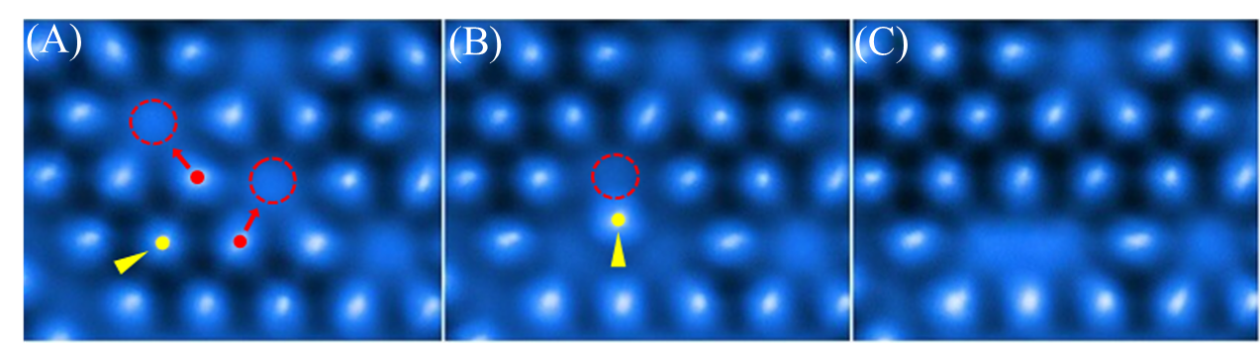
Fig. S1. A two-step CO manipulation that moves CO to empty sites (AFM images). (A) Step one: the original CO (yellow dot) is pushed by the probe in the yellow arrow direction; in turn, two other COs (red dots) are squeezed towards (red arrow) two empty sites (red dashed circles). (B) Step two: the original CO is pushed again upwards to fill in the empty site (red dashed circle). (C) Final state after manipulation.

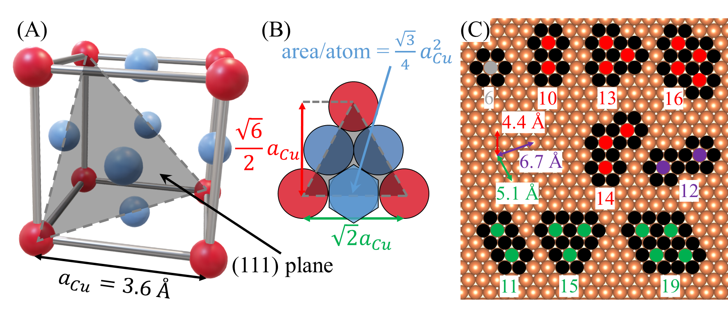
Fig. S2. Schematic side (A) and top (B) views of a Cu(111) surface showing two different surface Cu-Cu separation distances ($\frac{\sqrt{6}}{2}a_{Cu}=4.4 Å$, $\sqrt{2}a_{Cu}=5.1 Å$). The area per surface atom for Cu(111) surface equals $\frac{\sqrt{3}}{4}a_{Cu}^{2}=5.6 Å^{2}$. (C) Selected cases of CO dimer, trimer and tetramer formed on a Cu(111) surface. Brown: Cu atoms, black: deactivated sites, gray: a single CO occupied site, red: CO separation distance = 4.4 Å, green: CO separation distance = 5.1 Å, blue: CO separation distance = 6.7 Å.

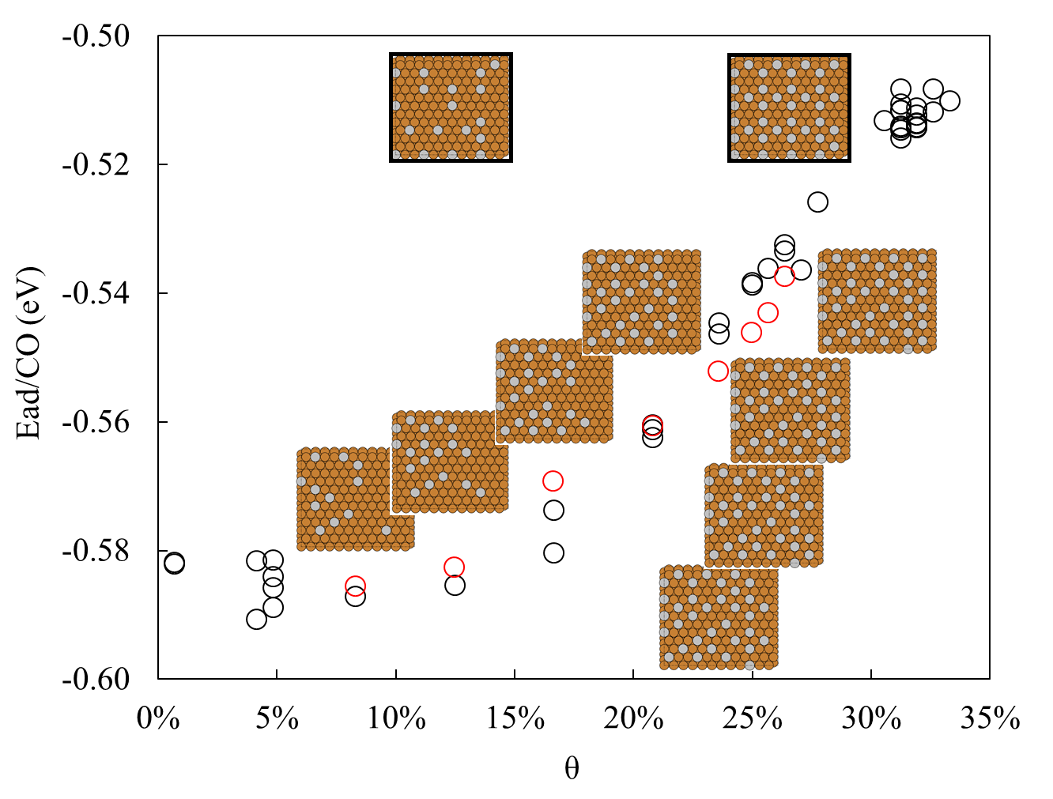
Fig. S3. Dependence of the adsorption energy on the distribution of the CO molecule. At identical coverage, variations in CO distribution lead to different adsorption energies. The eight insets (without black boxes) show structures featuring line vacancies (arranged from left to right on the plot), with red circles denoting the corresponding adsorption energies for each structure. Black circles represent structures devoid of any line vacancies; two of such structures corresponding to θ = 12.5% and 25.7% are shown by the insets within the black boxes in the upper part of the figure. Our computational findings suggest that with increasing θ, the system may tend to generate line vacancies over point vacancies.

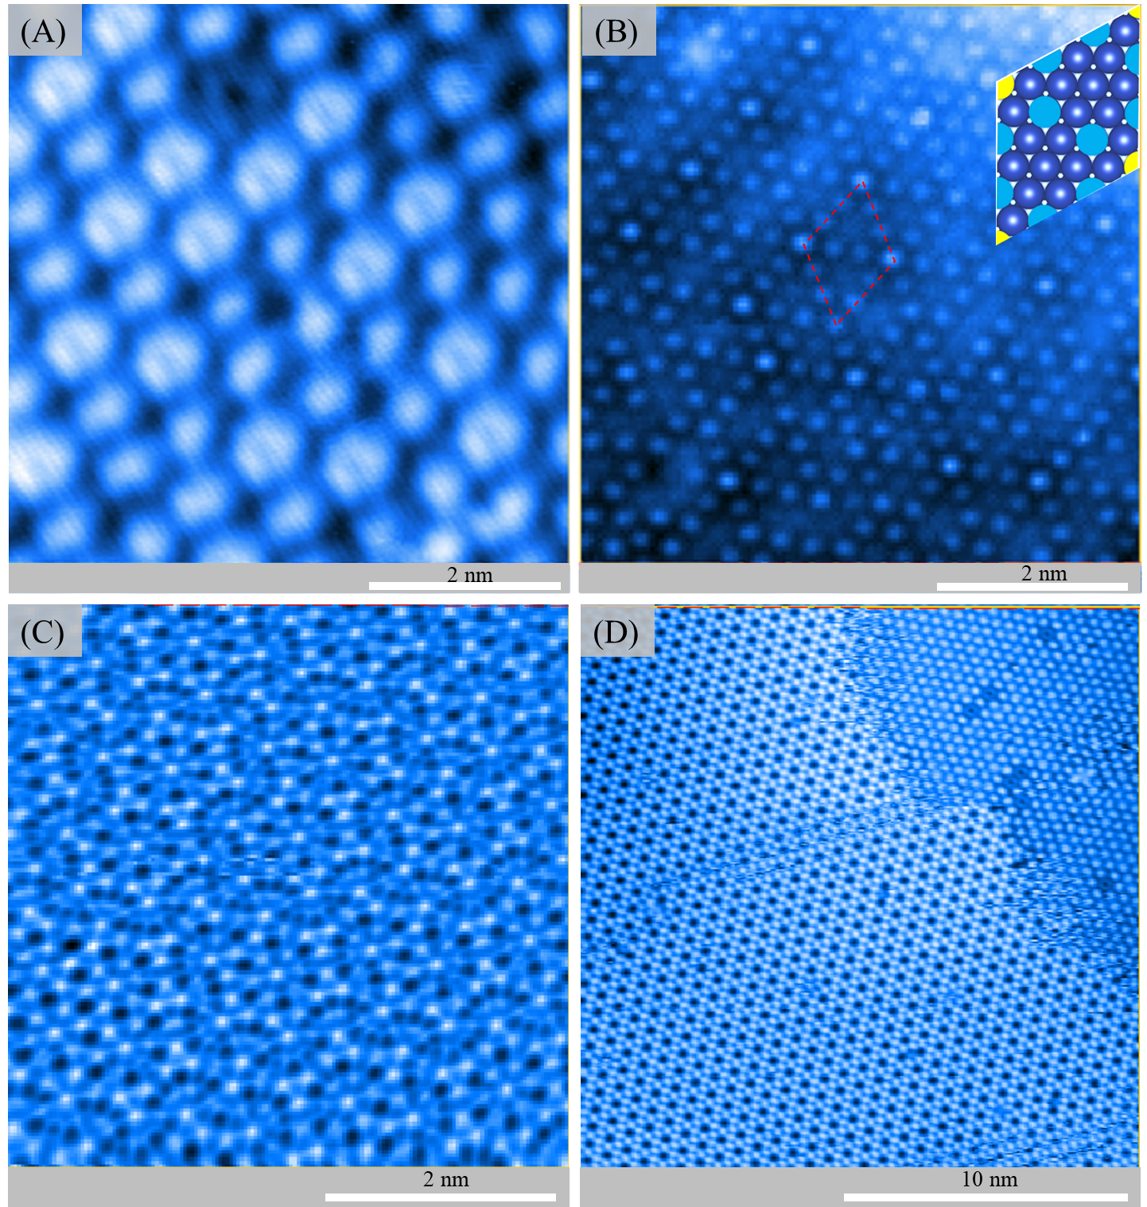
Fig. S4. SPM images of other CO patterns formed at 77.6 K. (A-B) STM and ATM images of the same region. The inset in (B) is a schematic figure of the unit cell of this specific pattern. The yellow and blue solid circles indicate COs in different adsorption environments. Ideally, the coverage limit for this pattern is 25.9%. (C-D) Two additional AFM images. A boundary between two patterns is identified in (D). In (A) and (B), AI generative fill was used to remove image defects caused by thermal drift and vibration interference. The original images are also available on GitHub.

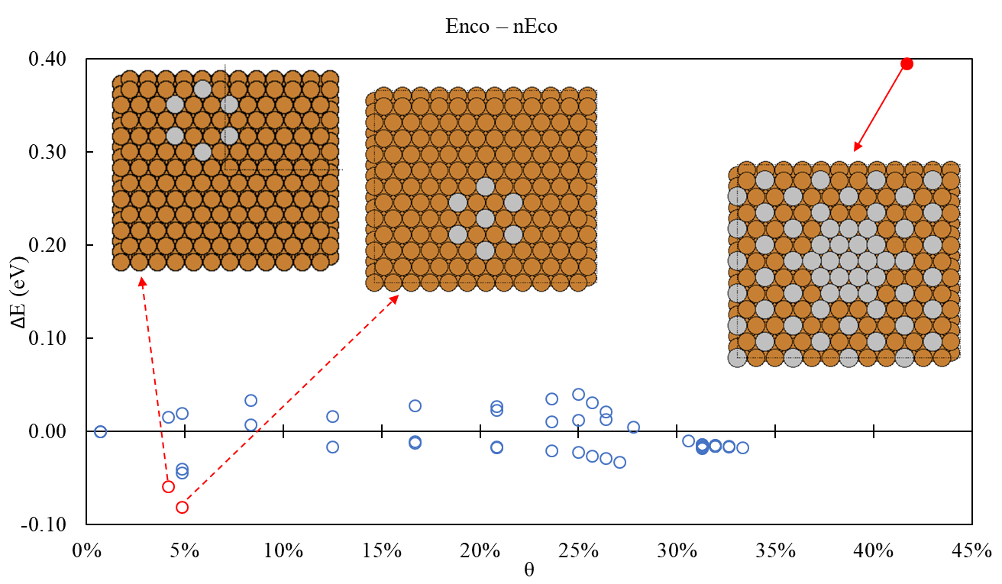
Fig. S5. Energy difference (ΔE) between $E_{nCO}$ and $nE_{CO}$. When θ ≤ 33%, ΔE is almost always less than 0.05 eV. The only two outliers are the special cases where the COs were forced to form a six-membered ring (for test purpose only). Even in these cases, the error is still less than 0.1 eV. This weak dependence of the CO distribution pattern ($Ω$) can be removed by applying Eq. 5 in the main text. The only case showing strong direct CO-CO interaction is a hypothetical situation we tested with θ = 42% (the red solid circle). This indicates that our calculations are reliable when θ is within the experimental limitation (33%).

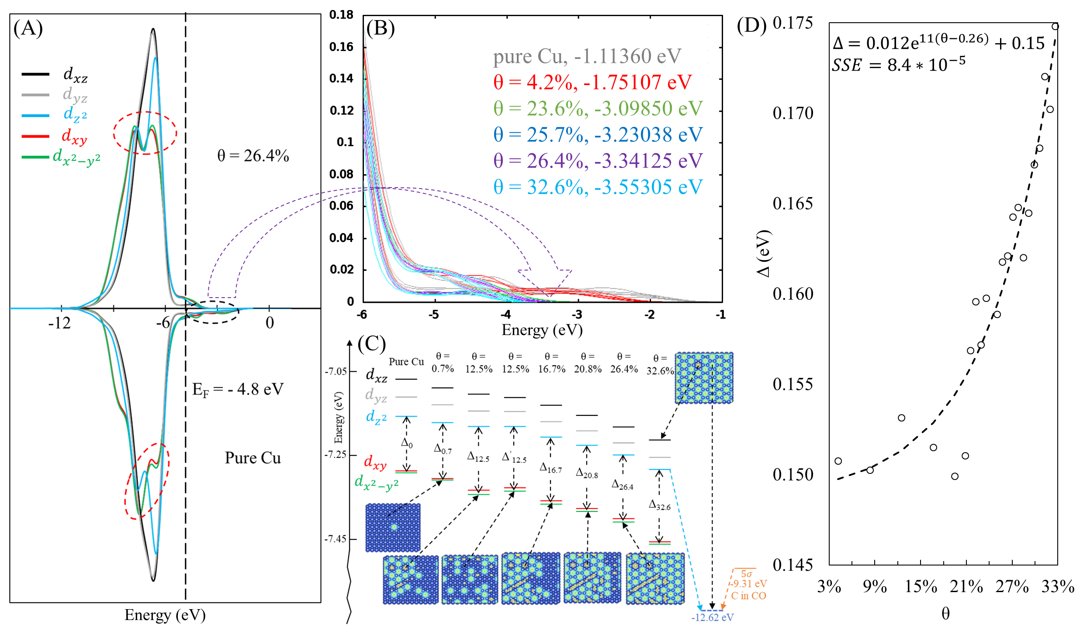
Fig. S6. Orbital analysis. (A) Calculated PDOS of a bare surface Cu site (the i site in Fig. 4B of the main text). Top panel: θ = 26.4%, bottom panel: pure Cu. The calculated Fermi level is ~4.8 eV. The red dashed circles show a redistribution of the in-plane 3d orbitals ($3d_{xy}$ and $3d_{x^{2}-y^{2}}$) toward the Fermi level upon CO adsorption. (B) Compression of the high energy tail (indicated by the black dashed circle in (A)) of the d band as a function of θ. (C) Calculated energy level diagram for an empty surface Cu site surrounded by six CO molecules as a function of θ. For comparison purpose, we also studied a case where COs are randomly distributed (Δ_{12.5} and Δ’_{12.5}). (D) The energy gap between $3d_{z^{2}}$ and in-plane orbitals as a function of θ. The dashed curve is a mathematically fitted trend line. The sum of squared estimate of errors (SSE) equals 8.4*10⁻⁵.

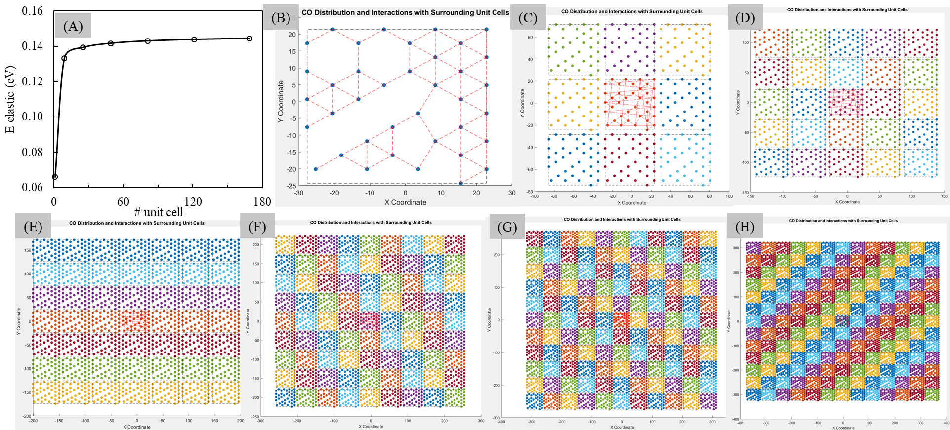
Fig. S7. Indirect Elastic Interaction Calculation. (A) Calculated elastic energy (eV) as a function of the number of unit cells. Visual representation of the model systems used to calculate the elastic energies, with 1 (B), 9 (C), 25 (D), 49 (E), 91 (F), 121 (G), and 169 (H) unit cells, corresponding to the seven energy data points from left to right in (A). The red dashed line in (B-H) indicates the presence of elastic interaction between two sites. For better illustration, we set the threshold to be 10 a.u., meaning interactions are not displayed if the distance between sites exceeds 10 a.u., even though the actual threshold should be around 100 a.u. (approximately 5.3 nm).

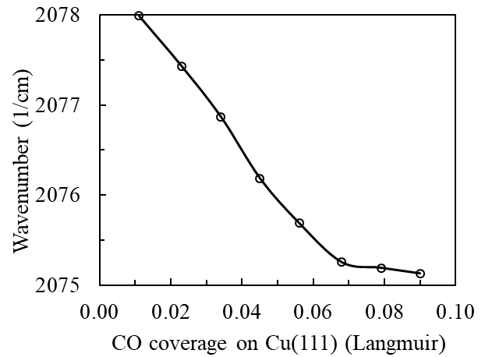
Fig. S8. Experimentally measured stretching frequency (1/cm) of CO as a function of its coverage on Cu(111). The unit of coverage used here is Langmuir.

References
1. Gross L, Mohn F, Moll N, Liljeroth P, Meyer G. The chemical structure of a molecule resolved by atomic force microscopy. Science 2009, 325(5944): 1110-1114.

2. Lasdon LS, Fox RL, Ratner MW. Nonlinear optimization using the generalized reduced gradient method. Revue française d'automatique, informatique, recherche opérationnelle Recherche opérationnelle 1974, 8(V3): 73-103.

3. Perdew JP, Burke K, Ernzerhof M. Generalized Gradient Approximation Made Simple. Physical Review Letters 1996, 77(18): 3865-3868.

4. Troullier N, Martins JL. Efficient pseudopotentials for plane-wave calculations. Physical Review B 1991, 43(3): 1993-2006.

5. Davey WP. Precision Measurements of the Lattice Constants of Twelve Common Metals. Physical Review 1925, 25(6): 753-761.

6. Demaison J, Császár AG. Equilibrium CO bond lengths. Journal of Molecular Structure 2012, 1023: 7-14.

7. Patra A, Peng H, Sun J, Perdew JP. Rethinking CO adsorption on transition-metal surfaces: Effect of density-driven self-interaction errors. Physical Review B 2019, 100(3): 035442.

8. Perdew JP, Chowdhury STuR, Shahi C, Kaplan AD, Song D, Bylaska EJ. Symmetry Breaking with the SCAN Density Functional Describes Strong Correlation in the Singlet Carbon Dimer. The Journal of Physical Chemistry A 2023, 127(1): 384-389.

9. Feibelman PJ, Hammer B, Nørskov JK, Wagner F, Scheffler M, Stumpf R, et al. The CO/Pt(111) Puzzle. The Journal of Physical Chemistry B 2001, 105(18): 4018-4025.

10. Zhao Q, Martirez JMP, Carter EA. Revisiting Understanding of Electrochemical CO2 Reduction on Cu(111): Competing Proton-Coupled Electron Transfer Reaction Mechanisms Revealed by Embedded Correlated Wavefunction Theory. Journal of the American Chemical Society 2021, 143(16): 6152-6164.

11. Gajdoš M, Eichler A, Hafner J. CO adsorption on close-packed transition and noble metal surfaces: trends from ab initio calculations. Journal of Physics: Condensed Matter 2004, 16(8): 1141.

12. Sharifzadeh S, Huang P, Carter E. Embedded Configuration Interaction Description of CO on Cu(111): Resolution of the Site Preference Conundrum. The Journal of Physical Chemistry C 2008, 112(12): 4649-4657.

13. Xu L, Lin J, Bai Y, Mavrikakis M. Atomic and Molecular Adsorption on Cu(111). Topics in Catalysis 2018, 61(9): 736-750.

14. Hammer B, Hansen LB, Nørskov JK. Improved adsorption energetics within density-functional theory using revised Perdew-Burke-Ernzerhof functionals. Physical Review B 1999, 59(11): 7413-7421.

15. Anisimov VI, Zaanen J, Andersen OK. Band theory and Mott insulators: Hubbard U instead of Stoner I. Physical Review B 1991, 44(3): 943-954.

16. Zeng Z, Chan MKY, Zhao Z-J, Kubal J, Fan D, Greeley J. Towards First Principles-Based Prediction of Highly Accurate Electrochemical Pourbaix Diagrams. The Journal of Physical Chemistry C 2015, 119(32): 18177-18187.

17. Dionigi F, Zeng Z, Sinev I, Merzdorf T, Deshpande S, Lopez MB, et al. In-situ structure and catalytic mechanism of NiFe and CoFe layered double hydroxides during oxygen evolution. Nature Communications 2020, 11(1): 2522.

18. Morosan E, Natelson D, Nevidomskyy AH, Si Q. Strongly Correlated Materials. Advanced Materials 2012, 24(36): 4896-4923.

19. Eren B, Zherebetskyy D, Patera LL, Wu CH, Bluhm H, Africh C, et al. Activation of Cu(111) surface by decomposition into nanoclusters driven by CO adsorption. Science 2016, 351(6272): 475-478.

20. Blyholder G. Molecular Orbital View of Chemisorbed Carbon Monoxide. The Journal of Physical Chemistry 1964, 68(10): 2772-2777.

21. Lau KH, Kohn W. Elastic interaction of two atoms adsorbed on a solid surface. Surface Science 1977, 65(2): 607-618.

22. Ledbetter HM, Naimon ER. Elastic Properties of Metals and Alloys. II. Copper. Journal of Physical and Chemical Reference Data 1974, 3(4): 897-935.

23. Freund LB, Suresh S. Thin Film Materials: Stress, Defect Formation and Surface Evolution. Cambridge University Press: Cambridge, 2004.

24. Zhang D, Jansen C, Berg OT, Bakker JM, Meyer J, Kleyn AW, et al. RAIRS Characterization of CO and O Coadsorption on Cu(111). The Journal of Physical Chemistry C 2022, 126(31): 13114-13121.

