Scalable and sustainable DMF-free solid-phase synthesis of liraglutide by 1-tert-butyl-3-ethylcarbodiimide-mediated couplings and catch-and-release acylation and purification strategies

Lorenzo Pacini,^{1,2} Manoj Kumar Muthyala,³ Robert Zitterbart,³ Oleg Marder,⁴ Paolo Rovero,^{2,5} Anna Maria Papini^{1,2*}

¹Department of Chemistry “Ugo Schiff”, University of Florence, 50019 Sesto Fiorentino, Italy
²Interdepartmental Research Unit of Peptide and Protein Chemistry and Biology - PeptLab, MoD&LS Laboratory, University of Florence, 50019 Sesto Fiorentino, Italy
³Gyros Protein Technologies Inc., 4675 South Coach Drive, Tucson, Arizona, 85714, USA
⁴Luxembourg Bio Technologies, 8 Sapir Pinhas St., Nes Ziona, 7403631, Israel
⁵Department of Neurosciences, Psychology, Drug Research and Child Health, Section of Pharmaceutical Sciences and Nutraceutics, University of Florence, 50019 Sesto Fiorentino, Italy

*Corresponding author Anna Maria Papini, annamaria.papini@unifi.it

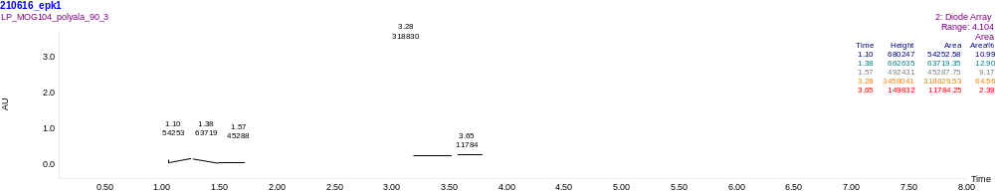
Figure S1. RP-HPLC trace of PolyAla synthesized using the mixture PrOAc/DMSO and T-Bec®/Oxyma Pure as coupling system at 90°C. C18 column Supelco BIOshell A160 Peptide (10 cm x 3.0 mm, 2.7 μm); temperature 35 °C; flow, 0.6 mL/min; eluent, 0.1% (v/v) TFA in H₂O (A) and 0.1% (v/v) TFA in CH₃CN (B); λ, 215 nm, gradient, 5−95% B in 5 min. Rt = 3.28 min: PolyAla.

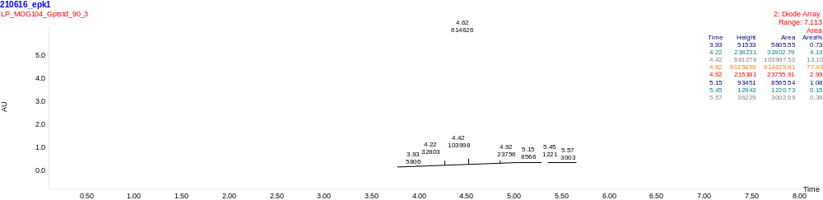
Figure S2. RP-HPLC trace of AlaSTD synthesized using the mixture PrOAc/DMSO and T-Bec®/Oxyma Pure as coupling system at 90°C. C18 column Supelco BIOshell A160 Peptide (10 cm x 3.0 mm, 2.7 μm); temperature 35 °C; flow, 0.6 mL/min; eluent, 0.1% (v/v) TFA in H₂O (A) and 0.1% (v/v) TFA in CH₃CN (B); λ, 215 nm, gradient, 5−95% B in 5 min. Rt = 4.62 min: AlaSTD.

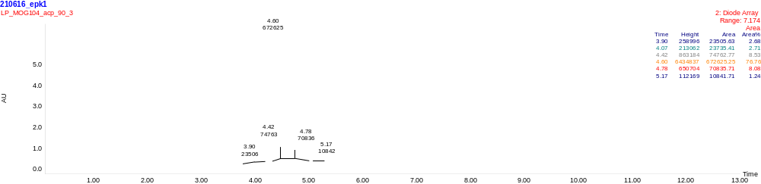
Figure S3. RP-HPLC trace of ACP synthesized using the mixture PrOAc/DMSO and T-Bec®/Oxyma Pure as coupling system at 90°C. C18 column Supelco BIOshell A160 Peptide (10 cm x 3.0 mm, 2.7 μm); temperature 35 °C; flow, 0.6 mL/min; eluent, 0.1% (v/v) TFA in H₂O (A) and 0.1% (v/v) TFA in CH₃CN (B); λ, 215 nm, gradient, 5−95% B in 10 min. Rt = 4.60 min: ACP.

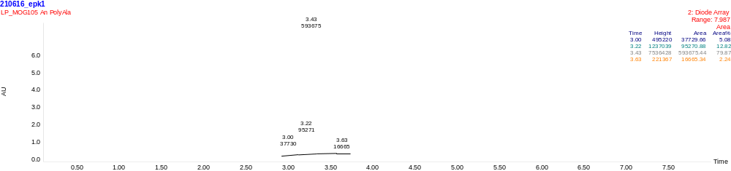
Figure S4. RP-HPLC trace of PolyAla synthesized using the mixture An/DMSO and T-Bec®/Oxyma Pure as coupling system at 90°C. C18 column Supelco BIOshell A160 Peptide (10 cm x 3.0 mm, 2.7 μm); temperature 35 °C; flow, 0.6 mL/min; eluent, 0.1% (v/v) TFA in H₂O (A) and 0.1% (v/v) TFA in CH₃CN (B); λ, 215 nm, gradient, 5−95% B in 5 min. Rt = 3.43 min: PolyAla.
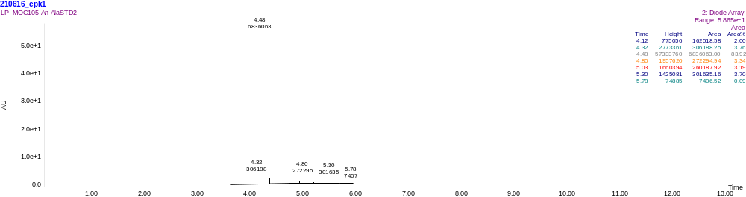
Figure S5. RP-HPLC trace of AlaSTD synthesized using the mixture An/DMSO and T-Bec®/Oxyma Pure as coupling system at 90°C. C18 column Supelco BIOshell A160 Peptide (10 cm x 3.0 mm, 2.7 μm); temperature 35 °C; flow, 0.6 mL/min; eluent, 0.1% (v/v) TFA in H₂O (A) and 0.1% (v/v) TFA in CH₃CN (B); λ, 215 nm, gradient, 5−95% B in 10 min. Rt = 4.48 min: AlaSTD.

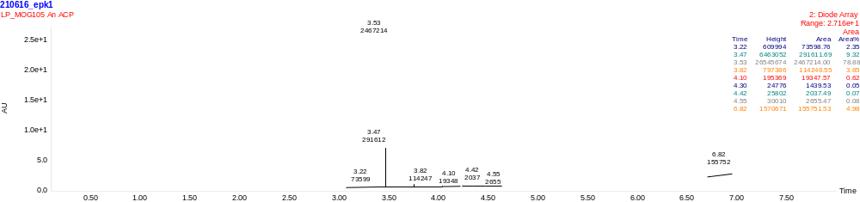
Figure S6. RP-HPLC trace of ACP synthesized using the mixture An/DMSO and T-Bec®/Oxyma Pure as coupling system at 90°C. C18 column Supelco BIOshell A160 Peptide (10 cm x 3.0 mm, 2.7 μm); temperature 35 °C; flow, 0.6 mL/min; eluent, 0.1% (v/v) TFA in H₂O (A) and 0.1% (v/v) TFA in CH₃CN (B); λ, 215 nm, gradient, 5−95% B in 5 min. Rt = 3.53 min: ACP.

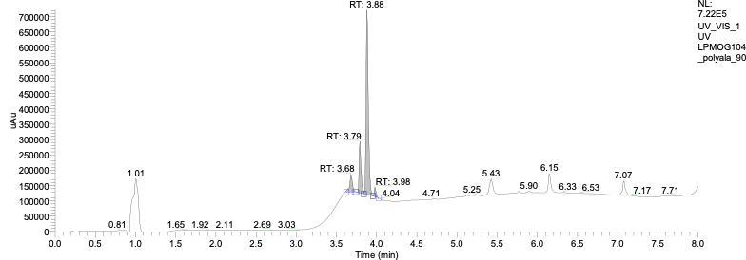
Figure S7. RP-UHPLC trace of PolyAla synthesized using the mixture BuOAc/DMSO and T-Bec®/Oxyma Pure as coupling system at 90°C. C18 column Waters Acquity BEH (130 Å, 1.7 μm, 2.1 × 100 mm); temperature 45 °C; flow, 0.5 mL/min; eluent, 0.1% (v/v) FA in H₂O (A) and 0.1% (v/v) FA in CH₃CN (B); λ, 215 nm, gradient, 5−95% B in 5 min. Rt = 3.88 min: PolyAla.
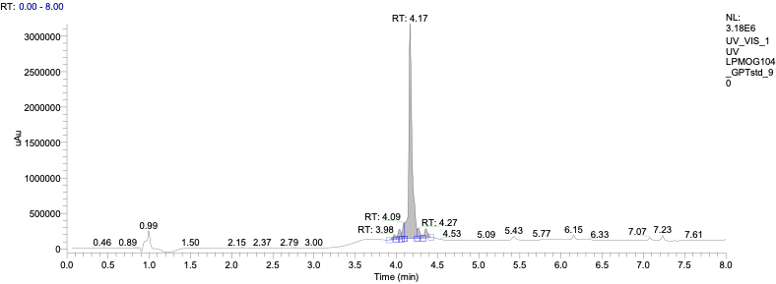
Figure S8. RP-UHPLC trace of AlaSTD synthesized using the mixture BuOAc/DMSO and T-Bec®/Oxyma Pure as coupling system at 90°C. C18 column Waters Acquity BEH (130 Å, 1.7 μm, 2.1 × 100 mm); temperature 45 °C; flow, 0.5 mL/min; eluent, 0.1% (v/v) FA in H₂O (A) and 0.1% (v/v) FA in CH₃CN (B); λ, 215 nm, gradient, 5−95% B in 5 min. Rt = 4.17 min: AlaSTD.

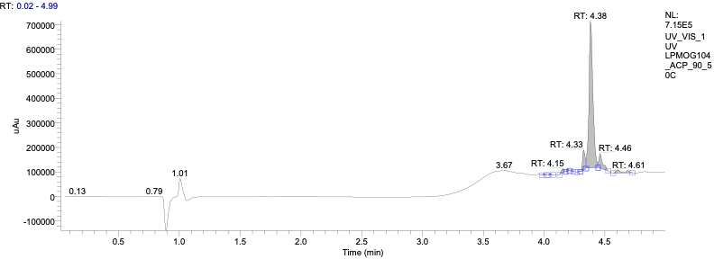
Figure S9. RP-UHPLC trace of ACP synthesized using the mixture BuOAc/DMSO and T-Bec®/Oxyma Pure as coupling system at 90°C. C18 column Waters Acquity BEH (130 Å, 1.7 μm, 2.1 × 100 mm); temperature 45 °C; flow, 0.5 mL/min; eluent, 0.1% (v/v) FA in H₂O (A) and 0.1% (v/v) FA in CH₃CN (B); λ, 215 nm, gradient, 5−95% B in 5 min. Rt = 4.38 min: ACP.
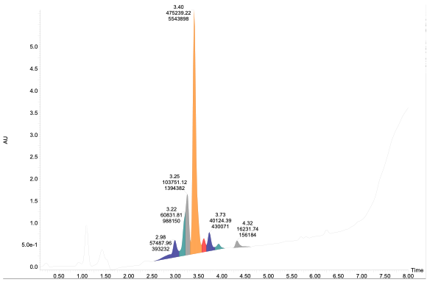
Figure S10. RP-HPLC trace of PolyAla synthesized using DMF and T-Bec®/Oxyma Pure as coupling system at 90°C. C18 column Supelco BIOshell A160 Peptide (10 cm x 3.0 mm, 2.7 μm); temperature 35 °C; flow, 0.6 mL/min; eluent, 0.1% (v/v) TFA in H₂O (A) and 0.1% (v/v) TFA in CH₃CN (B); λ, 215 nm, gradient, 5−95% B in 5 min. Rt = 3.40 min: PolyAla.
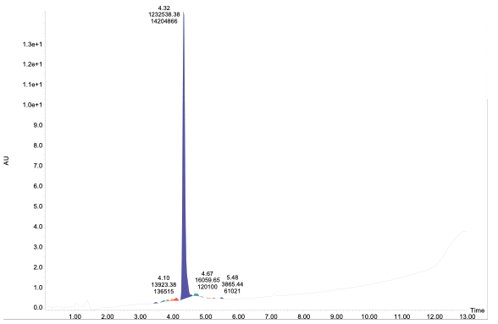
Figure S11. RP-HPLC trace of AlaSTD synthesized using DMF and T-Bec®/Oxyma Pure as coupling system at 90°C. C18 column Supelco BIOshell A160 Peptide (10 cm x 3.0 mm, 2.7 μm); temperature 35 °C; flow, 0.6 mL/min; eluent, 0.1% (v/v) TFA in H₂O (A) and 0.1% (v/v) TFA in CH₃CN (B); λ, 215 nm, gradient, 5−95% B in 10 min. Rt = 4.32 min: AlaSTD.
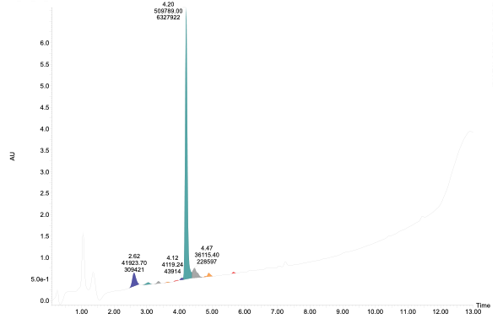
Figure S12. RP-HPLC trace of ACP synthesized using DMF and T-Bec®/Oxyma Pure as coupling system at 90°C. C18 column Supelco BIOshell A160 Peptide (10 cm x 3.0 mm, 2.7 μm); temperature 35 °C; flow, 0.6 mL/min; eluent, 0.1% (v/v) TFA in H₂O (A) and 0.1% (v/v) TFA in CH₃CN (B); λ, 215 nm, gradient, 5−95% B in 10 min. Rt = 4.20 min: ACP.

Table S1. Operation protocol on PurePep Chorus for r.t. synthesis
Step | Description | Solvent | Vol  (mL) | Time (s) | Rep | Temp.  (°C) | Mech. Mixing (rpm) | N2 bubb.
1 | Fmoc amino  acid add. | DMF vs. X/DMSO 8:2 (7:3) | 1.25 | 5 | 1 | r.t. | 0 | No
2 | T-Bec or DIC add. | DMF vs. X/DMSO 8:2 (7:3) | 1 | 5 | 1 | r.t. | 0 | No
3 | Oxyma pure add. and solution mixing | DMF vs. X/DMSO 8:2 (7:3) | 1 | 2700 | 1 | r.t. | 300 | Yes
4 | wash | EtOAc/DMSO 8:2 | 1.5 | 10 | 3 | r.t. | 300 | Yes
5 | capping | (DMF vs. X)/Pyr/Ac2O 15:16:19 | 3 | 240 | 1 | r.t. | 300 | Yes
6 | wash | EtOAc/DMSO 8:2 | 1.5 | 10 | 3 | r.t. | 300 | Yes
7 | Fmoc-deprotection | (DMF vs. X/DMSO 1:1)/Pip 4:1 | 3 | 300 | 2 | r.t. | 300 | Yes
8 | wash | EtOAc/DMSO 8:2 | 1.5 | 10 | 3 | r.t. | 300 | Yes

Table S2. Operation protocol on PurePep Chorus for 90°C synthesis
Step | Description | Solvent | Vol  (mL) | Time  (s) | Rep | Temp.  (°C) | Mech. Mixing (rpm) | N2 bubb.
1 | Fmoc amino  acid add. | DMF vs. X/DMSO  8:2 (7:3) | 1.25 | 5 | 1 | r.t. | 0 | No
2 | T-Bec or DIC add. | DMF vs. X/DMSO  8:2 (7:3) | 1 | 5 | 1 | r.t. | 0 | No
3 | Oxyma pure add. And solution mixing | DMF vs. X/DMSO  8:2 (7:3) | 1 | 120 | 1 | 90 | 300 | Yes
4 | wash | EtOAc/DMSO 8:2 | 1.5 | 10 | 3 | r.t. | 300 | Yes
5 | capping | (DMF vs. X)/Pyr/Ac2O 15:16:19 | 3 | 240 | 1 | 50 | 300 | Yes
6 | wash | EtOAc/DMSO  8:2 | 1.5 | 10 | 3 | r.t. | 300 | Yes
7 | Fmoc-deprotection | (DMF vs. X/DMSO 1:1)/Pip 4:1 | 3 | 60 | 1 | 90 | 300 | Yes
8 | wash | EtOAc/DMSO  8:2 | 1.5 | 10 | 3 | r.t. | 300 | Yes

1.67
2.22
2.33
2.77
2.80
2.84
2.88
2.90
2.95
3.00
3.07
3.11
3.17
3.29
3.33
3.38
3.42
AU
-0.10
0.00
0.10
0.20
0.30
0.40
0.50
0.60
0.70
Minutes
0.00
0.20
0.40
0.60
0.80
1.00
1.20
1.40
1.60
1.80
2.00
2.20
2.40
2.60
2.80
3.00
3.20
3.40
3.60
3.80
4.00
4.20
4.40
4.60
4.80
5.00
Figure S13. RP-UHPLC traces of crude Liraglutide synthesized using BuOAc/DMSO, direct synthesis strategy. C18 column Waters Acquity BEH (130 Å, 1.7 μm, 2.1 × 50 mm); temperature 65 °C; flow, 0.5 mL/min; eluent, 0.1% (v/v) TFA in H₂O (A) and 0.1% (v/v) TFA in CH₃CN (B); λ, 215 nm, gradient, 10−90% B in 5 min. Rt = 2.80 min: Liraglutide 45.05% purity.

237.0 - 1.22
122.2 - 1.26
677.7 - 1.30
1128.6 - 1.34
159.1 - 1.50
236.7 - 1.55
237.1 - 1.58
100.4 - 1.62
237.0 - 1.66
200.0 - 1.73
AU
-0.20
-0.15
-0.10
-0.05
0.00
0.05
0.10
0.15
0.20
0.25
0.30
0.35
0.40
0.45
0.50
Minutes
0.00
0.20
0.40
0.60
0.80
1.00
1.20
1.40
1.60
1.80
2.00
2.20
2.40
2.60
2.80
3.00
3.20
3.40
3.60
3.80
4.00
4.20
4.40
4.60
4.80
5.00
1128.5 - 1.431

Figure S14. RP-UHPLC traces of crude Liraglutide precursor synthesized using BuOAc/DMSO and 2CTC resin, catch-lipidation-and-release strategy. C18 column Waters Acquity BEH (130 Å, 1.7 μm, 2.1 × 50 mm); temperature 65 °C; flow, 0.5 mL/min; eluent, 0.1% (v/v) TFA in H₂O (A) and 0.1% (v/v) TFA in CH₃CN (B); λ, 215 nm, gradient, 30−90% B in 5 min. Rt = 1.43 min: Liraglutide precursor 65.05% purity.

122.3 - 1.18
122.0 - 1.21
122.1 - 1.25

237.0 - 1.29
539.3 - 1.33
159.2 - 1.38
1128.5 - 1.43
1082.5 - 1.49
1151.3 - 1.55
158.6 - 1.58
158.5 - 1.62
145.3 - 1.66
236.5 - 1.72
AU
-0.20
-0.10
0.00
0.10
0.20
0.30
0.40
0.50
0.60
0.70
0.80
0.90
Minutes
0.00
0.20
0.40
0.60
0.80
1.00
1.20
1.40
1.60
1.80
2.00
2.20
2.40
2.60
2.80
3.00
3.20
3.40
3.60
3.80
4.00
4.20
4.40
4.60
4.80
5.00
Figure S15. RP-UHPLC traces of crude Liraglutide precursor synthesized using BuOAc/DMSO and Tentagel Wang resin, catch-lipidation-and-release strategy. C18 column Waters Acquity BEH (130 Å, 1.7 μm, 2.1 × 50 mm); temperature 65 °C; flow, 0.5 mL/min; eluent, 0.1% (v/v) TFA in H₂O (A) and 0.1% (v/v) TFA in CH₃CN (B); λ, 215 nm, gradient, 30−90% B in 5 min. Rt = 1.43 min: Liraglutide precursor 65.9% purity.

737.8 - 2.01
773.3 - 2.04
539.3 - 2.08
1128.1 - 2.12
609.1 - 2.19
1161.3 - 2.24
1096.6 - 2.28
977.3 - 2.30
158.4 - 2.34
271.3 - 2.42
271.2 - 2.47
271.2 - 2.50
334.9 - 2.58
100.3 - 2.62
100.3 - 3.24
130.1 - 3.27
425.2 - 3.37
254.3 - 3.39
130.2 - 3.44
AU
-0.10
0.00
0.10
0.20
0.30
0.40
0.50
0.60
0.70
Minutes
0.00
0.20
0.40
0.60
0.80
1.00
1.20
1.40
1.60
1.80
2.00
2.20
2.40
2.60
2.80
3.00
3.20
3.40
3.60
3.80
4.00
4.20
4.40
4.60
4.80
5.00
Figure S16. RP-UHPLC traces of PEC Linker-Liraglutide precursor, catch-lipidation-and-release strategy. C18 column Waters Acquity BEH (130 Å, 1.7 μm, 2.1 × 50 mm); temperature 65 °C; flow, 0.5 mL/min; eluent, 0.1% (v/v) TFA in H₂O (A) and 0.1% (v/v) TFA in CH₃CN (B); λ, 215 nm, gradient, 30−90% B in 5 min. Rt = 2.19 min: PEC Linker-Liraglutide precursor 53.8% purity.

