Supplementary
Metabolites profiling and bioactivity of Aspergillus-Penicillium co-culture: Integrative GC-MS, LC-MS/MS, and in silico analysis for targeting Fusarium proliferatum in onion basal rot biocontrol

Fig. 1S. A heatmap analysis of the phylogenetic tree of Fusarium proliferatum AUMC15541 (OR346141) showed 99.4 -99.72 identity and 99% - 100% coverage with several strains of F. oxysporum. Percent similarity set in upper triangle and percent divergence set in lower triangle.
Fig. 2S. GC-MS chromatogram of the saponifiable matter of DCM fraction from AP co-culture.
Fig. 3S. GC-MS chromatogram of the unsaponifiable of DCM fraction of AP co-culture.

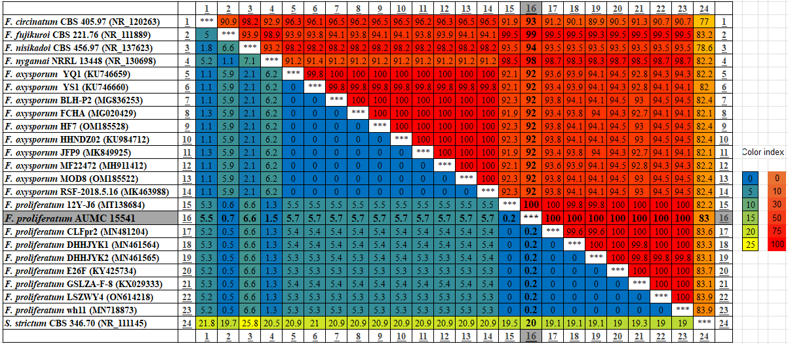
Fig. 1S. A heatmap analysis of the phylogenetic tree of Fusarium proliferatum AUMC15541 (OR346141) showed 99.4 -99.72 identity and 99% - 100% coverage with several strains of F. oxysporum. Percent similarity set in upper triangle and percent divergence set in lower triangle.

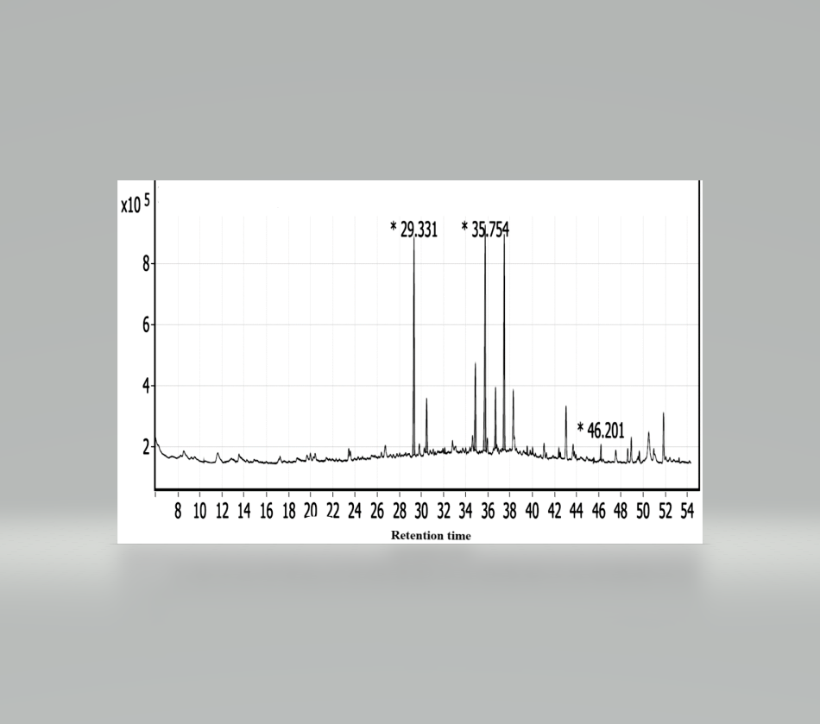
Fig. 2S. GC-MS chromatogram of the saponifiable matter of DCM fraction from AP co-culture.

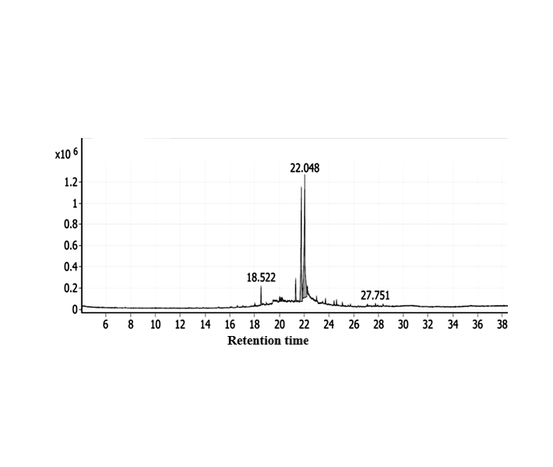
Fig. 3S. GC-MS chromatogram of the unsaponifiable of DCM fraction of AP co-culture.

