Table 1 study characteristics
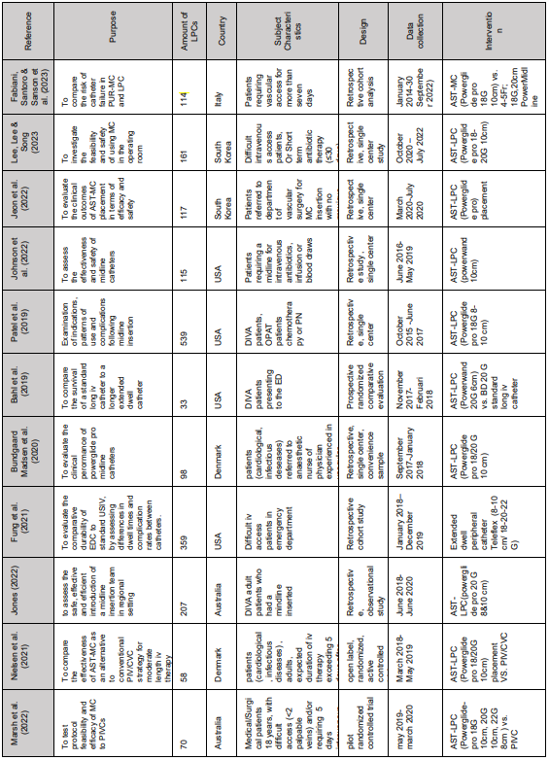
(Abbreviations: ED: emergency department, EDC: extended dwell catheter, MC: midline catheter, OPAT: outpatient antibiotic therapy, PICC: peripherally inserted central catheter, PIVC: peripheral intravenous catheter, PUR: polyurethane, USIV: ultrasound guided intravenous catheter)
Table 2: catheter-related outcomes
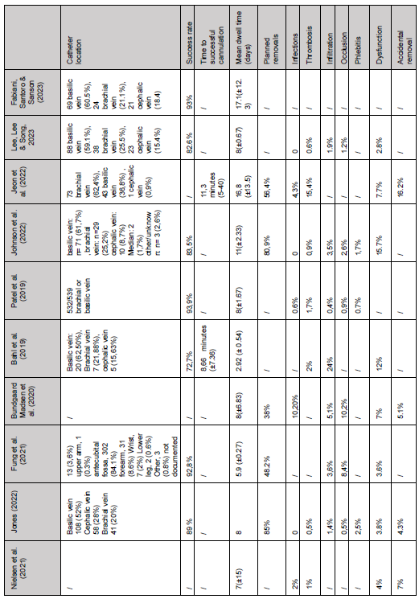
(Abbreviation: IQR: interquartile range)

