Supporting Information to
Molecular Simulations of the Lid Motion in Chimeras of Candida Antarctica Lipase B in Organic Solvents
Zuzana Sochorová Vokáčová¹, Karolína Fárníková² and Eva Pluhařová³*
J. Heyrovský Institute of Physical Chemistry of The Czech Academy of Sciences, v. v. i. Dolejškova 2155/3, 182 23 Prague 8, Czech Republic
ORCID iD:
¹ 0000-0001-5426-1597
² 0009-0009-6509-9068
³ 0000-0002-4167-4891
*Corresponding author
E-mail address: eva.pluharova@jh-inst.cas.cz

Table S1. Composition of the simulated systems with the average length of the cubic simulation cell given in (nm). CALB-W stands for the wild type of CALB, CALB-G for the mutant CALB-G. zeae, CALB-N for the mutant CALB-N. crassa, A for acetonitrile and T for toluene.
System | Charge of the enzyme | Number of ions | Number of solvent molecules |  |  | Box length (nm)
System | Charge of the enzyme | Number of ions | H₂O | A | T | Box length (nm)
CALB-W, H₂O | 0 | 0 | 22321 | 0 | 0 | 8.919
CALB-W, A | 0 | 0 | 286 | 7273 | 0 | 8.833
CALB-W, T | 0 | 0 | 286 | 0 | 3700 | 8.908
CALB-G, H₂O | 1 | 1 Cl⁻ | 22297 | 0 | 0 | 8.916
CALB-G, A | 1 | 1 Cl⁻ | 286 | 7273 | 0 | 8.833
CALB-G, T | 1 | 1 Cl⁻ | 286 | 0 | 3700 | 8.907
CALB-N, H₂O | 2 | 2 Cl⁻ | 22306 | 0 | 0 | 8.921
CALB-N, A | 2 | 2 Cl⁻ | 286 | 7273 | 0 | 8.837
CALB-N, T | 2 | 2 Cl⁻ | 286 | 0 | 3699 | 8.923

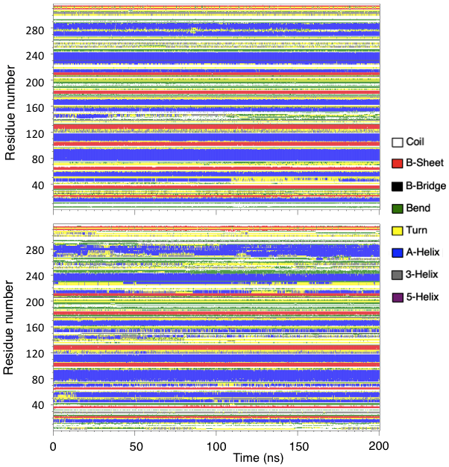
Figure S1. The secondary structure of CALB-W described by CHARMM36 force field (top) and AMBER03 force field (bottom) in water during the conventional MD simulation. Different colors correspond to different motifs of secondary structure as determined by DSSP utility.
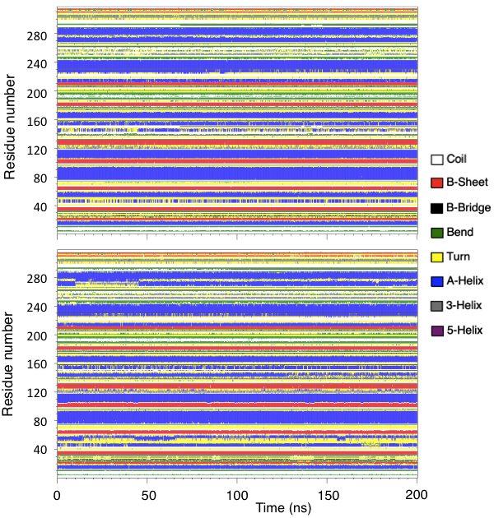
Figure S2. The secondary structure of CALB-W described by CHARMM36 force field (top) and AMBER03 force field (bottom) in acetonitrile during the conventional MD simulation. Different colors correspond to different motifs of secondary structure as determined by DSSP utility.
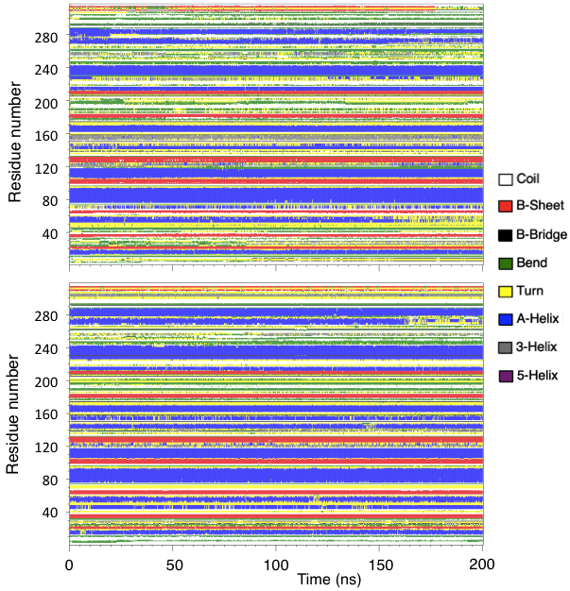
Figure S3. The secondary structure of CALB-W described by CHARMM36 force field (top) and AMBER03 force field (bottom) in toluene during the conventional MD simulation. Different colors correspond to different motifs of secondary structure as determined by DSSP utility.
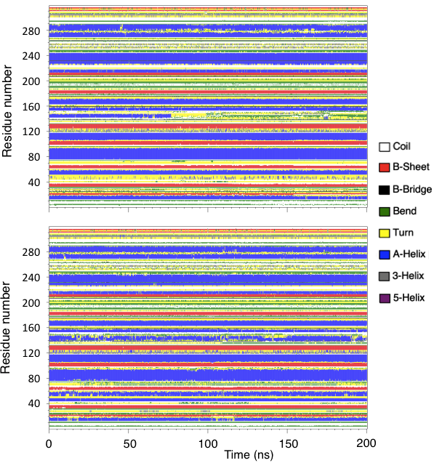
Figure S4. The secondary structure of CALB-G described by CHARMM36 force field (top) and AMBER03 force field (bottom) in water during the conventional MD simulation. Different colors correspond to different motifs of secondary structure as determined by DSSP utility.
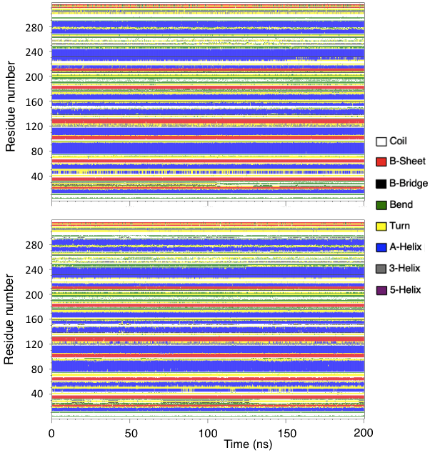
Figure S5. The secondary structure of CALB-G described by CHARMM36 force field (top) and AMBER03 force field (bottom) in acetonitrile during the conventional MD simulation. Different colors correspond to different motifs of secondary structure as determined by DSSP utility.
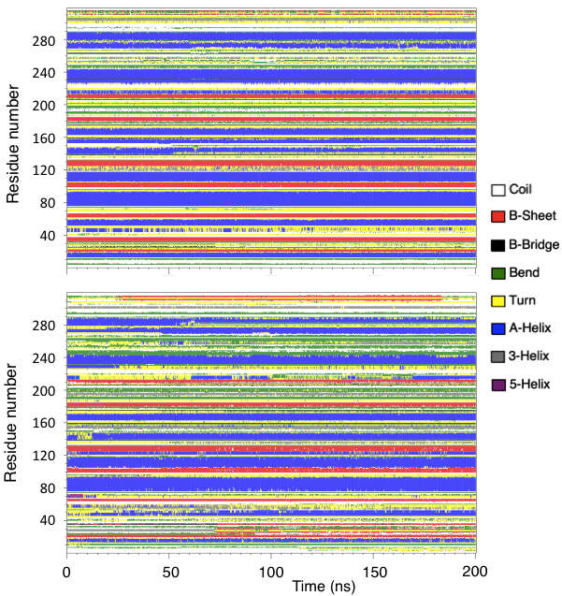
Figure S6. The secondary structure of CALB-G described by CHARMM36 force field (top) and AMBER03 force field (bottom) in toluene during the conventional MD simulation. Different colors correspond to different motifs of secondary structure as determined by DSSP utility.
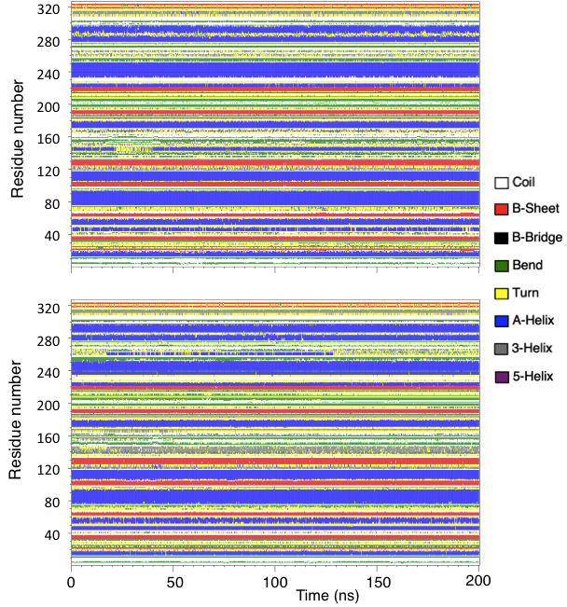
Figure S7. The secondary structure of CALB-N described by CHARMM36 force field (top) and AMBER03 force field (bottom) in water during the conventional MD simulation. Different colors correspond to different motifs of secondary structure as determined by DSSP utility.
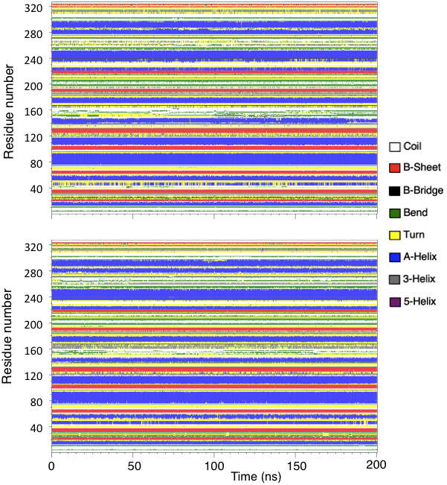
Figure S8. The secondary structure of CALB-N described by CHARMM36 force field (top) and AMBER03 force field (bottom) in acetonitrile during the conventional MD simulation. Different colors correspond to different motifs of secondary structure as determined by DSSP utility.
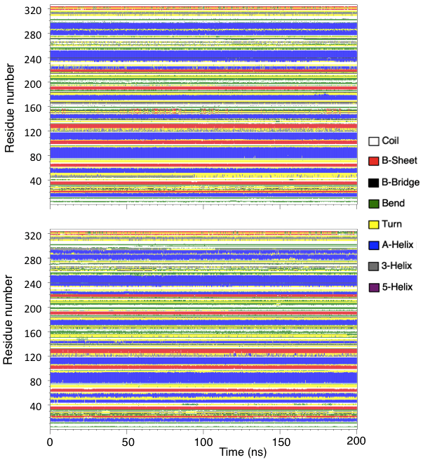
Figure S9. The secondary structure of CALB-N described by CHARMM36 force field (top) and AMBER03 force field (bottom) in toluene during the conventional MD simulation. Different colors correspond to different motifs of secondary structure as determined by DSSP utility.
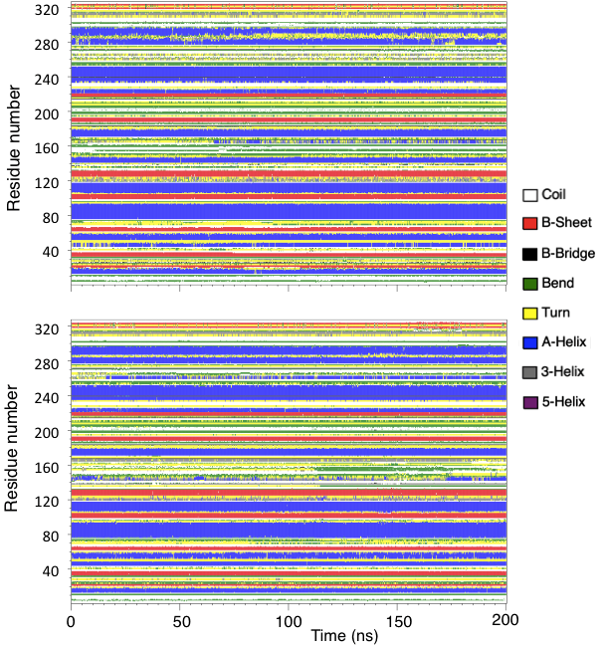
Figure S10. The secondary structure of CALB-N described by CHARMM36 force field (top) and AMBER03 force field (bottom) in water during the conventional MD simulation. In the course of equilibration (not shown), the helical structure of α₅ and α₁₀ was maintained by additional restraints. Different colors correspond to different motifs of secondary structure as determined by DSSP utility.
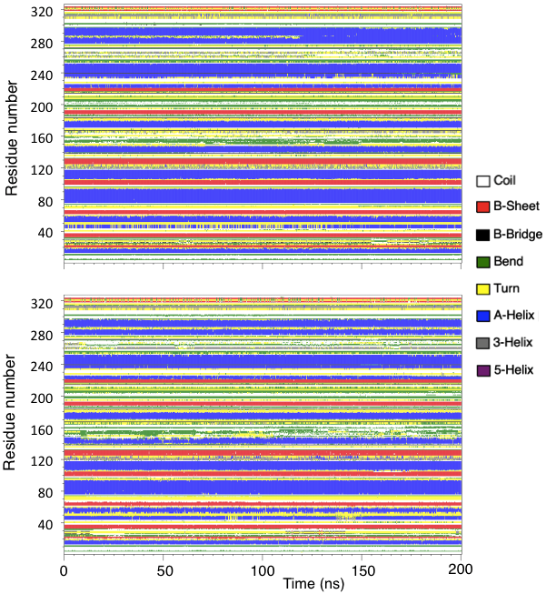
Figure S11. The secondary structure of CALB-N described by CHARMM36 force field (top) and AMBER03 force field (bottom) in acetonitrile during the conventional MD simulation. In the course of equilibration (not shown), the helical structure of α₅ and α₁₀ was maintained by additional restraints. Different colors correspond to different motifs of secondary structure as determined by DSSP utility.
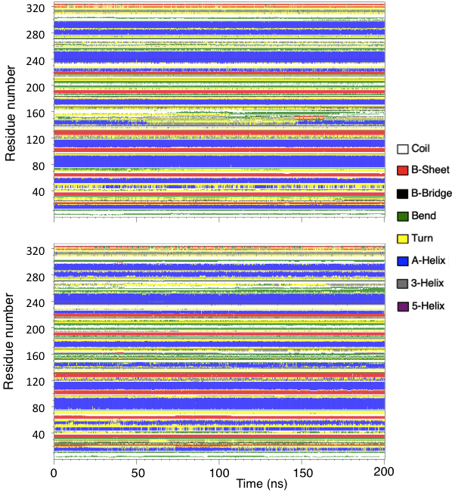
Figure S12. The secondary structure of CALB-N described by CHARMM36 force field (top) and AMBER03 force field (bottom) in toluene during the conventional MD simulation. In the course of equilibration (not shown), the helical structure of α₅ and α₁₀ was maintained by additional restraints. Different colors correspond to different motifs of secondary structure as determined by DSSP utility.
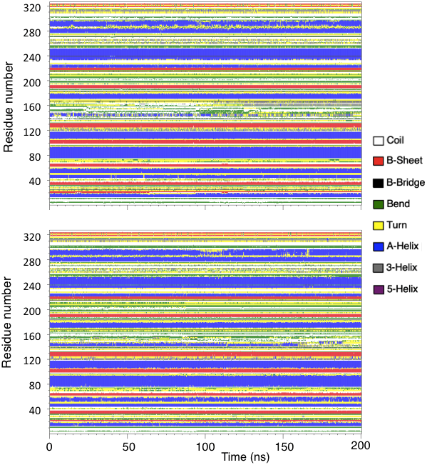
Figure S13. The secondary structure of CALB-N described by CHARMM36 force field (top) and AMBER03 force field (bottom) in water during the conventional MD simulation. In the course of equilibration (not shown), the helical structure of α₅ and α₁₀ was maintained by additional restraints and their distance was kept around 1.1 nm. Different colors correspond to different motifs of secondary structure as determined by DSSP utility.
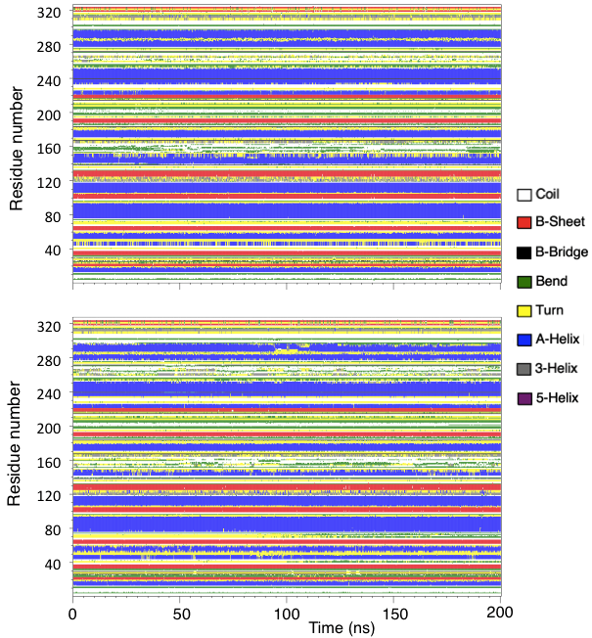
Figure S14. The secondary structure of CALB-N described by CHARMM36 force field (top) and AMBER03 force field (bottom) in acetonitrile during the conventional MD simulation. In the course of equilibration (not shown), the helical structure of α₅ and α₁₀ was maintained by additional restraints and their distance was kept around 1.1 nm. Different colors correspond to different motifs of secondary structure as determined by DSSP utility.
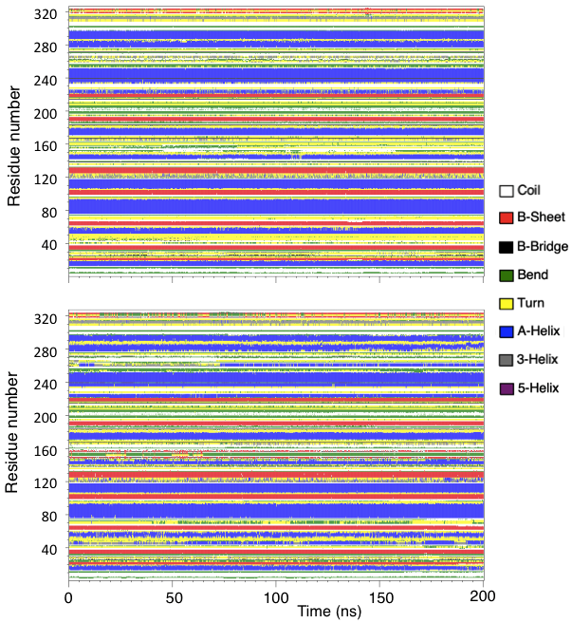
Figure S15. The secondary structure of CALB-N described by CHARMM36 force field (top) and AMBER03 force field (bottom) in toluene during the conventional MD simulation. In the course of equilibration (not shown), the helical structure of α₅ and α₁₀ was maintained by additional restraints and their distance was kept around 1.1 nm. Different colors correspond to different motifs of secondary structure as determined by DSSP utility.
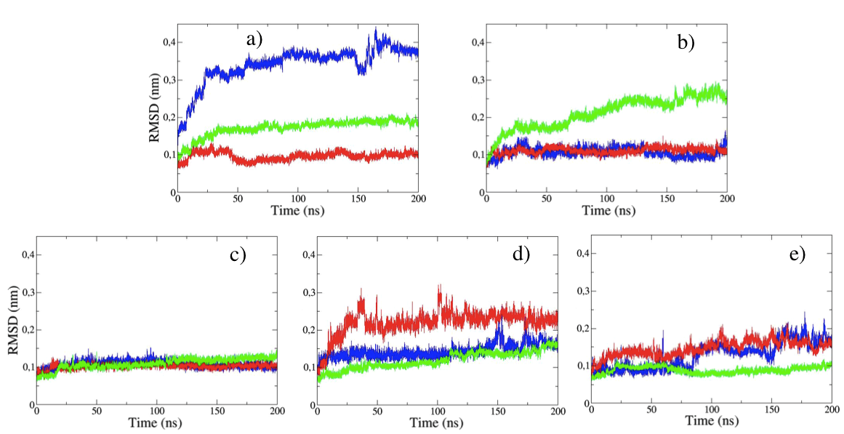
Figure S16. Root mean square deviation from the reference structure of the backbone atoms of CALB-W (a), CALB-G (b) and three independent simulations of CALB-N (c - e) described by AMBER03 force field in water (blue), acetonitrile (red), and toluene (green).

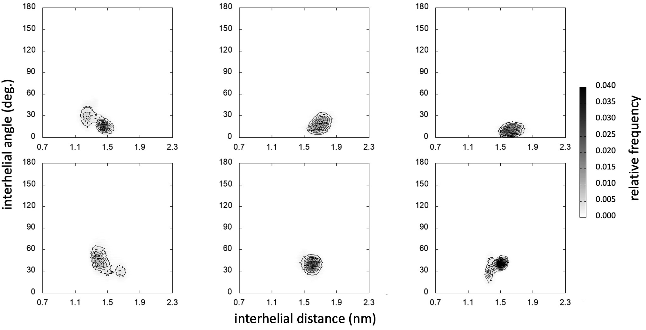
Figure S17. Histograms of sampled interhelical distances and interhelical angles in conventional MD simulations of CALB-W (top), CALB-G (bottom) described byAMBER03 FF in water (left), acetonitrile (center) and toluene (right).
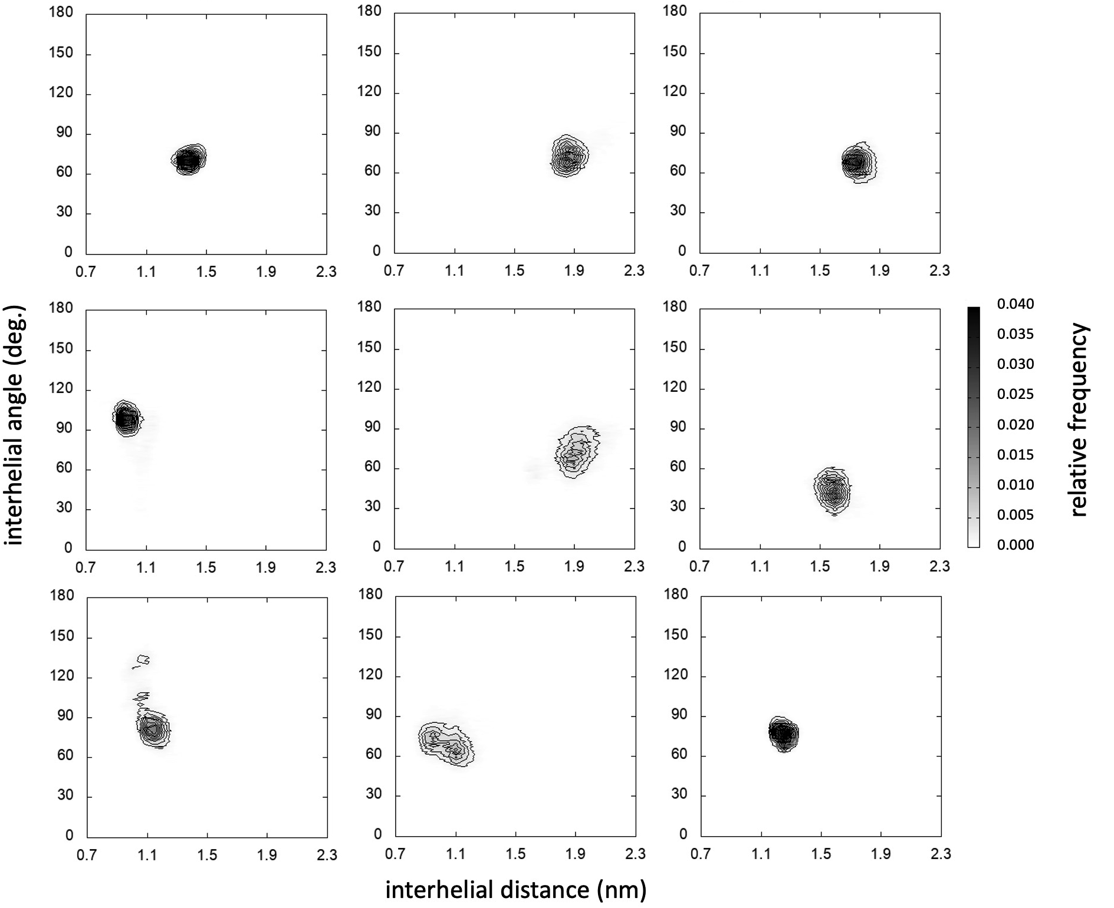
Figure S18. Histograms of sampled interhelical distances and interhelical angles in conventional MD simulations of 3 independent simulations of CALB-N (rows) described by AMBER03 FF in water (left), acetonitrile (center) and toluene (right).

Table S2. The average number of non-bonding interactions of selected parts of CALB-W with its surroundings analyzed in conventional MD simulation employing AMBER03 FF. The interactions involving the polar atoms of the amino acid side chains (N, O), all polar atoms of the α5 helix (α5pol), oxygen atoms of water molecules (OW) and nitrogen atoms of acetonitrile (ACN) were evaluated. For the non-polar α5-α10 interaction all carbon atoms were taken into account. The cutoff for all polar interactions was 0.35 nm, for the interhelical interaction α5-α10 it was set to 1 nm.
 | Water |  | Acetonitrile |  | Toluene
Asp145 | OW | 2.00±0.03 | OW | 1.21±0.61 | OW | 2.00±0.04
Asp145 | α5pol | 0.94±0.61 | α5pol | 0.88±0.35 | α5pol | 0.84±0.48
Asp145 | Ser150 | 0.002±0.05 | Ser150 | 0.46±0.50 | Thr158 | 0.16±0.37
Asp145 |  |  | ACN | 0.04±0.19 | Lys308Arg309 | 0.02±0.18
Lys290 | OW | 1.00±0.00 | OW | 0.13±0.34 | OW | 0.83±0.38
Lys290 | α5pol | 0.00±0.00 | ACN | 0.98±0.15
Lys290 | Ser150 | 0.00±0.00
α5-α10 | 6.83±5.66 |  | 3.96±0.80 |  | 4.29±0.73

Table S3: The average number of non-bonding interactions of selected parts of CALB-G.zeae with its surroundings analyzed in conventional MD simulation employing AMBER03 FF. The interactions involving the polar atoms of the amino acid side chains (N, O), all polar atoms of the α5 helix (α5pol), oxygen atoms of water molecules (OW) and nitrogen atoms of acetonitrile (ACN) were evaluated. For the non-polar α5-α10 interaction all carbon atoms were taken into account. The cutoff for all polar interactions was 0.35 nm, for the interhelical interaction α5-α10 and the Thr147(C) and loop it was set to 1 nm.
 | Water |  |  | Acetonitrile |  | Toluene
Asn142 | OW | 1.94±0.24 |  | OW | 0.05±0.23 | OW | 1.07±0.53
Asn142 | α5pol | 0.79±0.57 |  | α5pol | 0.98±0.14 | α5pol | 0.83±0.43
Asn142 |  |  |  | ACN | 0.95±0.29
Thr147 | OW | 0.60±0.49 |  | OW | 0.01±0.11 | OW | 0.00±0.05
Thr147 | α5pol | 0.44±0.50 |  | α5pol | 0.26±0.44 | α5pol | 0.00±0.00
Thr147 |  |  |  | ACN | 0.30±0.46
Thr147(C) | Loop |  | 2.76±0.87 | Loop | 0.62±1.12 | Loop |  | 3.52±0.80
α5-α10 | 2.47±1.53 |  |  | 0.76±0.79 |  | 2.51±0.72

