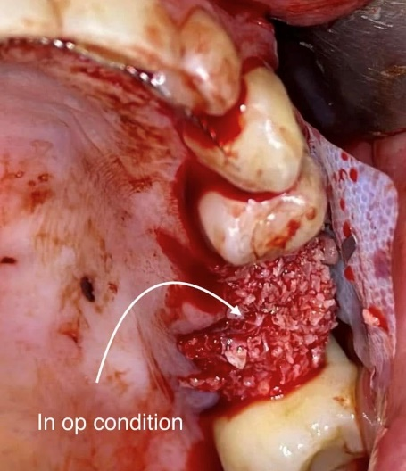
Photo 1. Autogenous bone, allograft, and xenograft.
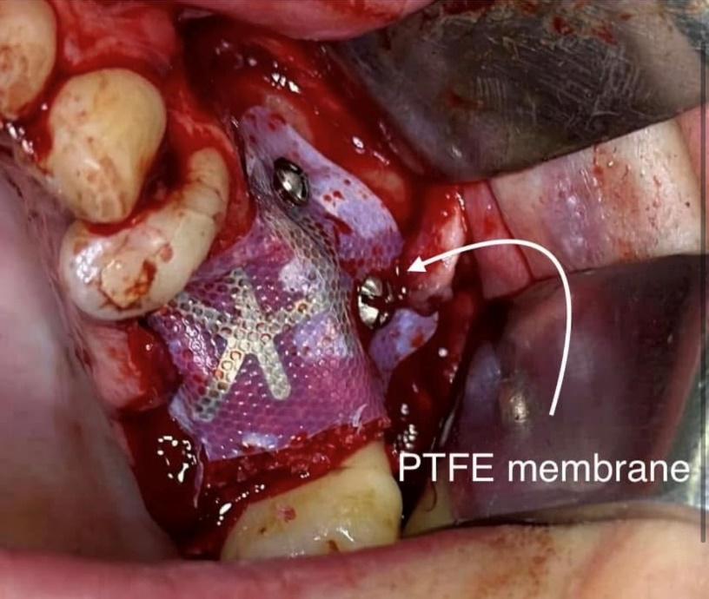
Photo 2. PTFEE Membrane coverage
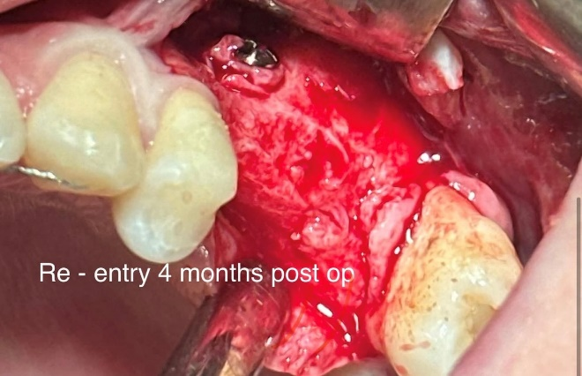
Photo 3. Re-entry after 4 months
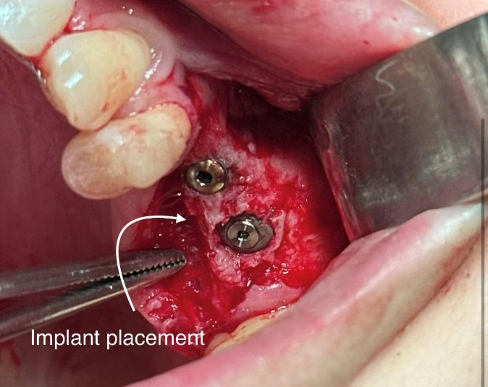
Photo 4 . Implant placement

