Supporting Information Appendix C : Chemical analysis fludioxonil

SI C Table 1: Conditions of fludioxonil chromatography
Agilent 1200 Series RRLC/uHPLC System
Initial Flow Rate (ml/min) | : 0.2 mL/min（1290 Infinity II System)
Column | : Agilent Zorbax Eclipse Plus-C18, (2.1 x 50mm, 1.8um)
Column Oven (℃) | : 35
Injection Volume(uL) | : 1
Mobile Phase A | : 0.1% Formic acid in H2O
Mobile Phase B | : MeOH
Run Time (min) | A (%) | B (%) | Flow (mL/min)
0.00 | 22 | 78 | 0.2
4.00 | 22 | 78 | 0.2

SI C Table2: Ion source parameters of QQQ
Source Parameters (Ultivo)
Source Type | : AJS ESI | Sheath Gas (L/min) | : 11
Polarity | : Negative | Sheath Gas Temp (℃) | : 250
Nebulizer (psi) | : 30 | Capillary Voltage (V) | : 4000
Dry Gas Flow (L/min) | : 5 | Nozzle Voltage (V) | : 1500
Dry Gas Temp (℃) | ：250 | Delta EMV (V) | : -

SI C Table3: Acquisition parameters of QQQ
Compound Name | Precursor Ion | MS1 Res | Product Ion | MS2 Res | Dwell | Fragmentor | Collision Energy | Polarity
Fludioxonil | 247 | Unit | 126.1 | Unit | 200 | 112 | 29 | Negative

SI C Table 4: Fludioxonil add recovery
sediment-spiked concentration, mg/kg | Actual concentration, mg/kg  Mean±sd | Recovery（%） | Standard deviation（%） | Coefficient of variation（%）
0.4 | 0.39±0.01 | 97.50 | 2.50 | 2.56
1.25 | 1.10±0.01 | 88.00 | 0.80 | 0.91
2.5 | 2.50±0.01 | 100.00 | 0.40 | 0.40
90 | 82.95±0.12 | 92.17 | 0.13 | 0.14

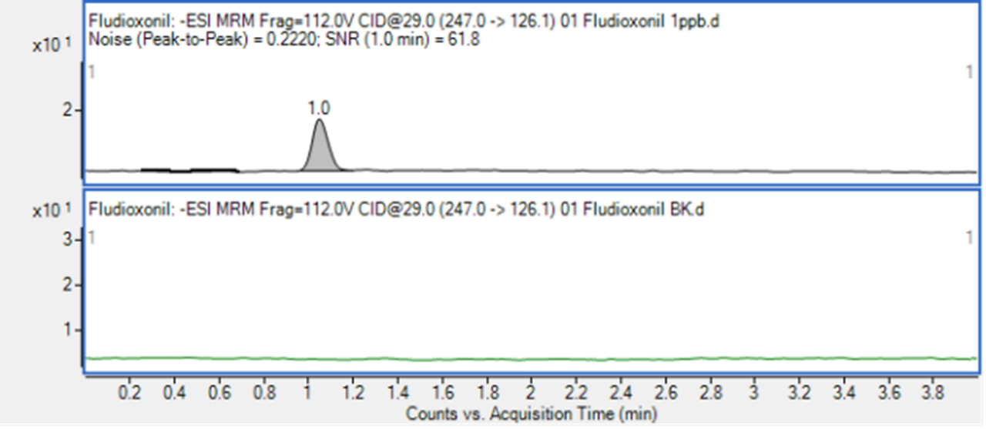
SI C Fig1: Chromatogram of1μg/L fludioxonil and blank
Note: Up: Chromatogram of1μg/L fludioxonil, under: Chromatogram of blank

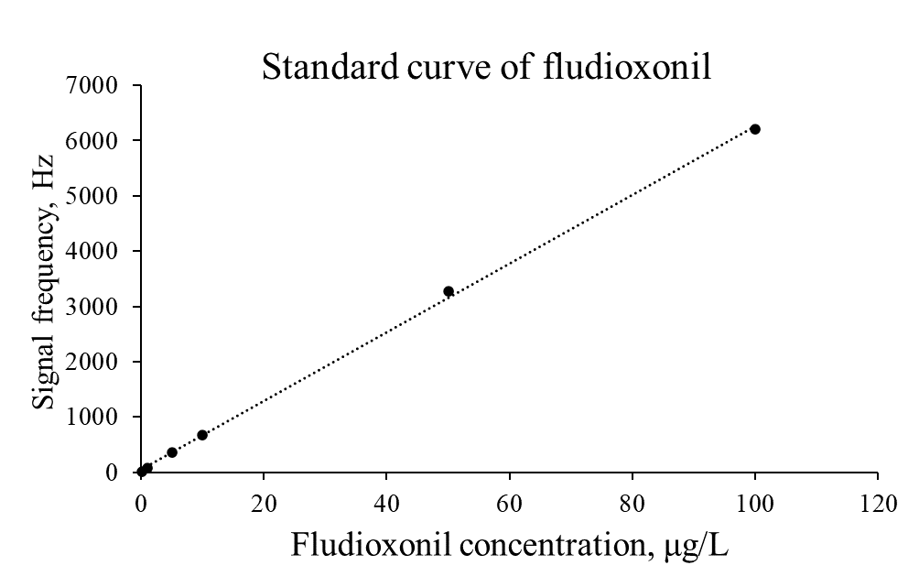
SI C Fig 2: Standard curve of fludioxonil

