Supporting Information Appendix B: Microcosm experiment
SI B Table 1: Freshwater algae, zooplankton, and benthic invertebrates used as seeding material when constructing the microcosm
 | Scientific name of species | Add abundance
Emergent invettebrate | Myriophyllum aquaticum | 5 individual/system, height 15 cm
Phytoplankton | Chlorella pyrenoidosa | Concentration 1×10³ cells∙mL⁻¹, add 3 mL
(freshwater | Scenedesmus quadricauda | Concentration 1×10³ cells∙mL⁻¹, add 3 mL
Algae) | Selenastrum capricornutum | Concentration 1×10³ cells∙mL⁻¹, add 3 mL
 | Navicula sp. | Concentration 1×10³ cells∙mL⁻¹, add 3 mL
Zooplankton | Dolerocypris sinensis | 20 individual/system
 | Brachionus calyciflorus | 300 individual/system
 | Polyarthra sp. | 300 individual/system
 | Eucyclops serrulatus | Adult of 400 individual/system
 | Cypridopsis sp. | Adult of 200 individual/system
 | Scapholeberis mucronata | Newborn larvae (<24 h), 70 individual/system
 | Daphnia carinata | Newborn larvae (<24 h), 40 individual/system
 | Moina macrocopa | Newborn larvae (<24 h), 100 individual/system
Benthic inverberate | Neocaridina denticulata | Adult without eggs, 30 individual/system; adult with eggs, 10 individual/system;
 | Dicrotendipes pelochloris | first instar larvae, 40 individual/system
 | Physa acuta | Length > 4 mm, 10 individual/system
 | Corbicula fluminea | Length > 10 mm, 20 individual/system
 | Limnodrilus hoffmeisteri | 100 individual/system
 | Branchiura sowerbyi | 20 individual/system
 | Dugesia japonica | 10 individual/system

SI B Table 2 : The concentration of fludioxonil in total sediment and overlying water on the 0 day in microcosms that received different treatment-levels of fludioxonil (F2 – F5)
0d | dry sediment（mg/kg） | pore-water（μg/L） | overlying water（μg/L）
F2 | 1.981 | 10.676 | 0.537
F2 | 1.953 | 10.842 | 0.529
F2 | 1.96 | 10.734 | 0.538
F3 | 6.142 | 34.451 | 1.709
F3 | 6.21 | 34.253 | 1.715
F3 | 6.172 | 34.601 | 1.722
F4 | 17.642 | 109.92 | 5.506
F4 | 17.44 | 108.841 | 5.492
F4 | 17.492 | 110.025 | 5.457
F5 | 51.672 | 452.947 | 22.712
F5 | 51.431 | 456.165 | 22.684
F5 | 51.248 | 455.814 | 22.849

SI B Table 3: Effects of Fludioxonil on macrobenthos Species Abundance: ↘ = mean decline; ↗ = mean increase; * = statistically different
Species | Actual concentration Sediment（0d） | 0d | 10d | 20d | 30d | 40d
Limnodrilus hoffmeisteri | Blank | 100 | 94±0.8 | 90.3±1.7 | 92±1.6 |  | 347.7±13.9
Limnodrilus hoffmeisteri | Acetone |  | ↘ | ↗ | ↗ | ↗
Limnodrilus hoffmeisteri | 1.96±0.01 |  | ↘ | ↗ | ↘ | ↘
Limnodrilus hoffmeisteri | 6.17±0.03 |  | ↘ | ↘ | ↘ | ↘
Limnodrilus hoffmeisteri | 17.52±0.09 |  | ↘* | ↘ | ↗ | ↘*
Limnodrilus hoffmeisteri | 51.5±0.17 |  | ↘* | ↘* | ↘* | ↘*
Branchiurasowerbyi | Blank | 20 | 18.3±1.7 | 18.7±3.9 | 17.6±1.2 | 123.3±13.9
Branchiurasowerbyi | Acetone |  | ↘ | ↘ | ↘ | ↘
Branchiurasowerbyi | 1.96±0.01 |  | ↘ | ↘ | ↘ | ↗
Branchiurasowerbyi | 6.17±0.03 |  | ↘ | ↘ | ↘ | ↘
Branchiurasowerbyi | 17.52±0.09 |  | ↘* | ↘ | ↘ | ↘*
Branchiurasowerbyi | 51.5±0.17 |  | ↘* | ↘ | ↘ | ↘*
Neocaridinadenticulata | Blank | 40 | 55.3±2.6 | 73.3±7.4 | 53.3±11.4 | 53.3±10.5
Neocaridinadenticulata | Acetone |  | ↘ | ↗ | ↘ | ↘
Neocaridinadenticulata | 1.96±0.01 |  | ↘ | ↘ | ↘ | ↘
Neocaridinadenticulata | 6.17±0.03 |  | ↘* | ↘* | ↘* | ↘
Neocaridinadenticulata | 17.52±0.09 |  | ↘* | ↘* | ↘* | ↘*
Neocaridinadenticulata | 51.5±0.17 |  | ↘* | ↘* | ↘* | ND*
Corbicula fluminea | Blank | 20 | 16.6±0.9 | 18.3±0.5 | 18.3±1.2 | 15.3±1.2
Corbicula fluminea | Acetone |  | ↗ | ↗ | ↘ | ↗
Corbicula fluminea | 1.96±0.01 |  | ↗ | ↗ | ↘ | ↘
Corbicula fluminea | 6.17±0.03 |  | ↘ | ↗ | ↘* | ↘
Corbicula fluminea | 17.52±0.09 |  | ↘ | ↘* | ↘* | ↘*
Corbicula fluminea | 51.5±0.17 |  | ↘* | ↘* | ↘* | ↘*
Physa acuta | Blank | 10 | 18.3±3.3 | 45.3±5.3 | 58.3±7.4 | 89.3±11.8
Physa acuta | Acetone |  | ↗ | ↘ | ↗ | ↘
Physa acuta | 1.96±0.01 |  | ↗ | ↘ | ↗ | ↘
Physa acuta | 6.17±0.03 |  | ↗ | ↘ | ↗ | ↗
Physa acuta | 17.52±0.09 |  | ↗ | ↘ | ↗ | ↗
Physa acuta | 51.5±0.17 |  | ↘* | ↘* | ↘* | ↘*
Dugesia japonica | Blank | 10 | 13.7±2.5 | 17.3±2.1 | 21.3±1.2 | 25.3±3.7
Dugesia japonica | Acetone |  | ↘ | ↘ | ↘ | ↘
Dugesia japonica | 1.96±0.01 |  | ↘ | ↘ | ↘ | ↘
Dugesia japonica | 6.17±0.03 |  | ↘ | ↗ | ↘ | ↘
Dugesia japonica | 17.52±0.09 |  | ↘* | ↘* | ↘ | ↘*
Dugesia japonica | 51.5±0.17 |  | ↘* | ↘* | ↘* | ↘*
Dicrotendipes weiqiangensi | Blank | 40 | 35.3±0.9 | 34.3±2.5 | 41.3±8.6 | 37.3±6.9
Dicrotendipes weiqiangensi | Acetone |  | ↗ | ↗ | ↗ | ↗
Dicrotendipes weiqiangensi | 1.96±0.01 |  | ↘ | ↗ | ↘ | ↘
Dicrotendipes weiqiangensi | 6.17±0.03 |  | ↗ | ↗ | ↗ | ↗
Dicrotendipes weiqiangensi | 17.52±0.09 |  | ↘ | ↘ | ↘ | ↗
Dicrotendipes weiqiangensi | 51.5±0.17 |  | ↘* | ↘* | ↘ | ↘
Note：see SI B Fig. 4

SI B Table 4: Effects of Fludioxonil on Zooplankton Species Abundance: ↘ = mean decline; ↗ = mean increase; * = statistically different
Species | Actual concentration Sediment（0d） | 0d | 10d | 20d | 30d | 40d
Daphnia carinata | Blank | 40 | 121.3±3.7 | 95.3±6 | 76.3±12.3 | 62.7±18.8
Daphnia carinata | Acetone |  | ↗ | ↘ | ↗ | ↘
Daphnia carinata | 1.96±0.01 |  | ↘ | ↗ | ↘ | ↘
Daphnia carinata | 6.17±0.03 |  | ↘ | ↘ | ↘ | ↘
Daphnia carinata | 17.52±0.09 |  | ↘* | ↘* | ↘* | ↘*
Daphnia carinata | 51.5±0.17 |  | ↘* | ↘* | ↘* | ↘*
Moina macrocopa | Blank | 100 | 236.3±33.8 | 363.3±18.7 | 322.3±23.6 | 306.3±25.7
Moina macrocopa | Acetone |  | ↗ | ↗ | ↗ | ↘
Moina macrocopa | 1.96±0.01 |  | ↗ | ↘ | ↘ | ↘
Moina macrocopa | 6.17±0.03 |  | ↗ | ↘ | ↘ | ↘
Moina macrocopa | 17.52±0.09 |  | ↘* | ↘* | ↘* | ↘*
Moina macrocopa | 51.5±0.17 |  | ↘* | ↘* | ↘* | ↘*
Scapholeberis mucronata | Blank | 70 | 173.3±38 | 146.3±30.6 | 137.3±21.6 | 143.3±35.1
Scapholeberis mucronata | Acetone |  | ↗ | ↗ | ↘ | ↘
Scapholeberis mucronata | 1.96±0.01 |  | ↗ | ↗ | ↘ | ↘
Scapholeberis mucronata | 6.17±0.03 |  | ↘ | ↘ | ↗ | ↗
Scapholeberis mucronata | 17.52±0.09 |  | ↘* | ↘* | ↘* | ↘*
Scapholeberis mucronata | 51.5±0.17 |  | ↘* | ↘* | ↘* | ↘*
Eucyelops serrulatus | Blank | 400 | 473.3±4.5 | 373.7±2.1 | 367.3±7.4 | 346.3±8.6
Eucyelops serrulatus | Acetone |  | ↘ | ↘ | ↘ | ↘
Eucyelops serrulatus | 1.96±0.01 |  | ↘ | ↘ | ↘ | ↘
Eucyelops serrulatus | 6.17±0.03 |  | ↘ | ↘ | ↘ | ↘
Eucyelops serrulatus | 17.52±0.09 |  | ↘ | ↘ | ↘ | ↘
Eucyelops serrulatus | 51.5±0.17 |  | ↘ | ↘ | ↘ | ↘
Brachionus calyciflorus | Blank | 300 | 450.7±26.5 | 405.3±46.9 | 440.7±34.7 | 427.3±29.8
Brachionus calyciflorus | Acetone |  | ↘ | ↘ | ↗ | ↘
Brachionus calyciflorus | 1.96±0.01 |  | ↗ | ↘ | ↗ | ↘
Brachionus calyciflorus | 6.17±0.03 |  | ↗ | ↗ | ↘ | ↘
Brachionus calyciflorus | 17.52±0.09 |  | ↘ | ↘ | ↘ | ↘
Brachionus calyciflorus | 51.5±0.17 |  | ↘ | ↘ | ↘ | ↘*
Polyarthra sp. | Blank | 300 | 540.3±20.4 | 674.3±66.5 | 588.7±60 | 634.3±47.8
Polyarthra sp. | Acetone |  | ↗ | ↘ | ↗ | ↘
Polyarthra sp. | 1.96±0.01 |  | ↘ | ↘ | ↘ | ↗
Polyarthra sp. | 6.17±0.03 |  | ↗ | ↘ | ↗ | ↗
Polyarthra sp. | 17.52±0.09 |  | ↗ | ↘ | ↘ | ↘
Polyarthra sp. | 51.5±0.17 |  | ↘ | ↘ | ↘ | ↘
Dolerocypris sinensis | Blank | 20 | 60.3±3.1 | 237.3±2.9 | 241±17.1 | 241.3±17.8
Dolerocypris sinensis | Acetone |  | ↗ | ↗ | ↗ | ↗
Dolerocypris sinensis | 1.96±0.01 |  | ↘ | ↗ | ↗ | ↗
Dolerocypris sinensis | 6.17±0.03 |  | ↘ | ↘ | ↘ | ↘
Dolerocypris sinensis | 17.52±0.09 |  | ↘ | ↘* | ↘* | ↘*
Dolerocypris sinensis | 51.5±0.17 |  | ↘* | ↘* | ↘* | ↘*
Cypridopsis | Blank | 200 | 237.3±37.5 | 234.3±30.8 | 241.3±43.1 | 196.3±22.5
Cypridopsis | Acetone |  | ↗ | ↘ | ↗ | ↗
Cypridopsis | 1.96±0.01 |  | ↗ | ↗ | ↘ | ↗
Cypridopsis | 6.17±0.03 |  | ↘ | ↘ | ↘ | ↘
Cypridopsis | 17.52±0.09 |  | ↘ | ↘* | ↘* | ↘*
Cypridopsis | 51.5±0.17 |  | ↘* | ↘* | ↘* | ↘*

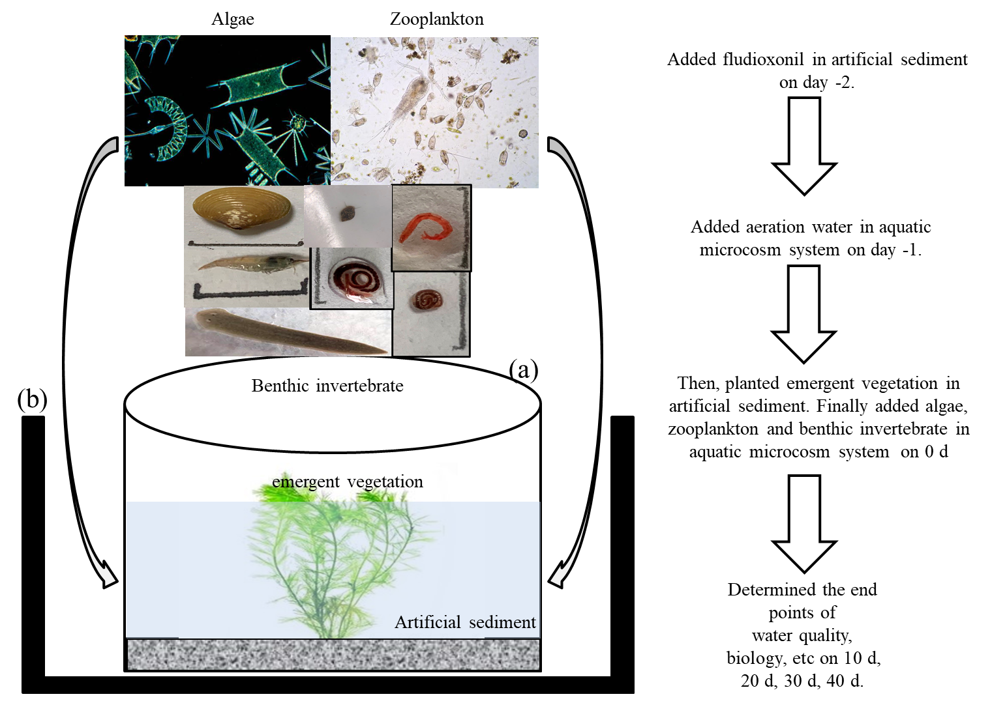

SI B Fig 1 : Aquatic microcosm system internal structure and establishment flow sheet
Note: (a) Aquatic microcosm system; (b) thermostat water bath equipment

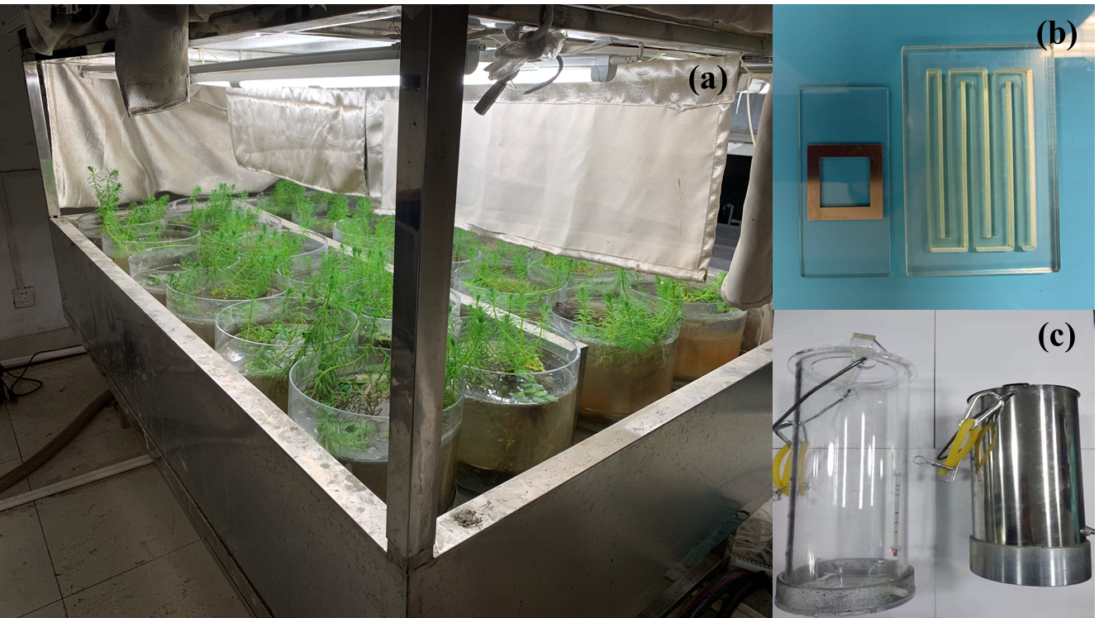
SI B Fig 2: Microcosmic test equipment
Note: (a) thermostat water bath equipment; (b) plankton counting chamber; (c) water sampler.

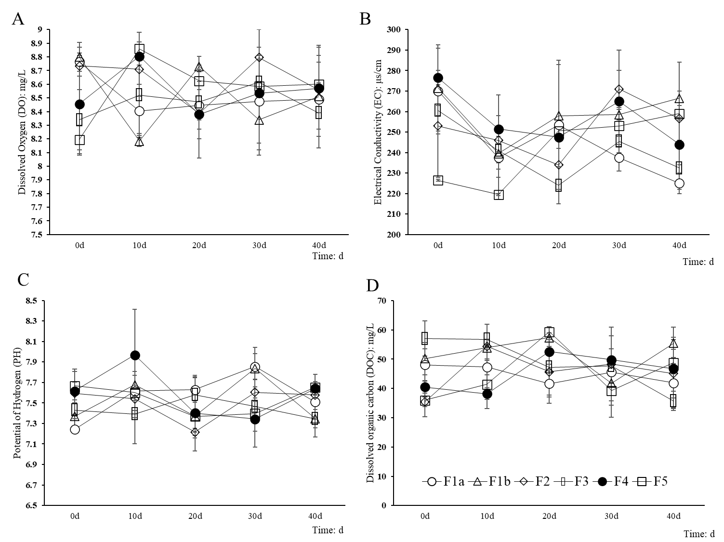
SI B Fig 3: Impact of difenoconazole on water quality parameters in indoor sediment-water aquatic microcosm A DO; B EC; C PH; D DOC

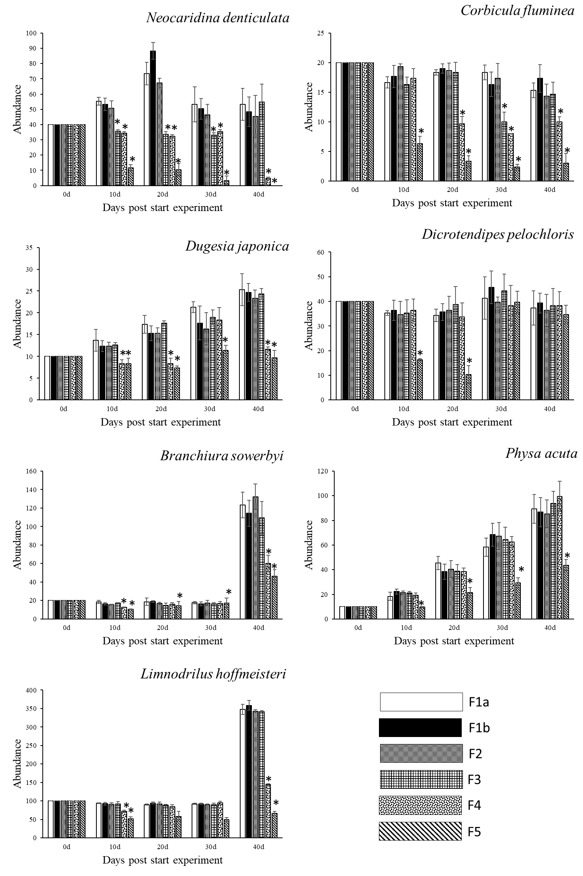
SI B Fig 4: Effects of fludioxonil on benthic animals abundance

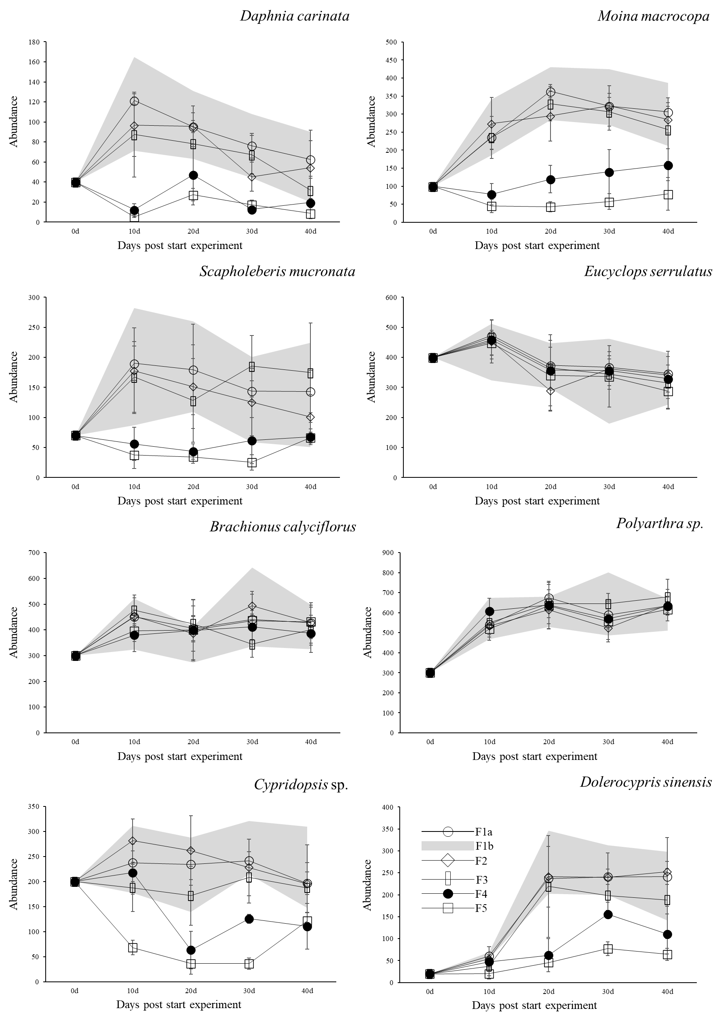

SI B Fig 5: Effects of fludioxonil on zooplankton abundance

