Supporting Information Appendix D : Top-rice exposure scenario
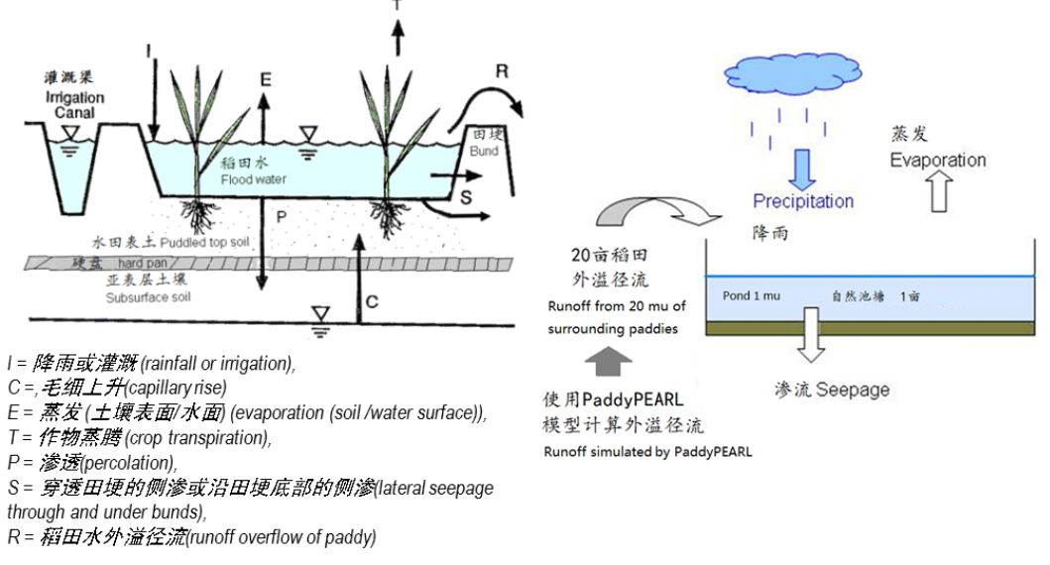
Pond：Water depth 2 m
width 20 m, length 33 m

Fig1 TOP-RICE Model Pond Scenario
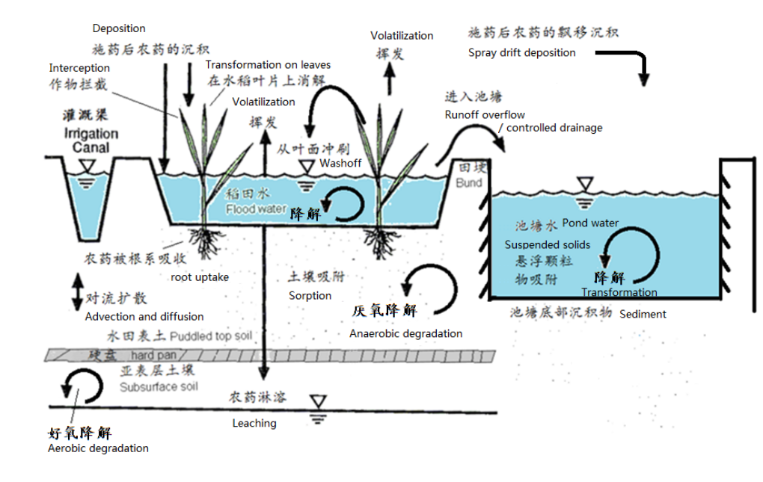
Fig 2 Environmental Behavior of Pesticides in TOP-RICE Model

China Pesticide Surface water Exposure Model （PSEM）exposure scenario
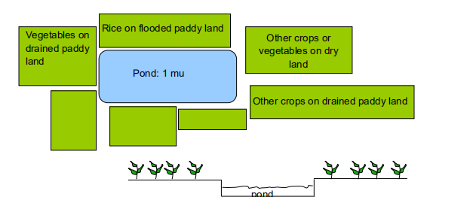
Peanut on dry land
Grape on dry land
Tomato on dry land
Fig 3 Conceptual model of the natural pond where the aquatic ecosystem should be protected in the scenario zones Yangtze River basin and South China （Spray drift deposition and surface run-off）

