Urinary tract infections among pregnant women in rural West Amhara, Ethiopia: Prevalence, bacterial etiology, risk factors, and antimicrobial resistance patterns
Mulatu Melese Derebe, MSc^{1,2}, Unmesha Roy Paladhi, PhD, MPH³, Firehiwot Workneh, PhD⁴, Abaineh Munshea, PhD¹, Gizachew Yismaw, PhD², Kalkidan Yibeltal, MD, MPH⁵, Nebiyou Fasil, PhD, MPH⁶, Alemayehu Worku, PhD⁴, Tsehaynesh Gebreyesus, MSc², Wudu Tafere, MSc², Alem Tsega, MSc², Parul Christian, PhD⁷, Rose L. Molina, MD, MPH,⁸ Blair J. Wylie, MD⁸, Yemane Berhane, MD, MPH, PhD⁴*, Anne CC Lee, MD, MPH³*

¹Health Biotechnology Division, Institute of Biotechnology, Bahir Dar University, Bahir Dar, Ethiopia
²Amhara Public Health Institute, Bahir Dar, Ethiopia
³Global Alliance for Infant and Maternal Health, Warren Alpert Medical School, Department of Pediatrics, Brown University, Providence, RI, USA
⁴Department of Epidemiology and Biostatistics, Addis Continental Institute of Public Health, Addis Ababa, Ethiopia
⁵Department of Reproductive Health and Population, Addis Continental Institute of Public Health, Addis Ababa, Ethiopia
⁶Department of Global Health and Health Policy, Addis Continental Institute of Public Health, Addis Ababa, Ethiopia
⁷Department of Human Development, Teachers College, Columbia University, New York, USA
⁸Beth Israel Deaconess Medical Center, Boston, MA
*Co-senior authors

Supplementary documents:
Supplementary Table S1: The etiology of uropathogens isolated among symptomatic and asymptomatic pregnant women diagnosed with UTIs in rural Amhara, Ethiopia, 2020-2022.

Bacterial Isolates | Asymptomatic  N= 12 | Symptomatic  N=9 | Total  N=21
Escherichia coli | 5 (41.7%) | 7 (58.3%) | 12 (57.1%)
Enterococcus faecalis | 3 (100.0%) | 0 (0.0) | 3 (1.3%)
Klebsiella pneumoniae | 2 (66.7%) | 1 (33.3%) | 3 (1.3%)
Staphylococcus aureus | 0 (0.0) | 1 (100.0%) | 1 (4.8%)
Staphylococcus saprophyticus | 1 (100.0%) | 0 (100.0%) | 1 (4.8%)
Other streptococcus species | 1 (100.0%) | 0 (0.0) | 1 (4.8%)
% | 12 (57.1%) | 9 (42.9%) | 21 (100.0%)
Supplementary Figure S1. Antimicrobial susceptibility profiles of UTI uropathogens (n=21) from urine culture among pregnant women attending ANC in rural Amhara region, Ethiopia, 2020-2022.
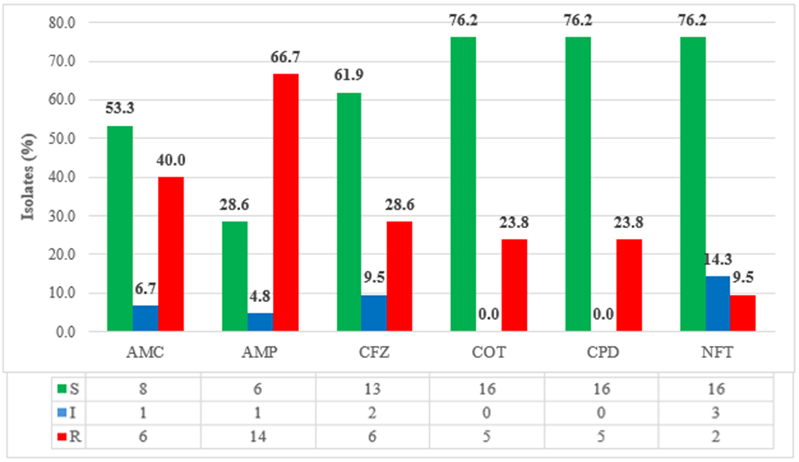
Abbreviations: AMC- amoxacillin-clavilanic acid; AMP- ampicillin; CFZ- cefazolin; COT- cotrimoxazole; CPD- cefpodoxime; NFT- nitrofurantoin.

