Supplementary Information

Supplementary figure legends
Figure S1. The immunogenicity of the spike protein produced from different protein expression systems.
A. RBD-specific IgG titers in sera induced by intranasal immunization with the spike protein of the original SARS-CoV-2 strain expressed in CHO cells and 293 cells. B. RBD-specific IgG titers in sera induced by intranasal immunization with the spike protein of the original SARS-CoV-2 strain expressed in baculovirus-infected cells and CHO cells. The data are presented as the means ± SEMs. Groups were compared via one-way ANOVA. *P<0.05, ***P<0.001; ns, nonsignificant.

Figure S2. The effectiveness and biocompatibility of LNT as a respiratory mucosal adjuvant.
A. RBD-specific IgG titers in sera induced by intranasal immunization with spike protein together with different adjuvants after the 2nd immunization. B. RBD-specific IgG serum titers induced by intranasal immunization with spike protein with pre- or co-instillation of LNT. C. RBD-specific serum IgG titers induced by intranasal immunization with the spike protein together with different doses of LNT. D. Enriched pathways associated with genes in the lung tissues of mice intranasally instilled with LNT. E. Index of the lungs (lung weight/body weight) at 24 h post-immunization. F. H&E staining of the nasals and lungs at 24 h post-immunization (scale bars, 100 μm). The data are presented as the means ± SEMs. Groups were compared via one-way ANOVA. *P<0.05; ** P<0.01; ns: nonsignificant.

Figure S3. S1- or S2-specific IFN-γ-secreting T-cell responses of spleen cells.
A. Representative images of the IFN-γ- and IL-17A-secreting T-cell responses of spleen cells stimulated with the S1 protein. B. Representative images of the IFN-γ- and IL-17A-secreting T-cell responses of spleen cells stimulated with the S2 protein.

Figure S4. Neutralizing antibody titers against authentic SARS-CoV-2 VOCs in mucosal samples.
A-B. RBD-specific IgA (A) and IgG (B) titers in VLF after the 2nd and 3rd immunizations. C-D. Neutralizing antibody titers against authentic SARS-CoV-2 VOCs in the BALF (C) or NLF (D) after the 2nd immunization. The data are presented as the means ± SEMs and are representative of at least three independent experiments. Groups were compared via ordinary one-way ANOVA or the Kruskal-Wallis test. *P<0.05, **P<0.01; ns, nonsignificant.

Fig. S5. Evaluation of the depletion efficiency of CD8+ T cells.
A. Representative dot plots (left) and frequency (right) of CD8+ T cells in the blood. The data are presented as the means ± SEMs and are representative of at least three independent experiments. Groups were compared via unpaired two-sided Student’s t-test. ****P<0.0001.

Figure S6. S-2P effectively activated innate immunity.
A. Enriched pathways associated with genes whose expression was upregulated in the lung tissues of mice intranasally immunized with S-2P. B Upregulation of type I IFN-related genes in BMDCs stimulated with S-2P but not HA. The data are presented as the means ± SEMs. Groups were compared via one-way ANOVA or the Kruskal-Wallis test. *P<0.05; **P<0.01; ***P<0.001; ****P<0.0001; ns, nonsignificant.

Supplementary figures
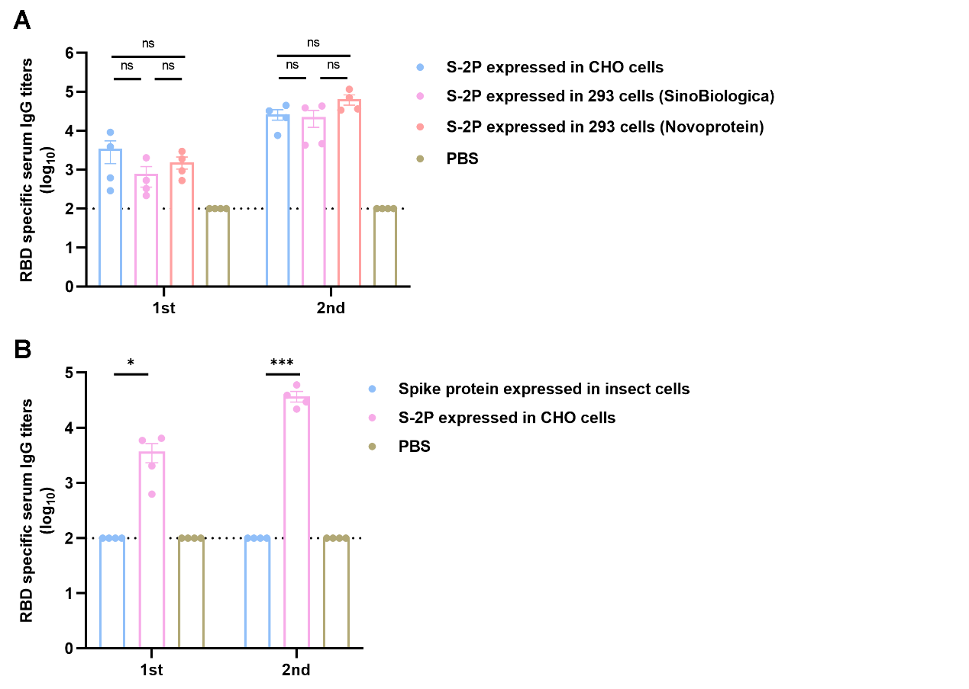
Fig. S1. Comparison of the immunogenicity of S-2P produced from different protein expression systems.

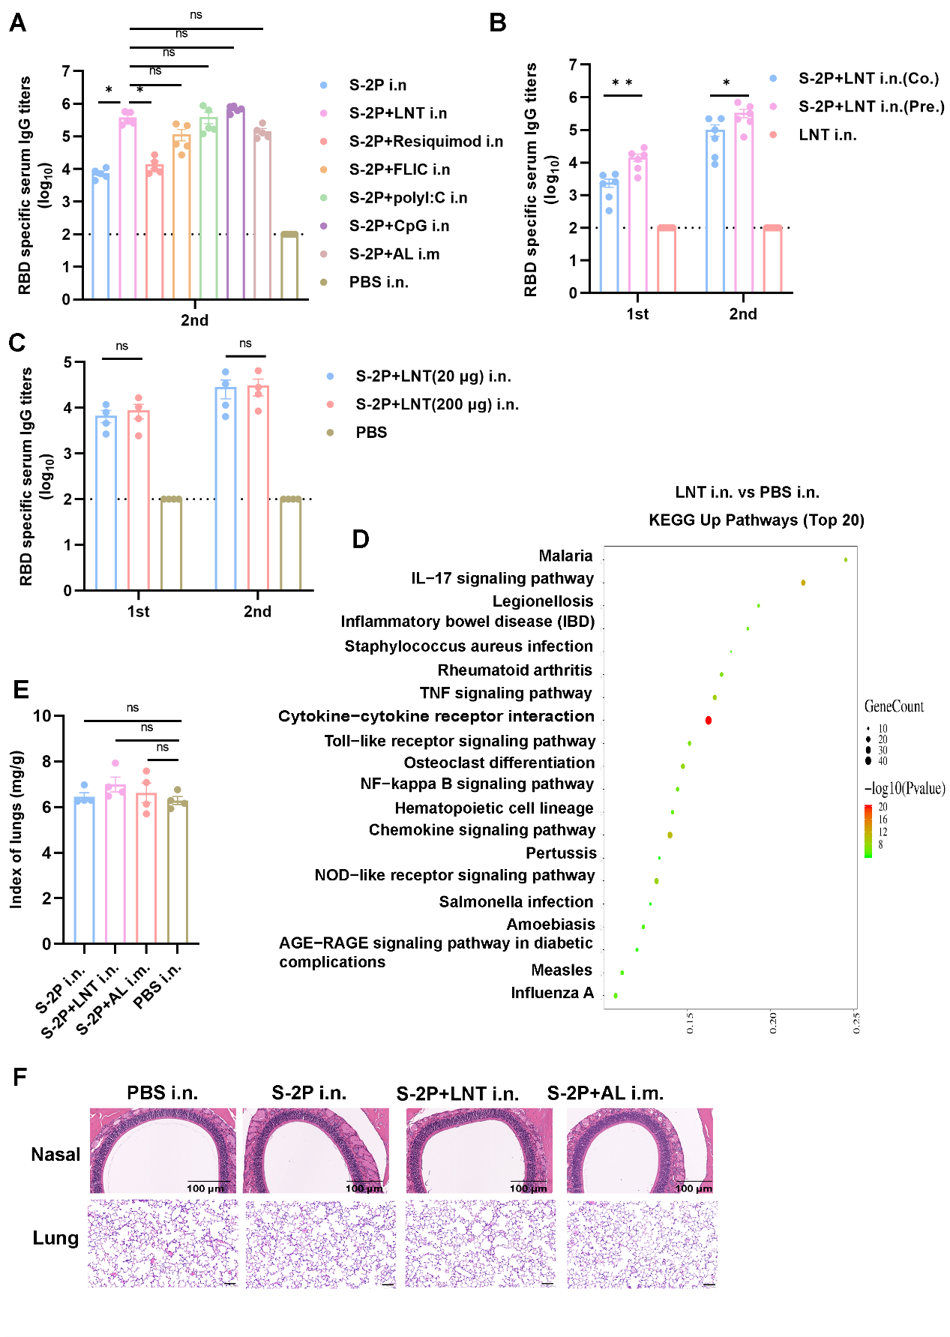
Fig. S2. Effectiveness and biocompatibility of LNT as a respiratory mucosal adjuvant.

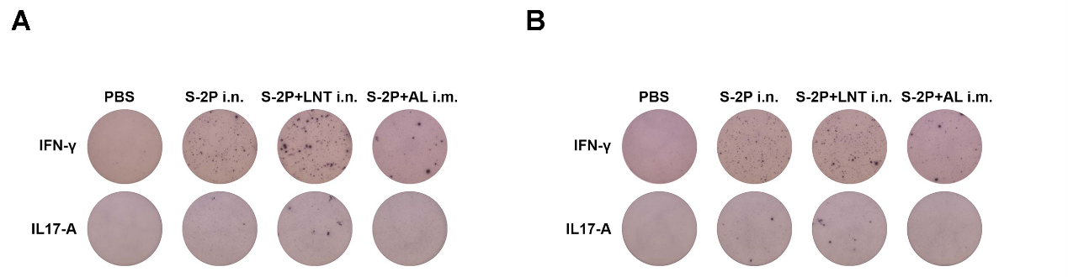
Fig. S3. S1- or S2-specific IFN-γ− and IL-17A-secreting T-cell responses of spleen cells.

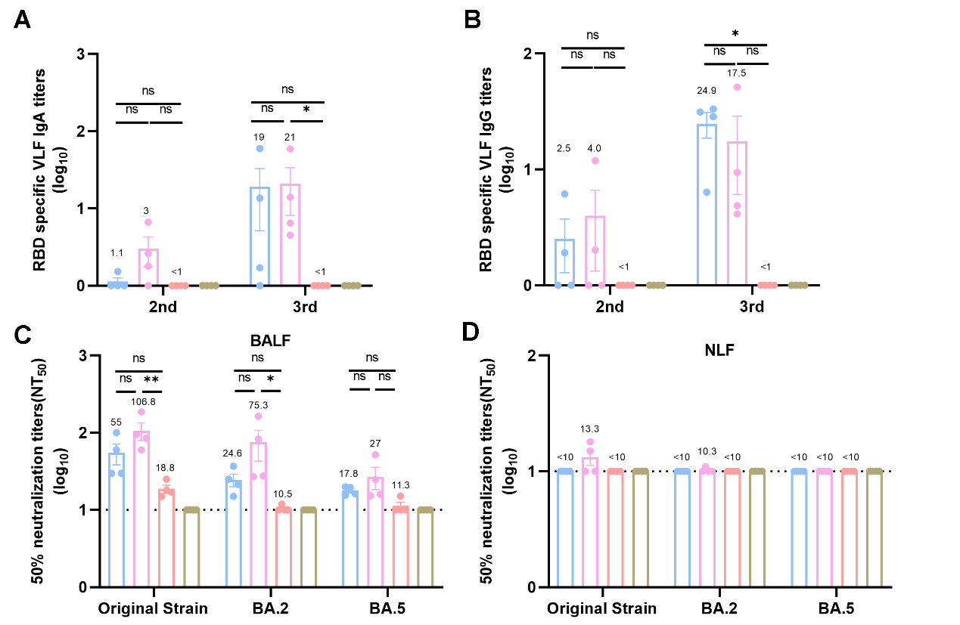
Fig. S4. Neutralizing antibody titers against authentic SARS-CoV-2 VOCs in mucosal samples.

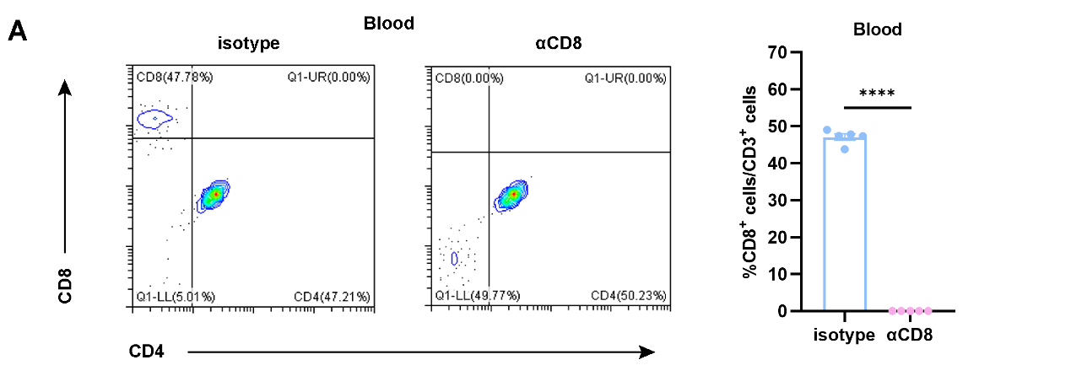
Fig. S5. Evaluation of the depletion efficiency of CD8+ T cells.

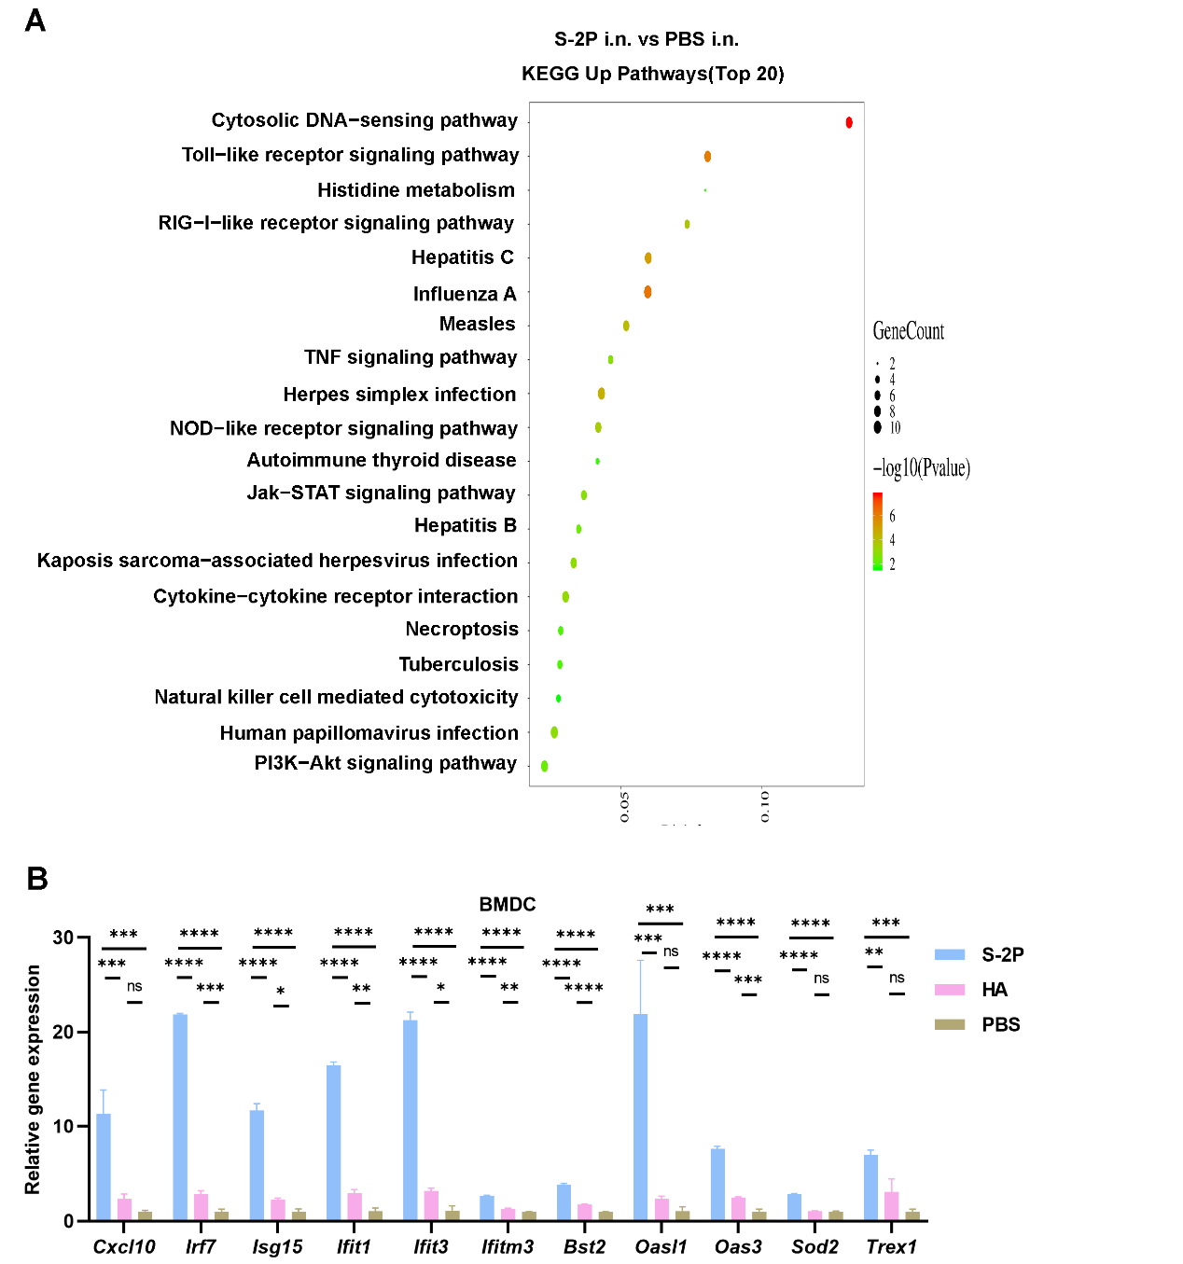
Fig. S6. S-2P effectively activated innate immunity.

