Supporting Information

Matrix Plainification Leads to High Thermoelectric Performance in Plastic Cu₂Se/SnSe Composites

Pan Ying^{1, #}, Qingyang Jian^{1, #}, Yaru Gong¹, Tong Song², Yuxuan Yang², Yang Geng¹, Junquan Huang³, Rongxin Sun³, Chen Chen³, Tao Shen³, Yanan Li¹, Wei Dou¹, Congmin Liang¹, Yuqi Liu¹, Deshang Xiang¹, Tao Feng¹, Yongsheng Zhang⁴, Kun Song⁵, Yang Zhang⁶, Haijun Wu^{2, ∗}, Guodong Tang^{1, ∗}
¹ School of Materials Science and Technology, Nanjing University of Science and Technology, Nanjing, 210094, China
² State Key Laboratory for Mechanical Behavior of Materials, Xi’an Jiaotong University, Xi’an, China
³ Center for High Pressure Science (CHiPS), State Key Laboratory of Metastable Materials Science and Technology, Yanshan University, Qinhuangdao, 066004, China
⁴ Advanced Research Institute of Multidisciplinary Sciences, Qufu Normal University, Qufu, Shandong Province, 273165, China
⁵ School of Mechanical and Power Engineering, Nanjing Tech University, Nanjing, 211816, China
⁶ Electronic Materials Research Laboratory (Key Lab of Education Ministry), School of Electronic and Information Engineering, and Instrumental Analysis Center, Xi’an Jiaotong University, Xi’an 710049, China
∗ To whom correspondence should be addressed
# These authors contributed equally to this work.
Email: wuhaijunnavy@xjtu.edu.cn (H.J. Wu); tangguodong@njust.edu.cn (G. D. Tang)
Experimental Section
Sample preparation
A series of polycrystalline Cu₂Se/Sn_{0.96}Pb_{0.01}Zn_{0.03}Se samples were synthesized in two steps by melting and hydrothermal methods. Stoichiometric high-purity raw elements Cu powders (shots, 99.999%, Alfa Aesar), Se powders (pieces, 99.999%, Alfa Aesar) were weighted in stoichiometric ratio and mix well by hand grinding for 30 minutes in a mortar. Then the mixture was vacuum sealed in quartz tubes. The sealed tubes were slowly raised to 1423 K within 10 hours and held at this temperature for 12 hours, followed by a cooling process for 50 hours down to 923 K. Finally, after holding at 923 K for 7 days, the sealed tubes were naturally cooled to room temperature. The obtained ingot was ground by hand in a mortar for 1 hour to obtain Cu₂Se powder. Sn_{0.96}Pb_{0.01}Zn_{0.03}Se powder was carried out through a hydrothermal method. SnCl₂‧2H₂O (99.99%, Aladdin), PbCl₂ (99.99%, Aladdin), ZnCl₂ powder (99.99%, Aladdin), Se powder (99.99%, Aladdin), and NaOH (98%, Aladdin) were used as raw materials to prepare SnSe powders and etailed methods were in our previously reported literature ¹ The Cu₂Se and Sn_{0.96}Pb_{0.01}Zn_{0.03}Se powders were weighed in mass ratio and mixed in a mortar for half an hour. The mixture was then subjected to spark plasma sintering (SPS, Sumitomo SPS-2040) and sintered at 50 MPa and 923 K for 5 minutes.
Structural characterization
The crystal structure of synthesized Cu₂Se/xwt.% Sn_{0.96}Pb_{0.01}Zn_{0.03}Se composites was examined by powder X-ray diffraction (Bruker D8 Advance) with Cu Kα radiation and a scanning step size of 0.02°.The structural morphology of samples were characterized using a scanning electron microscope (SEM, FEI Quanta 250 FEG) equipped with energy-dispersive X-ray spectroscopy (EDS). The Differential Scanning Calorimeter (DSC) was determined on DSC2500 under a N₂ flow. An X-ray photoelectron spectroscopy (XPS) instrument (Krayos AXIS Ultra DLD) was used to analysis the valence of element. The the valences of element Cu and Sn were measured using X-ray photoelectron spectroscopy (XPS) on a Krayos AXIS Ultra DLD instrument. High-angle annular dark-field scanning transmission electron microscopy (HAADF-STEM), and EDS investigations were performed at an aberration-corrected scanning transmission electron microscopy (STEM, JEM-ARM300F2) with a 300 kV accelerating voltage.
Mechanical properties
Prior to the hardness test, the surface of the sample is first polished to a mirror finish. The Vickers hardness (H_{V}) was measured with a microhardness tester (KB 30 BVZ, Prüftechnik GmbH) under loads of 0.98 N. The microhardness were measured using a nanoindenter (G200). Compressive strength was tested with a tensile/compressive system (SANS, UTM/CMT 5000).
Stability test
Stability tests were measured by our homemade TEG test system. In the testing process, the hot and cold end of a TEG are respectively controlled by the heating plate and water-cooling plate. An electronic load meter and a multi-channel temperature tester were utilized to measure the output power and temperatures, while the resistance of the TEG can be derived by utilizing the open-circuit voltage, the closed-loop voltage, and the current. The TEG under test consists of 17 pairs of P-type/N-type TE legs. P-type TE legs are prepared Cu₂Se/5 % Sn_{0.96}Pb_{0.01}Zn_{0.03}Se compositions and N-type TE legs are commercially available Bi₂Te₃-based TE material. All the TE legs are cut into a size of 1.5 x 1.5 mm² in cross-section and 4.0 mm in length. Thermogravimetric curves were measured by simultaneous thermal analysis (TGA/DSC3+) in an argon atmosphere.
Theoretical calculations
The formation energy were performed using the projector augmented wave method as implemented in VASP (Vienna ab initio simulation package) ^{2, 3, 4}. The total energy was converged within 10⁻⁵ eV at a plane-wave expansion kinetic energy cutoff of 450 eV. The defect formation energy (E_{f}) calculations using:
$$\begin{aligned}E_{f}=E\left(defect\right)−E\left(perfect\right)+\sum_{i}{n_{i}}{}_{i}\#\left(1\right)\end{aligned}$$
where E(defect) and E(perfect) are the total energies of cells with and without defects, respectively. The integer n_{i} represents the number of type i ato ms that have been added to (n_{i} > 0) or removed from (n_{i}<0) the cell. μ_{i} is the chemical potential of added or removed atom i. In the Cu₂Se system, we choose μ_{Se}=E(Se) and μ_{Sn}=E(SnSe) –μ_{Se}, where E(Se) and E(SnSe) are the total energies of bulk Se and SnSe compounds, respectively. The charge density difference was investigated based on the Cambridge sequential total energy package (CASTEP) code ⁵. GGA-PBE is used to describe the electronic exchange–correlation energy function.
Transport property measurement
Rectangular bulks (3×3×8 mm³) and disks (φ 6 mm×1.2 mm) were cut from the SPS pellets for electrical and thermal transport measurements, respectively. The electrical conductivity (s) and Seebeck coefficient (S) were measured on a commercial system (Ulvac-Riko ZEM-3). The thermal diffusion coefficient D was measured by Netzsch LFA-457 instrument under argon atmosphere. The specific heat (C_{p}) was taken from the ref. 30. The density (ρ) (Supplementary Table 2) was measured through the Archimedes’ method. Then the total thermal conductivity was calculated based on the formula κ_{tot} = D C_{p} ρ. Carrier concentration (n) and carrier mobility (μ) were obtained using a Hall measurement instrument (HMS-3000). The uncertainty of the Seebeck coefficient, electrical conductivity, thermal diffusion, specific heat capacity, and density error involved in calculating ZT is close to 20%. The longitudinal sound velocity (v_{l}) and shear sound velocity (v_{s}) were measured via an advanced ultrasonic material characterization system (UMS-100, France).
The calculation of Lorentz number
The Lorentz number is obtained according to the two-band model:
$$\begin{aligned}δL_{lh}={\left(\frac{κ_{B}}{e}\right)}^{2}\left[\frac{{{}_{}^{2}F}_{−2}^{1}\left(η,α\right)}{{{}_{}^{0}F}_{−2}^{1}\left(η,α\right)}−{\left(\frac{{{}_{}^{2}F}_{−2}^{1}\left(η,α\right)}{{{}_{}^{0}F}_{−2}^{1}\left(η,α\right)}\right)}^{2}\right]\#\left(2\right)\end{aligned}$$
and
$$\begin{aligned}δL_{lh}={\left(\frac{κ_{B}}{e}\right)}^{2}\left[\frac{{{}_{}^{2}F}_{−2}^{1}\left(η−Δν,0\right)}{{{}_{}^{0}F}_{−2}^{1}\left(η−Δν,0\right)}−{\left(\frac{{{}_{}^{2}F}_{−2}^{1}\left(η−Δν,0\right)}{{{}_{}^{0}F}_{−2}^{1}\left(η−Δν,0\right)}\right)}^{2}\right]\#\left(3\right)\end{aligned}$$

In the above equations, the integral ${{}_{}^{n}F}_{l}^{m}$ is defined by
$$\begin{aligned}{}_{}^{n}{F_{l}^{m}=\int_{0}^{ꝏ}{−\frac{f}{}}}{}^{n}{\left(+{}^{2}\right)}^{m}{\left[{\left(1+2\right)}^{2}+2\right]}^{\frac{1}{2}}d\#\left(4\right)\end{aligned}$$
Where $L_{lh}$ and $L_{hh}$ are the $L$ of light-hole band and heavy-hole band, respectively, $α$ is the nonparabolic parameter obtained by the formula $α=k_{B}T/E_{g}$, $η$ is the reduced chemical potential evaluated by $η=E_{f}/k_{B}T$, and ${{}_{}^{n}F}_{l}^{m}$ is the generalized Fermi function. We set $α=0$ and replace $η$ with $η−Δν$ in equation for the second valence band, where $Δν=ΔE/k_{B}T$, $ΔE$ is the energy difference between the first and second valence band. The total $L$ can be calculated by the following equation:
$$\begin{aligned}L_{total}=\frac{\left(σ_{lh}L_{lh}+σ_{hh}L_{hh}\right)}{\left(σ_{lh}+σ_{hh}\right)}\#\left(5\right)\end{aligned}$$
Weighted mobility calculation in detail:
Weighted mobility (μ_{w}) can be calculated based on the availability of combined electrical conductivity and Seebeck coefficient according to the following equation:
$\begin{aligned}μ_{W}=\frac{3h^{3}σ}{8πe{\left({2m}_{e}k_{B}T\right)}^{3/2}}\left[\frac{exp\left[\frac{\left|S\right|}{{k_{B}}/e}−2\right]}{1+exp\left[−5\frac{\left|S\right|}{{k_{B}}/e}−1\right]}+\frac{\frac{3}{π^{2}}\left[\frac{\left|S\right|}{{k_{B}}/e}\right]}{1+exp\left[5\frac{\left|S\right|}{{k_{B}}/e}−1\right]}\right]\#\left(6\right)\end{aligned}$

where T is the absolute temperature, k_{B} is the Boltzmann constant, e is the electron charge, h is the Planck constant, and m_{e} is the electron mass, respectively.
Sound velocity calculation
The longitudinal sound velocity (v_{l}) and transverse sound velocity (v_{t}) were measured at room temperature via an advanced ultrasonic material characterization system (UMS-100, France). The average sound velocity (v_{a}), Poisson ratio (r) and phonon mean free path (l_{ph}) were calculated as follows,
$\begin{aligned}v_{a}={\left[\frac{1}{3}\left(\frac{1}{v_{l}^{3}}+\frac{1}{v_{t}^{3}}\right)\right]}^{−\frac{1}{3}}\#\left(7\right)\end{aligned}$

$\begin{aligned}r=\frac{1−2(vt/{v_{l})^{2}}}{2−2(vt/{v_{l})^{2}}}\#\left(8\right)\end{aligned}$

$$\begin{aligned}l_{ph}=\frac{3κ_{L}}{C_{p}ρv_{a}}\#\left(9\right)\end{aligned}$$

Supplementary Table 1. Theoretically calculated defect formation energy for Cu₂Se after introducing SnSe.
Defect | Formation  Energy (eV)
V_{cu} | -0.66
Sn_{Cu} | 0.73
V_{cu}+ Sn_{Cu} | 0.07

Supplementary Table 2. Densities of Cu₂Se/x wt.%Sn_{0.96}Pb_{0.01}Zn_{0.03}Se composites.
Composition  (Cu₂Se/x wt.%Sn_{0.96}Pb_{0.01}Zn_{0.03}Se) | Density  (g/cm³)
x=0 | 6.59
x=1 | 6.55
x=3 | 6.50
x=5 | 6.48
x=10 | 6.32

Supplementary Figure 1. Hole transfer at the interface leading to the reduction of carrier concentration.
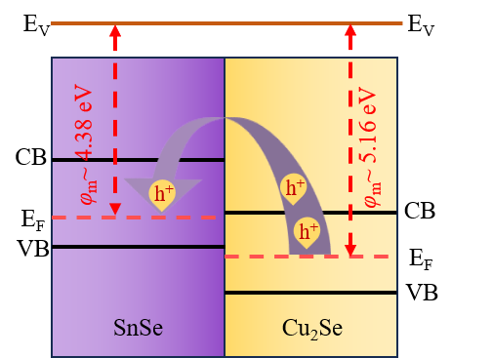

Supplementary Figure 2. Structural analysis of Cu₂Se/x wt.% Sn_{0.96}Pb_{0.01}Zn_{0.03}Se. (a) XRD patterns. (b) Variation of lattice parameter with Sn_{0.96}Pb_{0.01}Zn_{0.03}Se content based on XRD Rietveld refinement. (c) XPS core-level spectra of Cu⁺ for Cu₂Se/5 wt.% Sn_{0.96}Pb_{0.01}Zn_{0.03}Se. (d) XPS core-level spectra of Sn²⁺ for Cu₂Se/5 wt.% Sn_{0.96}Pb_{0.01}Zn_{0.03}Se.
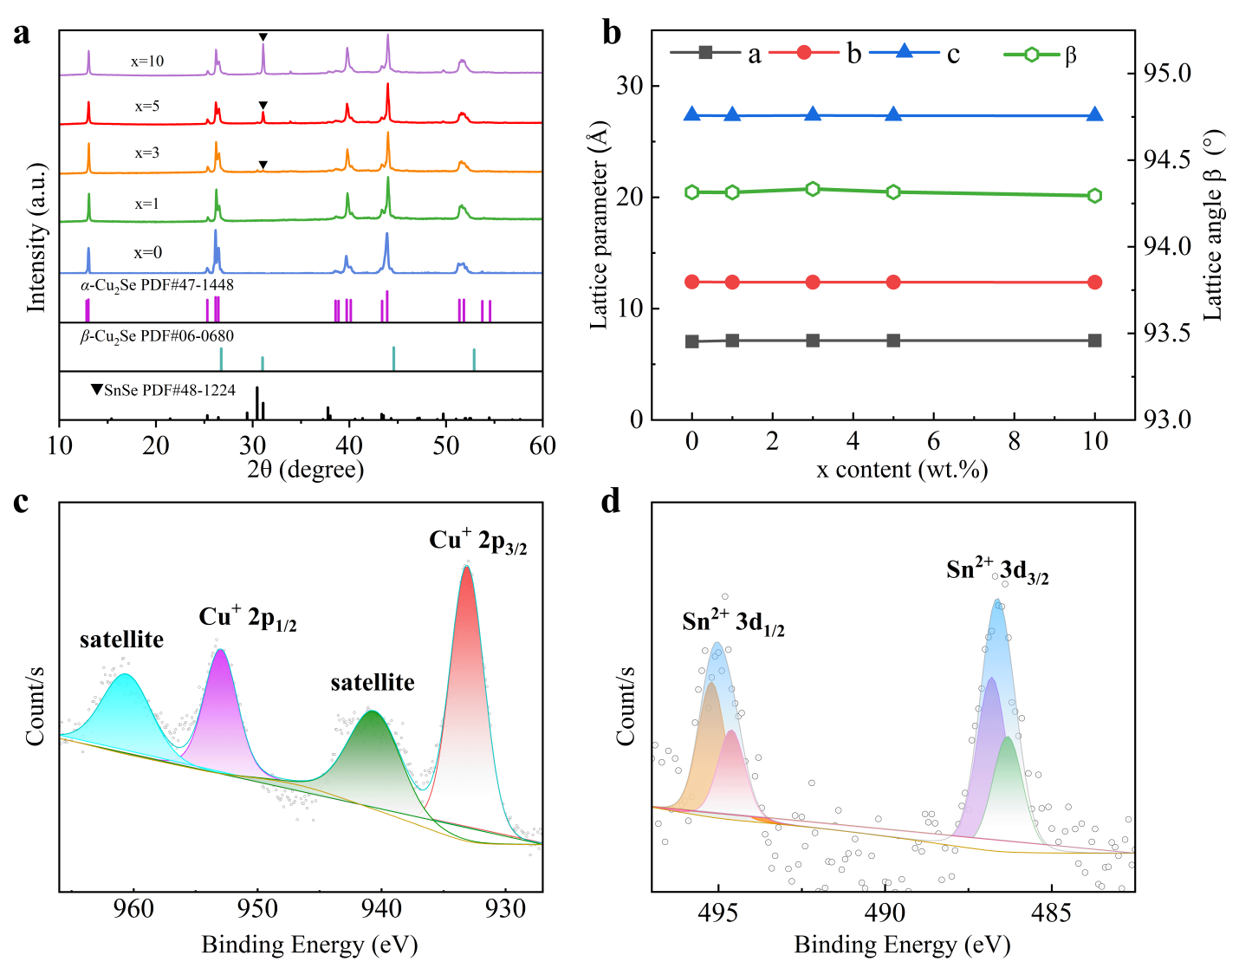

Supplementary Figure 3. (a) Room temperature crystal structure of Cu₂Se. (b) Crystal structure of Cu₂Se at high temperature ⁶.
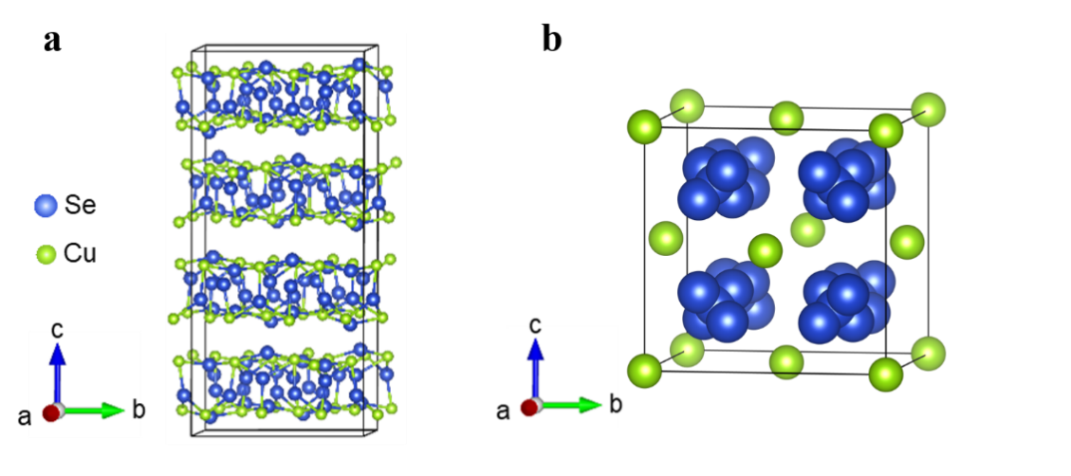

Supplementary Figure 4. Differential scanning calorimetry (DSC) analysis of Cu₂Se/x wt.%Sn_{0.96}Pb_{0.01}Zn_{0.03}Se samples.
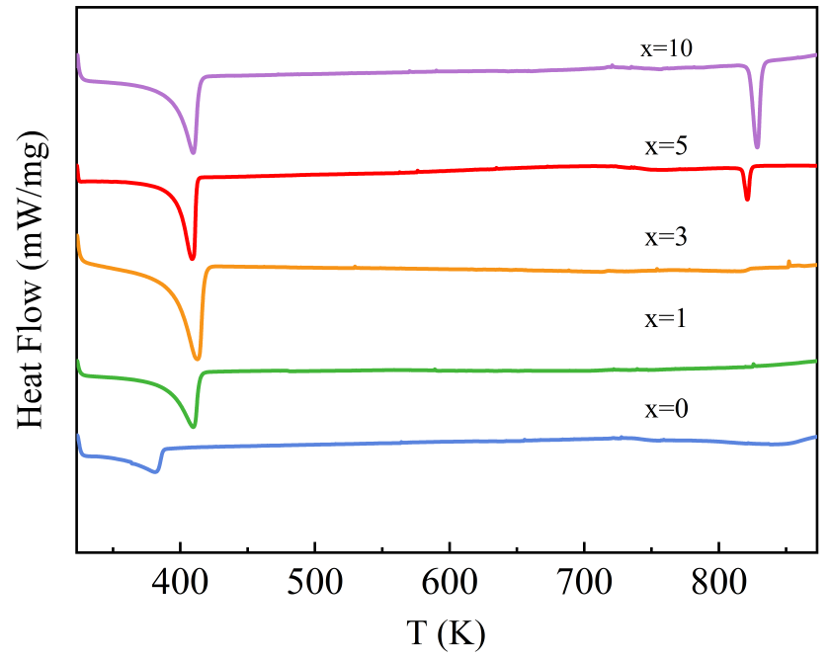

Supplementary Figure 5. Rietveld refinement details of Cu₂Se/x wt.%Sn_{0.96}Pb_{0.01}Zn_{0.03}Se samples. (a) x=0. (b) x=1. (c) x=3. (d) x=5. (e) x=10.
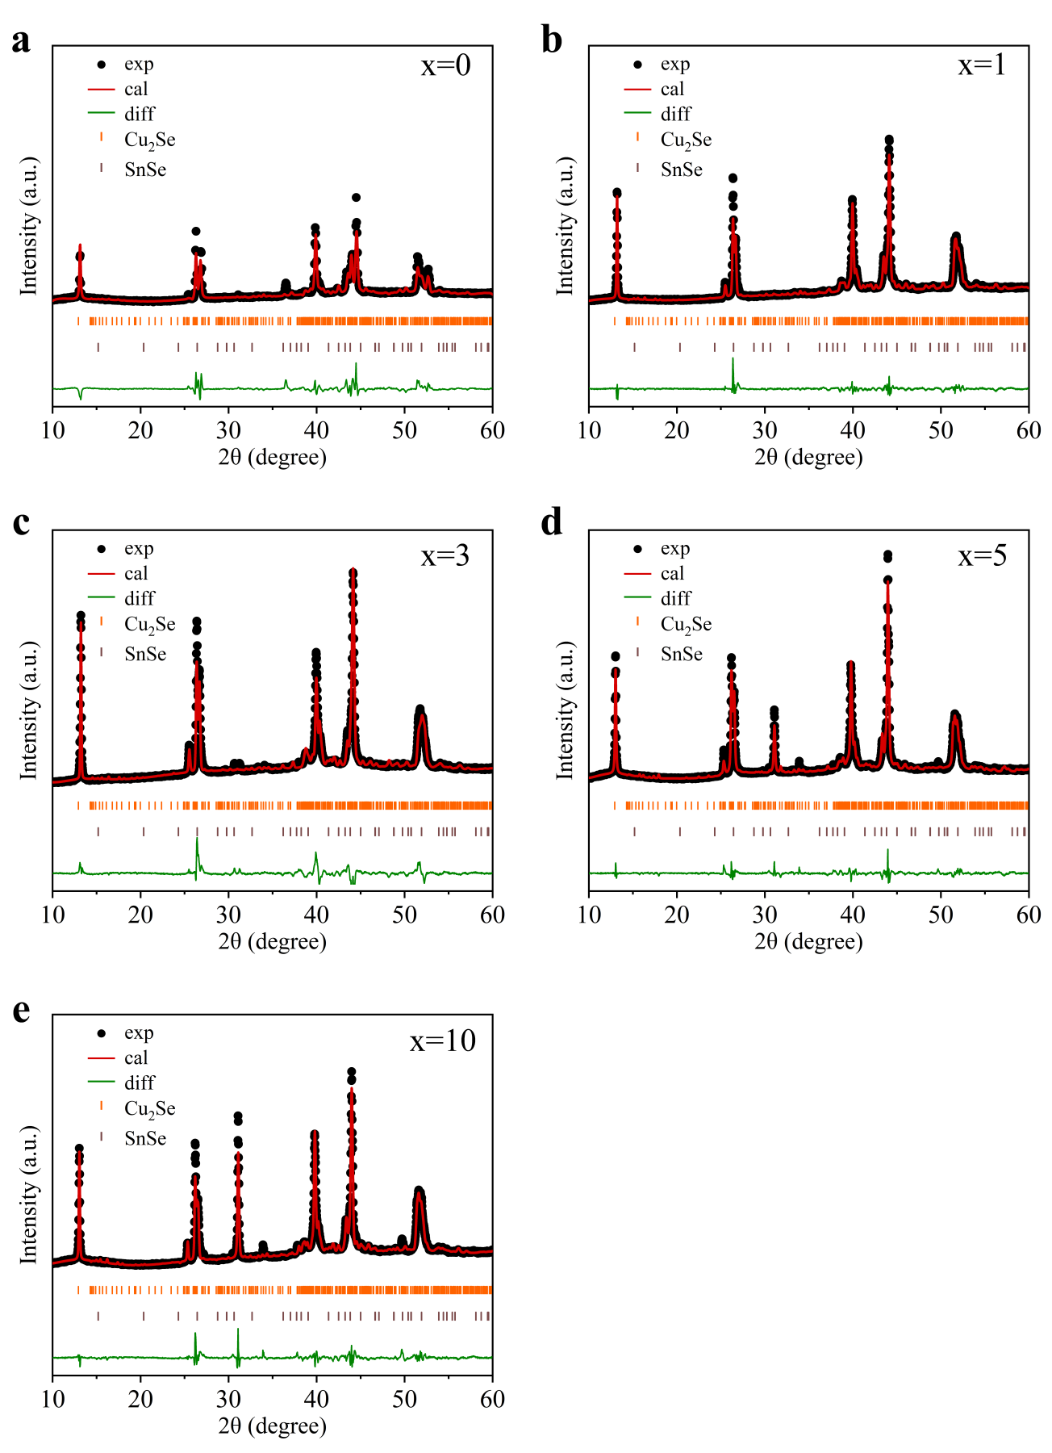

Supplementary Figure 6. Ultraviolet photoemission spectrum (UPS) of the Sn_{0.96}Pb_{0.01}Zn_{0.03}Se.
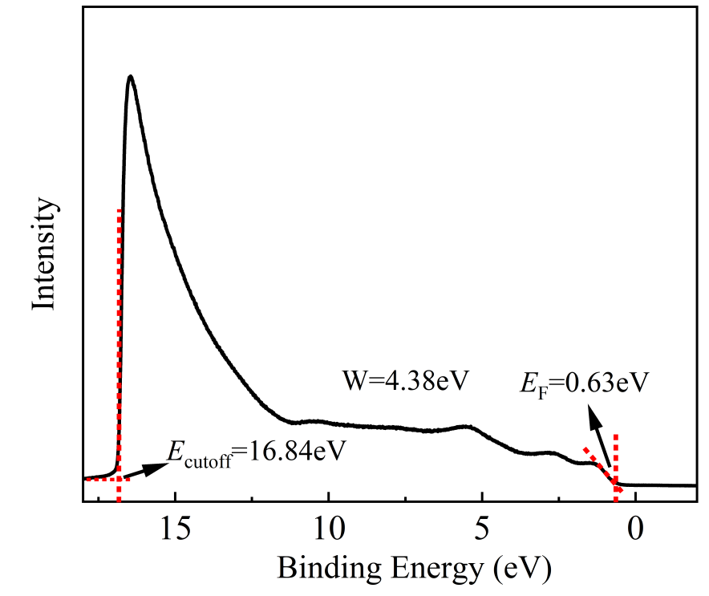

Supplementary Figure 7. Cu vacancies and Sn atoms occupy Cu vacancies in the Cu₂Se crystal structure.
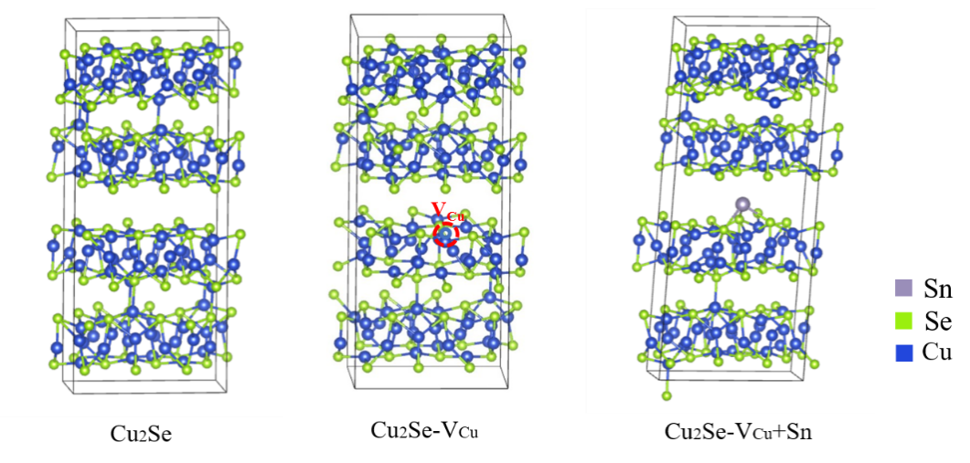

Supplementary Figure 8. Microstructural evolution in pure Cu₂Se and Cu₂Se/x wt.% Sn_{0.96}Pb_{0.01}Zn_{0.03}Se composites. (a) High-magnification HAADF image of pure Cu₂Se view along the [100] zone axis. (b) Intensity profile of the line in a. (c) EDS line scan in the grain of pure Cu₂Se. (d) High magnification HAADF image of Cu₂Se grain view along the [100] zone axis in the Cu₂Se/x wt.% Sn_{0.96}Pb_{0.01}Zn_{0.03}Se composites. (e) Intensity profile of the line in d. (f) EDS line scan in the Cu₂Se grain of Cu₂Se/x wt.% Sn_{0.96}Pb_{0.01}Zn_{0.03}Se composites.
Supplementary Figure 9. Comparison of power factor (PF) of Cu₂Se/5 wt.%Sn_{0.96}Pb_{0.01}Zn_{0.03}Se with previously reported Cu₂Se based materials ^{5, 6, 7, 8, 9}.
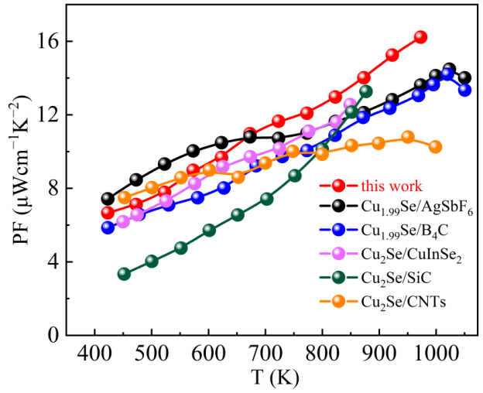

Supplementary Figure 10. (a) Temperature dependence of electronic thermal conductivity (κ_{ele}). (b) Lorenz number as a function of temperature for Cu₂Se/x wt.%Sn_{0.96}Pb_{0.01}Zn_{0.03}Se samples.
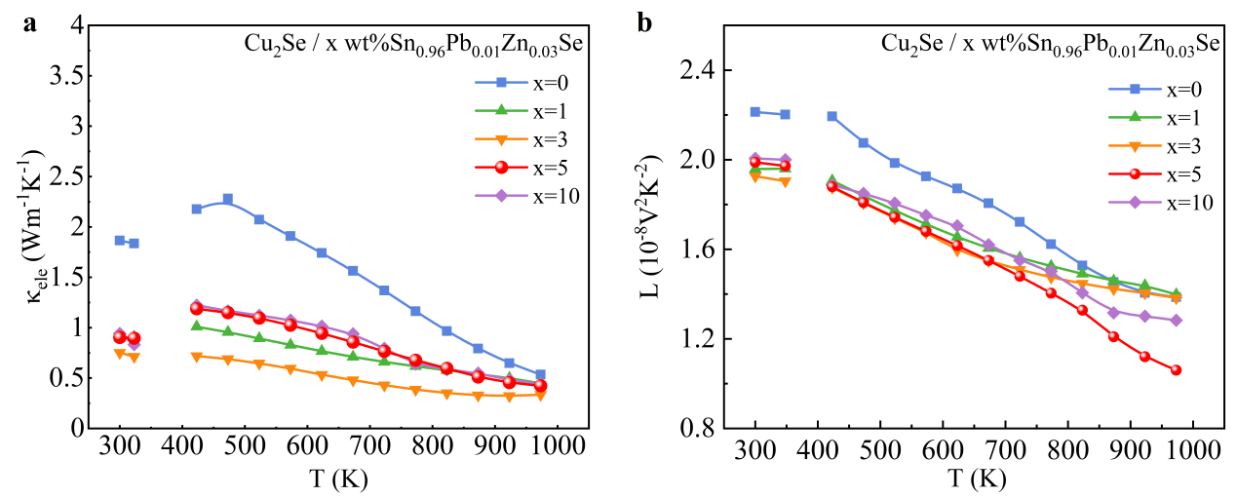

Supplementary Figure 11. Longitudinal and transverse sound velocities of Cu₂Se/x wt.%Sn_{0.96}Pb_{0.01}Zn_{0.03}Se samples at room temperature.

Supplementary Figure 12. SEM image of the fracture surface for Cu₂Se/5 wt.%Sn_{0.96}Pb_{0.01}Zn_{0.03}Se.
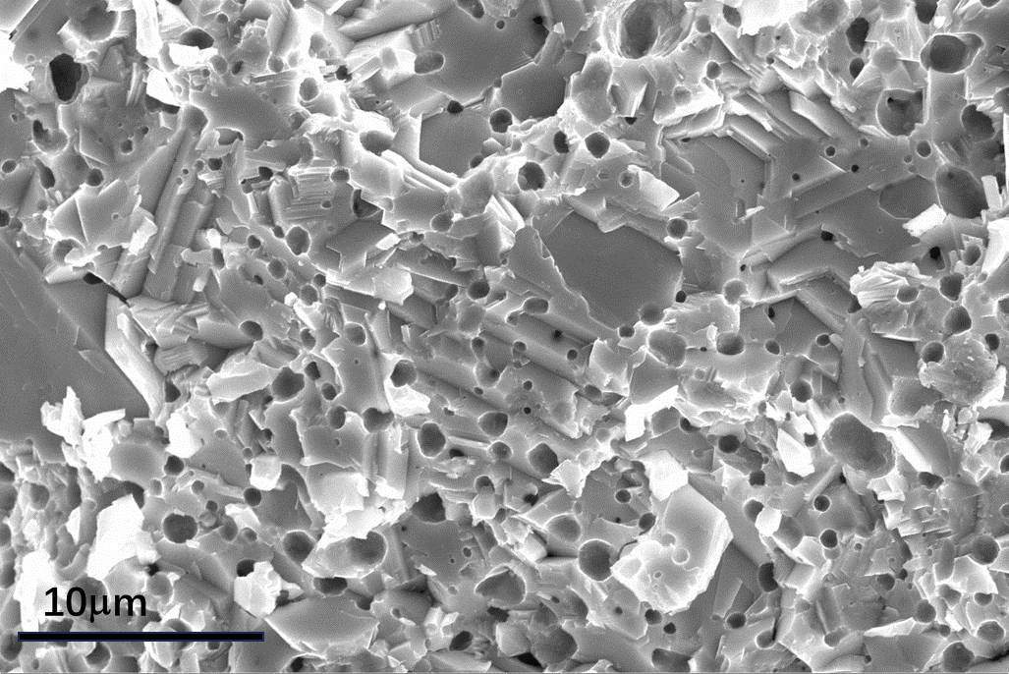

Supplementary Figure 13. (a) SEM-BES image and (b-d) Corresponding EDS mapping of polished surface for Cu₂Se/5 wt.%Sn_{0.96}Pb_{0.01}Zn_{0.03}Se.
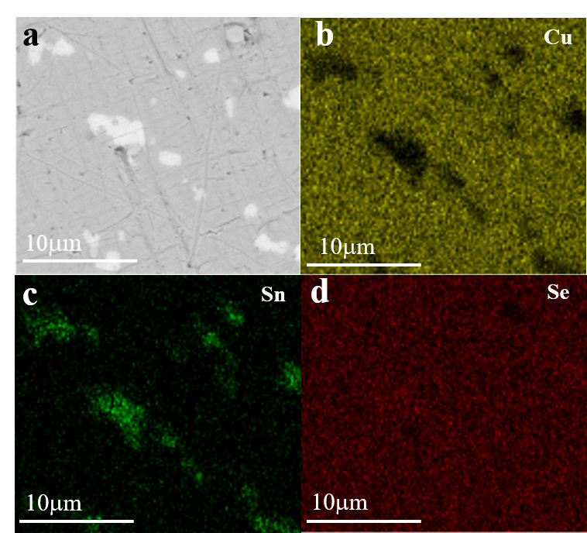

Supplementary Figure 14. (a) SEM image of the polished surface for Cu₂Se/5 wt.%Sn_{0.96}Pb_{0.01}Zn_{0.03}Se. (b) EDS line scan intensity curve.
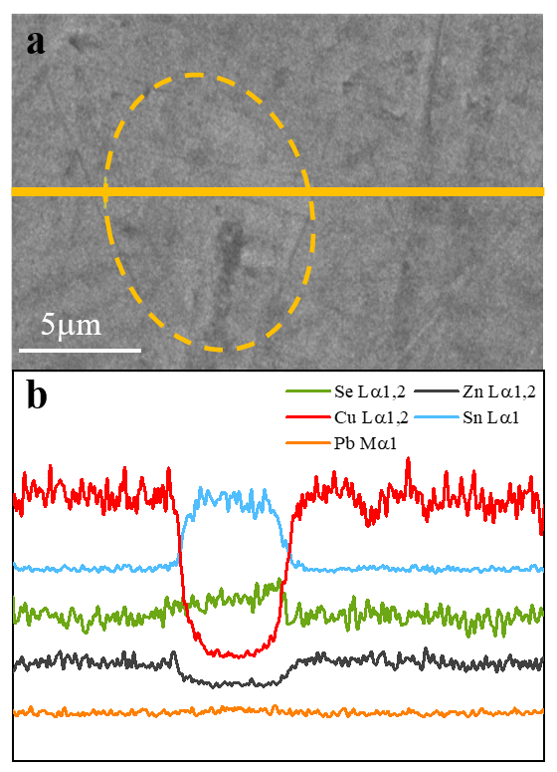

Supplementary Figure 15. Repeat measurement results of (a) electrical conductivity (σ). (b) Seebeck coefficient (S). (c) total thermal conductivity (κ_{tot}) and (d) ZT for Cu₂Se/5 wt.%Sn_{0.96}Pb_{0.01}Zn_{0.03}Se.

Supplementary Figure 16. Thermogravimetric analysis for Cu₂Se/x wt%Sn_{0.96}Pb_{0.01}Zn_{0.03}Se (x = 0 and 5).
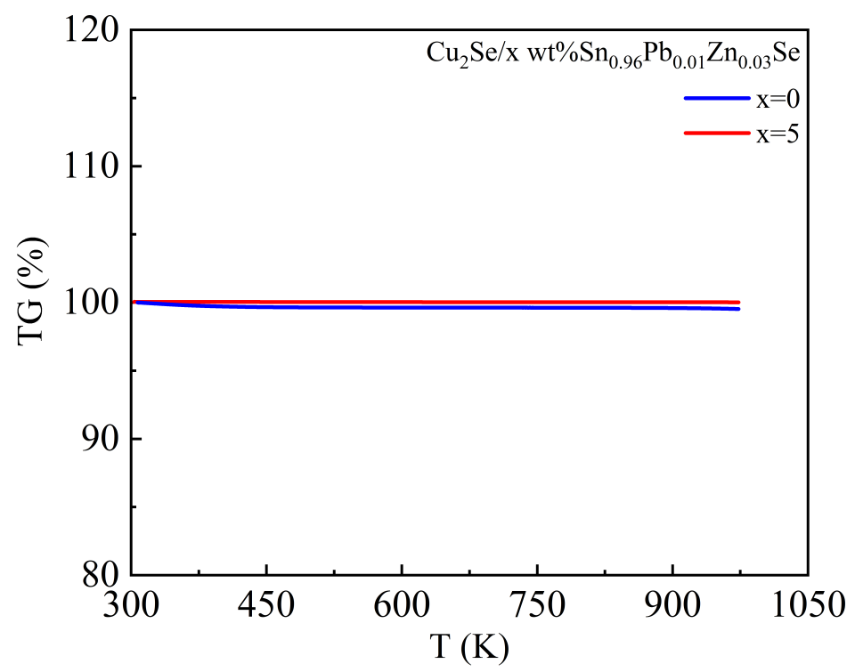

Supplementary Figure 17. EDS mappings of the surface for the samples (a) x = 0 and (b) x = 5 before and after testing.
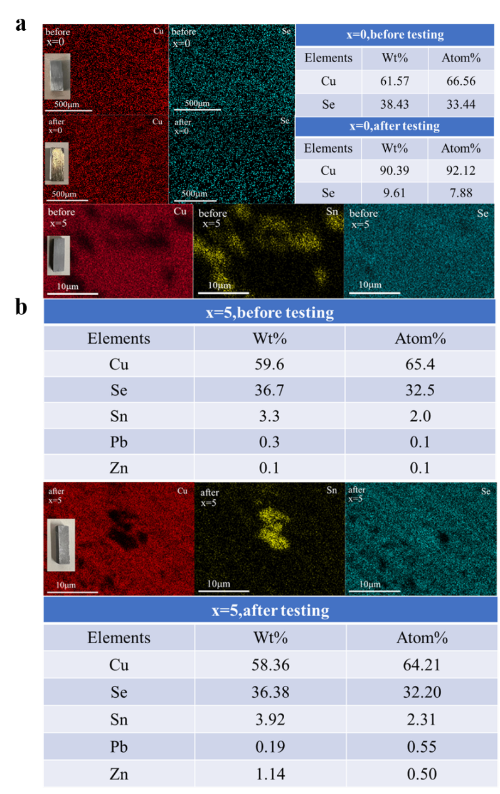

Supplementary Figure 18. Room temperature XRD patterns of (a) Cu₂Se (b) Cu₂Se/5 wt.% Sn_{0.96}Pb_{0.01}Zn_{0.03}Se before and after thermoelectric transport property tests.
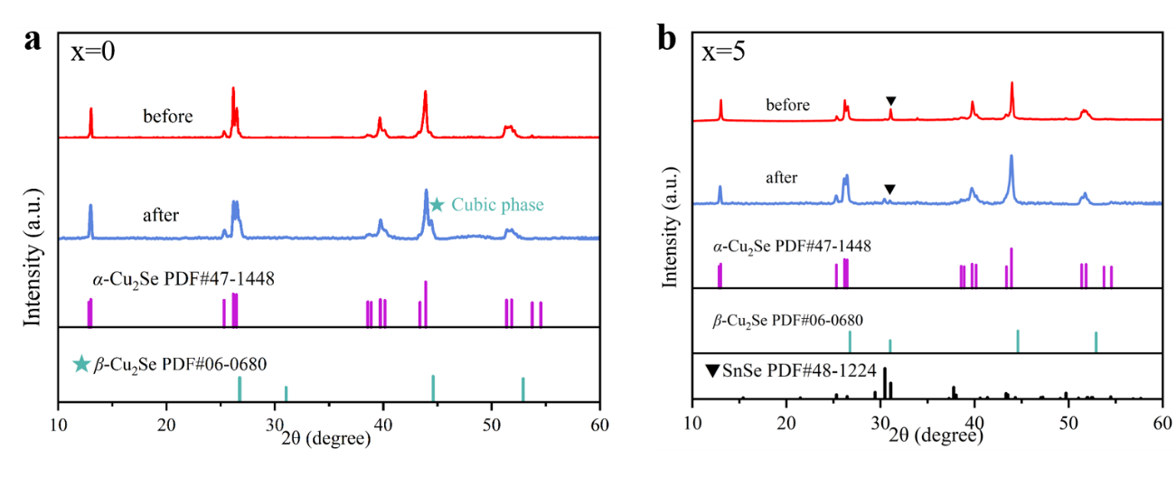

References:
1. Liu J, et al. Achieving high thermoelectric performance with Pb and Zn codoped polycrystalline SnSe via phase separation and nanostructuring strategies. Nano Energy 53, 683-689 (2018).
2. Medeiros PVC, Stafström S, Björk J. Effects of extrinsic and intrinsic perturbations on the electronic structure of graphene: Retaining an effective primitive cell band structure by band unfolding. Physical Review B 89, 041407 (2014).
3. Kresse G, Hafner J. Ab initio molecular dynamics for liquid metals. Physical Review B - Condensed Matter 47, 558-561 (1993).
4. Kresse G, Joubert D. From ultrasoft pseudopotentials to the projector augmented-wave method. Physical Review B 59, 1758-1775 (1998).
5. Hu H, et al. Highly stabilized and efficient thermoelectric copper selenide. Nat Mater 23, 527-534 (2024).
6. Yu J, et al. Interface‐Enhanced High‐Temperature Thermoelectricity in Cu1.99Se/B4C Composites with Synergistically Improved Mechanical Strength. Advanced Energy Materials 14, 2303942 (2024).
7. Olvera AA, et al. Partial indium solubility induces chemical stability and colossal thermoelectric figure of merit in Cu2Se. Energy & Environmental Science 10, 1668-1676 (2017).
8. Lei J, et al. High thermoelectric performance in Cu2Se superionic conductor with enhanced liquid-like behaviour by dispersing SiC. Journal of Materials Chemistry A 7, 7006-7014 (2019).
9. Nunna R, et al. Ultrahigh thermoelectric performance in Cu2Se-based hybrid materials with highly dispersed molecular CNTs. Energy & Environmental Science 10, 1928-1935 (2017).

