Supplementary tables

Table S1: Legacy MLST profiles of 11 novel sequence types
ST | aspA | glnA | gltA | glyA | pgm | tkt | uncA
14350 | 9 | 17 | 5 | 10 | 11 | 1164 | 3
14360 | 14 | 17 | 5 | 2 | 11 | 3 | 972
14365 | 188 | 313 | 876 | 2 | 89 | 5 | 6
14374 | 764 | 17 | 5 | 2 | 11 | 3 | 6
14388 | 765 | 34 | 27 | 33 | 1095 | 36 | 6
14396 | 2 | 55 | 2 | 3 | 2 | 1 | 5
14404 | 2 | 4 | 382 | 2 | 2 | 1 | 5
14407 | 4 | 7 | 10 | 4 | 90 | 7 | 1
14422 | 14 | 17 | 12 | 2 | 11 | 3 | 6
14423 | 9 | 17 | 52 | 10 | 10 | 3 | 5
14424 | 166 | 2 | 1 | 10 | 151 | 1 | 1

Table S2: 7-gene Sequence Types (ST) by source
 | Source
ST* | Infants | Siblings | Mothers | Chickens | Cattle | Goats | Sheep | Total
50 | 17 |  |  | 1 |  | 1 | 2 | 21
883 | 15 | 1 |  | 4 |  | 1 |  | 21
2042 | 18 |  |  |  |  | 2 |  | 20
19 | 8 | 2 |  | 7 |  | 1 |  | 18
849 | 7 |  | 3 | 6 |  |  |  | 16
2031 | 10 | 2 |  | 2 |  | 2 |  | 16
1038 | 4 | 2 |  | 5 | 2 | 1 |  | 14
305 | 8 |  |  | 3 | 1 | 1 |  | 13
362 | 10 |  |  | 2 |  |  |  | 12
1723 | 3 |  |  | 9 |  |  |  | 12
227 | 7 | 2 |  | 2 |  |  |  | 11
353 | 5 |  |  | 2 | 2 | 2 |  | 11
49 |  |  |  | 6 |  |  | 1 | 7
436 | 5 |  |  | 2 |  |  |  | 7
14423 | 6 |  |  | 1 |  |  |  | 7
1365 | 5 | 1 |  |  |  |  |  | 6
2100 | 1 |  |  | 5 |  |  |  | 6
2155 | 3 | 1 |  |  |  | 1 |  | 5
14365 | 1 |  |  | 2 | 1 |  | 1 | 5
14404 | 5 |  |  |  |  |  |  | 5
1751 | 4 |  |  |  |  |  |  | 4
3630 | 4 |  |  |  |  |  |  | 4
4624 | 4 |  |  |  |  |  |  | 4
10920 | 4 |  |  |  |  |  |  | 4
14424 | 4 |  |  |  |  |  |  | 4
403 |  | 3 |  |  |  |  |  | 3
824 | 3 |  |  |  |  |  |  | 3
14407 | 3 |  |  |  |  |  |  | 3
572 | 2 |  |  |  |  |  |  | 2
2304 |  | 2 |  |  |  |  |  | 2
5326 |  |  |  | 2 |  |  |  | 2
5596 | 2 |  |  |  |  |  |  | 2
14360 | 2 |  |  |  |  |  |  | 2
22 |  |  |  | 1 |  |  |  | 1
56 |  |  |  | 1 |  |  |  | 1
251 |  |  |  | 1 |  |  |  | 1
356 |  |  |  | 1 |  |  |  | 1
452 |  |  |  | 1 |  |  |  | 1
523 | 1 |  |  |  |  |  |  | 1
881 |  |  |  | 1 |  |  |  | 1
2109 |  |  |  | 1 |  |  |  | 1
3621 |  | 1 |  |  |  |  |  | 1
6839 | 1 |  |  |  |  |  |  | 1
14350 |  |  |  | 1 |  |  |  | 1
14374 |  |  |  | 1 |  |  |  | 1
14388 | 1 |  |  |  |  |  |  | 1
14396 | 1 |  |  |  |  |  |  | 1
14422 |  |  |  | 1 |  |  |  | 1
Total | 174 | 17 | 3 | 71 | 6 | 12 | 4 | 287
* Novel STs are highlighted in yellow

Table S3. PERMANOVA results
174 infant isolates
Level A | Kebele | Kebele | Ganda | Infant
Level B | Infant | Ganda | Infant | Sample
Sum of squares (%)
A | 13.7 | 13.7 | 58.2 | 67.5
Within A | 86.3* | 86.3• | 41.8 | 32.5
B in A | 53.8*** | 46.7*** | 9.3*** | 22.5**
Residual | 32.5 | 39.6 | 32.5 | 10.0***
•0.05≤p<0.10; *0.01≤p<0.05; **0.001≤p<0.01; ***p<0.001
Level A | Kebele | Kebele | Ganda | Infant
Level B | Infant | Ganda | Infant | Sample
p-values
Within A | 0.030* | 0.053• | 0.29 | 0.004**
B in A | 0*** | 0*** | 0*** | 0***

97 infant isolates
Level A | Kebele | Kebele | Ganda
Level B | Infant | Ganda | Infant
Sum of squares (%)
A | 13.2 | 13.2 | 57.5
Within A | 86.8• | 86.8• | 42.5
B in A | 53.1** | 46.8*** | 8.8
Residual | 33.7 | 40.0 | 33.7
•0.05≤p<0.10; *0.01≤p<0.05; **0.001≤p<0.01; ***p<0.001
Level A | Kebele | Kebele | Ganda
Level B | Infant | Ganda | Infant
p-values
Within A | 0.011• | 0.017• | 0.16
B in A | 0.008** | 9e-04** | 0.20

Table S4. Valid accuracies for the model selection and k-mer model construction steps. The algorithm with the highest accuracy used for model construction is marked in bold. The valid accuracy is then given for the model with the algorithm that gave the highest accuracy.
 | Model selection |  | Model construction
 | Average accuracy
Data set | Random forest | Logit boost | Selected algorithm | Valid accuracy (95% CI) | Kappa
Dataset 1 | 0.937 | 0.944 | Random forest | 0.903 (0.829-0.953) | 0.87
Dataset 2 | 0.943 | 0.944 | Random forest | 0.961 (0.89-0.992) | 0.941

Supplementary figures
Figure S1. Probability of each isolate from infants (n=233). Each bar represents one human case, with the height of the bar showing the probability of that case coming from a specific source.
- Asymmetric Island model

- PCO model

- k-mer model
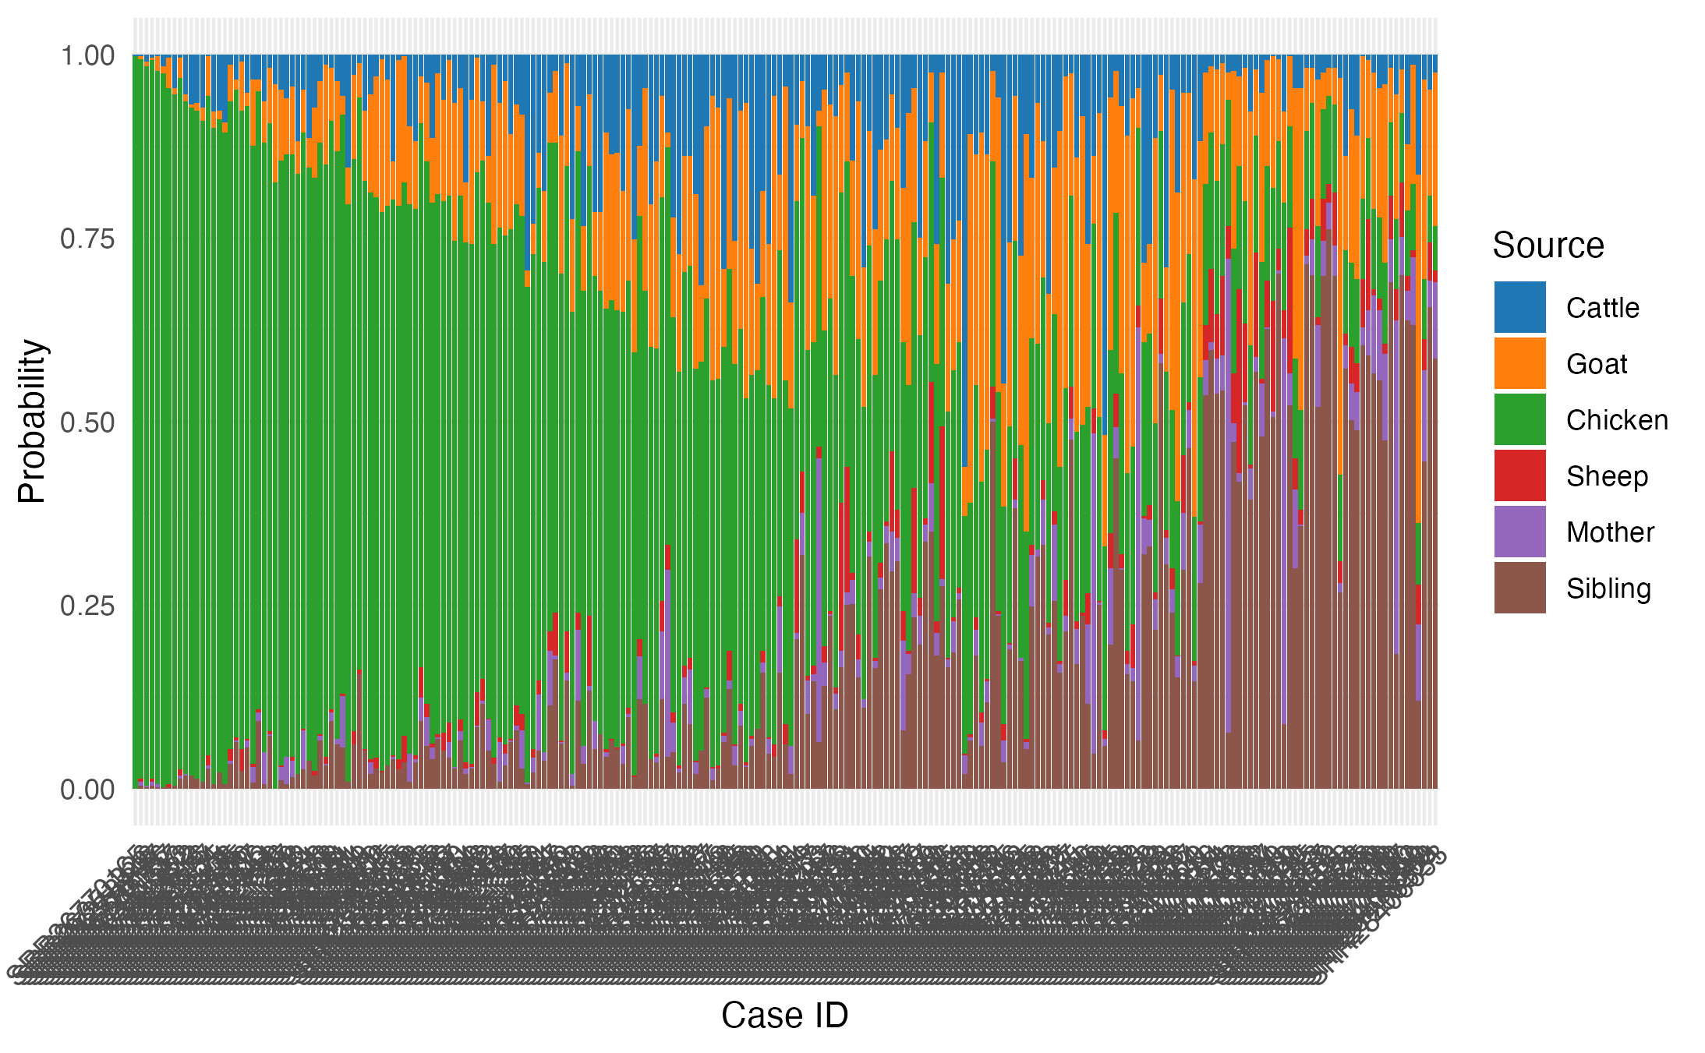
- Source sink model

