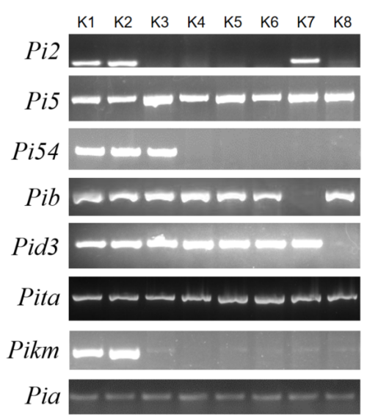

Figure S1. Electrophoresis analysis of amplified bands for selected molecular markers. Primer sequences, PCR amplification conditions, and expected band sizes are detailed in Table S3. Pi2 gene: Amplified using primers Pi2-F and Pi2-R. Pi5 gene: Amplified using primers Pi5-F1 and Pi5-R1. Pi54 gene: Amplified using primers Pi54-F1 and Pi54-R1. Pib gene: Amplified using primers Pib-F1 and Pib-R1. Pid3 gene: Amplified using primers Pid3-F1 and Pid3-R1. Pita gene: Amplified using primers Pita-F and Pita-R. Pikm gene: Amplified using primers Pikm/Pi1-F and Pikm/Pi1-R. Pia gene: Amplified using primers Pia-F and Pia-R.

