Supplementary Information

Platelets lead morphological, phenotypic and functional changes in tumor cells.

Alba Rodriguez-Martinez^{1,2}†, Iris Simon-Saez^{1,3}†, Sonia Perales^{1,3}, Carmen Garrido-Navas¹, Alessandro Russo⁴, Diego de Miguel-Perez⁴, Ignacio Puche-Sanz^{1,5}, Clara Alaminos⁶, Jorge Ceron^{1,3}, Jose A. Lorente^{1,2}, Massimo Cristofanilli⁷, Alba Ortigosa-Palomo¹, Pedro J. Real^{1,3,8}, Christian Rolfo*⁴, María J. Serrano*^{1,9,10}

Tables
Table S1. Primer sequences used for RT-qPCR in this study.

 | Forward Sequence (5´-3´) | Reverse Sequence (5´-3´)
VIMENTIN | CCAGGCAAAGCAGGAGTC | CGAAGGTGACGAGCCATT
SNAIL1 | GCTGCAGGACTCTAATCCAGA | ATCTCCGGAGGTGGGATG
SNAIL2 | TGGTTGCTTCAAGGACACAT | GCAAATGCTCTGTTGCAGTG
REX1 | CAGATCCTAAACAGCTCGCAGAAT | GCGTACGCAAATTAAAGTCCAGA
OCT4 | AGTGAGAGGCAACCTGGAGA | ACACTCGGACCACATCCTTC
NANOG | TGCAGTTCCAGCCAAATTCTC | CCTAGTGGTCTGCTGTATTACATTAAGG
GAPDH | TGCACCACCAACTGCTTAGC | GGCATGGACTGTGGTCATGAG

Figures
Fig. S1. Methods summary.
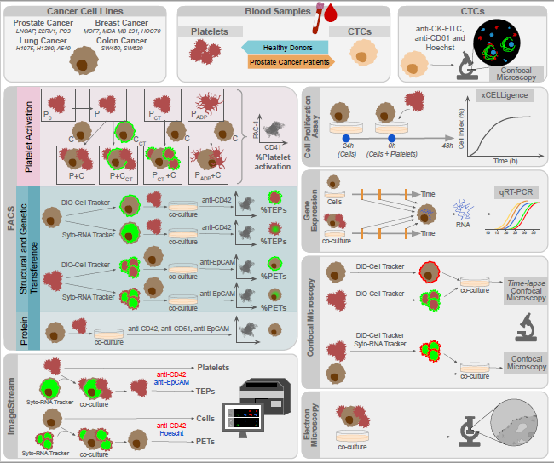
Fig. S2. Platelets and LNCAP prostate cancer cell line co-culture analysis gates. (A) Gates used for analysis of the platelets activation or (B) the transference of structural cell tracker from cells to platelets and (C) platelets to cells. All the gates were taken from a negative control.

Fig. S3. Platelet activation in co-culture models. (A) Platelet activation was presented as percentage (%) of PAC-1⁺ platelets. White bars showed platelets cultured alone: (P₀) resting platelets after isolation; after 24h in culture (P) untreated platelets, (P_{CT}) cell tracker-labeled platelets, (P_{ADP+T}) ADP+Thrombin-treated platelets. Black bars showed platelets after 24h co-culture with LNCAP cells: (P + C) platelets with unlabeled cells, (P + C_{CT}) platelets with cell tracker-labeled cells, (P_{CT} +C) cell tracker-labeled platelets with unlabeled cells, and (P_{ADP+T} + C) ADP+Thrombin-treated platelets with unlabeled cells. Data is presented as means ± SD. One-way ANOVA (Dunnett’s multiple comparisons test) were performed for all conditions vs control (P₀), (ns: no significant; * p<0.05; **p<0.01; ***p<0.001). (B) Transference of Lipids and RNA between resting or ADP+Trombin (ADP+T) platelets and LNCAP cells. Two-way ANOVA (Tukey’s multiple comparison test) A (*p<0.05, **p<0.01, ***p<0.001). TEPs: Tumor-educated platelets; PETs: Platelets-educated tumor cells.

A B
Fig. S4. Confocal Time Lapse of platelet and LNCAP co-culture. Platelets were labelled with DiO-cell tracker (green), cells with DiD-cell tracker (red) and DNA was stained with Hoechst (blue).

Fig. S5. ImageStream gallery of TEPS (A) and PETs (B).

A
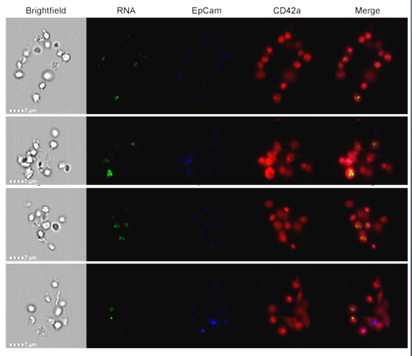
B
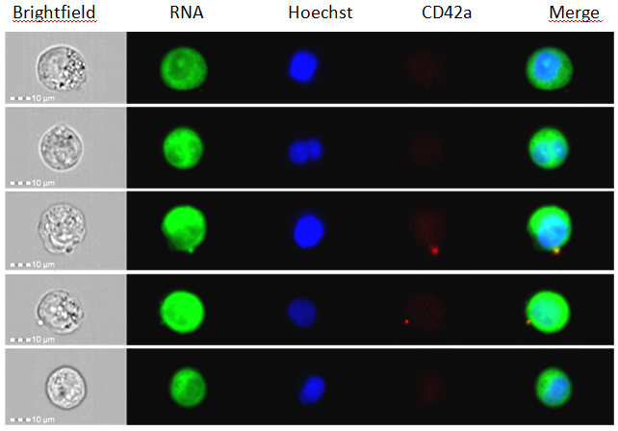

Fig. S6. Cell growth of cancer cell lines alone (black line) or in co-culture with platelets (grey line). Cell growth was measured during 72h, platelet addition is considered time 0. Impedance of cell cultured alone (C) at endpoint was considered 100% for normalization. Two-way (Sidak's multiple comparisons test) ANOVA for 24h and 48h of co-culture is shown (ns: no significant; *p<0.05; **p<0.01; ***p<0.001).

Fig. S7. Schematic overview of platelets and tumor cell interactions. Tight communication between platelets and tumor cells includes transference of biomolecules (lipids, nucleid acids and proteins), regulation of gene expression and increase of cell proliferation. After platelet interplay tumor cells show CD61, CD42 and platelet lipids in their membranes, moreover reduced EpCAM levels their surface and increase gene expression of stemness and EMT genes (OCT4, NANOG, VIMENTIN, SNAIL).

