Supplementary Material
Synthesis, structural diversity, and methanol vapor adsorption properties of three Hg(II) halide complexes derived from a helical Schiff base
Chao Huang, Tao Jiang, Ji-Hong Lu
(Key Laboratory of Macrocyclic and Supramolecular Chemistry of Guizhou Province, Guizhou University, Guiyang 550025, China)

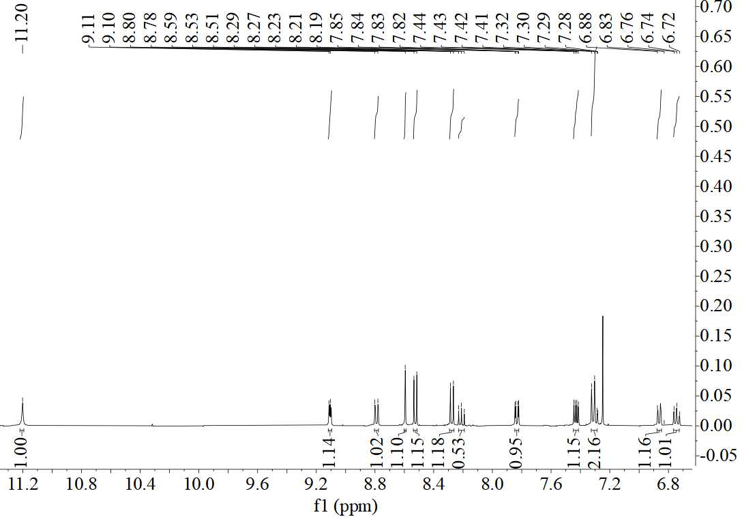
Fig. S1. ¹H NMR for ligand L

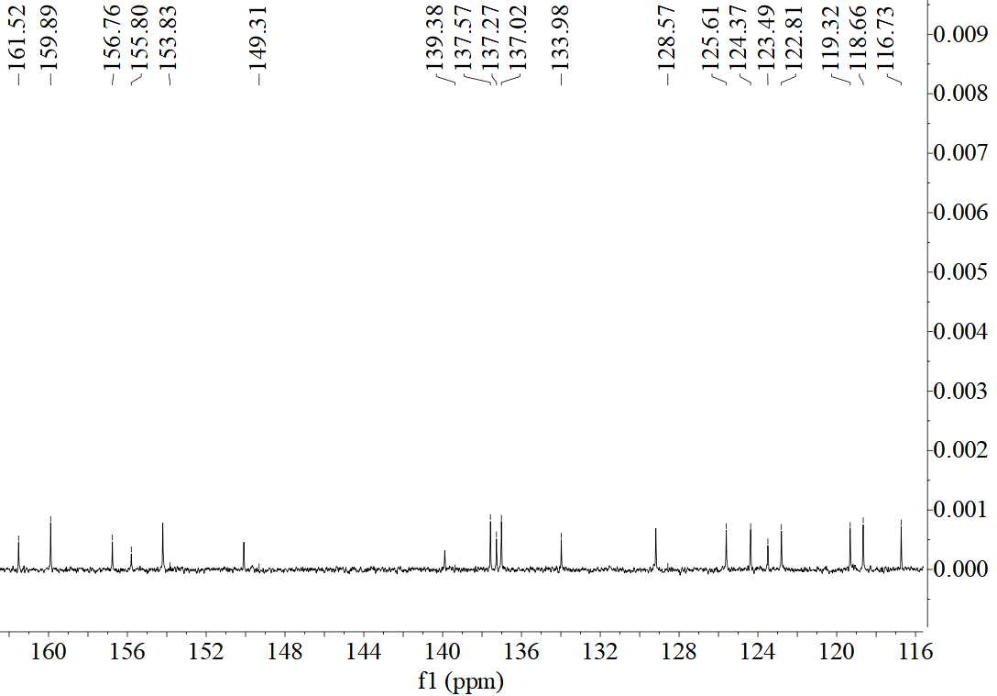
Fig. S2. ¹³C NMR for ligand L
Fig. S3. IR spectra for ligand L
Fig. S4. IR spectra for complex 1
Fig. S5. IR spectra for complex 2
Fig. S6. IR spectra for complex 3

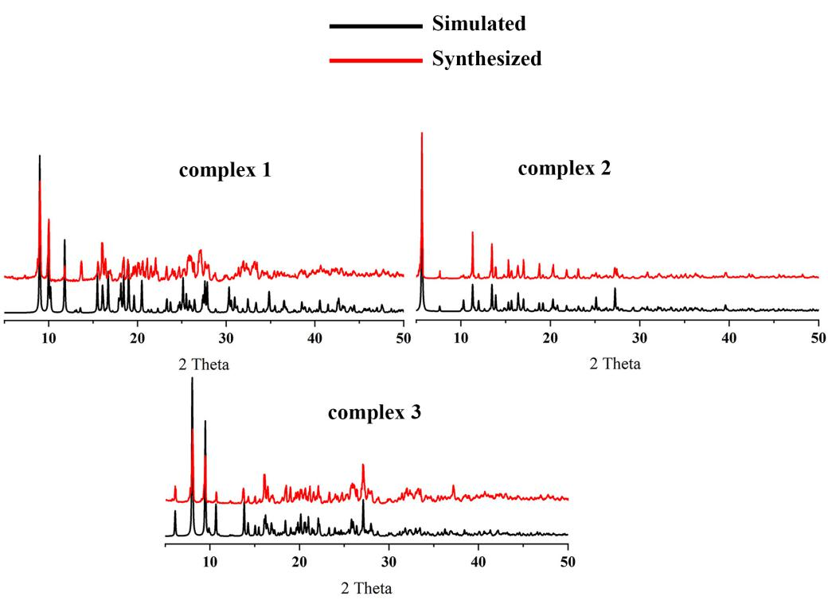
Fig. S7. PXRD patterns: synthesized and simulated from the single-crystal diffraction data

Table S1. Selected bond lengths (Å) and angles (°) for complexes 1−3
Complex 1
Hg1−N1 | 2.512(5) | Hg1−I1 | 2.612(7) | Hg1−I2 | 2.635(6)
I1−Hg1−I2 | 147.56(2) | N1−Hg1−I2 | 104.79(12) | N1−Hg1−I1 | 97.76(12)
Complex 2
Hg1−Br1 | 2.525(8) | Hg1−Br2 | 2.966(9) | Hg1−Br3 | 2.551(8)
Hg1−N1 | 2.282(5) | Hg2−Br2 | 2.671(8) | Hg2−Br3 | 2.840(8)
Hg2−Br4 | 2.539(8) | Hg2−N9 | 2.324(5)
Br1−Hg1−Br2 | 101.97(12) | Br1−Hg1−Br3 | 99.09(14) | Br3−Hg1−Br2 | 121.40(3)
N1−Hg1−Br1 | 148.16(12) | N1−Hg1−Br2 | 88.58(12) | N1−Hg1−Br3 | 73.46(13)
Br2−Hg2−Br3 | 90.44(2) | Br4−Hg2−Br3 | 112.15(3) | Br4−Hg2−Br2 | 125.34(3)
N9−Hg2−Br2 | 134.40(12) | N9−Hg2−Br3 | 96.56(13) | N9−Hg2−Br4 | 93.30(12)
Hg1−Br3−Hg2 | 91.97(2) | Hg2−Br2−Hg1 | 88.76(2)
Complex 3
Hg1−Cl1 | 2.379(3) | Hg1−Cl2 | 2.402(2) | Hg1−N1 | 2.428(6)
Hg1−N8 | 2.650(6)
Cl1−Hg1−Cl2 | 152.04(9) | Cl1−Hg1−N8 | 91.86(16) | Cl1−Hg1−N1 | 99.82(17)
Cl2−Hg1−N1 | 102.37(17) | Cl2−Hg1−N8 | 90.33(15) | N1−Hg1−N8 | 122.7(2)

Table S2. Hydrogen bonding distances (Å) and angles (°) for complexes 1−3
 | D−H⋅⋅⋅A | D−H (Å) | H⋅⋅⋅A (Å) | D⋅⋅⋅A (Å) | ∠DHA (°)
Complex 1 | C3−H3⋅⋅⋅O1 | 0.93 | 2.23 | 3.103(11) | 111
 | C14−H14⋅⋅⋅O1 | 0.93 | 2.41 | 2.973(13) | 113
Complex 2 | C3−H3⋅⋅⋅O2 | 0.93 | 2.49 | 3.345(8) | 153
 | C14−H14⋅⋅⋅O1 | 0.93 | 2.30 | 2.898(9) | 122
 | C24−H24⋅⋅⋅O2 | 0.93 | 2.37 | 2.937(8) | 119
 | C35−H35⋅⋅⋅O1 | 0.93 | 2.38 | 3.224(10) | 151
Complex 3 | C1−H1⋅⋅⋅N9 | 0.93 | 2.61 | 3.380(11) | 140
 | C3−H3⋅⋅⋅O1 | 0.93 | 2.46 | 3.178(11) | 135
 | C14−H14⋅⋅⋅O2 | 0.93 | 2.41 | 2.985(12) | 120
 | C24−H24⋅⋅⋅O1 | 0.93 | 2.33 | 2.914(12) | 121

