Table S1: Full BLAST results for sequences containing LOV domains from Diamante Lake
A | B | C | D | E | F | G | H | I | J | K | L | M | Specie | Family | Order | Class | Phylum
Ga0151614_1001628 | ERH10939.1 | 69.173 | 665 | 199 | 4 | 1 | 661 | 4 | 666 | 0.0 | 902 | 80.00 | halophilic archaeon J07HX64 | haloarchaea |  | Halobacteria | Euryarchaeotas
Ga0151614_100435 | MCQ4332159.1 | 66.722 | 607 | 147 | 3 | 1 | 561 | 1 | 598 | 0.0 | 791 | 76.44 | Natronomonas sp. F2-12 | halobacteriaceae | halobacteriales | Halobacteria | Euryarchaeotas
Ga0151614_102304 | MBP1923895.1 | 93.817 | 469 | 29 | 0 | 1 | 469 | 1 | 469 | 0.0 | 895 | 96.59 | Halorubrum alkaliphilum | halorubraceae | haloferacales | Halobacteria | Euryarchaeotas
Ga0151614_102516 | CCQ35503.1 | 76.558 | 674 | 156 | 2 | 1 | 673 | 1 | 673 | 0.0 | 1018 | 86.94 | Natronomonas moolapensis 8.8.11 | halobacteriaceae | halobacteriales | Halobacteria | Euryarchaeotas
Ga0151614_103558 | CCQ36406.1 | 67.203 | 497 | 163 | 0 | 14 | 510 | 142 | 638 | 0.0 | 615 | 78.07 | Natronomonas moolapensis 8.8.11 | halobacteriaceae | halobacteriales | Halobacteria | Euryarchaeotas
Ga0151614_104473 | MBP1922255.1 | 86.482 | 614 | 83 | 0 | 1 | 614 | 1 | 614 | 0.0 | 1074 | 92.02 | Halorubrum alkaliphilum | halorubraceae | haloferacales | Halobacteria | Euryarchaeotas
Ga0151614_104652 | CCQ35503.1 | 76.374 | 673 | 158 | 1 | 1 | 672 | 1 | 673 | 0.0 | 1028 | 86.92 | Natronomonas moolapensis 8.8.11 | halobacteriaceae | halobacteriales | Halobacteria | Euryarchaeotas
Ga0151614_105846 | SEO10489.1 | 44.654 | 477 | 259 | 3 | 184 | 659 | 255 | 727 | 1.97e-122 | 386 | 62.05 | Halorientalis persicus | haloarculaceae | halobacteriales | Halobacteria | Euryarchaeotas
Ga0151614_106091 | QAU14528.1 | 72.293 | 628 | 155 | 7 | 233 | 851 | 352 | 969 | 0.0 | 845 | 80.57 | Halorubrum sp. BOL3-1 | halorubraceae | haloferacales | Halobacteria | Euryarchaeotas
Ga0151614_107813 | MXR40423.1 | 72.886 | 402 | 109 | 0 | 11 | 412 | 11 | 412 | 0.0 | 621 | 86.57 | Halobaculum saliterrae | halorubraceae | haloferacales | Halobacteria | Euryarchaeotas
Ga0151614_110912 | MCL9817540.1 | 69.204 | 578 | 178 | 0 | 1 | 578 | 1 | 578 | 0.0 | 846 | 83.39 | Natronocalculus amylovorans | halorubraceae | haloferacales | Halobacteria | Euryarchaeotas
Ga0151614_115602 | OYR46193.1 | 69.020 | 510 | 138 | 6 | 4 | 497 | 16 | 521 | 0.0 | 688 | 79.61 | Halorubrum sp. Eb13 | halorubraceae | haloferacales | Halobacteria | Euryarchaeotas
Ga0151614_115812 | SIS18214.1 | 47.577 | 454 | 224 | 7 | 1 | 449 | 284 | 728 | 1.89e-125 | 387 | 63.22 | Natronorubrum thiooxidans | natrialbaceae | haloferacales | Halobacteria | Euryarchaeotas
Ga0151614_121681 | OYR39992.1 | 81.709 | 667 | 117 | 2 | 1 | 666 | 5 | 667 | 0.0 | 1099 | 89.51 | Halorubrum sp. Hd13 | halorubraceae | haloferacales | Halobacteria | Euryarchaeotas
Ga0151614_128332 | EMA66818.1 | 69.146 | 363 | 101 | 3 | 1 | 354 | 1 | 361 | 1.38e-171 | 494 | 79.61 | Halorubrum aidingense JCM 13560 | halorubraceae | haloferacales | Halobacteria | Euryarchaeotas
Ga0151614_143841 | QDX39520.1 | 32.072 | 555 | 324 | 10 | 30 | 540 | 634 | 1179 | 2.36e-83 | 290 | 52.07 | Salarchaeum sp. JOR-1 | halobacteriaceae | halobacteriales | Halobacteria | Euryarchaeotas
Ga0151614_148921 | MXV61616.1 | 54.034 | 533 | 245 | 0 | 1 | 533 | 177 | 709 | 0.0 | 624 | 75.80 | Natronorubrum halalkaliphilum | natrialbaceae | natrialbales | Halobacteria | Euryarchaeotas
Ga0151614_149972 | AUX08044.1 | 69.951 | 406 | 120 | 1 | 49 | 454 | 716 | 1119 | 0.0 | 558 | 81.03 | Halalkaliarchaeum desulfuricum | halorubraceae | haloferacales | Halobacteria | Euryarchaeotas
Ga0151614_151402 | MBX0302787.1 | 65.789 | 228 | 77 | 1 | 1 | 227 | 528 | 755 | 2.83e-98 | 308 | 79.39 | Halomicroarcula salinisoli | haloarculaceae | halobacteriales | Halobacteria | Euryarchaeotas
Ga0151614_154601 | SDY91998.1 | 67.195 | 442 | 145 | 0 | 3 | 444 | 7 | 448 | 0.0 | 653 | 83.71 | Halopenitus persicus | halorubraceae | haloferacales | Halobacteria | Euryarchaeotas
Ga0151614_159301 | TKX80159.1 | 82.783 | 424 | 72 | 1 | 1 | 423 | 42 | 465 | 0.0 | 714 | 91.04 | Halorubrum sp. SD626R | halorubraceae | haloferacales | Halobacteria | Euryarchaeotas
Ga0151614_173151 | PHQ40447.1 | 47.475 | 396 | 180 | 5 | 4 | 395 | 226 | 597 | 3.14e-115 | 354 | 65.91 | Halorubrum persicum | halorubraceae | haloferacales | Halobacteria | Euryarchaeotas
Ga0151614_178101 | TQQ81405.1 | 69.211 | 380 | 117 | 0 | 3 | 382 | 118 | 497 | 0.0 | 566 | 84.21 | Halonotius roseus | halorubraceae | haloferacales | Halobacteria | Euryarchaeotas
Ga0151614_181511 | AUX09055.1 | 56.410 | 156 | 67 | 1 | 12 | 166 | 197 | 352 | 5.52e-48 | 171 | 71.15 | Halalkaliarchaeum desulfuricum | halorubraceae | haloferacales | Halobacteria | Euryarchaeotas
Ga0151614_183521 | EMA57890.1 | 78.299 | 341 | 72 | 2 | 2 | 340 | 280 | 620 | 0.0 | 533 | 86.80 | Halorubrum lipolyticum DSM 21995 | halorubraceae | haloferacales | Halobacteria | Euryarchaeotas
Ga0151614_185661 | RJX44793.1 | 84.488 | 361 | 55 | 1 | 1 | 360 | 72 | 432 | 0.0 | 624 | 89.75 | Halonotius aquaticus | halorubraceae | haloferacales | Halobacteria | Euryarchaeotas
Ga0151614_189351 | MCQ4332159.1 | 71.633 | 349 | 92 | 1 | 1 | 349 | 124 | 465 | 6.98e-177 | 509 | 83.67 | Natronomonas sp. F2-12 | halobacteriaceae | halobacteriales | Halobacteria | Euryarchaeotas
Ga0151614_194791 | QGX93785.1 | 76.190 | 336 | 80 | 0 | 1 | 336 | 112 | 447 | 0.0 | 538 | 89.58 | Haloplanus rallus | haloferaceae | haloferacales | Halobacteria | Euryarchaeotas
# Fields: A: query accession ver, B: subject accession ver, C: % identity, D: alignment length, E: mismatches, F: gap opens, G: query start, H: query end,
I: subject start, J: subject end, K: evalue, L: bit score, M: % positives

Table S2: Gene product names for LOV domain containing ORFs in Diamante Lake Red biofilms metagenome
Gene ID | Gene Product Name
3300011121 assembled Ga0151614_178101 | Bacteriophytochrome (light-regulated signal transduction histidine kinase)/GAF domain-containing protein
3300011121 assembled Ga0151614_102516 | hypothetical protein
3300011121 assembled Ga0151614_104652 | hypothetical protein
3300011121 assembled Ga0151614_102304 | PAS domain-containing protein
3300011121 assembled Ga0151614_143841 | PAS domain-containing protein
3300011121 assembled Ga0151614_128332 | PAS domain-containing protein
3300011121 assembled Ga0151614_181511 | PAS domain-containing protein
3300011121 assembled Ga0151614_189351 | PAS domain-containing protein/Bacteriophytochrome (light-regulated signal transduction histidine kinase)
3300011121 assembled Ga0151614_159301 | PAS domain-containing protein/DNA-binding response regulator, NarL/FixJ family, contains REC and HTH domains
3300011121 assembled Ga0151614_148921 | PAS domain-containing protein/K+-sensing histidine kinase KdpD
3300011121 assembled Ga0151614_151402 | PAS domain-containing protein/PAS domain-containing protein
3300011121 assembled Ga0151614_107813 | PAS domain-containing protein/PAS domain-containing protein
3300011121 assembled Ga0151614_154601 | PAS domain-containing protein/PAS domain-containing protein
3300011121 assembled Ga0151614_115812 | PAS domain-containing protein/PAS domain-containing protein/K+-sensing histidine kinase KdpD
3300011121 assembled Ga0151614_194791 | PAS domain-containing protein/PAS domain-containing protein/PAS domain-containing protein
3300011121 assembled Ga0151614_185661 | PAS domain-containing protein/PAS domain-containing protein/PAS domain-containing protein
3300011121 assembled Ga0151614_103558 | PAS domain-containing protein/Signal transduction histidine kinase
3300011121 assembled Ga0151614_100435 | PAS domain-containing protein/Signal transduction histidine kinase/DNA-binding transcriptional response regulator, NtrC family, contains REC, AAA-type ATPase, and a Fis-type DNA-binding domains/Bacteriophytochrome (light-regulated signal transduction histidine kinase)
3300011121 assembled Ga0151614_106091 | PAS domain-containing protein/Signal transduction histidine kinase/PAS domain-containing protein
3300011121 assembled Ga0151614_121681 | Predicted DNA binding protein, contains HTH domain/PAS domain-containing protein
3300011121 assembled Ga0151614_1001628 | Predicted DNA binding protein, contains HTH domain/PAS domain-containing protein
3300011121 assembled Ga0151614_173151 | Signal transduction histidine kinase
3300011121 assembled Ga0151614_183521 | Signal transduction histidine kinase
3300011121 assembled Ga0151614_110912 | Signal transduction histidine kinase
3300011121 assembled Ga0151614_115602 | Signal transduction histidine kinase
3300011121 assembled Ga0151614_104473 | Signal transduction histidine kinase/DNA-binding transcriptional response regulator, NtrC family, contains REC, AAA-type ATPase, and a Fis-type DNA-binding domains
3300011121 assembled Ga0151614_149972 | Signal transduction histidine kinase/PAS domain-containing protein
3300011121 assembled Ga0151614_105846 | Signal transduction histidine kinase/PAS domain-containing protein/PAS domain-containing protein

Table S3: Salt bridges as calculated via RING4.0 for ALovD-1, DL6091 and DL0912 (modeled PDBs), YtvA (2MWG) and VVD (3RH8). To make comparable calculations, each PDB was modified, and only 120 residues from the LOV core were left, excluding A´α and most of the J α in all structures.
ALovD-1
NodeId1 | NodeId2 | Distance | Angle | Positive
A:20:_:ASP^{a,b} | A:47:_:ARG | 3.546 | 105.699 | A:47:_:ARG
A:28:_:ASP^{a,b} | A:38:_:LYS | 2.733 | 72.461 | A:38:_:LYS
A:40:_:GLU^{a,b} | A:81:_:LYS | 2.660 | 101.752 | A:81:_:LYS
A:61:_:GLU^{b} | A:64:_:LYS | 2.800 | 33.545 | A:64:_:LYS
A:64:_:LYS^{b} | A:70:_:GLU | 3.087 | 73.974 | A:64:_:LYS
A:69:_:GLU^{b} | A:96:_:ARG | 3.402 | 78.996 | A:96:_:ARG
A:77:_:ARG^{b} | A:114:_:GLU | 3.476 | 96.902 | A:77:_:ARG
A:75:_:GLUª | A:115:_:ARG | 3.896 | 114.687 | A:118:_:ARG
A:89:_:ARG^{a,b} | A:110:_:GLU | 3.802 | 26.511 | A:89:_:ARG
A:116:_:LYS^{b} | A:119:_:GLU | 2.708 | 47.971 | A:116:_:LYS
YtvA
A:85:_:LYS | A:112:_:GLU | 3.674 | 106.325 | A:85:_:LYS
VVD
A:57:_:ARG | A:144:_:GLU | 3.720 | 128.846 | A:57:_:ARG
A:77:_:ASP | A:176:_:ARG | 3.739 | 43.411 | A:176:_:ARG
A:82:_:ASP | A:109:_:ARG | 3.701 | 114.064 | A:109:_:ARG
A:102:_:GLU | A:154:_:LYS | 3.117 | 89.045 | A:154:_:LYS
A:153:_:LYS | A:184:_:GLU | 3.297 | 99.762 | A:153:_:LYS
DL6091
A:33:_:ASP | A:60:_:ARG | 3.491 | 115.648 | A:60:_:ARG
A:41:_:ASP | A:51:_:ARG | 3.531 | 67.845 | A:51:_:ARG
A:45:_:GLU | A:93:_:ARG | 3.668 | 77.374 | A:93:_:ARG
A:53:_:GLU | A:94:_:LYS | 2.775 | 137.192 | A:94:_:LYS
A:70:_:GLU | A:73:_:LYS | 3.061 | 28.548 | A:73:_:LYS
A:73:_:LYS | A:77:_:GLU | 2.803 | 46.382 | A:73:_:LYS
A:76:_:ARG | A:80:_:ASP | 3.498 | 61.206 | A:76:_:ARG
A:82:_:GLU | A:109:_:ARG | 3.375 | 120.324 | A:109:_:ARG
A:88:_:GLU | A:129:_:ARG | 3.384 | 69.874 | A:129:_:ARG
A:90:_:ARG | A:98:_:GLU | 3.344 | 62.559 | A:90:_:ARG
DL0912
A:41:_:GLU | A:83:_:ARG | 3.419 | 120.759 | A:83:_:ARG
A:48:_:ASP | A:58:_:ARG | 3.470 | 75.557 | A:58:_:ARG
A:60:_:GLU | A:101:_:LYS | 2.626 | 105.126 | A:101:_:LYS
A:77:_:GLU | A:81:_:ARG | 3.503 | 39.886 | A:81:_:ARG
A:95:_:GLU | A:136:_:LYS | 3.788 | 91.687 | A:136:_:LYS
A:130:_:GLU | A:136:_:LYS | 3.719 | 103.949 | A:136:_:LYS

Table S4. Surface exposed residues (≥10%) for ALovD-1, DL-6091 and DL-0912 (modeled PDBs), YtvA (PDB: 2MWG) and VVD (PDB:3RH8) were calculated via SwissPDBViewer.

 | ALovD-1 |  | DL6091 |  | DL0912 |  | YtvA |  | VVD
Residue | Number | % | Number | % | Number | % | Number | % | Number | %
Ala (A) | 5 | 5.7 | 3 | 3.5 | 5 | 5.6 | 2 | 2.2 | 4 | 4.3
Arg (R) | 9 | 10.3 | 10 | 11.6 | 12 | 13.3 | 2 | 2.2 | 7 | 7.6
Asn (N) | 3 | 3.4 | 6 | 7.0 | 1 | 1.1 | 6 | 6.7 | 7 | 7.6
Asp (D) | 9 | 10.3 | 9 | 10.5 | 12 | 13.3 | 9 | 10.1 | 6 | 6.5
Cys (C) | 0 | 0.0 | 1 | 1.2 | 1 | 1.1 | 0 | 0.0 | 1 | 1.1
Gln (Q) | 5 | 5.7 | 6 | 7.0 | 2 | 2.2 | 7 | 7.9 | 5 | 5.4
Glu (E) | 11 | 12.6 | 15 | 17.4 | 12 | 13.3 | 12 | 13.5 | 8 | 8.7
Gly (G) | 8 | 9.2 | 5 | 5.8 | 6 | 6.7 | 5 | 5.6 | 8 | 8.7
His (H) | 0 | 0.0 | 0 | 0.0 | 2 | 2.2 | 1 | 1.1 | 0 | 0.0
Ile (I) | 5 | 5.7 | 7 | 8.1 | 5 | 5.6 | 3 | 3.4 | 1 | 1.1
Leu (L) | 2 | 2.3 | 1 | 1.2 | 3 | 3.3 | 5 | 5.6 | 5 | 5.4
Lys (K) | 4 | 4.6 | 3 | 3.5 | 2 | 2.2 | 9 | 10.1 | 8 | 8.7
Met (M) | 0 | 0.0 | 1 | 1.2 | 3 | 3.3 | 3 | 3.4 | 3 | 3.3
Phe (F) | 2 | 2.3 | 2 | 2.3 | 3 | 3.3 | 2 | 2.2 | 1 | 1.1
Pro (P) | 7 | 8.0 | 4 | 4.7 | 3 | 3.3 | 5 | 5.6 | 7 | 7.6
Ser (S) | 2 | 2.3 | 1 | 1.2 | 8 | 8.9 | 1 | 1.1 | 3 | 3.3
Thr (T) | 7 | 8.0 | 3 | 3.5 | 3 | 3.3 | 6 | 6.7 | 7 | 7.6
Trp (W) | 1 | 1.1 | 1 | 1.2 | 1 | 1.1 | 1 | 1.1 | 0 | 0.0
Tyr (Y) | 4 | 4.6 | 3 | 3.5 | 2 | 2.2 | 5 | 5.6 | 6 | 6.5
Val (V) | 3 | 3.4 | 5 | 5.8 | 4 | 4.4 | 5 | 5.6 | 4 | 4.3

Table S5: Solvent Accessible Surface Area as calculated using GetArea (1)

Protein | Residue | Total | Apolar | Backbone | Sidechain | Ratio(%) | In/Out
WT | TYR 30 | 0 | 0 | 0 | 0 | 0 | i
 | TYR 36 | 33.17 | 10.80 | 0.00 | 33.17 | 17.2 | i
 | CYS 46 | 33.76 | 23.66 | 2.12 | 31.64 | 30.9
 | TYR 48 | 50.19 | 35.94 | 26.92 | 23.27 | 12.1 | i
Y48F | TYR 30 | 0 | 0 | 0 | 0 | 0 | i
 | TYR 36 | 36.12 | 13.50 | 0.57 | 35.56 | 18.4 | i
 | CYS 46 | 35.36 | 25.93 | 2.50 | 32.86 | 32.1
 | PHE 48 | 41.00 | 26.32 | 26.92 | 14.08 | 7.8 | i
Y30F | PHE 30 | 0 | 0 | 0 | 0 | 0 | i
 | TYR 36 | 31.22 | 10.01 | 0.00 | 31.22 | 16.2 | i
 | CYS 46 | 34.54 | 23.66 | 2.67 | 31.87 | 31.2
 | TYR 48 | 46.76 | 33.03 | 25.65 | 21.10 | 10.9 | i

Figure S1: Full alignment of 27 LOV domain only sequences from Lake Diamante metagenome
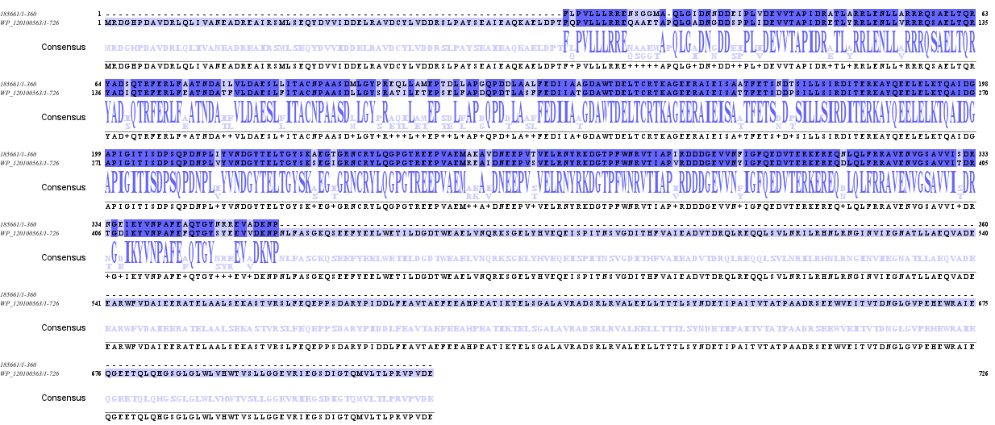
Figure S2: A. Domain architecture for Ga0151614_185661 (incomplete contig) with protein accession WP_120100563 from Halonotius aquaticus annotated as a PAS domain S-box protein. B. Alignment of Ga0151614_185661 with WP_120100563.
A
B

Figure S3: ALovD-1, DL6091, DL0912 models and B. subtilis YtvA structure (2MWG) showing spatial position of the FMN cofactor and potential ionic bridges.

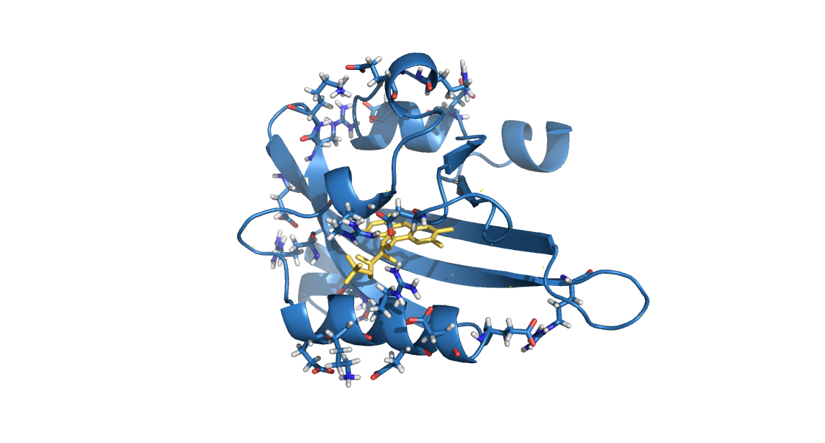
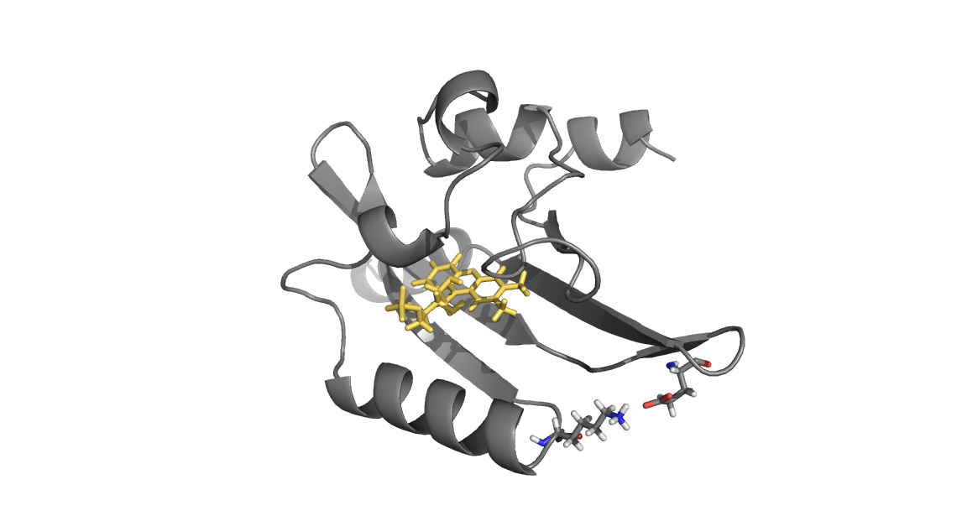
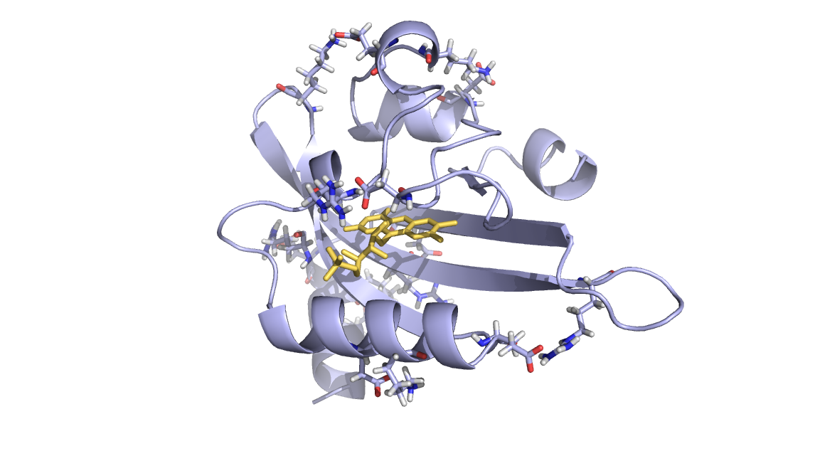
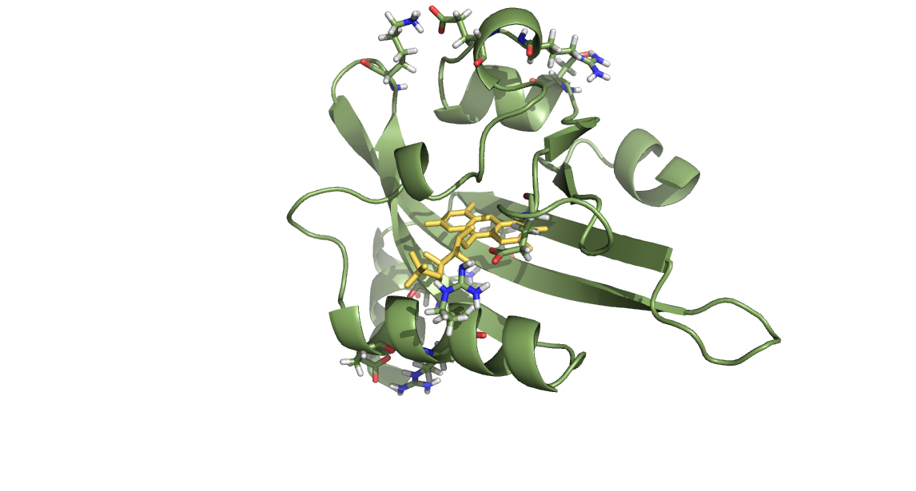
DL-6091
YtvA
ALovD-1
DL-0912
Figure S4: A. Open reading frame (ORF) of alovd-1 gen expressed as fusion with His-tag in C-terminal, for wild type protein and mutants Y30F and Y48F. B. SDS-PAGE with final purification for the three products in PBS buffer. C. Averaged absorbance spectra for ALovD-1 WT in PBS 0.5 M NaCl (grey); for ALovD-1 WT in PBS 0.5 M NaCl heated at 95°C (pink), and for ALovD-1 WT in PBS 0.5 M NaCl heated at 95°C with HCl added (cyan). D. Averaged fluorescence emission spectra (excitation at 450 nm) for ALovD-1 in same conditions as describe in C (same color codes as well). After the heating, the flavin is released, increasing the intensity of the emission and the shift to longer wavelengths of the maximum. When HCl is added to the free flavin, the loss of intensity evidences that the flavin is FMN.
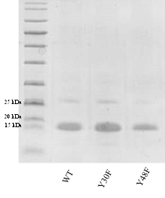
1
66
67
133
A
B
D
C
ALovD-1 WT
ALovD-1 Y30F
ALovD-1 Y48F
Figure S5: Normalized fluorescence emission spectra of ALovD-1446 (λ_{exc}= 295 nm) in PBS with 0.5 M of chloride salt: 0.5 M NaCl (full back line), 0.5 M KCl (back dashed line), 3 M NaCl (full red line) and 3 M KCl (dashed red line). Arrow indicates hypsochromic shift at high salt concentration.

Figure S6: Kinetic profile of ALovD-1₃₉₀ formation, followed at 446 nm by two sequential series of exposure to blue light (blue double arrows) and then recovery in the dark (back double arrows). Illumination was performed using a Royal Blue Led (443 ± 20) nm, at 15° C in PBS with 0.5 M NaCl, pH 8. Mono-exponential fit of the photodepletion of the dark-adapted state (yellow lines) resulted in a τ_{LOV390.}

Figure S7: Steady state fluorescence anisotropy of ALovD-1 (open blue circles) and FMN (open black squares) registered in PBS, together with the respective normalized emission spectra.

Figure S8: Interactions between Y36-Y48-Y30 triad in ALovD-1 and mutants Y30F and Y48F. Determined using RING 4.0. Dashed lines in orange: ππ stalk; in green: π-cation; in grey: Van der Waals (VDW) and in blue: H-bond. Table listing nodes of interactions, type of interaction, level (SC: side chain, MC: main chain), distance (Å) and residue acting as cation.

Figure S9: Fluorescence emission intensity changes on time for Y48F mutant obtained by excitation at 450 nm at different salt concentration: 0.5 M (black symbols) and 3 M (red symbols).

1. Robert Fraczkiewicz, Werner Braun. Exact and efficient analytical calculation of the accessible surface areas and their gradients for macromolecules. J Comp Chem. 1998;19(3):319–33.

