Exploring the Potential of Machine Learning in Gastric Cancer: Prognostic Biomarkers, Subtyping, and Stratification

Haniyeh Rafiepoor^{1ǂ}, Mohammad M. Banoei^{2,3ǂ}, Alireza Ghorbankhanloo¹, Ahad Muhammadnejad¹, Amirhossein Razavirad^{1,4} , Saeed Soleymanjahi⁵, Saeid Amanpour^{1*}

¹Cancer Biology Research Center, Cancer Institute, Tehran University of Medical Sciences, Tehran, Iran.
²Department of Critical Care Medicine, University of Calgary, Alberta, Canada. mmbanoei@ucalgary.ca.
³Department of Biological Science, University of Calgary, Alberta, Canada.
⁴Cancer Research Center, Cancer Institute, Tehran University of Medical Sciences, Tehran, Iran,
⁵Department of Internal Medicine, Department of Digital Health, Yale School of Medicine, New Haven, CT, USA.

ǂ Equally contributed to this manuscript as co-first authors.
Corresponding author: Saeid Amanpour^{1*}

Variables |  | Frequency | Percent (%)
Sex | Male  Female | 109  31 | 78  22
Grade | 1  2  3 | 26  51  63 | 18.4  36.9  44.7
pT | T0  T1  T2  T3  T4 | 2  2  21  39  76 | 1.4  1.4  14.9  28.4  53.9
pN | N0  N1  N2  N3 | 43  27  30  40 | 30.5  19.1  21.3  29.1
Stage | I  II  III | 22  41  77 | 15.6  29.1  55.3
Tumor site | Proximal  Distal  Total | 60  69  11 | 43.3  48.9  7.8
Tumor histology | Intestinal type  Mix  Diffuse | 89  25  26 | 63.8  17.7  18.4
Surgical margin | No  Yes | 83  57 | 58.9  41.1
Vascular invasion | No  Yes | 46  94 | 32.6  67.4
Perineural invasion | No  Yes | 61  79 | 43.3  56.7
Her2 | 0  1  2  3 | 36  36  30  37 | 25.71  26.43  21.43  26.43
Vimentin | 0  1  2  3  4  5  6 | 23  10  28  34  19  23  2 | 16.43  7.14  20.71  24.29  13.57  16.43  1.43
Cox-2 | 0  1  2  3  4  5  6  7 | 17  11  42  23  28  8  8  2 | 12.14  7.86  30.71  16.43  20.00  5.71  5.71  1.43
MMP-7 | 0  1  2  3  4  5  6 | 21  12  54  14  29  7  2 | 15.00  9.29  38.57  10.00  20.71  5.00  1.43
Ki-67 | 15.91 ± 6.30
P53 | 11.05 ± 10.06
CD34 | 29.47 ± 9.73
Type of surgery | Partial  Total | 43  97 | 30.5  69.5

Supplementary Table E1. Distribution of patients’ demographics, histological and paraclinical biomarkers among patients with gastric cancer.
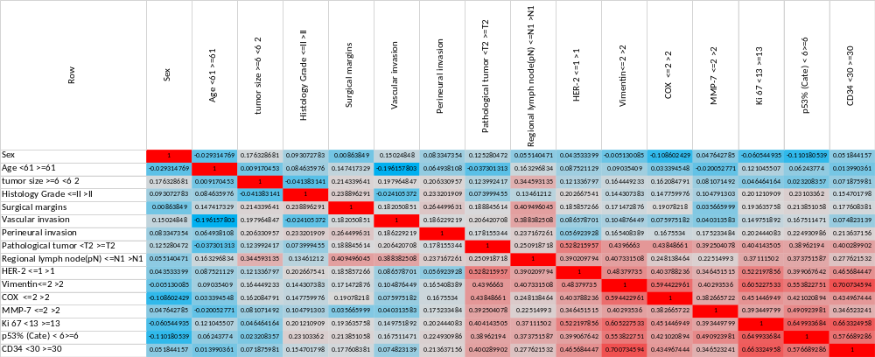
Supplementary Table E2. PCA correlations among the variables. Red color shows the higher correlation and blue shows the lower correlation.
Model Screening 18-months Mortality (Training group)-A

Method | N | Entropy R Square | Misclassification Rate | AUC | Sen. | Spe. | RASE | Generalized R Square
XGBoost | 93 | 0.728 | 0.086 | 0.975 | 93 | 92 | 0.232 | 0.847
Boosted Tree | 93 | 0.685 | 0.086 | 0.965 | 89 | 89 | 0.250 | 0.817
Support Vector Machines | 93 | 0.680 | 0.086 | 0.961 | 91 | 91 | 0.253 | 0.814
Nominal Logistic | 93 | 0.667 | 0.096 | 0.960 | 89 | 89 | 0.264 | 0.804
Fit Stepwise | 93 | 0.662 | 0.107 | 0.961 |  |  | 0.267 | 0.800
Decision Tree | 93 | 0.658 | 0.086 | 0.957 | 89 | 82 | 0.264 | 0.797
Neural Boosted | 93 | 0.649 | 0.096 | 0.961 | 91 | 88 | 0.264 | 0.791
Bootstrap Forest | 93 | 0.646 | 0.107 | 0.964 | 87 | 89 | 0.265 | 0.788
Generalized Regression Lasso | 93 | 0.646 | 0.107 | 0.961 | 87 | 89 | 0.268 | 0.788
K Nearest Neighbors | 93 | 0.452 | 0.172 | . | 91 | 73 | . | .
Naive Bayes | 93 | 0.216 | 0.118 | 0.940 | 89 | 76 | 0.318 | 0.345

Model Screening 18-months Mortality (Validation group)-B

Method | N | Entropy R Square | Misclassification Rate | AUC | Sen. | Spe. | RASE | Generalized R Square
Neural Boosted | 48 | 0.379 | 0.187 | 0.896 | 93 | 91 | 0.370 | 0.540
Support Vector Machines | 48 | 0.293 | 0.229 | 0.882 | 86 | 86 | 0.402 | 0.440
Boosted Tree | 48 | 0.236 | 0.270 | 0.868 | 86 | 86 | 0.418 | 0.367
Bootstrap Forest | 48 | 0.224 | 0.291 | 0.841 | 86 | 91 | 0.422 | 0.352
Generalized Regression Lasso | 48 | 0.221 | 0.291 | 0.867 | 86 | 91 | 0.428 | 0.348
Fit Stepwise | 48 | 0.200 | 0.291 | 0.874 |  |  | 0.427 | 0.319
Nominal Logistic | 48 | 0.109 | 0.312 | 0.851 | 86 | 86 | 0.439 | 0.185
Decision Tree | 48 | 0.091 | 0.333 | 0.841 | 93 | 91 | 0.465 | 0.156
K Nearest Neighbors | 48 | 0.065 | 0.229 | . | 100 | 82 | . | .
XGBoost | 48 | -0.014 | 0.291 | 0.820 | 86 | 91 | 0.472 | -0.025
Naive Bayes | 48 | -0.436 | 0.229 | 0.862 | 93 | 78 | 0.468 | -1.078

Model Screening 24-months Mortality (Training group)-C

Method | N | Entropy R Square | Misclassification Rate | AUC | Sen. | Spe. | RASE | Generalized R Square
Nominal Logistic | 93 | 1.000 | 0.000 | 1.000 | 95 | 96 | 4 e-8 | 1.000
Fit Stepwise | 93 | 0.976 | 0.010 | 0.999 |  |  | 0.073 | 0.988
Boosted Tree | 93 | 0.915 | 0.010 | 1.000 | 95 | 100 | 0.105 | 0.956
XGBoost | 93 | 0.913 | 0.010 | 0.999 | 95 | 100 | 0.109 | 0.955
Support Vector Machines | 93 | 0.897 | 0.032 | 0.998 | 95 | 96 | 0.125 | 0.946
Generalized Regression Lasso | 93 | 0.839 | 0.021 | 0.998 | 94 | 100 | 0.154 | 0.912
Decision Tree | 93 | 0.796 | 0.064 | 0.985 | 92 | 86 | 0.200 | 0.885
Naive Bayes | 93 | 0.793 | 0.032 | 0.996 | 93 | 96 | 0.169 | 0.884
Bootstrap Forest | 93 | 0.792 | 0.032 | 0.997 | 95 | 96 | 0.180 | 0.883
Neural Boosted | 93 | 0.772 | 0.021 | 0.999 | 97 | 100 | 0.195 | 0.870
K Nearest Neighbors | 93 | 0.706 | 0.053 | . | 91 | 81 | . | .

Model Screening 24-months Mortality (Validation group)-D

Method | N | Entropy R Square | Misclassification Rate | AUC | Sen. | Spe. | RASE | Generalized R Square
Neural Boosted | 48 | 0.645 | 0.083 | 0.9579 | 100 | 100 | 0.237 | 0.754
Generalized Regression Lasso | 48 | 0.513 | 0.062 | 0.9579 | 100 | 92 | 0.262 | 0.638
Boosted Tree | 48 | 0.468 | 0.062 | 0.9579 | 96 | 84 | 0.250 | 0.594
K Nearest Neighbors | 48 | 0.467 | 0.062 | . | 96 | 100 | . | .
XGBoost | 48 | 0.466 | 0.062 | 0.9579 | 96 | 84 | 0.253 | 0.603
Bootstrap Forest | 48 | 0.445 | 0.083 | 0.9553 | 96 | 92 | 0.282 | 0.571
Support Vector Machines | 48 | 0.437 | 0.083 | 0.9526 | 96 | 92 | 0.266 | 0.563
Fit Stepwise | 48 | 0.348 | 0.062 | 0.9605 |  |  | 0.253 | 0.468
Decision Tree | 48 | 0.196 | 0.083 | 0.9316 | 92 | 84 | 0.337 | 0.284
Nominal Logistic | 48 | 0.084 | 0.104 | 0.9026 | 100 | 84 | 0.309 | 0.129
Naive Bayes | 48 | -0.348 | 0.104 | 0.9474 | 96 | 100 | 0.298 | -0.667

Supplementary Table E3 A-D. Model screening of prediction mortality of gastric cancer patients shows a high AUC and specificity for most ML-based methods such as support vector machine (SVM), neural boosted (NB) and K Nearest Neighbors (KNN).

Model Screening TNM staging (Training group)

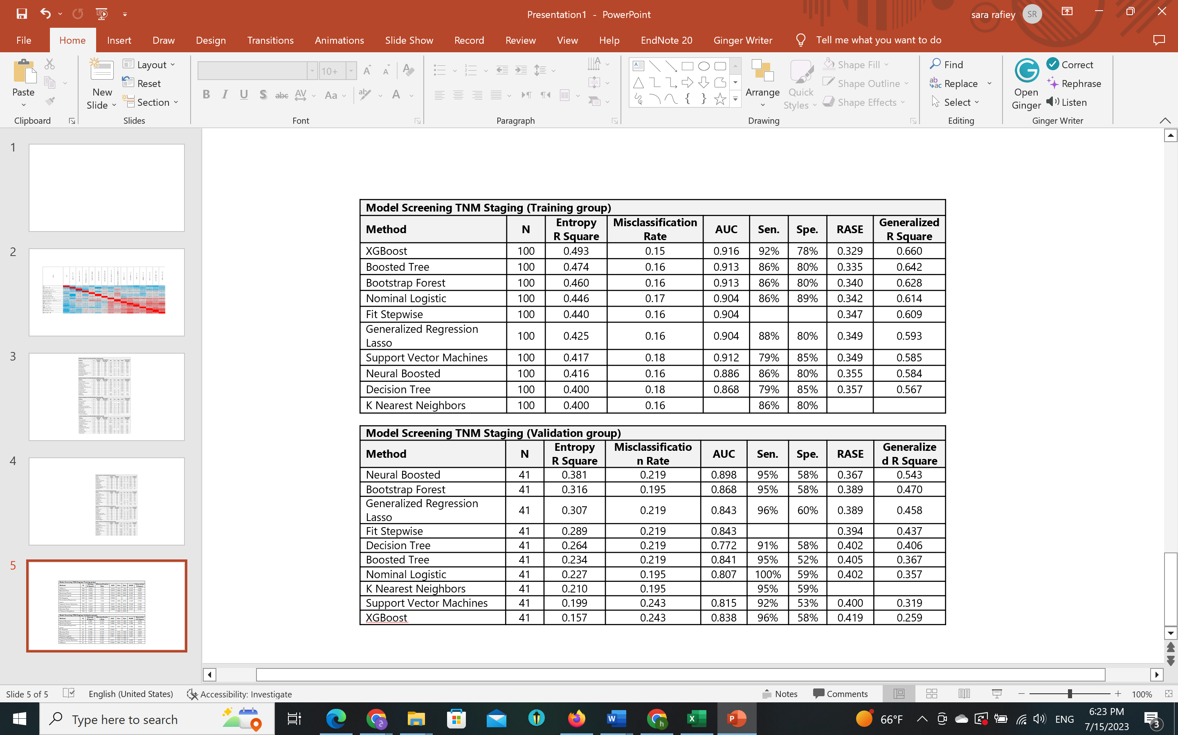
Model Screening TNM staging (Validation group)

Supplementary Table E4. Model screening of prediction TNM staging of gastric cancer patients shows a high AUC and specificity for most ML-based methods such as support vector machine (SVM), neural boosted (NB) and K Nearest Neighbors (KNN)

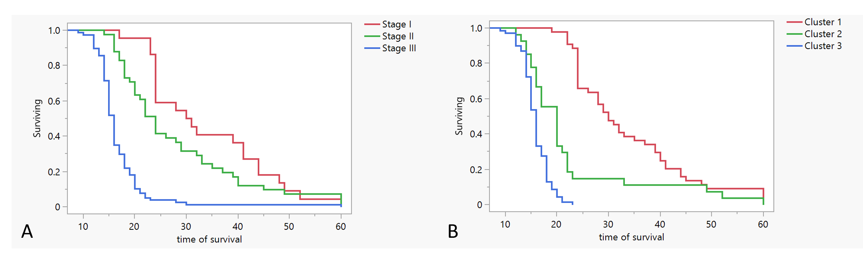
Supplementary Figure E1. Kaplan-Meier survival curve of GC patients for (A) TNM staging and (B) clustering methods

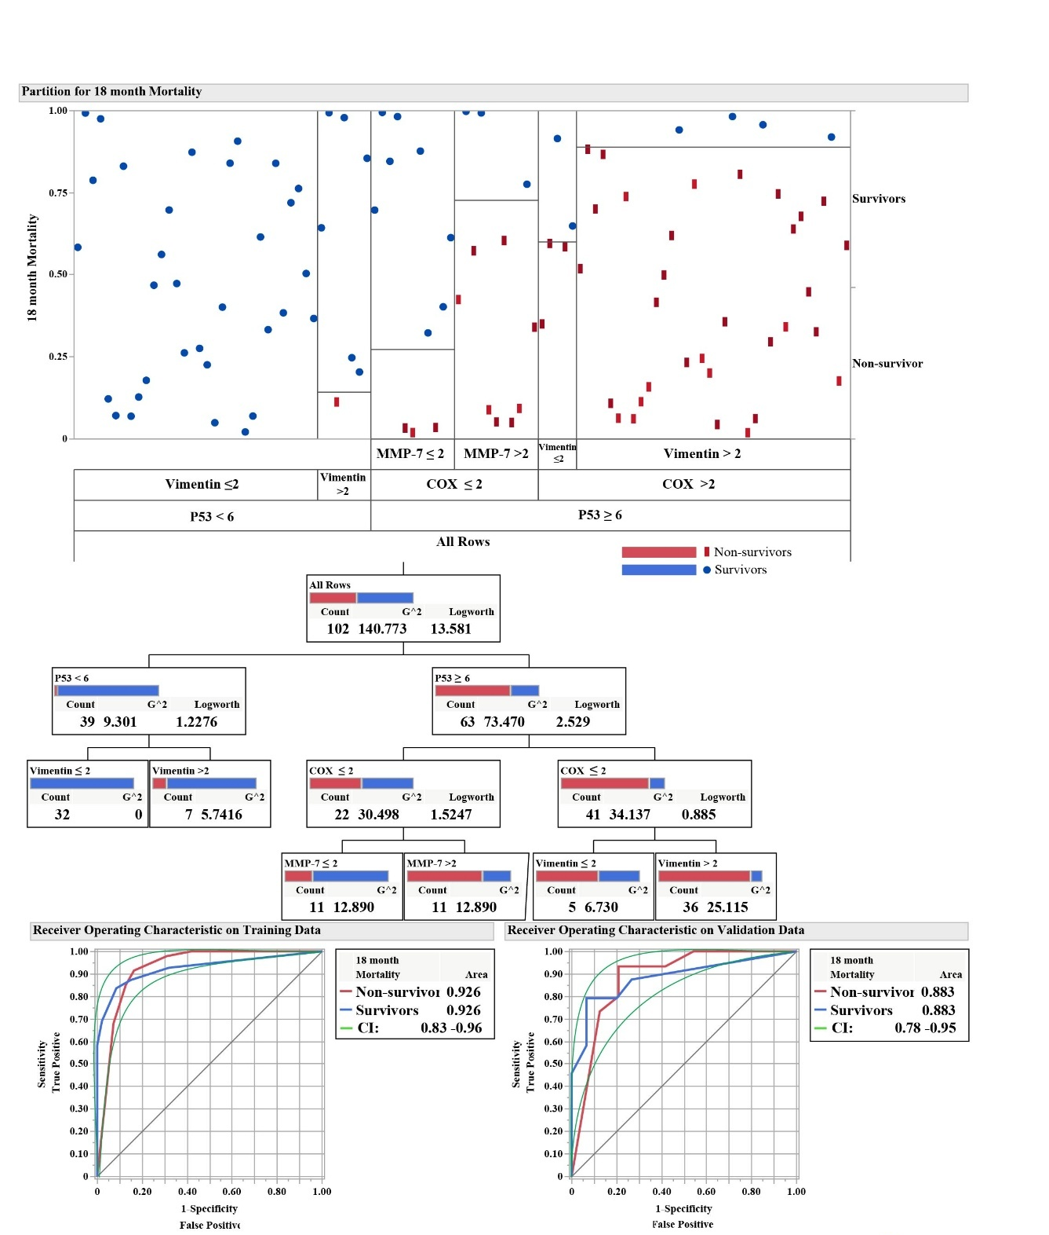
Supplementary Figure E2. Predictive partition analysis shows the most differentiating markers predicting mortality in 18-month.
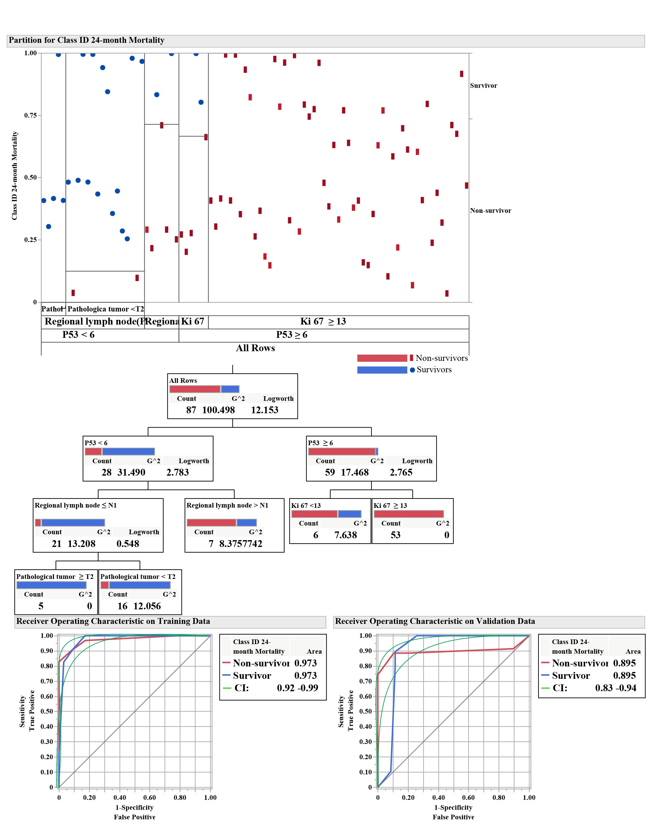
Supplementary Figure E3. Predictive partition analysis shows the most differentiating markers predicting mortality in 24-month
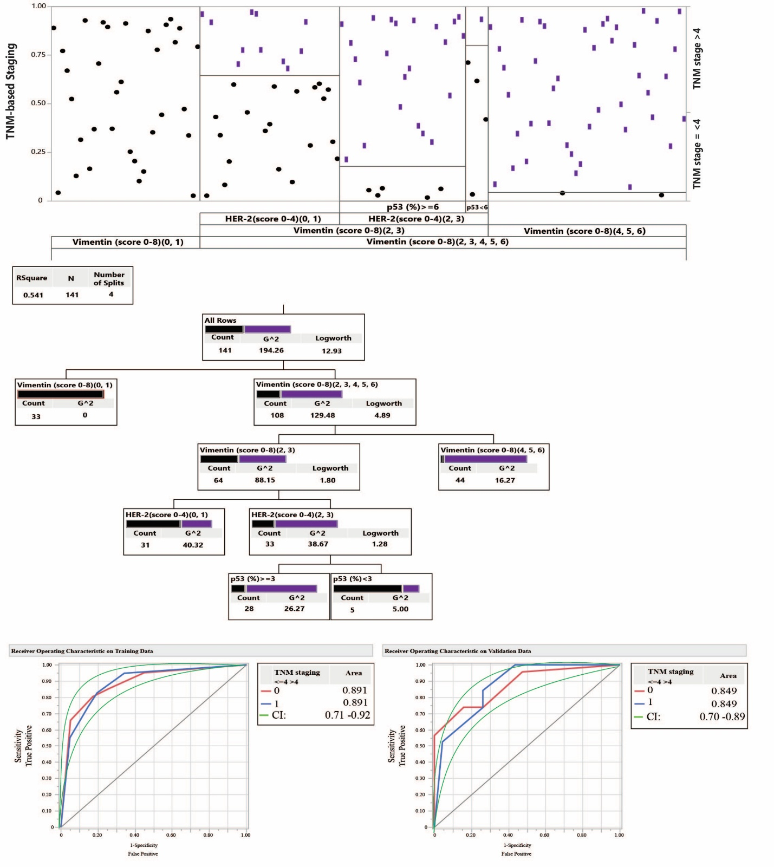
Supplementary Figure E4. Predictive partition analysis shows the most differentiating markers predicting TNM staging.

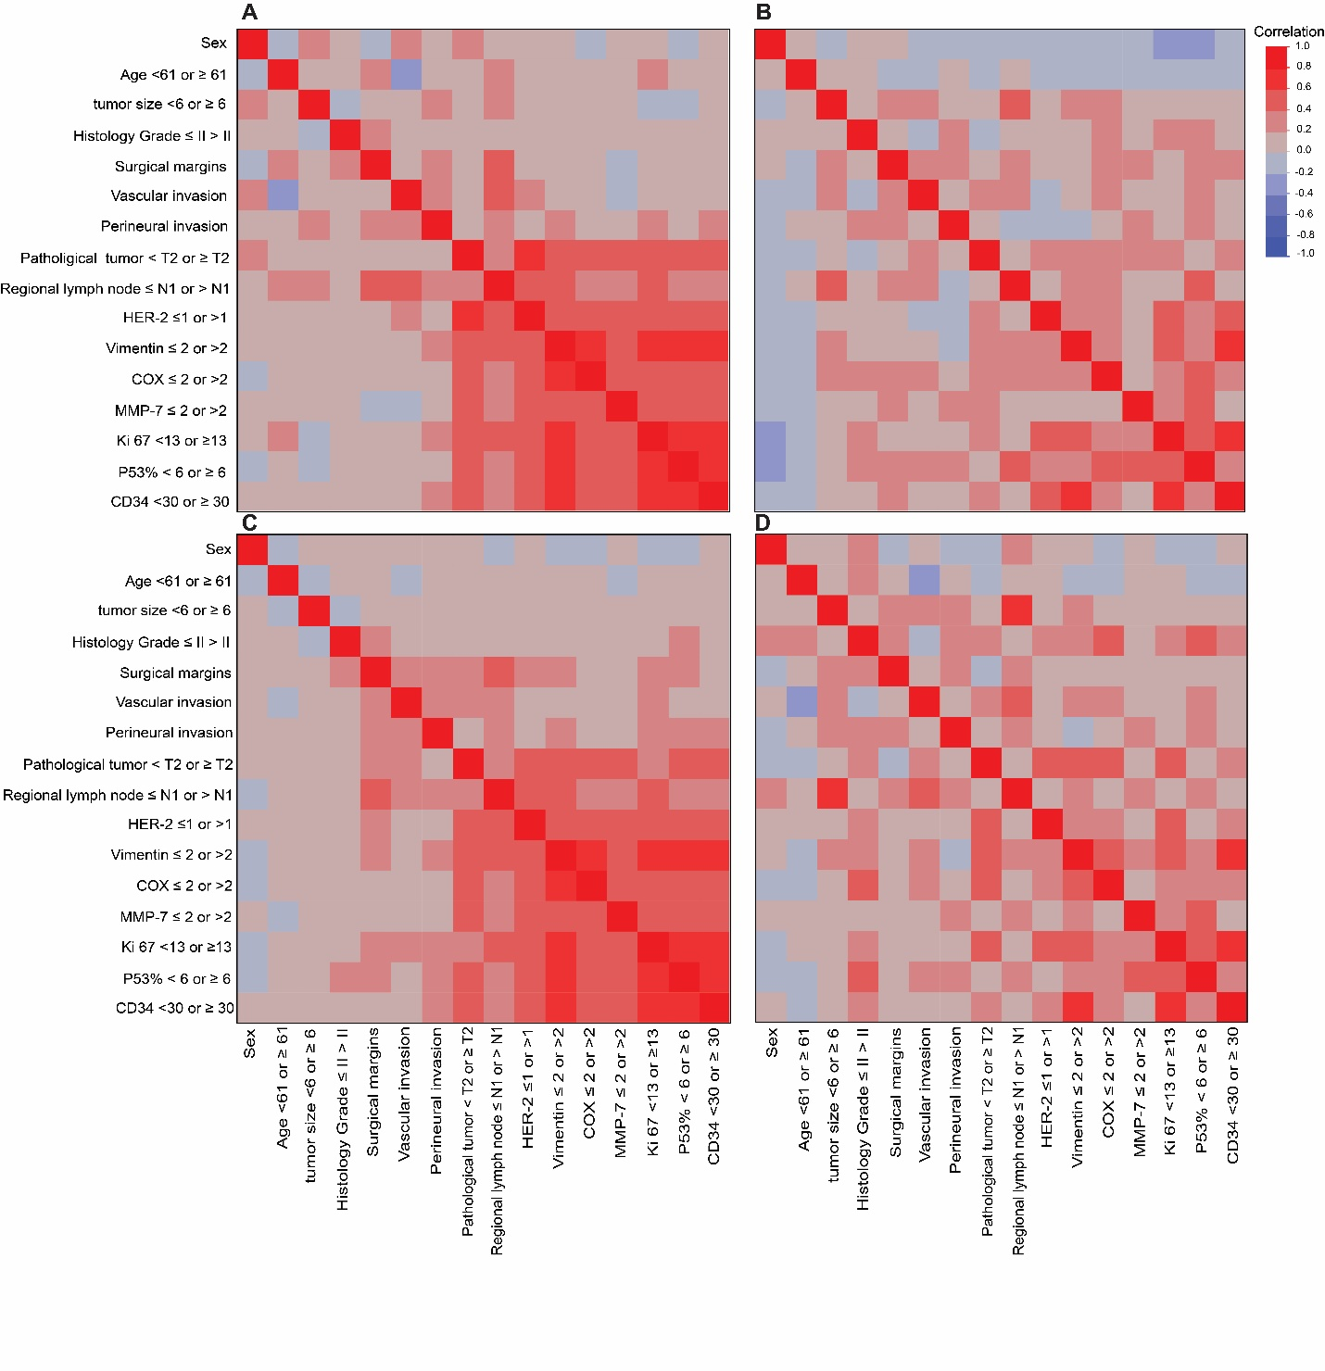

Supplementary Figure E5. Multivariate correlation heat map indicating a different pattern between cardia (A) and non-cardia (B), intestinal (C) and non-intestinal (D) types of gastric cancer.

