Supplementary Information
Nanoscale size effects in α-FAPbI3 evinced by large-scale ab initio simulations
Virginia Carnevali,†,‡ Lorenzo Agosta,†,‡ Vladislav Slama,† Nikolaos Lempesis,†
Andrea Vezzosi,† and Ursula Rothlisberger∗,†
†Laboratory of Computational Chemistry and Biochemistry,Institute of Chemical Sciences and Engineering, Swiss Federal Institute of Technology (EPFL), Lausanne, Switzerland
‡these authors contributed equally to this work
E-mail: ursula.roethlisberger@epfl.ch

FA 3-fold symmetry

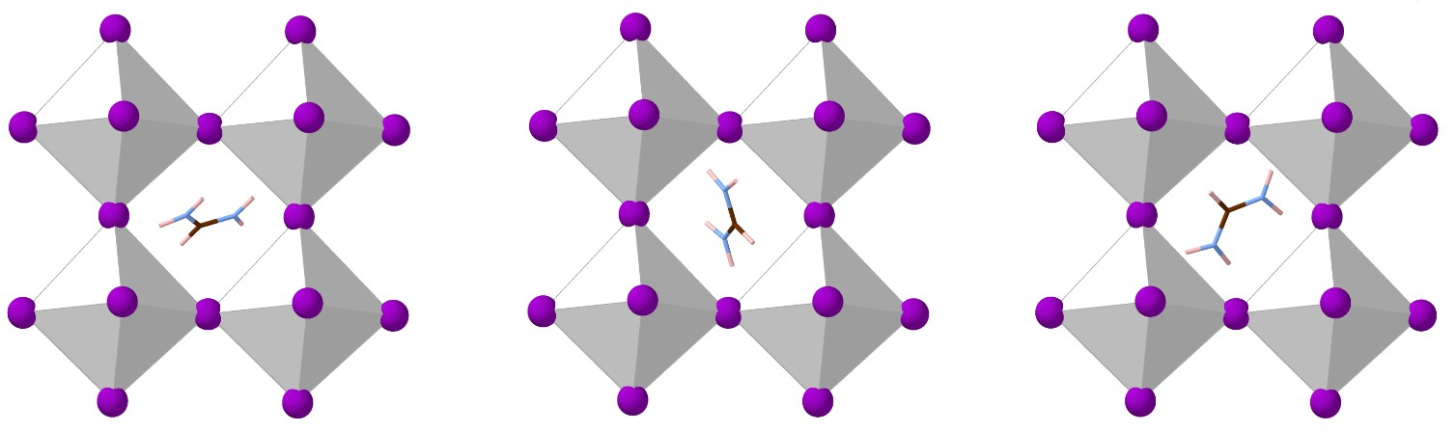
Figure 1: Orientations of the FA molecule satisfy the 3-fold symmetry within the PbI₆ cage. I, Pb, C, N, and H are shown in violet, white octahedra, brown, lightblue, and pink, respectively.

Octahedra tilting
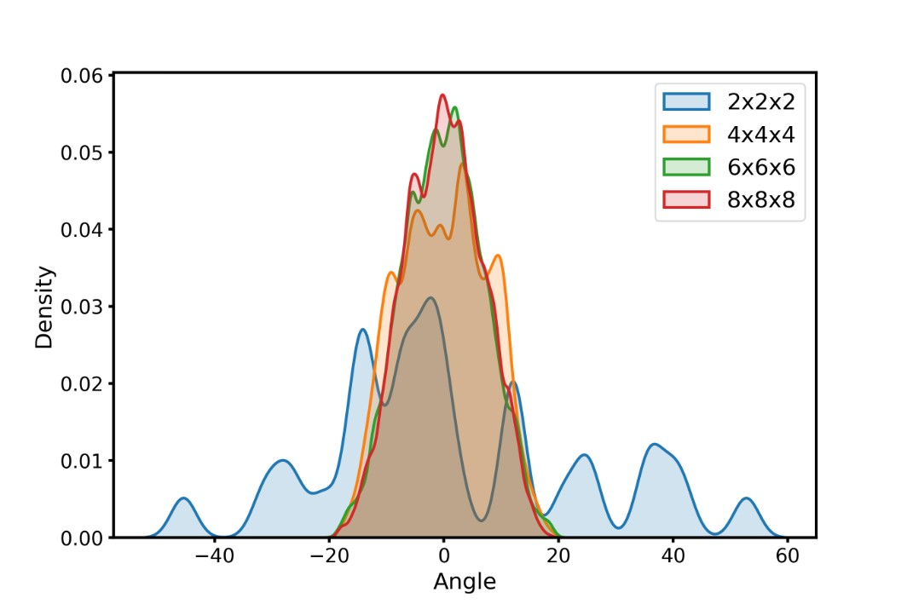
Figure 2: Distributions of the octahedra tilting angles for the different supercells optimized from a pseudo-random FA configuration.
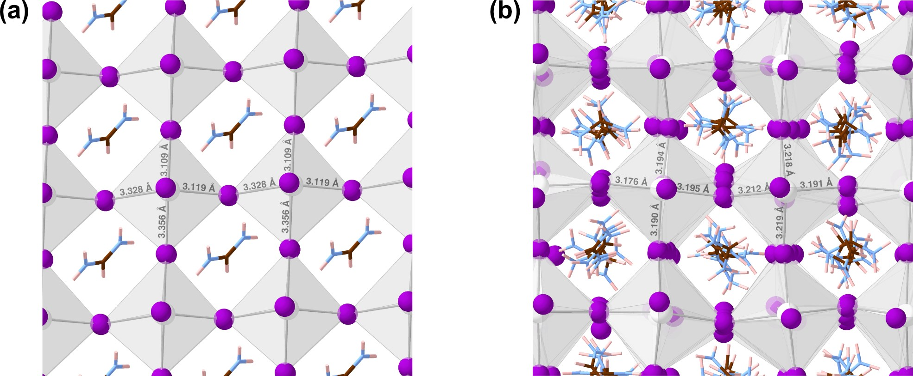
Figure 3: Zoom of the final FAPbI₃ structures starting from all-aligned (a) and pseudorandom (b) FA configurations after vc-relax. The Pb-I distances for two adjacent octahedra are highlighted. The typical tilting pattern of the octahedra can be recognised in the pseudorandom case, while the fully aligned case shows a non-physical collective I-shift. The colour code is the same as in Fig.1.

Band gap
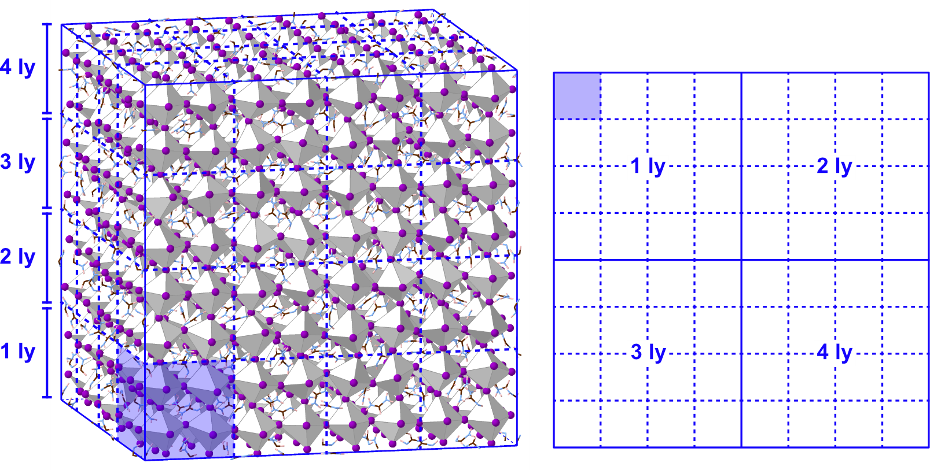
Figure 4: Band gap mapping of the 6144-cell from 3D to 2D. 64 96-cells were identified in the 6144-cell, as shown by the blue grid superimposed on the 3D model in the left panel, and rearranged into a 2D map as shown in the right panel. The area shaded in blue highlights a single 96-cell. The colour code is the same as in Fig.1.
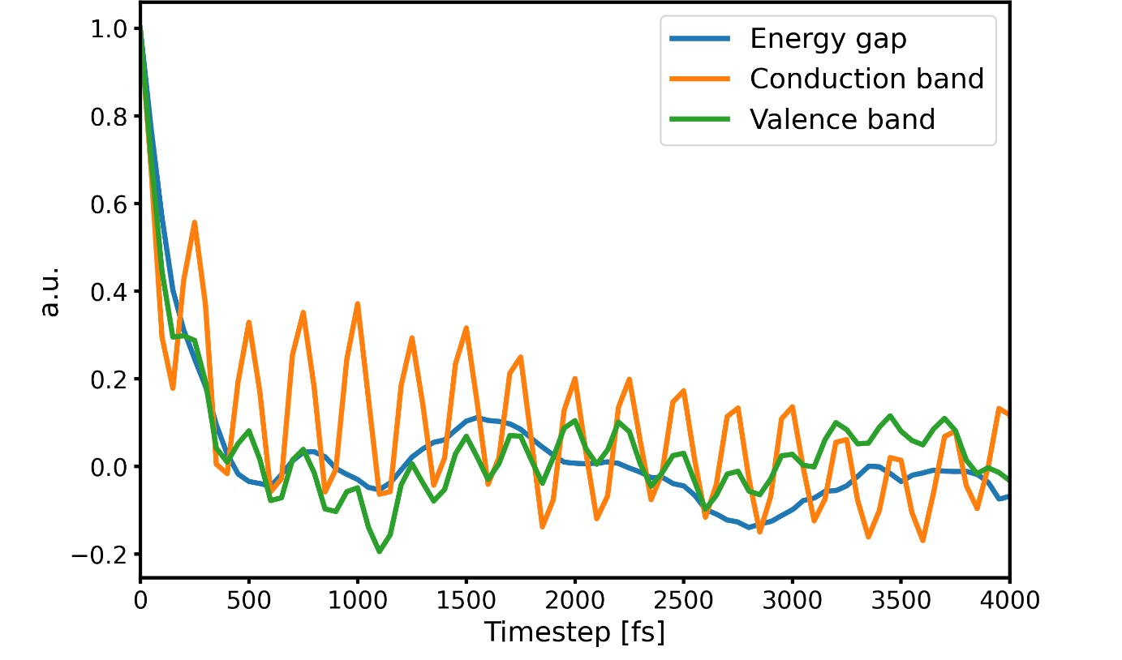
Figure 5: Time correlation function characterizing the band gap oscillations (blue curve), the bottom of the conduction band eigenvalue (orange curve), and the top of the valence band eigenvalue (green curve). The analysis was done on the 2592-atom one.

Dipole moment
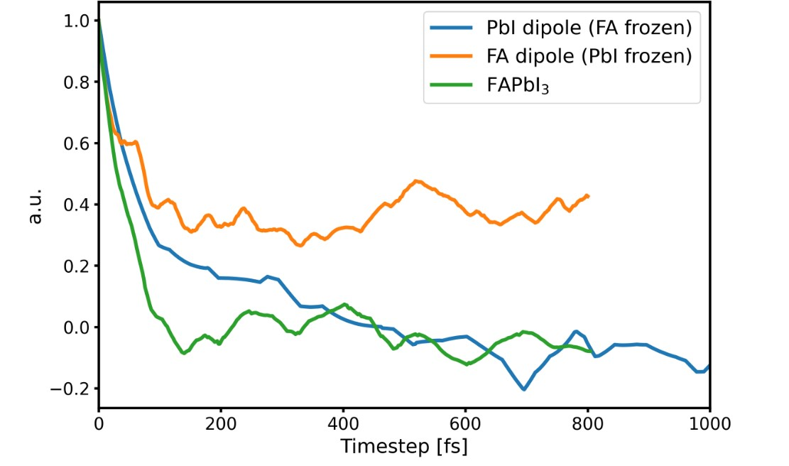
Figure 6: Time correlation function characterizing the dipole moment oscillations of the PbI₆ (blue curve), the FAs (orange curve), and the total one (green curve) for the 768-atom cell. Two NPT-F simulations were performed with FA or PbI₆ frozen to get the two separate contributions - PbI₆ and FA - to the dipole moment. FA alone cannot compensate the dipole moment of the lattice, but the PbI₆ fluctuations can (correlation goes to 0).
Fig.7 shows the different starting configurations of FAs for the 768-atom cell. In the "aligned" configuration all the FAs are aligned in the same direction, in the "random" configuration they are oriented randomly, in the "random_best" configuration they are oriented randomly so as to minimize the dipole moment, in the "smart_100" configuration they are oriented along the 100, 010, 001 directions minimizing the dipole moment, in the "smart_quasi" configuration they are pseudo-randomly oriented preserving the 3-fold symmetry (Supplementary Fig.1) and minimizing the dipole moment.
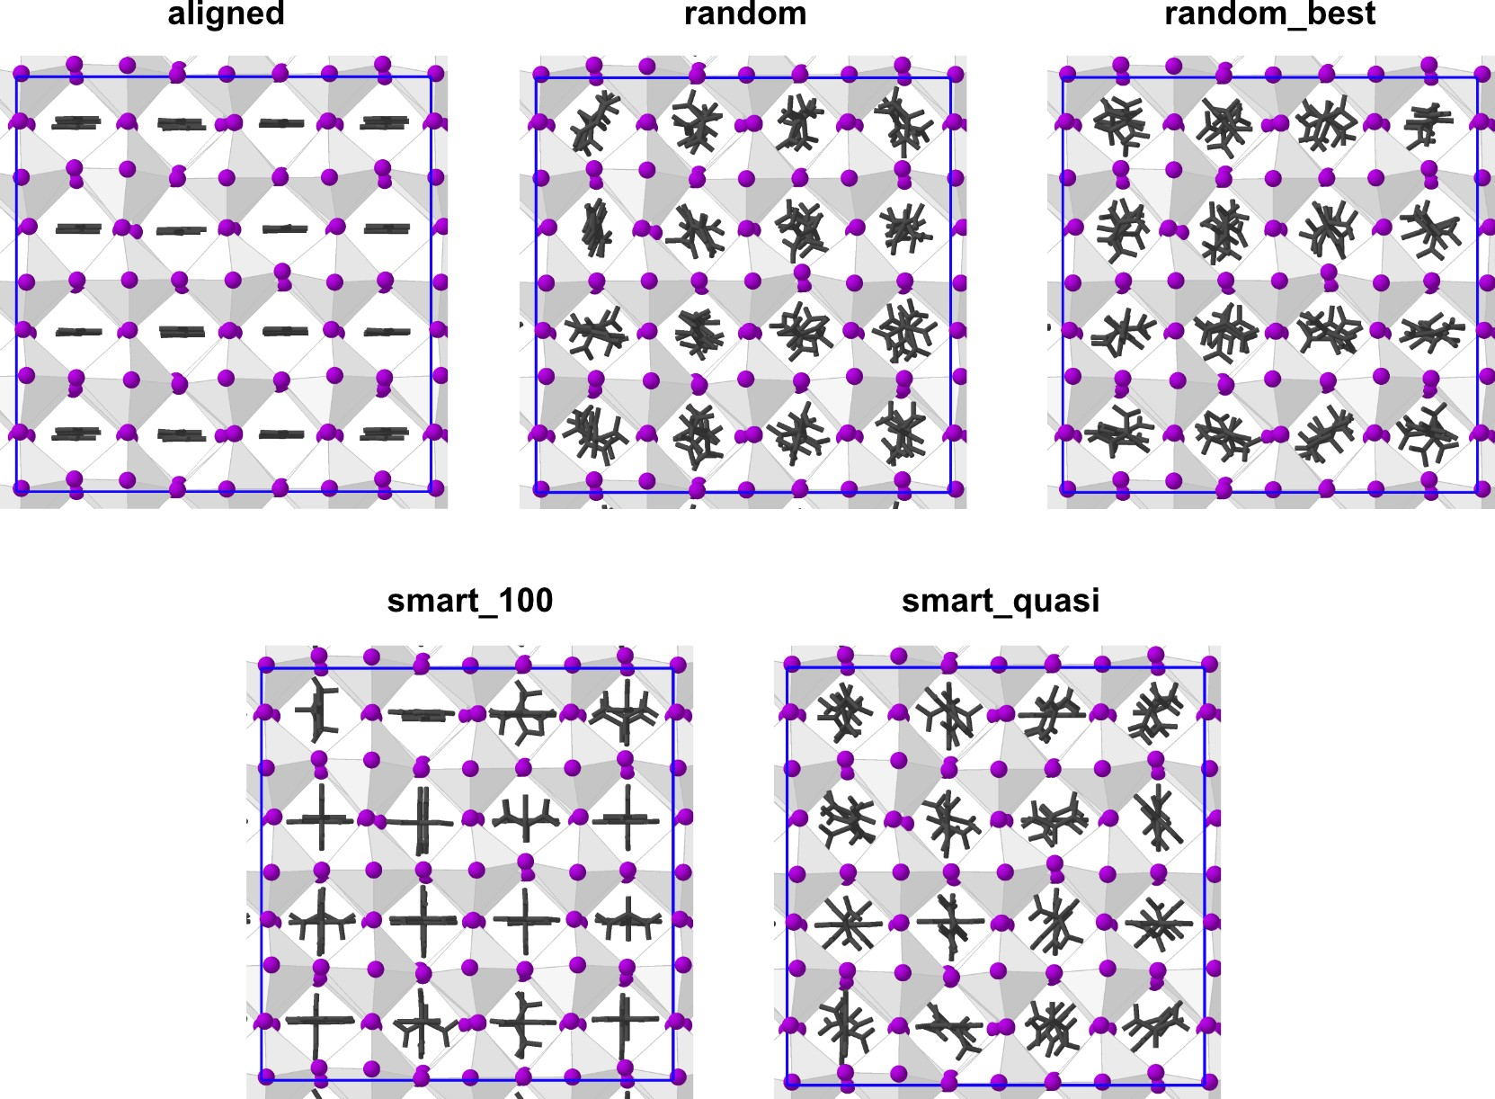
Figure 7: Initial configurations of the 768-atom cell with different FA orientations. FA molecules are shown in dark grey to facilitate the visualization. I and Pb are shown in violet and white octahedra, respectively.
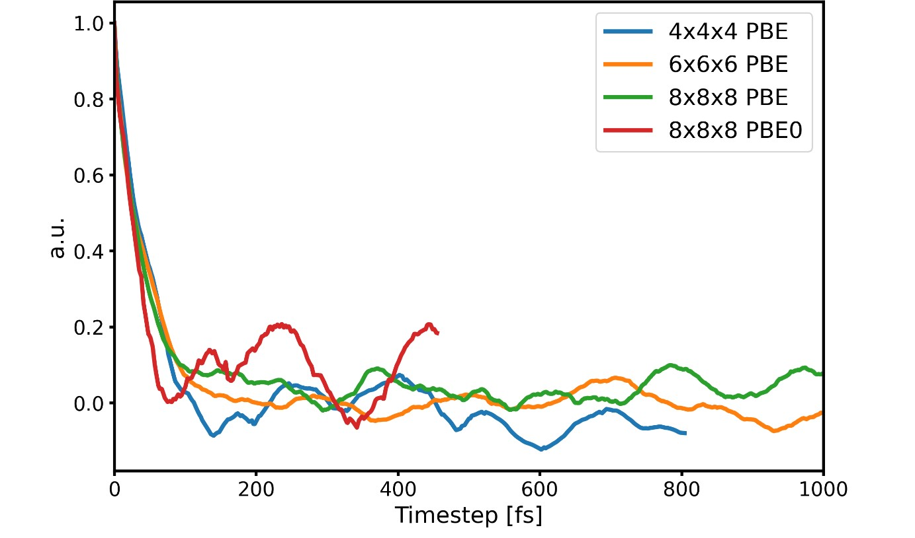
Figure 8: Time correlation function characterizing the dipole moment oscillations for different supercell size. The 6144-atom cell results are reported with both PBE and PBE0 level of theory.

