Online Supplementary Material 8

Results
- Outliers detection from eligible studies
The meta and metafor packages for R were used to detect the outliers from all eligible studies. Four studies were detected out and will be removed for R219K and TG level analysis (Figure S8-1 and Figure S8-2)
Figure S8-1. Plot of the various diagnostic measures of influence analyses. The influence measures of each study: retudent, the externally standardized residuals; diffits, DFFITS values; cook.d, Cook’s distances; cov.r, covariance ratios; tau2.del, estimates of T²; QE.del, the test statistics for (residual) heterogeneity when each study is removed in turn; hat, the diagonal elements of the hat matrix; weight, the weights (in%) given to the observed outcomes during the model fitting. Study considered to be influential, was colored in red in the plot.
Figure S8-2. Plot of DFBETAS values of influence analyses. Study considered to be influential, was colored in red in the plot.

- The overall and sub-group meta-analyses (Figure S8-3 and Figure S8-4)
Figure S8-3. The relationship between R219K and TG level grouped by race.
Figure S8-4. The relationship between R219K and TG level grouped by clinical status.
- To explore the source of heterogeneity by meta-regression analysis (Table S8-1)

Table S8-1. The meta-regressions of moderators for the estimated effect of R219K
Moderator | No. of studies | β | 95%CI | z | P | R-square
Intercept |  | 0.62 | -26.79 to 28.04 | 0.04 | 0.965 | 0.00
Publication data | 92 | -0.01 | -0.01 to 0.01 | -0.08 | 0.940 | 0.00
Raceª
Asian | 65 | 0.20 | -0.23 to 0.62 | 0.91 | 0.364 | 0.00
Caucasian | 23 | 0.17 | -0.27 to 0.60 | 0.75 | 0.451 | 0.00
 |  | Q= 0.92, df = 2,P= 0.630
Health condition ^{b}
Patients | 36 | 0.10 | -0.05 to 0.24 | 1.29 | 0.196 | 0.00
Random | 31 | 0.12 | -0.06 to 0.30 | 1.26 | 0.206 | 0.00
 |  | Q = 2.17, df = 2, P = 0.338
Mean sample age | 86 | -0.13 | -0.38 to 0.13 | -0.98 | 0.326 | 0.00
Percentage of females | 87 | 0.01 | -0.01 to 0.01 | 1.71 | 0.087 | 0.00
ª Samples which consisted multiple ethnic subjects set as reference;
^{b}Samples including patients and controls set as reference.

- Publication bias analysis
The publication bias of current study was assessed with Begg’s rank correlation [1] and Egger’s weighted regression [2] methods, and visualized by funnel plots (Figure S5-5). The missing studies were estimated by trim-and-fill method [3], and analyzed the difference between the effect values and their adjusted values considering missing studies.
The results of publication bias showed that neither the Begg’s correlation (Tau = -0.06, Z = 0.79, two-tailed P=0.432) nor the Egger’s regression (t ₍₈₉₎ = 0.69, two-tailed P= 0.493) showed significant bias. But the initial effect of R219K on HDLC level still was significantly changed (the estimated missing studies n = 21, SMD_{adj} = 0.142, 95% CI = 0.08 ~ 0.20; t = 2.37, P = 0.019) after adjustment with missing studies.
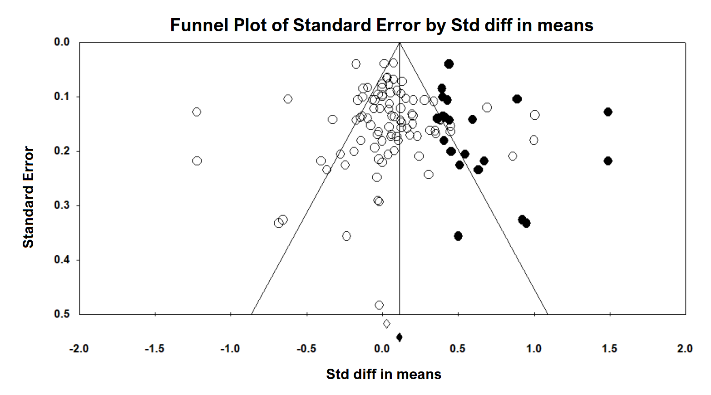
Figure S8-5: Shows the visually assessing on the asymmetry of funnel plot with imputed number of studies in all data (the black dots in the figure indicate the data that may be predicted).

References:
1. Begg CB, Mazumdar M. Operating characteristics of a rank correlation test for publication bias.Biometrics 1088-1101 (1994).
2. Egger M, Smith GD, Schneider M, Minder C. Bias in meta-analysis detected by a simple, graphical test.Bmj 315(7109), 629-634 (1997).
3. Duval S. The trim and fill method.Publication bias in meta-analysis: Prevention, assessment and adjustments 127-144 (2005).

