Online Supplementary Material 7

Results
- Outliers detection from eligible studies
The meta and metafor packages for R were used to detect the outliers from all eligible studies. Four studies were detected out and will be removed for R219K and TC level analysis (Figure S7-1 and Figure S7-2)
Figure S7-1. Plot of the various diagnostic measures of influence analyses. The influence measures of each study: retudent, the externally standardized residuals; diffits, DFFITS values; cook.d, Cook’s distances; cov.r, covariance ratios; tau2.del, estimates of T²; QE.del, the test statistics for (residual) heterogeneity when each study is removed in turn; hat, the diagonal elements of the hat matrix; weight, the weights (in%) given to the observed outcomes during the model fitting. Study considered to be influential, was colored in red in the plot.
Figure S7-2. Plot of DFBETAS values of influence analyses. Study considered to be influential, was colored in red in the plot.
- The overall and sub-group meta-analyses (Figure S7-3 and Figure S7-4)
Figure S7-3. The relationship between R219K and TC level grouped by race.
Figure S7-4. The relationship between R219K and TC level grouped by clinical status.
- To explore the source of heterogeneity by meta-regression analysis (Table S7-1)

Table S7-1. The meta-regressions of moderators for the estimated effect of R219K
Moderator | No. of studies | β | 95%CI | z | P | R-square
Intercept |  | -15.11 | -50.11 to 19.88 | -0.85 | 0.397 | 0.00
Publication data | 92 | 0.01 | -0.01 to 0.02 | 0.80 | 0.422 | 0.02
Raceª
Asian | 65 | 0.96 | -0.03 to 1.94 | 1.90 | 0.058 | 0.06
Caucasian | 26 | 0.91 | -0.06 to 1.88 | 1.85 | 0.064 | 0.06
 |  | Q= 3.62, df = 2, P= 0.164
Health condition ^{b}
Patients | 37 | 0.05 | -0.13 to 0.24 | 0.57 | 0.571 | 0.09
Random | 30 | -0.04 | -0.27 to 0.19 | -0.34 | 0.732 | 0.07
 |  | Q = 0.87, df = 2, P = 0.647
Mean sample age | 84 | 0.01 | -0.29 to 0.31 | 0.06 | 0.948 | 0.07
Percentage of females | 87 | -0.00 | -0.01 to 0.01 | -0.54 | 0.587 | 0.04
ª Samples which consisted multiple ethnic subjects set as reference;
^{b}Samples including patients and controls set as reference.

- Publication bias analysis
The publication bias of current study was assessed with Begg’s rank correlation [1] and Egger’s weighted regression [2] methods, and visualized by funnel plots (Figure S7-5). The missing studies were estimated by trim-and-fill method [3], and analyzed the difference between the effect values and their adjusted values considering missing studies.
The Begg’s correlation showed no publication bias (Tau = -0.11, Z = 1.59, two-tailed P=0.111) in current study, while the Egger’s regression showed a significant bias(t ₍₉₀₎ = 2.85, two-tailed P= 0.005). And comparing the initial effect, the trim-and-fill method also looked an obvious change for the adjusted effect of R219K on TC level (the estimated missing studies n = 25, SMD_{adj} = -0.08, 95% CI = -0.14 ~ -0.02; t = -1.80, P = 0.073), by adjustment with estimated missing studies. Together, it indicated that, the publication selection bias may be happened during investigation about the effect of R219K on TC level in present study.
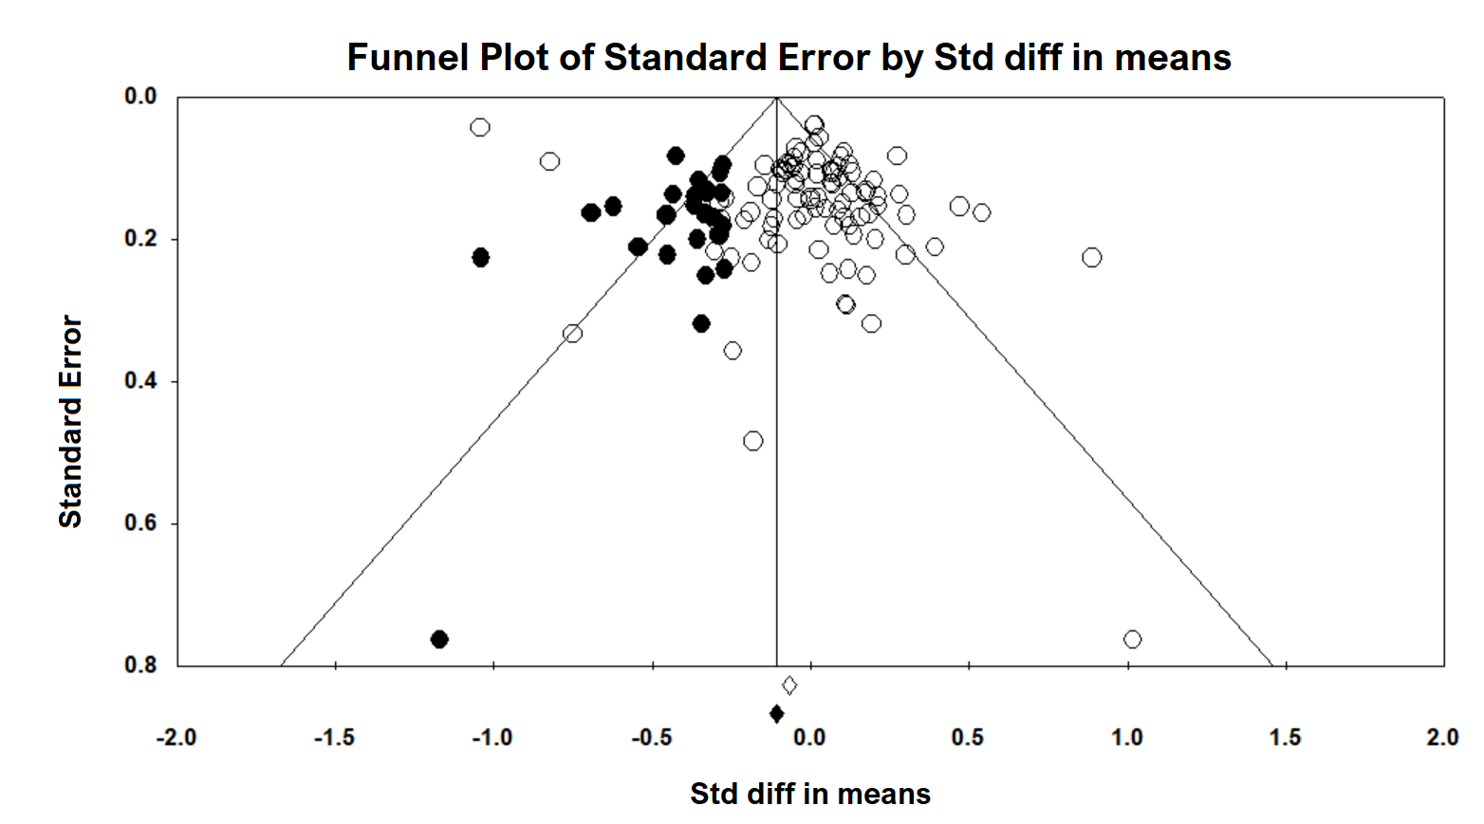
Figure S7-5: Shows the visually assessing on the asymmetry of funnel plot with imputed number of studies in all data (the black dots in the figure indicate the data that may be predicted).

References:
1. Begg CB, Mazumdar M. Operating characteristics of a rank correlation test for publication bias.Biometrics 1088-1101 (1994).
2. Egger M, Smith GD, Schneider M, Minder C. Bias in meta-analysis detected by a simple, graphical test.Bmj 315(7109), 629-634 (1997).
3. Duval S. The trim and fill method.Publication bias in meta-analysis: Prevention, assessment and adjustments 127-144 (2005).

