Supplementary information
Carbon nanotube fibers provide no measurement contribution when monitoring CNT/epoxy nanocomposites
Sergei P. Shadrov^{1#}, Hassaan A. Butt^{1*#}, Aliya R. Vildanova¹, Ekaterina E. Agafonova¹, Veronika A. Dmitrieva¹, Vladislav A. Kondrashov¹, Yaotian Yan², Junlei Qi², Zeyu Wang³, Dmitry V. Krasnikov¹, Albert G. Nasibulin¹
¹Skolkovo Institute of Science and Technology, Moscow, Russia.
²Harbin Institute of Technology, Harbin, China.
³Jiangsu University, Zhenjiang, China.
- Materials characterization

1.1 SWCNT thin film characterization
Single-walled carbon nanotube (SWCNT) thin films with thicknesses of 18, 39, and 59 nm were used to create carbon nanotube fibers (CNTFs) of various diameters. A UV-vis-NIR spectroscope (Lambda 1050 spectrophotometer) was employed at a wavelength of 550 nm to determine film thickness through transmittance values, using the following equation (S1):
Film thickness = 239 ∙ [2 – log(%T₅₅₀)], (S1)
where [2 – log(%T₅₅₀)] is equal to absorbance of the SWCNT thin films at 550 nm [1]. Raman spectroscopy (ThermoFisher Scientific DXRxi Raman imaging microscope, 10X optical zoom, 532 nm green solid-state laser) was employed to determine the quality (I_{G}/I_{D}) of the SWCNT thin films. The Raman spectra of SWCNT thin films presented in Fig. S1.
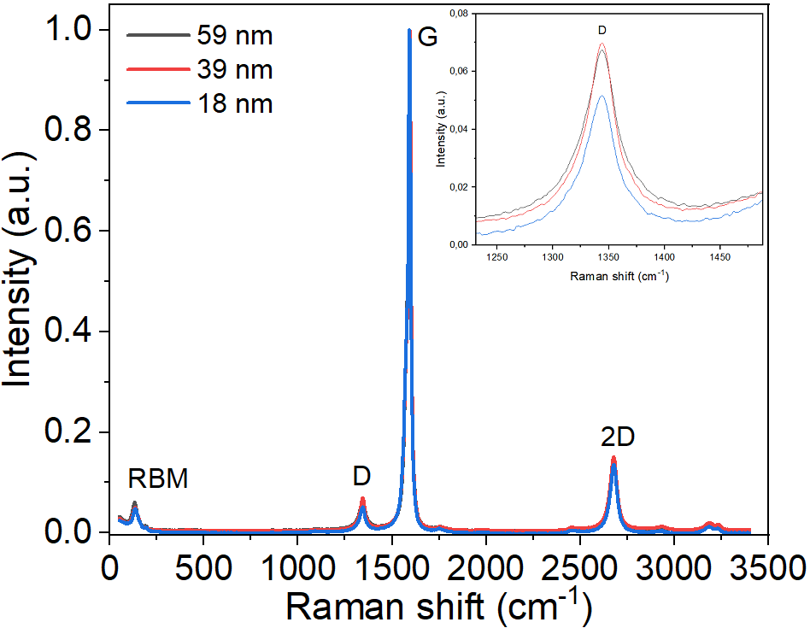
Fig. S1 Raman spectra of SWCNT thin films with different thicknesses
The corresponding values of SWCNT thin films transmittances, thicknesses and I_{G}/I_{D} ratios shown in Table S1.
Table S1. Characteristics of SWCNT thin films
SWCNT film transmittance (%) | SWCNT film thickness (nm) | I_{G}/I_{D} ratio
60 | 59 ± 5 | 15 ± 0.7
70 | 39 ± 4 | 14 ± 0.6
90 | 18 ± 4 | 22 ± 0.9
  - Characterization of masterbatches
In this work commercial masterbatches (MBs) were used instead of CNT powders. The two MBs differed in additive type, and one contained SW-, with the second containing MWCNTs. The characteristics of the CNTs are shown in Table S2.
Table S2. Characteristics of commercial MBs used for polymer nanocomposite production
Type of CNTs | Estimated aspect ratio | MBs matrix
SWCNT | 2500-3000 | Bisphenol A diglycidyl ether epoxy resin
MWCNT | 6-1000 | Bisphenol A diglycidyl ether epoxy resin
- CNTF production

The wet-pulling process is a straightforward technique as illustrated in Fig. S2. The procedure begins with carefully cutting a strip with specified dimensions from the filter with nanotubes by a razor blade. The strip is then fully covered with an ethanol. Using tweezers, the SWCNT film is carefully pulled out. During this step, the film wraps into a CNTF due to the combined effects of surface tension from the wetting agent, adhesion to the substrate, and mechanical pulling. Once the wet fiber is removed from the solvent, it is placed on a dryer, where solvent evaporation causes the fiber to shrink to its final dimensions. Ethanol was chosen due to its low-toxicity and excellent ability to separate SWCNT films from both the glass surface.

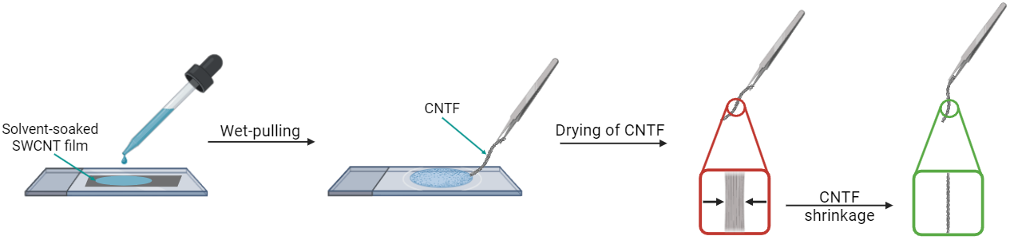
Fig. S2 Schematic representation of Wet-pulling technique.
- Nanocomposite production
Nanocomposite preparation consisted of soaking the MBs in acetone, followed by ultrasonication for 30 minutes to soften the material for further processing. The material was then dispersed within the matrix resin using an IKA T-25 Ultra Turrax homogenizer. Three stages of homogenization were employed, with the first stage conducted at an RPM of 3200 for 5 minutes, followed by the second at an RPM of 7500 for 45 minutes, and the final conducted with an RPM of 10000 for 15 minutes. Subsequently, the resulting suspension was again ultrasonicated for one hour at 40 °C. The dispersion was then degassed for 30 minutes in a vacuum chamber to remove trapped air. Once completed, the hardener was added and the mixture was hand-mixed for 5-10 minutes. The resulting mixture was degassed again for 10-15 minutes before being molded in silicone molds.
References:
[1] G.A. Ermolaev, A.P. Tsapenko, V.S. Volkov, A.S. Anisimov, Y.G. Gladush, A.G. Nasibulin, Express determination of thickness and dielectric function of single-walled carbon nanotube films, Appl Phys Lett 116 (2020). https://doi.org/10.1063/5.0012933.

# These authors contributed equally to the work. * Corresponding authors. E-mail address: hassaan.butt@skoltech.ru (Hassaan Ahmad Butt); a.nasibulin@skol.tech (Albert G. Nasibulin).

