MUC3A promotes lung cancer progress via activating NFκB pathway and attenuates radiosensitivity

Yingming Sun, Xiaoge Sun, Chengcheng You, Shijing Ma, Yuan Luo, Shan Peng, Fang Tang, Xiaoli Tian, Feng Wang, Zhengrong Huang, Hongnv Yu, Yu Xiao, Xiaoyong Wang, Junhong Zhang, Yan Gong, Conghua Xie

Table S1. List of primary antibodies.
Antigen | Species | Dilution (IF) | Dilution (WB) | Supplier
53BP1, human | Rabbit, polyclonal | 1:200 | - | Abcam, Cat. #ab36823
Ki-67, human/mouse | Rabbit, monoclonal | 1:200 | - | Abcam, Cat. #ab16667
P65, human/mouse | Mouse, monoclonal | 1:100 (IHC) | 1:1000 | Proteintech, #66535-1-Ig
p-P65(Ser279), human/mouse | Rabbit, monoclonal |  | 1:500 | Abclonal, # AP0123
p-P65(Ser536), human/mouse | Rabbit, monoclonal | 1:100 | 1:1000 | CST, Cat. #3033T
IκB | Rabbit, monoclonal | 1:100 | 1:1000 | Proteintech, Cat. #10268-1-AP
γ-H2AX, human | Mouse, monoclonal | 1:100 | 1:2000 | CST, Cat. #80321
p-ATM, human | Rabbit, monoclonal | - | 1:500 | Abcam, Cat. #ab81292
BRCA1, human | Mouse, monoclonal | - | 1:1000 | Abcam, Cat. #ab16781
RAD51, human | Rabbit, polyclonal | 1:100 | 1:1500 | Proteintech, Cat. #14961-1-AP
XCRR5, human | Rabbit, polyclonal | - | 1:1000 | Proteintech, Cat. #14961-1-AP
XCRR6, human | Rabbit, polyclonal | - | 1:1000 | Proteintech, Cat. #16389-1-AP
GADD45, human | Rabbit, polyclonal | 1:100 | 1:1000 | Proteintech, Cat. # 13747-1-AP
P53, human/mouse | Rabbit, polyclonal | 1:150 (IHC) | 1:2000 | Proteintech, Cat. # 10442-1-AP
pP53, human | Rabbit, polyclonal | - | 1:1000 | Abcam, Cat. #ab1431
LC3, human | Rabbit, polyclonal | - | 1:1000 | Proteintech, Cat. #14600-1-AP
ATG5, human | Rabbit, polyclonal | - | 1:1000 | Proteintech, Cat. #10181-2-AP
Beclin1, human | Rabbit, polyclonal | - | 1:1000 | Proteintech, Cat. # 11306-1-AP
GAPDH, human | Rabbit, polyclonal | - | 1:10000 | Proteintech, Cat. #10494-1-AP
BCL2, human | Rabbit, monoclonal | - | 1:2000 | Abcam, Cat. #32124
BAX, human | Rabbit, monoclonal | - | 1:1000 | Proteintech, Cat. #50599-2-Ig
PARP, human | Rabbit, monoclonal | - | 1:2000 | CST, Cat. #9532
Caspase-3, human | Rabbit, polyclonal | - | 1:1500 | Proteintech, Cat. #19677-1-AP
Caspase-8, human | Rabbit, polyclonal | - | 1:1500 | Proteintech, Cat. #13423-1-AP
MMP2, human/mouse | Rabbit, polyclonal | 1:100 (IHC) | - | Proteintech, Cat. #10373-2-AP
MMP9, human | Rabbit, monoclonal | - | 1:1000 | Proteintech, Cat. #10375-2-AP
ICAM1, human | Rabbit, monoclonal | 1:100 | - | Proteintech, Cat. #10831-1-AP
E-cadherin, human | Mouse, monoclonal | - | 1:1000 | CST, Cat. #3195
N-cadherin, human | Rabbit, monoclonal | - | 1:1000 | CST, Cat. #13116
Vimentin, human | Rabbit, monoclonal | - | 1:1000 | CST, Cat. #5741
VEGF, mouse | Rabbit, monoclonal | 1:100 (IHC) | - | Abcam, Cat. #ab32152

Table S2. List of secondary antibodies and counterstaining of nuclei.
The secondary detection system used | Host | Method | Dilution | Supplier
Anti-Mouse-IgG (H + L)-HRP | Goat | WB | 1:10000 | Proteintech, Cat. #SA00001-1
Anti-Rabbit-IgG (H + L)-HRP | Goat | WB | 1:10000 | Proteintech, Cat. #SA00001-2
Anti-Rabbit-IgG (H + L)-Alexa Fluor 488 | Goat | IF | 1:500 | Proteintech, Cat. #SA00006-3
Hoechst 33342 nucleic acid staining (DAPI) | - | IF | 2 μg/ml | Sigma, Cat. #D8417

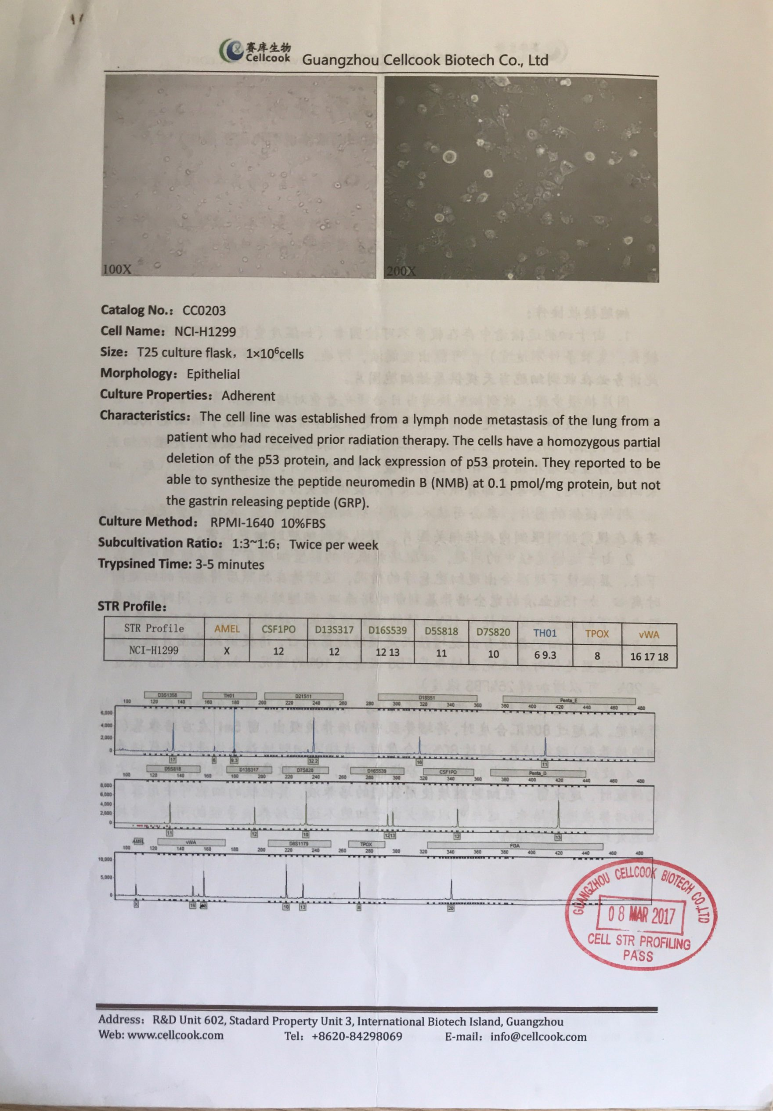
Figure S1. Authentication of the H1299 cell line. PCR was amplified with STR Multi-amplification KIT (PowerPlexTM 16HS System). No loci have tri-alleles or tetra-alleles. The contamination of other human cells was not found. The cell STR profiling passed on 2017/3/8.

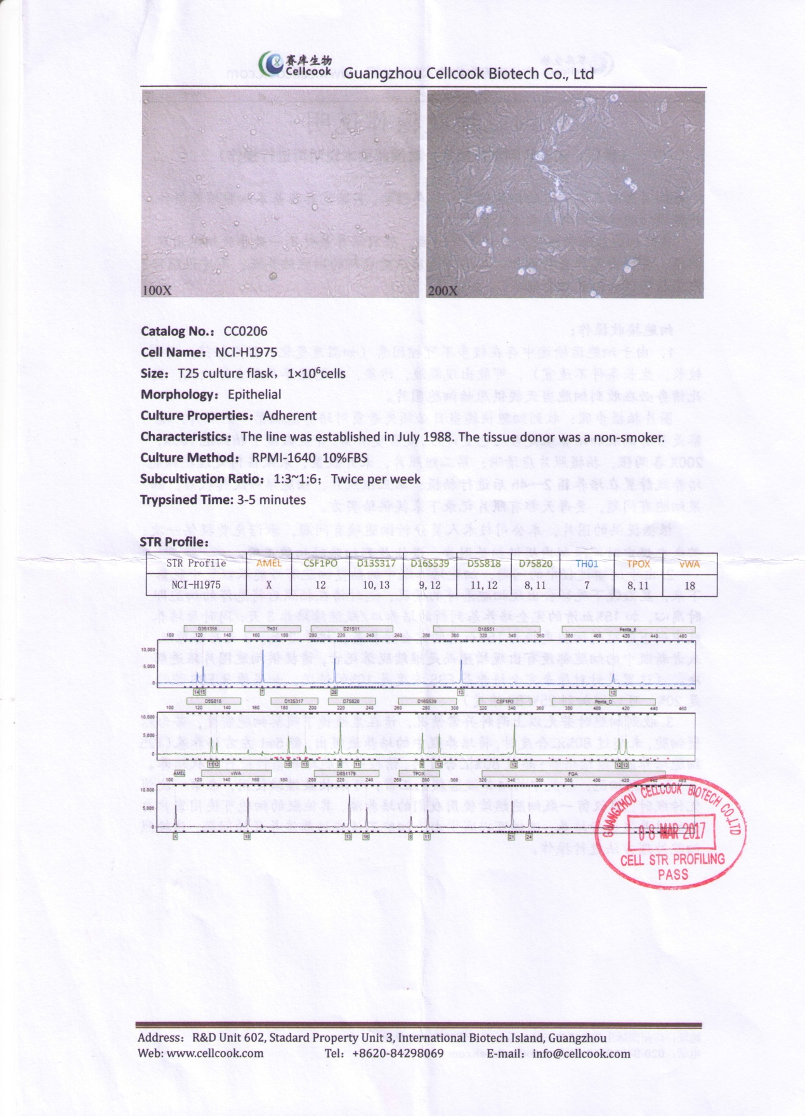
Figure S2. Authentication of the H1975 cell line. PCR was amplified with STR Multi-amplification KIT (PowerPlexTM 16HS System). No loci have tri-alleles or tetra-alleles. The contamination of other human cells was not found. The cell STR profiling passed on 2017/3/8.

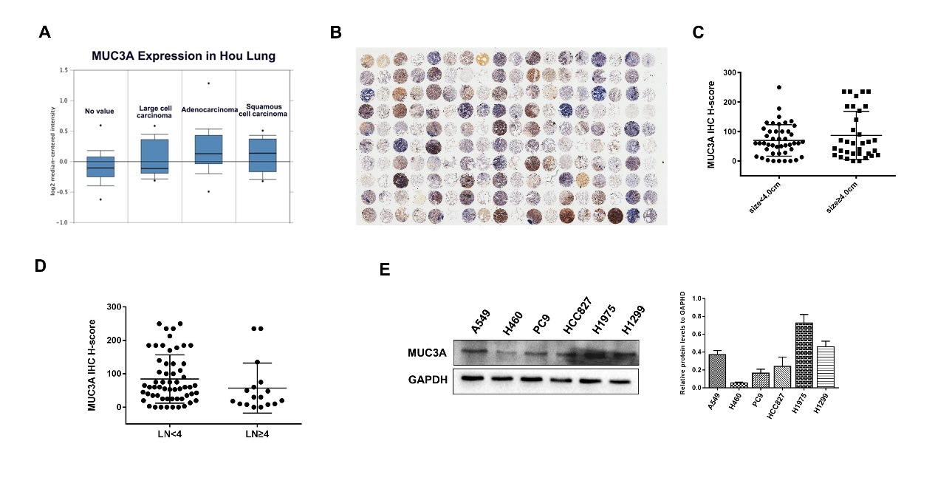
Figure S3. Microarray and MUC3A expression in various NSCLC cell lines. (A) MUC3A expression in the online database of Hou Lung. The levels of MUC3A was higher in adenocarcinoma than others. (B) The HE overview of tissue microarray to primarily verify the adjacent and cancer tissues. (C) MUC3A expression in lung cancer tissues subgrouped by size (p＞0.05). (D) MUC3A expression in lung cancer tissues subgrouped by lymph node metastasis (p＞0.05). (E) Representative WB images of MUC3A in different NSLCL cell lines. MUC3A was highly expressed in H1975 and H1299 cell lines.

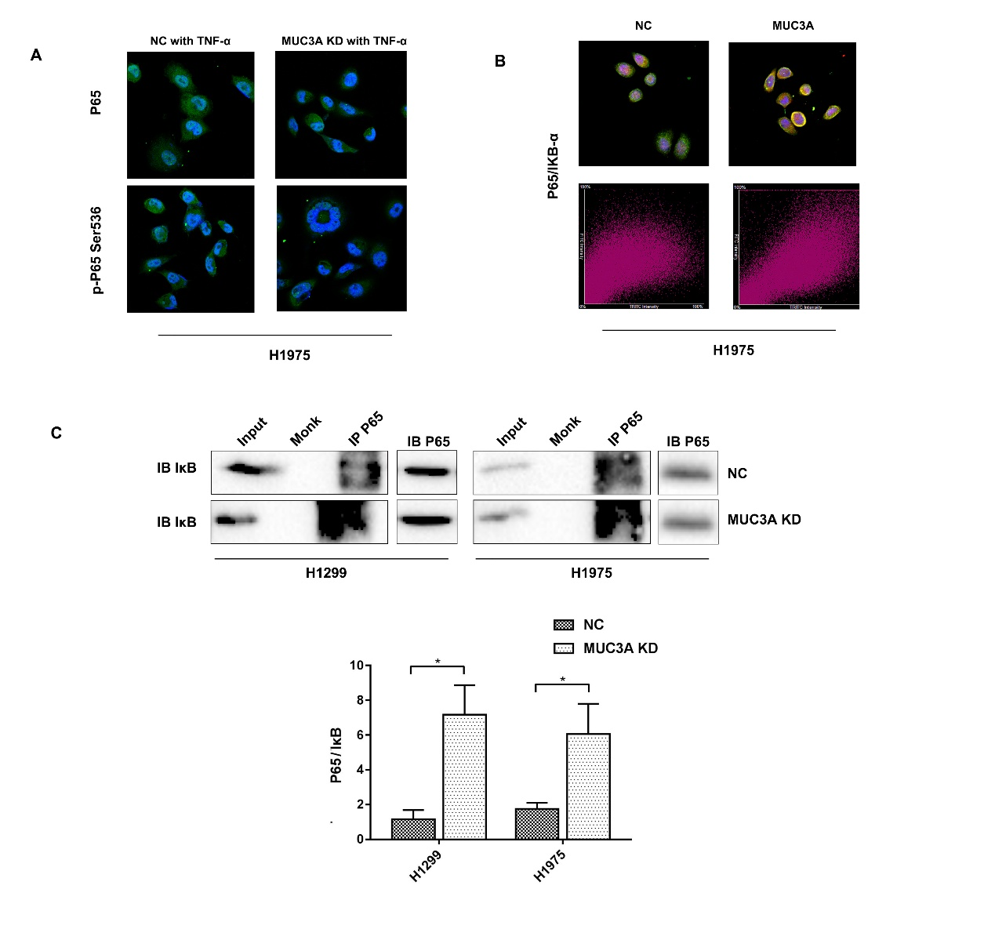

Figure S4. MUC3A intetferred the binding between P65 and IκB. (A) Representative images of p65 and p-p65 IF staining in H1975 cells. The MUC3A deficiency group had less p-p65 positive staining (green) than the control group. For total p65, there was no statistical difference between control and MUC3A deficiency groups. (B) IF to detect the binding condition of p65 (green) and IκB (red) in H1975. In the MUC3A deficiency cells, more p65 protein banded to IκB. (C) Co-IP to analyze the binding of p65 and IκB in control and MUC3A deficiency cells. In the MUC3A deficiency cells, the ratio of p65/IκB was significantly increased.

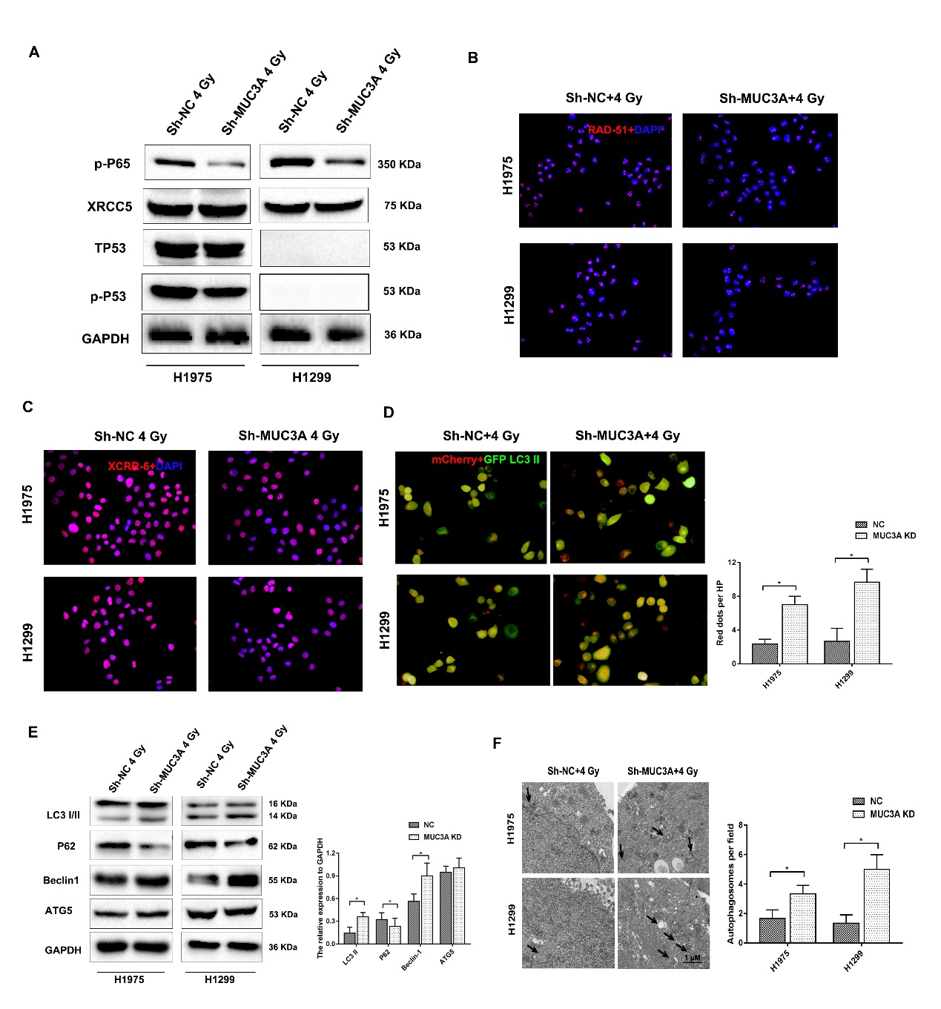
Figure S5. MUC3A facilitated the radiosensitivity of NSCLC cells. (A) Western blotting analysis of p-P65, XCRR-5, TP-53, and p-p53 protein levels in H1975 and H1299 parental and MUC3A knockdown cells after 4 Gy irradiation. (B) Representative images of RAD51 in H1975 and H1299 cells after 4 Gy irradiation. The MUC3A deficiency group had less GADD45 foci (red) in the nuclear (blue) than the control group. *, p < 0.05. (C) Representative images of XRCC 6 in H1975 and H1299 cells after 4 Gy irradiation. The MUC3A deficiency group had less GADD45 foci (red) in the nuclear (blue) than the control group. *, p < 0.05. (D) mCherry-GFP-LC3II adenovirus was infected into the cells for 24 hours and exposed to 4 Gy irradiation. MUC3A deficient cells after 4 Gy irradiation-induced more red dots, indicating more late-stage autophagy. *, p < 0.05. (E) . TEM was applied to investigate the autophagy vacuoles formation. The black arrow point to an autophagy vacuole. MUC3A deficient cells with 4 Gy irradiation induced more autophagy vacuoles. *, p < 0.05. (F) Western blotting analysis the autophagy relevant proteins, LC3, p62, Beclin1, and ATG5 in H1975 and H1299 parental and MUC3A knockdown cells. MUC3A deficient cells with 4 Gy irradiation promoted the expression of LC3II and Beclin-1 and decreased the level of p62. *, p < 0.05.

