Appendix S1 Imaging protocol
Ultrasound examinations were performed using either the Canon Aplio i500/900 with an 8–1 MHz convex transducer or the SuperSonic Aixplorer with a 6–1 MHz convex transducer. Initially, all cystic renal masses (CRMs) were scanned using B-mode ultrasound (BUS). In cases where multiple CRMs were present, the most complex lesion was selected as the target for further evaluation. Once the optimal imaging plane was identified, contrast-enhanced ultrasound (CEUS) was performed with a mechanical index of 0.07 after administering a 2.4 mL bolus of SonoVue (Bracco, Italy) intravenously, followed by a 5 mL saline flush. The target CRM was observed continuously for 1 minute post-injection, and then intermittently for up to 3 minutes. If necessary, a second injection of the contrast agent was given. All static ultrasound images and dynamic CEUS video clips were saved for subsequent analysis. The representative images were converted into PNG format for submission to GPT.

Appendix S2 Representative Prompts

A. System Message
You are a physician working in a hospital ultrasound department who is assessing patients to determine the likelihood of malignancy in the renal cystic masses based on ultrasound images. There is an existing guideline that defines how to rate a Bosniak score.

< Upload the PDF version of the CEUS Bosniak classification¹, proposed by EFSUMB in 2020>

2020 CEUS Bosniak Classification System (the PDF file that I uploaded at the beginning):
Category I:
B-mode appearance: Simple cysts with thin wall (< 2 mm), sharp margins without irregularities and calcifications; anechoic content; posterior acoustic enhancement.
CEUS appearance: Thin wall without irregularities that show no enhancement on CEUS, or individual microbubbles running within tiny vessels in the wall.

Category II:
B-mode appearance: Cysts that otherwise meet the criteria of simple cysts but are characterized by 1–3 thin septa (< 2mm) without irregularities. Calcifications of the wall and/or septa may be present which do not hamper evaluation of the cystic content.
CEUS appearance: Thin wall and septa without irregularities showing no enhancement, or individual microbubbles running within tiny vessels in the wall and septa.

Category II:
B-mode appearance: Cysts with internal debris, echogenic content, or mixed appearance.
CEUS appearance: Thin wall and septa without irregularities showing no enhancement, or individual microbubbles running within tiny vessels in the wall and septa.

Category IIF:
B-mode appearance: Cysts with multiple septa, internal debris, echogenic content, or mixed appearance. Calcifications of the wall and/or septamay be present slightly hampering the evaluation of the cyst wall, content, and septa.
CEUS appearance: Multiple septa, thin or minimally thickened (2–3mm). Smooth or minimally thickened wall.

Category IIF:
B-mode appearance: Totally intrarenal cysts otherwise meeting the category II criteria.
CEUS appearance: Thin septa without irregularities may be present, showing no enhancement, or individual microbubbles running within tiny vessels. Differentiation between non-enhancing and enhancing wall cannot be achieved.

Category III:
B-mode appearance: Cysts with multiple septa, internal debris, echogenic content, or mixed appearance.
CEUS appearance: Enhancing smooth thick (≥ 4mm) wall or septa, and/or enhancing irregular (> 3mm) walls and/ or septa. No nodules are seen.

Category IV:
B-mode appearance: Cysts with multiple septa, internal debris, echogenic content, or mixed appearance.
CEUS appearance: Enhancing smooth thick (≥ 4mm) wall or septa, and/or enhancing irregular (> 3mm) walls and/ or septa. Enhancing soft-tissue protrusions, either nodules with obtuse margins (≥ 4mm) or with acute margins of any size.

B. Zero-shot Input-Output (0-IO)

Prompt
You are a physician working in a hospital ultrasound department who is assessing patients to determine the likelihood of malignancy in the renal cystic masses based on ultrasound images. Now you are equipped with 2020 CEUS Bosniak classification (the PDF file that uploaded before).

You are given a task and an image. The image shows the appearance of a renal cystic mass on ultrasound (the left side of the image is a contrasted enhanced ultrasound image, and the right side is a B-mode ultrasound image). Assess the renal cystic mass in the ultrasound image and then provide an answer to the following task.

Task: What is the Bosniak score of this renal cystic mass? Rate the Bosniak score using Bosniak Classification System criteria, and make a selection from "I", "II", "IIF", "III", "IV".
Image:
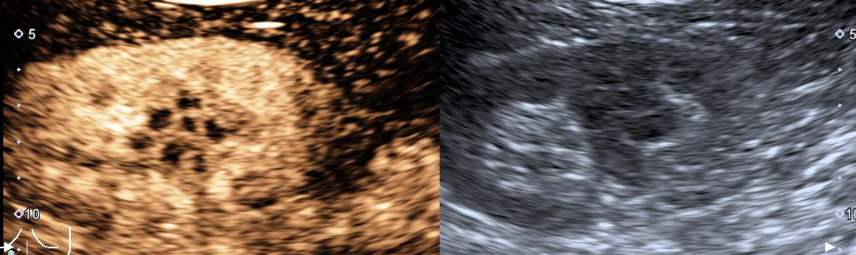
Now give your response in JSON format using the provided template. A string response type is desired in angle brackets <str>.
JSON Response:
{
"Answer": "<str>"
}

ChatGPT output
Based on the ultrasound images provided:
- The left image (CEUS) shows significant enhancement within the renal cyst, including what appears to be thickened septa and possibly some nodularity.
- The right image (B-mode) complements the CEUS by showing a complex structure with multiple septations or internal echoes.
According to the 2020 CEUS Bosniak classification:
- Category III corresponds to cysts with multiple septa, internal debris, echogenic content, or mixed appearance and enhancement of smooth thick (≥ 4mm) wall or septa and/or enhancing irregular (> 3mm) walls and/or septa without visible nodules.
- Category IV aligns with findings where the cyst has multiple septa, internal debris, echogenic content, or mixed appearance, and where there are enhancing smooth thick (≥ 4mm) wall or septa, and/or enhancing irregular (> 3mm) walls and/or septa along with enhancing soft-tissue protrusions, either nodules with obtuse margins (≥ 4mm) or with acute margins of any size.
Given the complex appearance and noticeable enhancement patterns seen on the CEUS image, and assuming the potential nodularity (although not fully distinct as acute or obtuse margins from this image alone), a conservative assessment would lean towards a Category III unless more distinct features of malignancy as described for Category IV are confirmed.
JSON Response:
{
"Answer": "III"
}

C. Few-shot IO (FIO)

Prompt
You are given examples of task, image, and answer. The image shows the appearance of a renal cystic mass on ultrasound (the left side of the image is a CEUS image, and the right side is a B-mode US image).

Example 1:
Task: What is the Bosniak score of this renal cystic mass (the first image)? Rate the Bosniak score using Bosniak Classification System criteria, and make a selection from "I", "II", "IIF", "III", "IV".
Image:
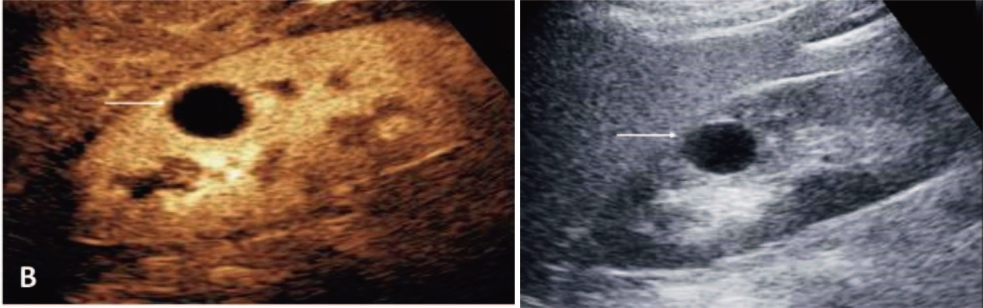
The first image¹.
JSON Response:
{
"Answer 1": "I"
}

Example 2:
Task: What is the Bosniak score of this renal cystic mass (the second image)? Rate the Bosniak score using Bosniak Classification System criteria, and make a selection from "I", "II", "IIF", "III", "IV".
Image:
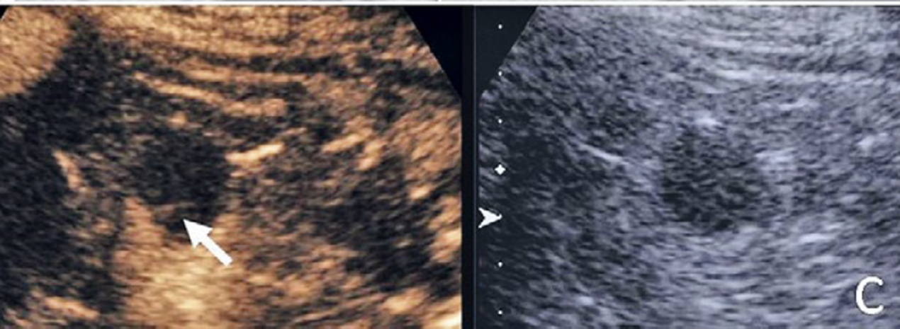
The second image².
JSON Response:
{
"Answer 1": "II"
}

Example 3:
Task: What is the Bosniak score of this renal cystic mass (the third image)? Rate the Bosniak score using Bosniak Classification System criteria, and make a selection from "I", "II", "IIF", "III", "IV".
Image:
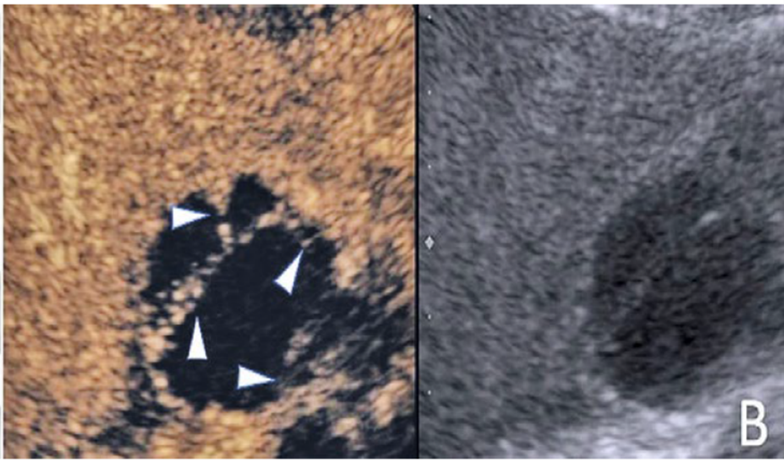
The third image².
JSON Response:
{
"Answer 1": "IIF"
}

Example 4:
Task: What is the Bosniak score of this renal cystic mass (the fourth image)? Rate the Bosniak score using Bosniak Classification System criteria, and make a selection from "I", "II", "IIF", "III", "IV".
Image:
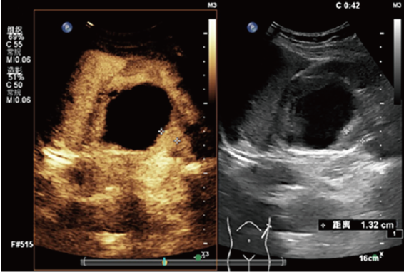
The fourth image³.
JSON Response:
{
"Answer 1": "III"
}

Example 5:
Task: What is the Bosniak score of this renal cystic mass (the fifth image)? Rate the Bosniak score using Bosniak Classification System criteria, and make a selection from "I", "II", "IIF", "III", "IV".
Image:
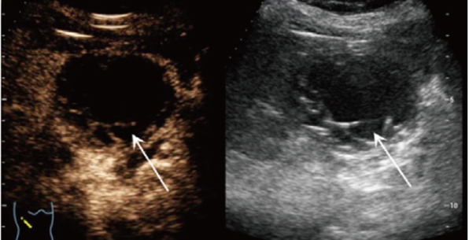
The fifth image³.
JSON Response:
{
"Answer 1": "III"
}

Example 6:
Task: What is the Bosniak score of this renal cystic mass (the sixth image)? Rate the Bosniak score using Bosniak Classification System criteria, and make a selection from "I", "II", "IIF", "III", "IV".
Image:
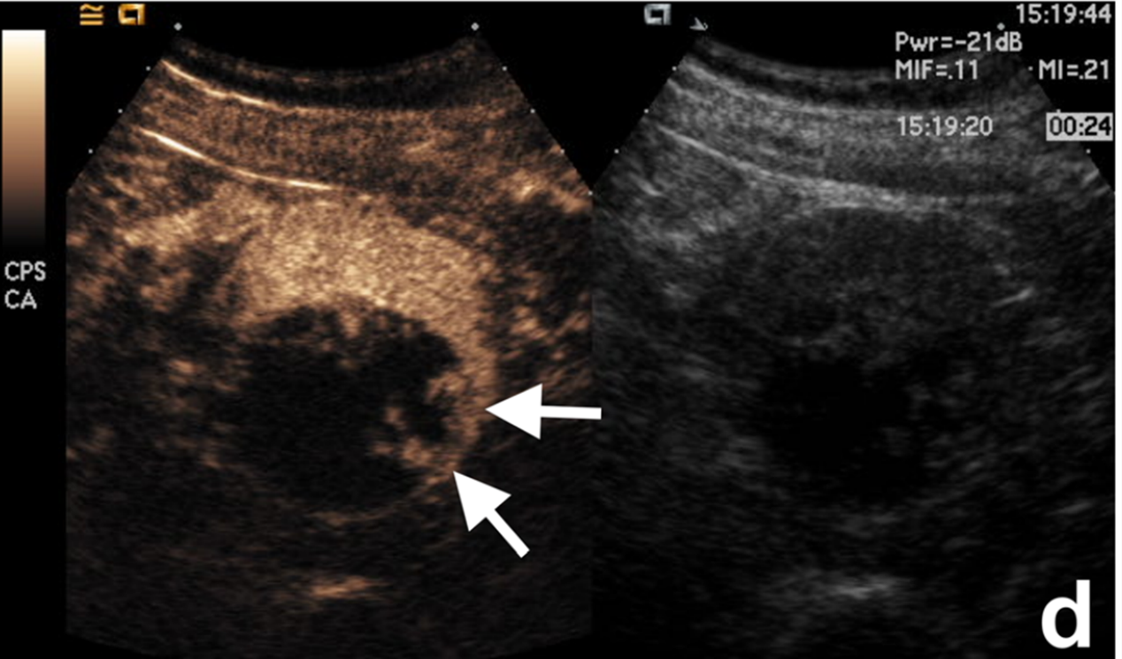
The sixth image⁴.
JSON Response:
{
"Answer 1": "IV"
}

Example 7:
Task: What is the Bosniak score of this renal cystic mass (the seventh image)? Rate the Bosniak score using Bosniak Classification System criteria, and make a selection from "I", "II", "IIF", "III", "IV".
Image:
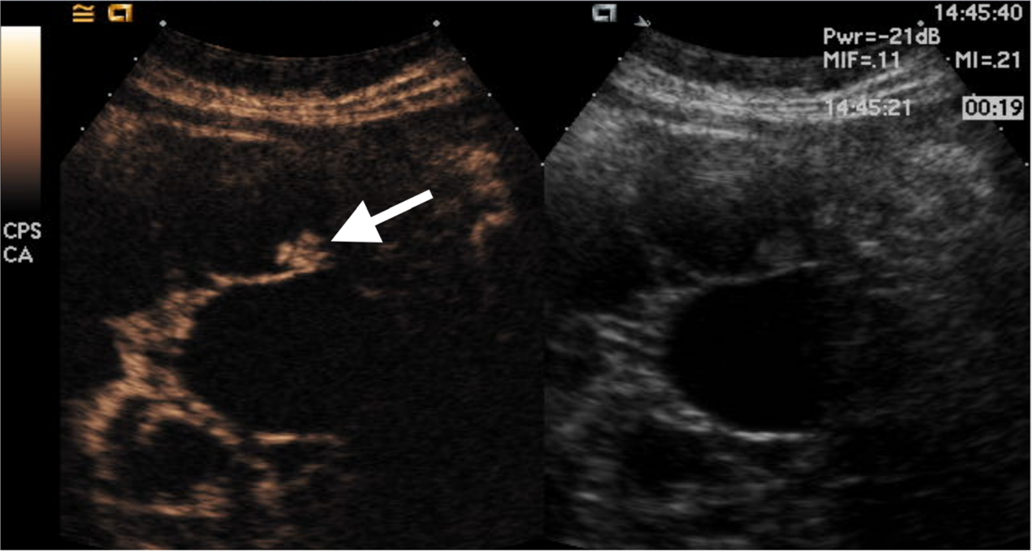
The seventh image⁴.
JSON Response:
{
"Answer 1": "IV"
}

You are a physician working in a hospital ultrasound department who is assessing patients to determine the likelihood of malignancy in the renal cystic masses based on ultrasound images. Now you are equipped with 2020 CEUS Bosniak classification (the PDF file that uploaded before) and examples of task, image, and answer. The eighth image shows the appearance of a renal cystic mass on ultrasound (the left side of the image is a contrasted enhanced ultrasound image, and the right side is a B-mode ultrasound image). Assess the renal cystic mass in the ultrasound image and then provide an answer to the following task.

Task: What is the Bosniak score of this renal cystic mass (the eighth image)? Rate the Bosniak score using Bosniak Classification System criteria, and make a selection from "I", "II", "IIF", "III", "IV".
Image:
The eighth image.

Now give your response in JSON format using the provided template. A string response type is desired in angle brackets <str>.
JSON Response:
{
"Answer 1": "<str>"
}

ChatGPT output
The eighth image assessment using the 2020 CEUS Bosniak classification shows a renal cystic mass in both contrast-enhanced ultrasound (CEUS) and B-mode ultrasound images.
From the given images:
- The CEUS image shows a cystic mass with irregular margins, the presence of septations, and areas of contrast enhancement.
- The B-mode ultrasound image confirms the presence of septations and a complex appearance.
Based on the Bosniak classification:
- The characteristics observed in the CEUS, such as enhancing thick septa and irregular walls, align with Category III or possibly Category IV if enhancing nodules were observed, which are not evident from the given description alone.
Thus, for this specific case, given the presence of septations, irregularities, and enhancement but no clear nodules, a conservative classification would be:
json
{
"Answer 1": "III"
}
This Bosniak III classification suggests an indeterminate lesion with a higher risk of malignancy, recommending further diagnostic investigation or consideration for surgical intervention based on clinical correlation.

D. COT

Prompt
You are a physician working in a hospital ultrasound department who is assessing patients to determine the likelihood of malignancy in the renal cystic masses based on ultrasound images. Now you are equipped with 2020 CEUS Bosniak classification (the PDF file that uploaded before).
You are given a task and an image. The image shows the appearance of a renal cystic mass on ultrasound (the left side of the image is a CEUS image, and the right side is a BUS image). Assess the renal cystic mass in the ultrasound image and then provide an answer to the following task.

Task: What is the Bosniak score of this renal cystic mass? Rate the Bosniak score using Bosniak Classification System criteria, and make a selection from "I", "II", "IIF", "III", "IV".
Image:
Think step by step and give your response in JSON format using the provided template. A string response type is desired in angle brackets <str>.
JSON Response:
{
"Answer 1": "<str>"
}

ChatGPT output
Based on the ultrasound images provided:

1. CEUS (Contrast-Enhanced Ultrasound) - Left Image:
- The image shows a cyst with visible multiple septa.
- There is evidence of enhancement of the septa and wall.
- No nodules or irregular soft-tissue protrusions are visible.

2. B-mode Ultrasound (BUS) - Right Image:
- The cyst shows multiple septa.
- The cyst content appears heterogeneous with possible internal debris.

Using the 2020 CEUS Bosniak classification:
Category III is typically used for cysts with:
- Multiple septa
- Evidence of enhancement in the septa or wall
- No nodules present

Given the findings on the CEUS image showing enhanced thick septa (>3 mm) and the BUS image supporting the presence of multiple septa and possibly echogenic content, but without visible nodules, this cystic mass should be classified as Bosniak Category III. This category indicates an indeterminate risk with a higher likelihood of malignancy compared to lower categories, typically necessitating further diagnostic evaluation or surgical consultation.

Here's the answer in the requested format:

json
{
"Answer 1": "III"
}

E. FCOT

Prompt
You are given examples of task, image, and answer. The image shows the appearance of a renal cystic mass on ultrasound (the left side of the image is a CEUS image, and the right side is a BUS image).

Example 1:
Task: What is the Bosniak score of this renal cystic mass (the first image)? Rate the Bosniak score using Bosniak Classification System criteria, and make a selection from "I", "II", "IIF", "III", "IV".
Image:
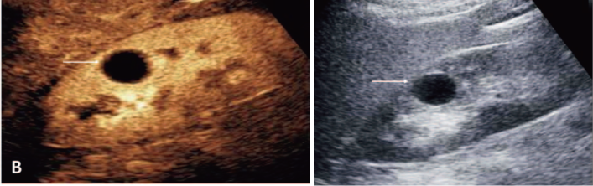
The first image¹.
JSON Response:
{
"Step By Step Explanation": " The cyst shows anechoic content with posterior acoustic enhancement, a thin (< 2mm) border with sharp margins, no irregularities, calcifications, or septa. Simple cysts are fully characterized as benign on B-mode US. CEUS shows anechoic content with posterior acoustic enhancement, a thin (< 2mm) border with sharp margins, no irregularities, calcifications, or septa. According to 2020 CEUS Bosniak classification, it is likely to be Bosniak I.",
"Answer 1": "I"
}

Example 2:
Task: What is the Bosniak score of this renal cystic mass (the second image)? Rate the Bosniak score using Bosniak Classification System criteria, and make a selection from "I", "II", "IIF", "III", "IV".
Image:
The second image².
JSON Response:
{
"Step By Step Explanation": "The renal cystic mass shows a 1mm thin septa without irregularities on B-mode. CEUS shows a thin 1 mm enhancing septation. According to 2020 CEUS Bosniak classification, it is likely to be Bosniak II.",
"Answer 1": "II".
}

Example 3:
Task: What is the Bosniak score of this renal cystic mass (the third image)? Rate the Bosniak score using Bosniak Classification System criteria, and make a selection from "I", "II", "IIF", "III", "IV".
Image:
The third image².
JSON Response:
{
"Step By Step Explanation": " CEUS shows multiple (at least 4) thin but partially enhancing septations. According to 2020 CEUS Bosniak classification, it is likely to be Bosniak IIF ",
"Answer 1": "IIF".
}

Example 4:
Task 1: What is the Bosniak score of this renal cystic mass (the fourth image)? Rate the Bosniak score using Bosniak Classification System criteria, and make a selection from "I", "II", "IIF", "III", "IV".
Image:
The fourth image³.
JSON Response:
{
"Step By Step Explanation": " CEUS image shows marked enhancement of the thick wall (13.2 mm) with several irregularities. According to 2020 CEUS Bosniak classification, it is likely to be Bosniak III ",
"Answer 1": "III".
}

Example 5:
Task: What is the Bosniak score of this renal cystic mass (the fifth image)? Rate the Bosniak score using Bosniak Classification System criteria, and make a selection from "I", "II", "IIF", "III", "IV".
Image:
The fifth image³.
JSON Response:
{
"Step By Step Explanation": " CEUS shows marked enhancement of the thick wall (4.8 mm) and multiple thick septa (4.1 mm). According to 2020 CEUS Bosniak classification, it is likely to be Bosniak III ",
"Answer 1": "III".
}

Example 6:
Task: What is the Bosniak score of this renal cystic mass (the sixth image)? Rate the Bosniak score using Bosniak Classification System criteria, and make a selection from "I", "II", "IIF", "III", "IV".
Image:
The sixth image⁴.
JSON Response:
{
"Step By Step Explanation": " CEUS shows multiple solid peripheral enhancing nodules. According to 2020 CEUS Bosniak classification, it is likely to be Bosniak IV.",
"Answer 1": "IV".
}

Example 7:
Task: What is the Bosniak score of this renal cystic mass? Rate the Bosniak score using Bosniak Classification System criteria, and make a selection from "I", "II", "IIF", "III", "IV".
Image:
The seventh image⁴.
JSON Response:
{
"Step By Step Explanation": " CEUS shows a 1.5cm enhancing nodule. According to 2020 CEUS Bosniak classification, it is likely to be Bosniak IV.",
"Answer 1": "IV".
}

You are a physician working in a hospital ultrasound department who is assessing patients to determine the likelihood of malignancy in the renal cystic masses based on ultrasound images. Now you are equipped with 2020 CEUS Bosniak classification (the PDF file that uploaded before) and examples of task, image, and answer. The eighth image shows the appearance of a renal cystic mass on ultrasound (the left side of the image is a contrasted enhanced ultrasound image, and the right side is a B-mode ultrasound image). Assess the renal cystic mass in the ultrasound image and then provide an answer to the following task.

Task: What is the Bosniak score of this renal cystic mass (the eighth image)? Rate the Bosniak score using Bosniak Classification System criteria, and make a selection from "I", "II", "IIF", "III", "IV".
Image:
The eighth image.

Think step by step and give your response in JSON format using the provided template. A string response type is desired in angle brackets <str>.
JSON Response:
{
" Step By Step Explanation ": "<str>”,
“Answer 1": "<str>".
}

ChatGPT output
Based on the last image provided and the 2020 CEUS Bosniak classification criteria:
- B-mode ultrasound (right image): The renal cystic mass shows a thick wall and multiple septa that are visible, which are characteristics suggestive of a more complex nature.
- Contrast-enhanced ultrasound (left image): The image reveals marked enhancement of the wall and septa. The thickness of the wall and septa appears to be substantial, and there are multiple enhancing septa visible.

Following the Bosniak classification:
- Category III is characterized by a cyst with multiple septa or thickening of the wall and/or septa with enhancement but no visible nodules.
- Category IV is distinguished by enhancing nodules within the cyst or associated with the wall or septa, which could indicate a higher likelihood of malignancy.
The described features from the ultrasound images (thick, enhancing walls and septa, but without any nodules clearly identified) best fit the description for Category III, indicating an "indeterminate" potential for malignancy but not definitively malignant, which would require surgical intervention based on clinical judgment and additional imaging or follow-up.
json
{
"Step By Step Explanation": "The renal cystic mass exhibits multiple thickened septa and a thickened wall, both showing enhancement on CEUS, but no nodules are visible. This aligns with Bosniak Category III characteristics, which include enhancing thickened septa and walls without nodules.",
"Answer 1": "III"
}

F. PCOT

Prompt
You are a physician working in a hospital ultrasound department who is assessing patients to determine the likelihood of malignancy in the renal cystic masses based on ultrasound images. Now you are equipped with 2020 CEUS Bosniak classification (the PDF file that uploaded before).
You are given a task and an image. The image shows the appearance of a renal cystic mass on ultrasound (the left side of the image is a CEUS image, and the right side is a BUS image). Assess the renal cystic mass in the ultrasound image and then provide an answer to the following task.

Task: What is the Bosniak score of this renal cystic mass? Rate the Bosniak score using Bosniak Classification System criteria, and make only one selection from "I", "II", "IIF", "III", "IV".
Image:
Complete the task above step by step:
Step 1: Analyze the CEUS image to accurately identify the location and morphology of the cystic mass.
Step 2: Determine whether septa are present. If present, assess their number, thickness and regulariity.
Step 3: Evaluate if the wall of the cystic mass is thin, regular and smooth.
Step 4: Check for any calcifications on the septa or wall.
Step 5: Assess if there are areas of irregular thickening in the septa or wall.
Step 6: Identify if nodules are present within the septa or wall.
Step 7: Assign a Bosniak score based on the characteristics identified in Steps 2–6.

Now give your response in JSON format using the provided template. A string response type is desired in angle brackets <str>.
JSON Response:
{
" Step 1": "<str>”,
" Step 2": "<str>”,
" Step 3": "<str>”,
" Step 4": "<str>”,
" Step 5": "<str>”,
" Step 6": "<str>”,
" Step 7": "<str>”.
}

ChatGPT output
Based on the image and the CEUS Bosniak classification criteria provided:

Step 1: Analyze the CEUS image to accurately identify the location and morphology of the cystic mass.
The CEUS image on the left shows a complex cystic structure with mixed echogenicity, indicating areas of varied density or composition within the cyst.
Step 2: Determine whether septa are present. If present, assess their number, thickness, and regularity.
There are multiple septa visible within the cyst, which appear to be thin and irregular.
Step 3: Evaluate if the wall of the cystic mass is thin, regular, and smooth.
The wall of the cyst appears to be irregular and not uniformly smooth.
Step 4: Check for any calcifications on the septa or wall.
No obvious calcifications are seen in the provided images.
Step 5: Assess if there are areas of irregular thickening in the septa or wall.
There is irregular thickening in the septa and possibly the wall.
Step 6: Identify if nodules are present within the septa or wall.
No clear nodules are evident within the septa or wall from the images provided.
Step 7: Assign a Bosniak score based on the characteristics identified in Steps 2–6.
Based on the presence of multiple irregular septa with areas of thickening and no identifiable nodules, the mass would be classified as Bosniak Category III, indicating an indeterminate lesion where malignancy cannot be ruled out but is not definitively indicated.

json
{
"Step 1": "Identified a complex cystic mass with mixed echogenicity",
"Step 2": "Multiple thin and irregular septa are present",
"Step 3": "The cyst wall is irregular and not uniformly smooth",
"Step 4": "No calcifications observed on the septa or wall",
"Step 5": "Irregular thickening observed in the septa and wall",
"Step 6": "No nodules are present within the septa or wall",
"Step 7": "Bosniak Category III"
}

G. FPCOT

Prompt
You are given examples of task, image, and answer. The image shows the appearance of a renal cystic mass on ultrasound (the left side of the image is a CEUS image, and the right side is a BUS image).

Example 1:
Task: What is the Bosniak score of this renal cystic mass (the first image)? Rate the Bosniak score using Bosniak Classification System criteria, and make a selection from "I", "II", "IIF", "III", "IV".
Image:
The first image¹.
Complete the task above step by step:
Step 1: Analyze the CEUS image to accurately identify the location and morphology of the cystic mass.
Step 2: Determine whether septa are present. If present, assess their number, thickness and regulariity.
Step 3: Evaluate if the wall of the cystic mass is thin, regular and smooth.
Step 4: Check for any calcifications on the septa or wall.
Step 5: Assess if there are areas of irregular thickening in the septa or wall.
Step 6: Identify if nodules are present within the septa or wall.
Step 7: Assign a Bosniak score based on the characteristics identified in Steps 2–6.

JSON Response:
{
"Step 1": "The CEUS (Contrast-Enhanced Ultrasound) image is shown on the left side, while the BUS (B-mode Ultrasound) image is on the right. The cystic mass is located in the kidney, and the majority of the mass shows no enhancement. The BUS image reveals anechoic content with posterior acoustic enhancement, a thin (< 2mm) border with well-defined margins, and no irregularities, calcifications, or septa. The CEUS image demonstrates a thin, enhancing wall.",
"Step 2": "No septa are present.",
"Step 3": "The wall of the cystic mass appears thin, regular and smooth.",
"Step 4": "No calcifications are observed.",
"Step 5": "There are no areas of irregular thickening in the septa or wall.",
"Step 6": "No nodules are detected.",
"Step 7": "Bosniak classification: Class I."
}

Example 2:
Task: What is the Bosniak score of this renal cystic mass (the second image)? Rate the Bosniak score using Bosniak Classification System criteria, and make a selection from "I", "II", "IIF", "III", "IV".
Image:
The second image².
Complete the task above step by step:
Step 1: Analyze the CEUS image to accurately identify the location and morphology of the cystic mass.
Step 2: Determine whether septa are present. If present, assess their number, thickness and regulariity.
Step 3: Evaluate if the wall of the cystic mass is thin, regular and smooth.
Step 4: Check for any calcifications on the septa or wall.
Step 5: Assess if there are areas of irregular thickening in the septa or wall.
Step 6: Identify if nodules are present within the septa or wall.
Step 7: Assign a Bosniak score based on the characteristics identified in Steps 2–6.

JSON Response:
{
"Step 1": "The CEUS (Contrast-Enhanced Ultrasound) image is displayed on the left, while the BUS (B-mode Ultrasound) image is on the right. The cystic mass is located in the kidney, with most of the mass showing no enhancement. The BUS image reveals a thin (< 2mm) border with sharp margins and a thin enhancing septation, without any irregularities or calcifications. The CEUS image also shows a thin 1 mm enhancing septation.",
"Step 2": "A single thin, regular septum is present.",
"Step 3": "The wall of the cystic mass appears thin, regular and smooth.",
"Step 4": "No calcifications are observed.",
"Step 5": "No areas of irregular thickening are present in the septum or wall.",
"Step 6": "No nodules are detected.",
"Step 7": "Bosniak classification: Class II."
}

Example 3:
Task: What is the Bosniak score of this renal cystic mass (the third image)? Rate the Bosniak score using Bosniak Classification System criteria, and make a selection from "I", "II", "IIF", "III", "IV".
Image:
The third image².
Complete the task above step by step:
Step 1: Analyze the CEUS image to accurately identify the location and morphology of the cystic mass.
Step 2: Determine whether septa are present. If present, assess their number, thickness and regulariity.
Step 3: Evaluate if the wall of the cystic mass is thin, regular and smooth.
Step 4: Check for any calcifications on the septa or wall.
Step 5: Assess if there are areas of irregular thickening in the septa or wall.
Step 6: Identify if nodules are present within the septa or wall.
Step 7: Assign a Bosniak score based on the characteristics identified in Steps 2–6.

JSON Response:
{
"Step 1": "The CEUS (Contrast-Enhanced Ultrasound) image is shown on the left, while the BUS (B-mode Ultrasound) image is on the right. The cystic mass is located in the kidney, with most of the mass showing no enhancement. The BUS image reveals multiple thin septations without any irregularities or calcifications. The CEUS image shows multiple (at least 4) thin, partially enhancing septations.",
"Step 2": "More than 3 septations are present, and they are thin and regular.",
"Step 3": "The wall of the cystic mass appears thin, regular, and smooth.",
"Step 4": "No calcifications are observed.",
"Step 5": "No areas of irregular thickening are present in the septa or wall.",
"Step 6": "No nodules are detected.",
"Step 7": "Bosniak classification: Class IIF."
}

Example 4:
Task: What is the Bosniak score of this renal cystic mass (the fourth image)? Rate the Bosniak score using Bosniak Classification System criteria, and make a selection from "I", "II", "IIF", "III", "IV".
Image:
The fourth image³.
Complete the task above step by step:
Step 1: Analyze the CEUS image to accurately identify the location and morphology of the cystic mass.
Step 2: Determine whether septa are present. If present, assess their number, thickness and regulariity.
Step 3: Evaluate if the wall of the cystic mass is thin, regular and smooth.
Step 4: Check for any calcifications on the septa or wall.
Step 5: Assess if there are areas of irregular thickening in the septa or wall.
Step 6: Identify if nodules are present within the septa or wall.
Step 7: Assign a Bosniak score based on the characteristics identified in Steps 2–6.

JSON Response:
{
"Step 1": "The CEUS (Contrast-Enhanced Ultrasound) image is displayed on the left, while the BUS (B-mode Ultrasound) image is on the right. The cystic mass is located in the kidney, with most of the mass showing no enhancement. The BUS image shows a thick wall with several irregularities, without any calcifications. The CEUS image reveals marked enhancement of the thick wall (measuring 13.2 mm) with multiple irregularities.",
"Step 2": "No septations are present.",
"Step 3": "The wall of the cystic mass appears thick.",
"Step 4": "No calcifications are observed.",
"Step 5": "Irregular thickening is present in the wall.",
"Step 6": "No nodules are detected.",
"Step 7": "Bosniak classification: Class III."
}

Example 5:
Task: What is the Bosniak score of this renal cystic mass (the fifth image)? Rate the Bosniak score using Bosniak Classification System criteria, and make a selection from "I", "II", "IIF", "III", "IV".
Image:
The fifth image³.
Complete the task above step by step:
Step 1: Analyze the CEUS image to accurately identify the location and morphology of the cystic mass.
Step 2: Determine whether septa are present. If present, assess their number, thickness and regulariity.
Step 3: Evaluate if the wall of the cystic mass is thin, regular and smooth.
Step 4: Check for any calcifications on the septa or wall.
Step 5: Assess if there are areas of irregular thickening in the septa or wall.
Step 6: Identify if nodules are present within the septa or wall.
Step 7: Assign a Bosniak score based on the characteristics identified in Steps 2–6.

JSON Response:
{
"Step 1": "The CEUS (Contrast-Enhanced Ultrasound) image is displayed on the left, while the BUS (B-mode Ultrasound) image is on the right. The cystic mass is located in the kidney, with most of the mass showing no enhancement. The BUS image shows a thick wall and multiple thick septa, with no irregularities or calcifications. The CEUS image reveals marked enhancement of the thick wall and multiple thick septa, with the cystic renal mass displaying a thick enhancing wall (4.8 mm) and septa (4.1 mm).",
"Step 2": "Thick, multiple septa (>3) are present.",
"Step 3": "The wall of the cystic mass appears thick.",
"Step 4": "No calcifications are observed.",
"Step 5": "No areas of irregular thickening are present in the septa or wall.",
"Step 6": "No nodules are detected.",
"Step 7": "Bosniak classification: Class III."
}

Example 6:
Task: What is the Bosniak score of this renal cystic mass (the sixth image)? Rate the Bosniak score using Bosniak Classification System criteria, and make a selection from "I", "II", "IIF", "III", "IV".
Image:
The sixth image⁴.
Complete the task above step by step:
Step 1: Analyze the CEUS image to accurately identify the location and morphology of the cystic mass.
Step 2: Determine whether septa are present. If present, assess their number, thickness and regulariity.
Step 3: Evaluate if the wall of the cystic mass is thin, regular and smooth.
Step 4: Check for any calcifications on the septa or wall.
Step 5: Assess if there are areas of irregular thickening in the septa or wall.
Step 6: Identify if nodules are present within the septa or wall.
Step 7: Assign a Bosniak score based on the characteristics identified in Steps 2–6.

JSON Response:
{
"Step 1": "The CEUS (Contrast-Enhanced Ultrasound) image is displayed on the left, while the BUS (B-mode Ultrasound) image is on the right. The cystic mass is located in the kidney, with most of the mass showing no enhancement. The BUS image reveals multiple solid peripheral nodules, and the CEUS image shows enhancement of these solid peripheral nodules on the wall.",
"Step 2": "No septa are present.",
"Step 3": "The wall of the cystic mass appears thick.",
"Step 4": "No calcifications are observed.",
"Step 5": "No areas of irregular thickening are present in the septa or wall.",
"Step 6": "Nodules are detected on the wall.",
"Step 7": "Bosniak classification: Class IV."
}

Example 7:
Task: What is the Bosniak score of this renal cystic mass (the seventh image)? Rate the Bosniak score using Bosniak Classification System criteria, and make a selection from "I", "II", "IIF", "III", "IV".
Image:
The seventh image⁴.
Complete the task above step by step:
Step 1: Analyze the CEUS image to accurately identify the location and morphology of the cystic mass.
Step 2: Determine whether septa are present. If present, assess their number, thickness and regularity.
Step 3: Evaluate if the wall of the cystic mass is thin, regular and smooth.
Step 4: Check for any calcifications on the septa or wall.
Step 5: Assess if there are areas of irregular thickening in the septa or wall.
Step 6: Identify if nodules are present within the septa or wall.
Step 7: Assign a Bosniak score based on the characteristics identified in Steps 2–6.

JSON Response:
{
"Step 1": "The CEUS (Contrast-Enhanced Ultrasound) image is displayed on the left, while the BUS (B-mode Ultrasound) image is on the right. The cystic mass is located in the kidney, with most of the mass showing no enhancement. The BUS image reveals a nodule on the septum, while the CEUS image shows a 1.5-cm enhancing nodule on the septum.",
"Step 2": "A few irregular septa (<3) are present.",
"Step 3": "The wall of the cystic mass appears thick and irregular.",
"Step 4": "No calcifications are observed.",
"Step 5": "No areas of irregular thickening are present in the septa or wall.",
"Step 6": "A nodule is detected on the septum.",
"Step 7": "Bosniak classification: Class IV."
}

You are a physician working in a hospital ultrasound department who is assessing patients to determine the likelihood of malignancy in the renal cystic masses based on ultrasound images. Now you are equipped with 2020 CEUS Bosniak classification (the PDF file that uploaded before) and examples of task, image, and answer. The eighth image shows the appearance of a renal cystic mass on ultrasound (the left side of the image is a contrasted enhanced ultrasound image, and the right side is a B-mode ultrasound image). Assess the renal cystic mass in the ultrasound image and then provide an answer to the following task.

Task: What is the Bosniak score of this renal cystic mass (the eighth image)? Rate the Bosniak score using Bosniak Classification System criteria, and make a selection from "I", "II", "IIF", "III", "IV".
Image:
The eighth image.

Complete the task above step by step:
Step 1: Analyze the CEUS image to accurately identify the location and morphology of the cystic mass.
Step 2: Determine whether septa are present. If present, assess their number, thickness and regularity.
Step 3: Evaluate if the wall of the cystic mass is thin, regular and smooth.
Step 4: Check for any calcifications on the septa or wall.
Step 5: Assess if there are areas of irregular thickening in the septa or wall.
Step 6: Identify if nodules are present within the septa or wall.
Step 7: Assign a Bosniak score based on the characteristics identified in Steps 2–6.

Now give your response in JSON format using the provided template. A string response type is desired in angle brackets <str>.
JSON Response:
{
" Step 1": "<str>”,
" Step 2": "<str>”,
" Step 3": "<str>”,
" Step 4": "<str>”,
" Step 5": "<str>”,
" Step 6": "<str>”,
" Step 7": "<str>”.
}

ChatGPT output
To assess the Bosniak score for the eighth renal cystic mass:
Step 1: Analyze the CEUS image
The CEUS image is on the left, and the BUS image is on the right. The mass shows significant internal echoes with thickening of the walls in the BUS, while the CEUS demonstrates significant enhancement of the walls and septa, but without any obvious nodules.
Step 2: Determine if septa are present
Multiple septa are visible in the cyst, which are enhanced on CEUS, indicating a higher complexity.
Step 3: Evaluate the wall of the cystic mass
The wall appears thickened and irregular in some areas in the CEUS image, indicating a higher likelihood of malignancy.
Step 4: Check for calcifications
No significant calcifications are visible in the septa or the wall.
Step 5: Assess areas of irregular thickening
Irregular thickening is noted in both the wall and septa, especially in the CEUS image.
Step 6: Identify if nodules are present
No nodules are seen within the septa or wall, but the thickening itself is notable.
Step 7: Assign a Bosniak score
Given the thickened irregular walls and septa without visible nodules but showing significant enhancement, this mass can be categorized as Bosniak Category III. This category suggests an indeterminate lesion, where the risk of malignancy is significant enough to consider further diagnostic steps, often surgical exploration.
json
{
"Step 1": "The CEUS shows significant internal echoes and thickened walls, indicating a complex cystic mass located in the kidney.",
"Step 2": "Multiple septa are present, enhanced on CEUS.",
"Step 3": "The wall is thickened and irregular.",
"Step 4": "No significant calcifications are visible.",
"Step 5": "Irregular thickening is noted in the wall and septa.",
"Step 6": "No nodules are detected within the septa or wall.",
"Step 7": "Bosniak classification: Class III."
}

H. ROT

Prompt
Imagine three different experts, each with their own specialized expertise:
- Expert A: A senior radiologist with 10 years of experience in ultrasound diagnostics.
- Expert B: A nephrology specialist with in-depth knowledge of the pathological characteristics of renal cysts.
- Expert C: A urologist with extensive clinical experience, specializing in the diagnosis and treatment of renal tumors.

They are equipped with 2020 CEUS Bosniak classification (the PDF file that uploaded before) and are given a task and an image. The image shows the appearance of a renal cystic mass on ultrasound (the left side of the image is a CEUS image, and the right side is a BUS image). Assess the renal cystic mass in the ultrasound image and then provide answers to the following task.

Task: What is the Bosniak score of this renal cystic mass? Rate the Bosniak score using Bosniak Classification System criteria, and make only one selection from "I", "II", "IIF", "III", "IV".
Image:
Completing the tasks above step by step and give your response in JSON format using the provided template:
Step 1: Each expert independently evaluates the image without knowing others’ thoughts.
JSON Response:
{
Expert A: “<Insert initial thoughts>”;
Expert B: “<Insert initial thoughts>”;
Expert C: “<Insert initial thoughts>”;
}
Step 2: Each expert independently studies 2020 CEUS Bosniak classification (the PDF file that I uploaded at the beginning) without knowing others’ thoughts.
JSON Response:
{
Expert A: “<Insert review insights>”;
Expert B: “<Insert review insights>”;
Expert C: “<Insert review insights>”;
}
Step 3: Experts share what they have learned.
JSON Response:
{
Expert A: “<Insert shared knowledge>”;
Expert B: “<Insert shared knowledge>”;
Expert C: “<Insert shared knowledge>”;
}
Step 4: Each expert independently evaluates the image to determine whether the features included in the 2020 CEUS Bosniak classification—such as septa, wall characteristics, nodules, and calcifications—are present.
JSON Response:
{
Expert A: “<Insert detailed evaluation>”;
Expert B: “<Insert detailed evaluation>”;
Expert C: “<Insert detailed evaluation>”;
}
Step 5: Each expert independently assign Bosniak score for the image based on based on their findings and the features identified in Step 4, as the following format without knowing others’ thoughts:
JSON Response:
{
Expert A: “<Insert a Bosniak score and reasons>”;
Expert B: “<Insert a Bosniak score and reasons>”;
Expert C: “<Insert a Bosniak score and reasons>”;
}
Step 6: Experts discuss together, and experts should be open to reconsidering their initial evaluations based on others’ thoughts.
JSON Response:
{
“summary”: <Insert a group discussion summary>
}
Step 7: After discussing, experts reach a final Bosniak score for the image as the following format:
JSON Response:
{
“Score”: “<Insert a final consensus Bosniak score>.”
“Reasons”: “<Explain the reasons for the score given>”
}

I must emphasize that in Step 1, 2, 4 and 5, experts absolutely should not know others' thoughts. Show your work of each step.

ChatGPT output
Here's how each expert might respond at each step using the provided JSON format, based on the 2020 CEUS Bosniak classification criteria and the dual-image ultrasound provided:

Step 1: Initial Evaluation by Each Expert
json
{
"Expert A": "The CEUS image shows significant enhancement that needs closer assessment for septa and wall characteristics.",
"Expert B": "From a nephrological perspective, the echogenicity and the complexity of the structure suggest that further analysis of septa and wall thickness is required.",
"Expert C": "The BUS image displays a complex cystic structure, possibly with multiple septa or internal debris, which may indicate a higher Bosniak category."
}
Step 2: Independent Review of 2020 CEUS Bosniak Classification
json
{
"Expert A": "Reviewing the classification system has clarified the importance of detecting enhancement in septa and wall, as well as the presence of nodules.",
"Expert B": "Understanding the CEUS criteria better, I focus on the wall thickness, septa enhancement, and signs of any nodules which are critical for accurate scoring.",
"Expert C": "The guidelines helped emphasize the significance of nodule detection and the characteristics of wall and septal enhancement for categorizing the cyst."
}
Step 3: Sharing of Knowledge
json
{
"Expert A": "In discussion, it's clear that enhancement features critically influence our Bosniak categorization, especially any irregularities or thickening.",
"Expert B": "We all agree that the detection of any solid components or irregular septa is crucial in distinguishing between the categories especially III and IV.",
"Expert C": "It's crucial to differentiate between simple enhancement and enhancement with irregular features or nodules, as they push the classification higher."
}
Step 4: Detailed Evaluation of Image Features
json
{
"Expert A": "On careful evaluation, the CEUS image shows potential thickened septa and wall enhancement without visible nodules.",
"Expert B": "The enhanced areas suggest the presence of complex features like thickened septa, possibly pushing towards a higher Bosniak category.",
"Expert C": "I observe thickening and irregularity in the septa along with some areas of the wall which may indicate a potential malignancy risk."
}
Step 5: Independent Bosniak Scoring
json
{
"Expert A": "Given the presence of enhancing septa and the wall thickness, I assign a Bosniak III, due to no visible nodules but clear abnormalities.",
"Expert B": "Based on the enhanced septa and thick wall, the classification should be Bosniak III as these features are indicative of possible malignancy.",
"Expert C": "I concur with a Bosniak III score due to the enhancing irregular septa and wall thickness, in absence of nodules."
}
Step 6: Group Discussion Summary
json
{
"summary": "After a thorough discussion, all experts agreed that the renal cyst displays characteristics of Category III due to the presence of enhancing, thick and irregular septa and wall characteristics. There was a consensus that no definitive nodules were observed, which would have indicated a Category IV."
}
Step 7: Final Consensus on Bosniak Score
json
{
"Score": "III",
"Reasons": "The final classification is based on the presence of thickened and enhancing septa and wall. These characteristics suggest an increased risk of malignancy, qualifying the cyst as Bosniak III. The absence of solid enhancing components prevented categorization as Bosniak IV."
}

Reference
1. Cantisani, V. et al. EFSUMB 2020 Proposal for a Contrast-Enhanced Ultrasound-Adapted Bosniak Cyst Categorization – Position Statement. Ultraschall Med 42, 154–166 (2021).
2. Lee, C. H., Liu, J. J. K., Zheng, Y. & Tan, C. H. Bosniak classification of cystic renal masses: utility of contrastenhanced ultrasound using version 2019. Med Ultrason 22, 279–286 (2020).
3. Lan, L. et al. Clinical Evaluation of Cystic Renal Masses With Bosniak Classification by Contrast‐Enhanced Ultrasound and Contrast‐Enhanced Computer Tomography. J Ultras Med jum.16324 (2023) doi:10.1002/jum.16324.
4. Elbanna, K. Y. et al. The added value of contrast-enhanced ultrasound in evaluation of indeterminate small solid renal masses and risk stratification of cystic renal lesions. Eur Radiol 31, 8468–8477 (2021).

