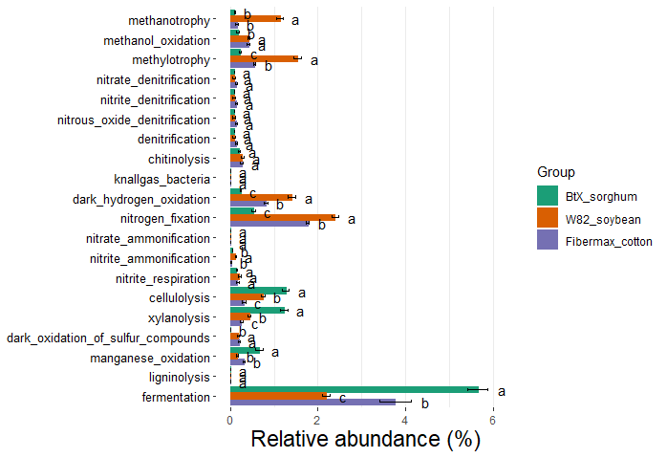
Figure S1. Functional pathway prediction of rhizobacteriomes associated with sorghum, soybean, and cotton using FABROTAX. The bar plot represents the relative abundance (%) of predicted functional pathways within the rhizobacteriomes of ‘BTx’ sorghum, ‘Williams 82’ soybean, and ‘Fibermax’ cotton. Pathways significantly enriched in each crop are denoted with letters (a, b, c) derived from Dunnett post-hoc pairwise comparisons following ANOVA statistical test.

