Appendix

Fig S1. Daytime population index by 25 districts in Seoul
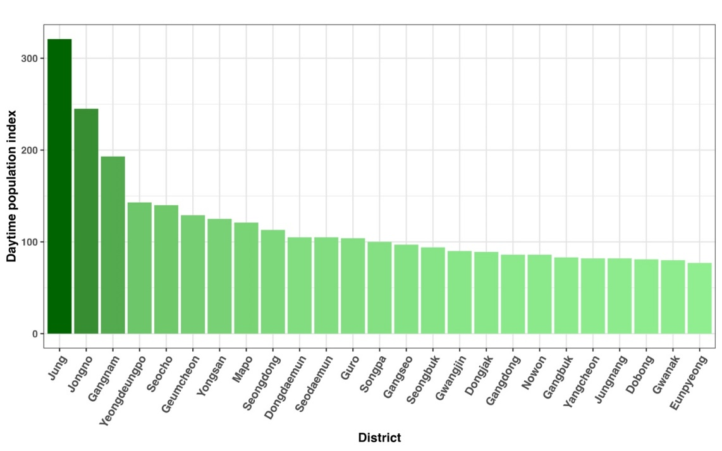
The daytime population index¹ value was provided by the Department of Statistics, which is defined as a relative number of populations during the daytime and nighttime based on mobile phone data. The index >100 indicates that the relative number of populations during daytime is greater than nighttime and <100 indicates the relative number of populations during daytime is less than nighttime. We grouped top 3 districts Jung-gu, Jongno-gu and Gangnam-gu as commercial areas while other as non-commercial areas.

Fig S2. Map of Seoul’s 25 Districts with Labeled Names
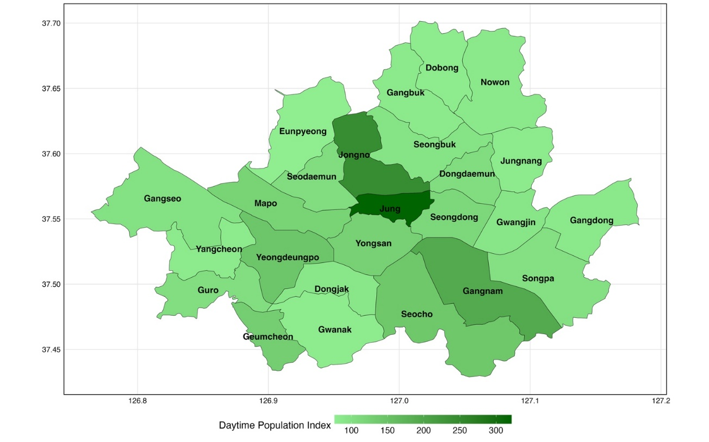
Figure S2. illustrates the boundaries and spatial layout of the 25 districts that comprise the city of Seoul. Each district is labeled with its name to provide a geographic reference framework which will assist readers in visually locating and identifying each district across the metropolitan area. Districts are shaded according to their daytime population index.
Table S1. District level coefficients

- Estimation results for mobility as outcome.
Estimation results for equation mobility:
mobility = incidences.l1 + mobility.l1 + policy.l1 + incidences.l2 + mobility.l2 + policy.l2 + const + trend + vaccination_coverage
DIST | Incidence.l1 | Incidence.l2 | Mobility.l1 | Mobility.l2 | Policy.l1 | Policy.l2 | Vacc
Whole city | -0.046 (0.014) ** | 0.002 (0.016) | 0.249 (0.158) | 0.075 (0.152) | -2.054 (0.910) ** | 1.249 (0.819) | 2.225 (0.694) **
Jung | -0.058 (0.040) | -0.048 (0.044) | -0.035 (0.157) | -0.157 (0.157) | -0.375 (0.093) ** | 0.091 (0.082) | 0.249 (0.068) **
Jongno | -0.069 (0.036) * | -0.001 (0.036) | 0.246 (0.176) | 0.086 (0.180) | -0.263 (0.089) ** | 0.155 (0.077) ** | 0.178 (0.078) **
Gangnam | -0.061 (0.038) | 0.028 (0.041) | 0.080 (0.148) | -0.069 (0.149) | -0.561 (0.176) ** | 0.093 (0.164) | 0.186 (0.094) *
Yeongdeungpo | -0.033 (0.015) ** | -0.026 (0.017) | 0.237 (0.149) | 0.088 (0.149) | -0.140 (0.063) ** | 0.104 (0.056) * | 0.143 (0.046) **
Seocho | -0.076 (0.030) ** | 0.026 (0.032) | 0.120 (0.148) | 0.034 (0.148) | -0.254 (0.100) ** | 0.040 (0.091) | 0.074 (0.049)
Geumcheon | -0.032 (0.011) ** | -0.010 (0.013) | -0.102 (0.136) | -0.126 (0.135) | -0.048 (0.020) ** | 0.002 (0.019) | 0.084 (0.024) **
Yongsan | -0.019 (0.012) | -0.003 (0.013) | 0.597 (0.160) ** | 0.189 (0.168) | -0.062 (0.036) * | 0.080 (0.033) ** | 0.017 (0.020)
Mapo | -0.042 (0.016) ** | 0.008 (0.017) | 0.543 (0.151) ** | 0.251 (0.154) | -0.067 (0.060) | 0.123 (0.053) ** | 0.030 (0.034)
Seongdong | -0.015 (0.012) | -0.022 (0.012) * | 0.287 (0.151) * | 0.044 (0.152) | -0.069 (0.034) ** | 0.033 (0.031) | 0.043 (0.019) **
Dongdaemun | -0.014 (0.005) ** | 0.004 (0.006) | 0.498 (0.146) ** | 0.134 (0.145) | -0.063 (0.024) ** | 0.059 (0.022) ** | 0.034 (0.020) *
Seodaemun | -0.028 (0.010) ** | 0.008 (0.011) | 0.504 (0.152) ** | 0.100 (0.150) | -0.053 (0.026) ** | 0.052 (0.023) ** | 0.023 (0.017)
Guro | -0.014 (0.006) ** | 0.005 (0.006) | 0.664 (0.145) ** | -0.237 (0.144) | -0.037 (0.027) | 0.009 (0.027) | 0.041 (0.030)
Songpa | -0.014 (0.008) * | -0.002 (0.009) | 0.522 (0.167) ** | 0.128 (0.172) | -0.103 (0.057) * | 0.099 (0.050) * | 0.064 (0.036) *
Gangseo | -0.012 (0.005) ** | -0.007 (0.006) | 0.468 (0.161) ** | -0.020 (0.150) | -0.050 (0.027) * | 0.032 (0.026) | 0.055 (0.019) **
Seongbuk | -0.015 (0.004) ** | -0.001 (0.005) | 0.782 (0.156) ** | 0.120 (0.152) | -0.004 (0.016) | 0.033 (0.015) ** | 0.025 (0.013) *
Gwangjin | -0.008 (0.005) * | -0.002 (0.005) | 0.866 (0.144) ** | 0.177 (0.160) | -0.013 (0.021) | 0.059 (0.020) ** | -0.002 (0.012)
Dongjak | -0.022 (0.007) ** | 0.008 (0.008) | 0.691 (0.153) ** | 0.125 (0.155) | -0.004 (0.023) | 0.026 (0.022) | 0.011 (0.012)
Gangdong | -0.009 (0.005) * | -0.001 (0.005) | 0.699 (0.163) ** | 0.176 (0.165) | -0.027 (0.019) | 0.047 (0.017) ** | 0.016 (0.013)
Nowon | -0.015 (0.006) ** | -0.002 (0.006) | 0.723 (0.153) ** | 0.148 (0.152) | -0.017 (0.020) | 0.043 (0.019) ** | 0.018 (0.014)
Gangbuk | -0.012 (0.005) ** | 0.000 (0.005) | 0.625 (0.145) ** | 0.166 (0.144) | -0.017 (0.013) | 0.031 (0.012) ** | 0.017 (0.011)
Yangcheon | -0.019 (0.005) ** | 0.006 (0.005) | 0.798 (0.139) ** | -0.076 (0.132) | -0.019 (0.014) | 0.027 (0.014) * | 0.011 (0.009)
Jungnang | -0.011 (0.004) ** | 0.003 (0.004) | 0.515 (0.138) ** | 0.224 (0.134) | -0.011 (0.012) | 0.020 (0.011) * | 0.007 (0.008)
Dobong | -0.007 (0.004) * | -0.005 (0.005) | 0.545 (0.129) ** | 0.172 (0.134) | -0.015 (0.011) | 0.020 (0.010) * | 0.014 (0.008) *
Gwanak | -0.007 (0.003) * | 0.001 (0.004) | 0.891 (0.153) ** | -0.096 (0.157) | -0.011 (0.021) | 0.029 (0.019) | 0.007 (0.010)
Eunpyeong | -0.007 (0.004) * | 0.003 (0.004) | 0.525 (0.132) ** | 0.230 (0.137) * | -0.021 (0.013) | 0.028 (0.012) ** | 0.006 (0.009)

- Estimation results for incidence as outcome

Estimation results for equation incidences:
incidences = incidences.l1 + mobility.l1 + policy.l1 + incidences.l2 + mobility.l2 + policy.l2 + const + trend + vaccination_ coverage
DIST | Incidence.l1 | Incidence.l2 | Mobility.l1 | Mobility.l2 | Policy.l1 | Policy.l2 | Vacc
Whole city | 1.242 (0.110) ** | -0.632 (0.129) ** | -2.095 (1.263) | 2.238 (1.220) * | 1.747 (7.290) | 2.538 (6.559) | 16.688 (5.560) **
Jung | 1.102 (0.100) ** | -0.590 (0.108) ** | 0.016 (0.391) | 0.797 (0.391) ** | 0.422 (0.230) * | 0.010 (0.204) | 0.386 (0.168) **
Jongno | 0.905 (0.128) ** | -0.428 (0.130) ** | -1.323 (0.626) ** | 0.034 (0.640) | -0.135 (0.318) | -0.129 (0.275) | 0.748 (0.279) **
Gangnam | 0.867 (0.125) ** | 0.024 (0.134) | -0.366 (0.488) | 0.963 (0.491) * | -0.791 (0.583) | 0.748 (0.543) | -0.359 (0.309)
Yeongdeungpo | 0.504 (0.130) ** | 0.222 (0.142) | -1.077 (1.275) | 2.500 (1.274) * | 0.688 (0.543) | -0.359 (0.476) | 0.928 (0.398) **
Seocho | 0.853 (0.130) ** | -0.074 (0.136) | 0.211 (0.638) | 0.465 (0.636) | 0.024 (0.432) | -0.241 (0.392) | 0.172 (0.210)
Geumcheon | 0.548 (0.161) ** | -0.134 (0.180) | -0.862 (1.917) | 4.808 (1.895) ** | 0.463 (0.280) | -0.060 (0.269) | 1.231 (0.335) **
Yongsan | 0.588 (0.126) ** | -0.054 (0.132) | -2.322 (1.684) | 3.292 (1.776) * | 0.240 (0.384) | -0.034 (0.345) | 0.023 (0.214)
Mapo | 1.082 (0.126) ** | -0.388 (0.139) ** | -0.579 (1.216) | 0.065 (1.241) | 0.042 (0.481) | -0.205 (0.425) | 0.309 (0.275)
Seongdong | 0.529 (0.133) ** | 0.013 (0.140) | -0.681 (1.698) | 2.418 (1.712) | 0.233 (0.379) | -0.083 (0.343) | 0.225 (0.210)
Dongdaemun | 0.833 (0.112) ** | -0.494 (0.120) ** | -8.239 (3.009) ** | 8.891 (2.993) ** | -0.148 (0.503) | 0.506 (0.456) | 1.702 (0.405) **
Seodaemun | 0.667 (0.131) ** | 0.046 (0.158) | -2.436 (2.092) | 3.929 (2.074) * | 0.451 (0.352) | -0.262 (0.315) | 0.111 (0.234)
Guro | 0.642 (0.120) ** | -0.101 (0.125) | -9.015 (2.796) ** | 9.902 (2.784) ** | -0.211 (0.516) | 0.577 (0.515) | 2.231 (0.581) **
Songpa | 1.016 (0.118) ** | -0.507 (0.128) ** | -0.799 (2.460) | 1.632 (2.538) | 0.221 (0.847) | 0.142 (0.738) | 1.241 (0.531) **
Gangseo | 0.825 (0.141) ** | -0.060 (0.155) | -2.703 (4.360) | 2.034 (4.054) | -0.419 (0.720) | -0.145 (0.703) | 0.825 (0.510)
Seongbuk | 0.699 (0.138) ** | -0.574 (0.152) ** | -8.176 (5.003) | 2.380 (4.867) | -0.097 (0.505) | -0.144 (0.487) | 2.094 (0.424) **
Gwangjin | 0.475 (0.127) ** | 0.138 (0.136) | -4.049 (3.769) | 6.533 (4.178) | 0.249 (0.554) | 0.212 (0.519) | -0.004 (0.318)
Dongjak | 0.780 (0.127) ** | 0.019 (0.139) | 2.418 (2.815) | -3.052 (2.856) | 0.774 (0.434) * | -1.157 (0.398) ** | 0.280 (0.229)
Gangdong | 0.545 (0.124) ** | -0.303 (0.130) ** | -2.378 (4.051) | 1.345 (4.109) | 0.647 (0.462) | -0.645 (0.428) | 1.585 (0.335) **
Nowon | 0.568 (0.133) ** | -0.268 (0.144) * | -2.999 (3.678) | -1.675 (3.642) | 0.059 (0.472) | -0.641 (0.451) | 1.481 (0.335) **
Gangbuk | 0.612 (0.143) ** | -0.228 (0.148) | 0.276 (4.421) | -1.560 (4.387) | 0.135 (0.411) | -0.125 (0.381) | 0.978 (0.327) **
Yangcheon | 0.782 (0.146) ** | -0.221 (0.167) | -0.975 (4.453) | -1.565 (4.219) | 0.263 (0.459) | -0.309 (0.443) | 0.614 (0.282) **
Jungnang | 0.683 (0.143) ** | -0.208 (0.157) | -2.904 (5.560) | 0.003 (5.426) | 0.363 (0.494) | -0.353 (0.452) | 0.551 (0.316) *
Dobong | 0.703 (0.122) ** | -0.308 (0.136) ** | 2.257 (3.832) | -3.408 (3.988) | 0.416 (0.338) | -0.435 (0.305) | 0.772 (0.224) **
Gwanak | 0.822 (0.140) ** | -0.101 (0.145) | -6.201 (6.173) | 2.750 (6.365) | 0.220 (0.832) | -0.703 (0.785) | 0.874 (0.406) **
Eunpyeong | 0.935 (0.145) ** | -0.445 (0.163) ** | -2.770 (4.855) | 1.384 (5.043) | 0.551 (0.472) | -0.353 (0.429) | 0.894 (0.326) **

- Estimation results for policy as outcome
Estimation results for equation policy:
policy = incidences.l1 + mobility.l1 + policy.l1 + incidences.l2 + mobility.l2 + policy.l2 + const + trend + vaccination_ coverage
DIST | Incidence.l1 | Incidence.l2 | Mobility.l1 | Mobility.l2 | Policy.l1 | Policy.l2 | Vacc
Whole city | -0.003 (0.004) | 0.014 (0.004) ** | -0.006 (0.042) | 0.016 (0.041) | 0.785 (0.242) ** | -0.195 (0.218) | -0.576 (0.185) **
Jung | -0.010 (0.105) | 0.239 (0.113) ** | -0.411 (0.408) | 0.049 (0.409) | 0.876 (0.241) ** | -0.230 (0.213) | -0.408 (0.175) **
Jongno | 0.051 (0.112) | -0.001 (0.113) | -0.798 (0.547) | -0.348 (0.560) | 0.721 (0.278) ** | -0.286 (0.240) | -0.124 (0.244)
Gangnam | 0.031 (0.048) | 0.093 (0.052) * | -0.173 (0.190) | -0.051 (0.191) | 0.693 (0.226) ** | -0.045 (0.211) | -0.275 (0.120) **
Yeongdeungpo | 0.020 (0.058) | 0.134 (0.064) ** | -0.633 (0.572) | -0.184 (0.572) | 0.721 (0.244) ** | -0.251 (0.214) | -0.498 (0.179) **
Seocho | 0.001 (0.077) | 0.145 (0.081) * | -0.294 (0.378) | -0.135 (0.377) | 0.694 (0.256) ** | -0.102 (0.232) | -0.155 (0.125)
Geumcheon | 0.334 (0.123) ** | 0.058 (0.137) | -0.054 (1.456) | -0.003 (1.439) | 0.851 (0.213) ** | -0.200 (0.204) | -0.850 (0.255) **
Yongsan | 0.080 (0.082) | 0.180 (0.087) ** | -2.187 (1.101) * | 0.674 (1.161) | 0.558 (0.251) ** | -0.036 (0.226) | -0.186 (0.140)
Mapo | -0.037 (0.063) | 0.227 (0.070) ** | -0.329 (0.612) | -0.044 (0.624) | 0.740 (0.242) ** | -0.220 (0.214) | -0.339 (0.138) **
Seongdong | 0.055 (0.083) | 0.170 (0.088) * | -1.524 (1.067) | -0.295 (1.076) | 0.650 (0.238) ** | -0.091 (0.216) | -0.285 (0.132) **
Dongdaemun | 0.011 (0.053) | 0.101 (0.057) * | -0.744 (1.427) | -0.794 (1.420) | 0.901 (0.238) ** | -0.250 (0.216) | -0.410 (0.192) **
Seodaemun | 0.140 (0.086) | 0.206 (0.103) * | -0.237 (1.364) | -0.262 (1.352) | 0.763 (0.230) ** | -0.223 (0.205) | -0.429 (0.152) **
Guro | 0.049 (0.053) | 0.094 (0.056) * | -0.383 (1.244) | 0.563 (1.239) | 0.976 (0.230) ** | -0.241 (0.229) | -0.841 (0.258) **
Songpa | -0.044 (0.035) | 0.116 (0.038) ** | -1.011 (0.734) | 0.276 (0.757) | 0.775 (0.253) ** | -0.171 (0.220) | -0.318 (0.158) **
Gangseo | -0.023 (0.052) | 0.134 (0.057) ** | 0.327 (1.592) | 0.161 (1.480) | 0.947 (0.263) ** | -0.201 (0.257) | -0.384 (0.186) **
Seongbuk | -0.024 (0.070) | 0.115 (0.077) | -2.431 (2.552) | -0.185 (2.482) | 0.675 (0.257) ** | -0.157 (0.248) | -0.236 (0.216)
Gwangjin | 0.076 (0.055) | 0.145 (0.059) ** | -1.895 (1.628) | -1.032 (1.805) | 0.579 (0.240) ** | -0.224 (0.224) | -0.245 (0.137) *
Dongjak | 0.154 (0.077) ** | -0.001 (0.084) | -0.531 (1.706) | -1.483 (1.730) | 0.682 (0.263) ** | -0.204 (0.241) | -0.213 (0.139)
Gangdong | -0.114 (0.070) | 0.146 (0.074) * | -2.866 (2.295) | -0.935 (2.328) | 0.768 (0.262) ** | -0.284 (0.242) | -0.139 (0.190)
Nowon | -0.109 (0.073) | 0.140 (0.079) * | -1.052 (2.011) | -1.581 (1.991) | 0.896 (0.258) ** | -0.389 (0.246) | -0.077 (0.183)
Gangbuk | -0.078 (0.083) | 0.194 (0.086) ** | 0.249 (2.569) | -0.858 (2.548) | 1.107 (0.239) ** | -0.371 (0.221) * | -0.306 (0.190)
Yangcheon | 0.044 (0.073) | 0.198 (0.084) ** | 1.242 (2.230) | -1.061 (2.113) | 0.880 (0.230) ** | -0.292 (0.222) | -0.351 (0.141) **
Jungnang | 0.106 (0.069) | 0.054 (0.075) | 1.477 (2.667) | -3.602 (2.603) | 0.871 (0.237) ** | -0.291 (0.217) | -0.258 (0.151) *
Dobong | -0.118 (0.077) | 0.254 (0.086) ** | -0.466 (2.418) | -3.413 (2.516) | 0.828 (0.213) ** | -0.257 (0.192) | -0.186 (0.141)
Gwanak | -0.039 (0.044) | 0.087 (0.046) * | -1.145 (1.950) | -2.771 (2.010) | 0.793 (0.263) ** | -0.426 (0.248) * | -0.122 (0.128)
Eunpyeong | 0.056 (0.062) | 0.172 (0.069) ** | 0.058 (2.061) | -2.473 (2.141) | 0.774 (0.200) ** | -0.313 (0.182) * | -0.421 (0.138) **
Notes: Each row represents a different district, including an aggregate labeled “Whole city”. Ordered by daytime population index¹, as shown in Appendix Figure S1, the top three districts are classified as commercial areas, while the remaining ones are categorized as non-commercial districts. Each column represents different variables (I: Incidence, M: Mobility, P: Policy) with lagged effects (.1: one week lag, .2: two weeks lag), and Vaccination coverage (Vacc) as an exogenous factor. The colors indicate significance and direction: Red: Positive significant relationship (dark red for 95% significance, light red for 90%). Blue: Negative significant relationship (dark blue for 95% significance, light blue for 90%). White: No significant relationship.

As Table S1 shows, COVID-19 cases have a strong immediate negative association with mobility (Panel A, I.1), especially in non-commercial districts, suggesting that fear of infection drives voluntary mobility reductions². In contrast, commercial district mobility is unaffected by prior mobility trends but responds significantly to social distancing policy interventions (Panel A, M.1 and P.1), highlighting the impact of stringent policies in these areas. Social distancing policies had minimal direct effects on COVID-19 incidence in most of the districts (Panel B, P.1 and P.2). However, past mobility was positively associated with current incidence (Panel B, M.2), particularly in commercial areas, reflecting a lag from increased transmission due to the incubation period. Social distancing policies likely influence incidence indirectly by reducing mobility, which impacts transmission with a one-week lag. Additionally, incidence is positively affected social distancing policy measures after two weeks (Panel C, I.2), while mobility does not significantly affect social distancing policy decisions (Panel C, M.1 and M.2), indicating that recent mobility trends did not directly drive social distancing policy changes.

Furthermore, higher vaccination coverage is consistently associated with increased mobility and reduced social distancing policy restrictions (Panel A and Panel B, Vacc), particularly in commercial districts, highlighting the role of vaccination in easing mobility constraints and revitalizing activity levels. However, contrary to expectations, the incidence rate is positively correlated with vaccination coverage. This unexpected relationship may be attributed to the emergence of the Delta variant while scaling up vaccination efforts.

Table S2. Lag selection

Criteria | 1 | 2 | 3 | 4 | 5 | 6 | 7 | 8 | 9 | 10
AIC(n) | -2.71 | -3.07 | -3.11 | -3.55 | -3.72 | -3.75 | -3.79 | -4.05 | -4.03 | -4.15
HQ(n) | -2.51 | -2.74 | -2.66 | -2.98 | -3.03 | -2.94 | -2.86 | -2.99 | -2.85 | -2.85
SC(n) | -2.19 | -2.24 | -1.96 | -2.10 | -1.96 | -1.67 | -1.40 | -1.35 | -1.02 | -0.83
FPE(n) | 0.07 | 0.05 | 0.05 | 0.03 | 0.03 | 0.03 | 0.03 | 0.02 | 0.02 | 0.02

We considered four key criteria for determining the optimal lag length in our VAR model: Akaike Information Criterion (AIC), Hannan-Quinn Criterion (HQ), Schwarz Criterion (SC, also known as BIC), and Final Prediction Error (FPE). Each of these criteria offers a different perspective on balancing model fit and complexity. The AIC and FPE tend to favor models with more lags, potentially capturing more intricate relationships but also increasing the risk of overfitting. On the other hand, the HQ and SC criteria emphasize model simplicity, penalizing the inclusion of too many lags to reduce the chances of overfitting and improving model generalizability.

After evaluating all criteria, we selected a 2-week lag based on the Schwarz Criterion (SC), which is known for its conservative nature in selecting model parameters. This choice is particularly important for the VARX model, as it allows us to capture the dynamic interactions between endogenous variables (social distancing policy, mobility, and COVID-19 incidences) while accounting for the influence of exogenous factors such as vaccination coverage. Furthermore, selecting a shorter lag aligns with practical considerations in pandemic studies, where the effects of social distancing policies, such as lockdowns or mobility restrictions, often manifest within a short time frame. Therefore, the 2-week lag strikes a balance between capturing the necessary temporal dynamics and maintaining a parsimonious model that is interpretable and relevant for analyzing the interactions between social distancing policy, mobility, vaccination coverage, and COVID-19 incidence rates. Consistent with our approach, a 2-week lag was also optimal in all other regions analyzed, ensuring comparability of results.

Figure S2. Unit root test
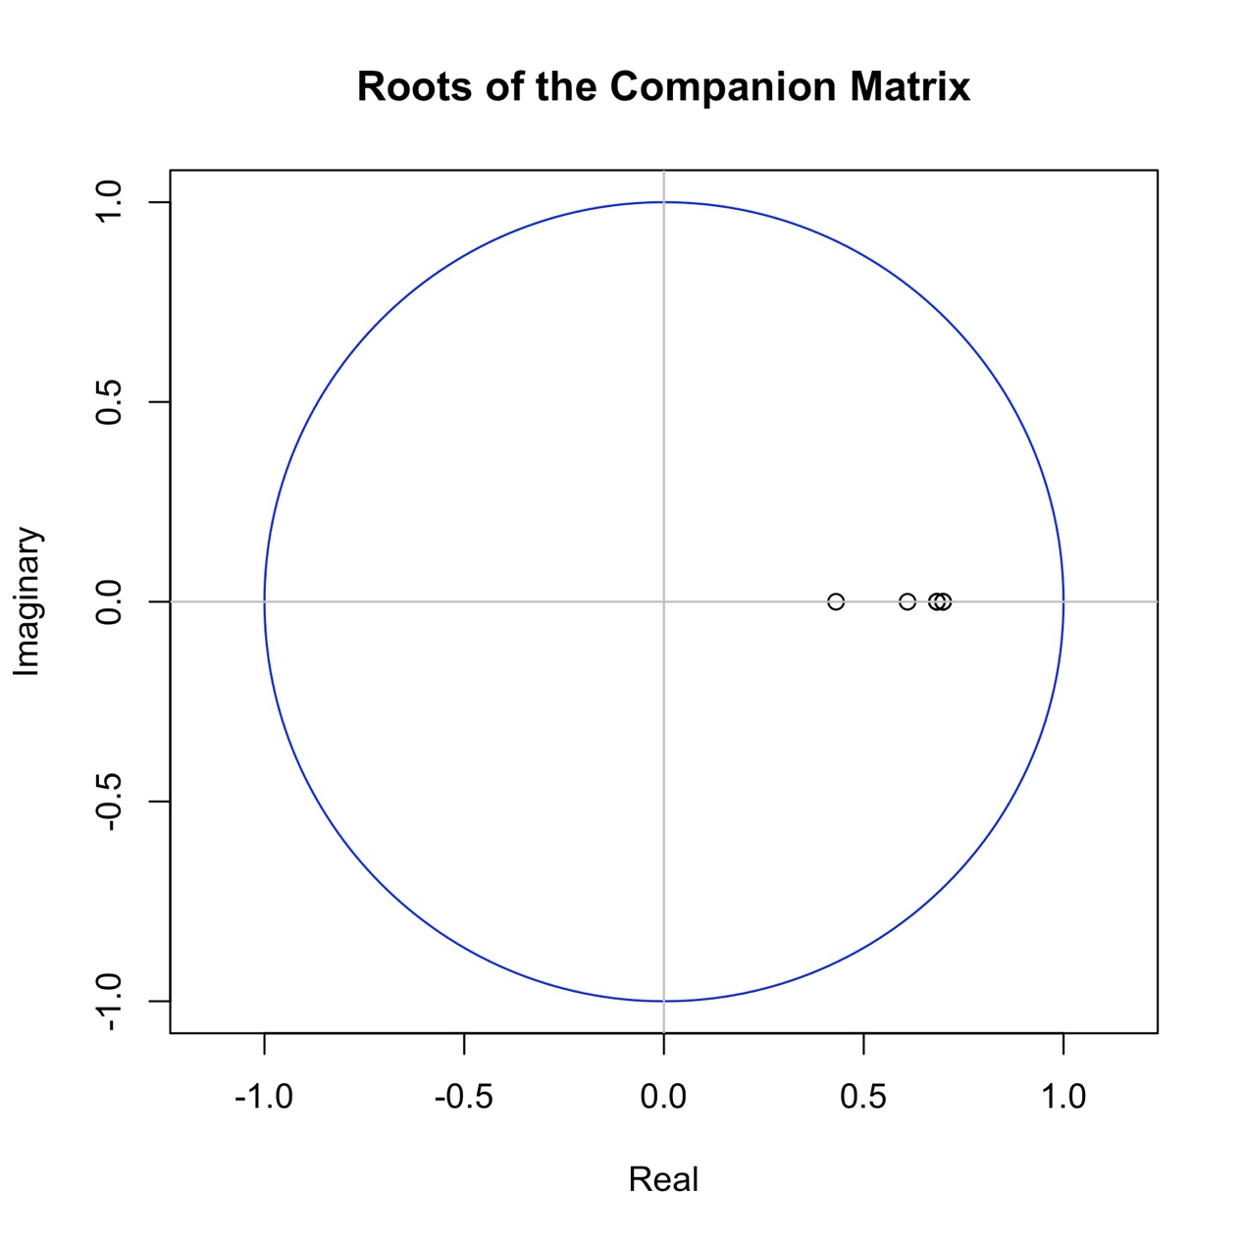
Roots of the characteristic polynomial: 0.6985 0.6985 0.6831 0.6831 0.6097 0.4306
The characteristic polynomial roots are derived from the coefficients of the VARX model and represent the dynamics of the time series process. Specifically, they help determine if the process is stable over time. In a stable VARX model, the influence of shocks or past values diminishes over time rather than amplifying, leading to a stationary process.

For the model to be stable, all roots of the characteristic polynomial must lie within the unit circle (i.e., have an absolute value less than one). This ensures that the time series will revert to its mean or equilibrium following a shock, rather than diverging over time. In our case, the roots all fall within the unit circle, confirming that the model is stable.

This stability check was performed across all models in each district as well, with all roots confirming stability as each root has an absolute value less than 1. This validation supports the robustness of our results and ensures that each district’s model is appropriate for interpreting long-term dynamics.

Reference
1. Seoul Metropolitan Government, Seoul Open Data Plaza. https://data.seoul.go.kr/dataService/boardList.do.
2. Lee, M. et al. Human Mobility Trends during the COVID-19 Pandemic in the United States. PLoS ONE 15, e0241468 (2020).

