Plate 1 Centriod structure of natural honey

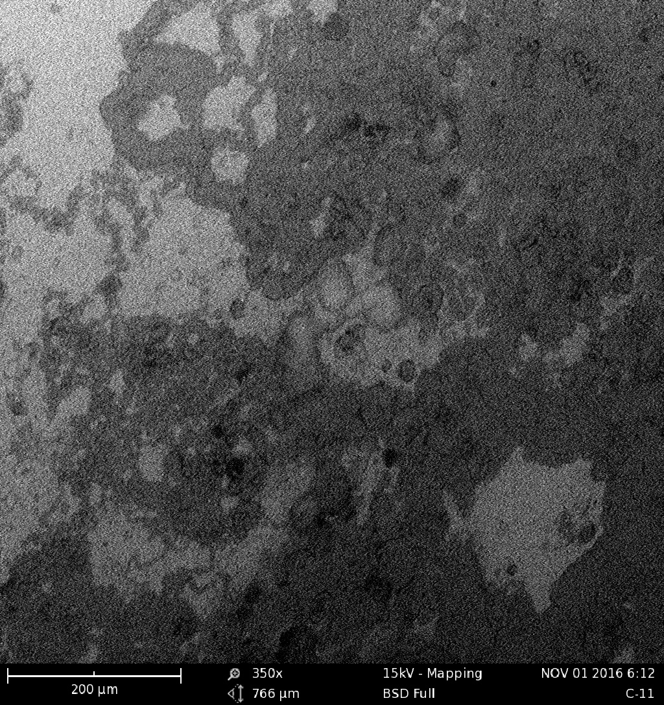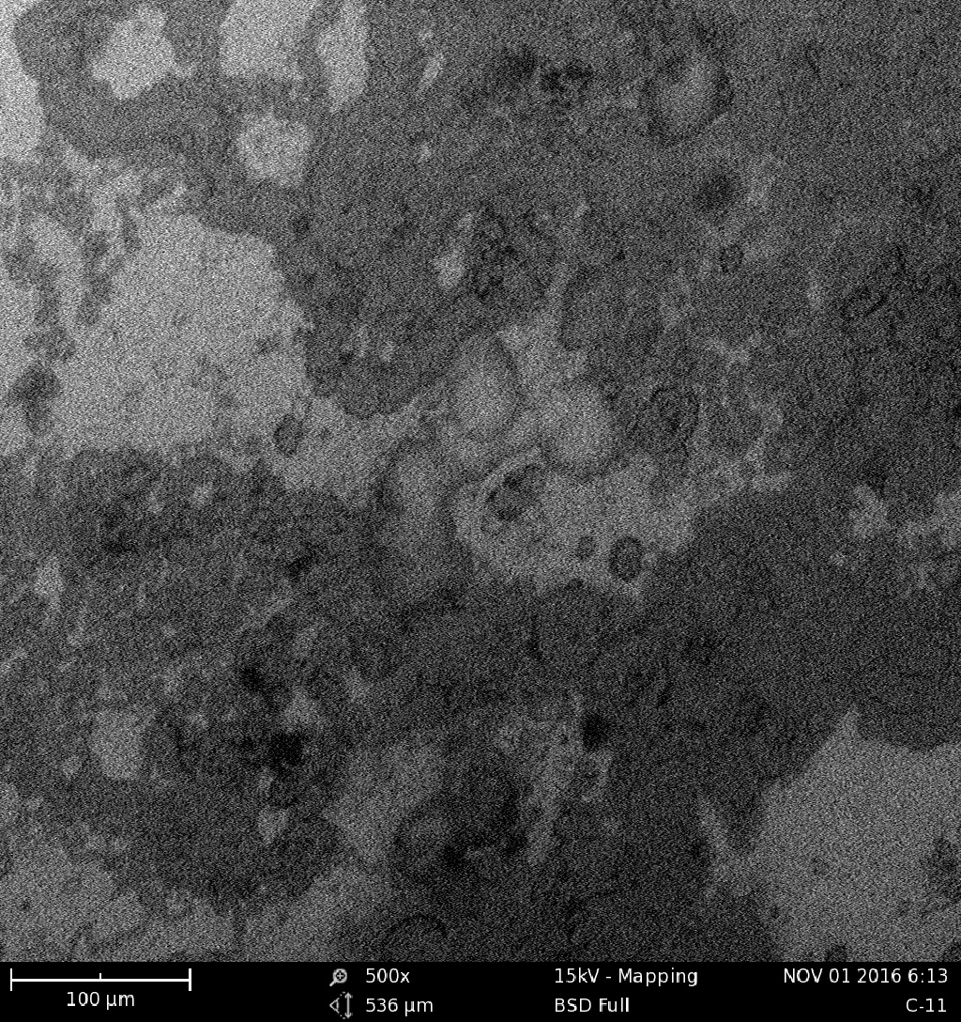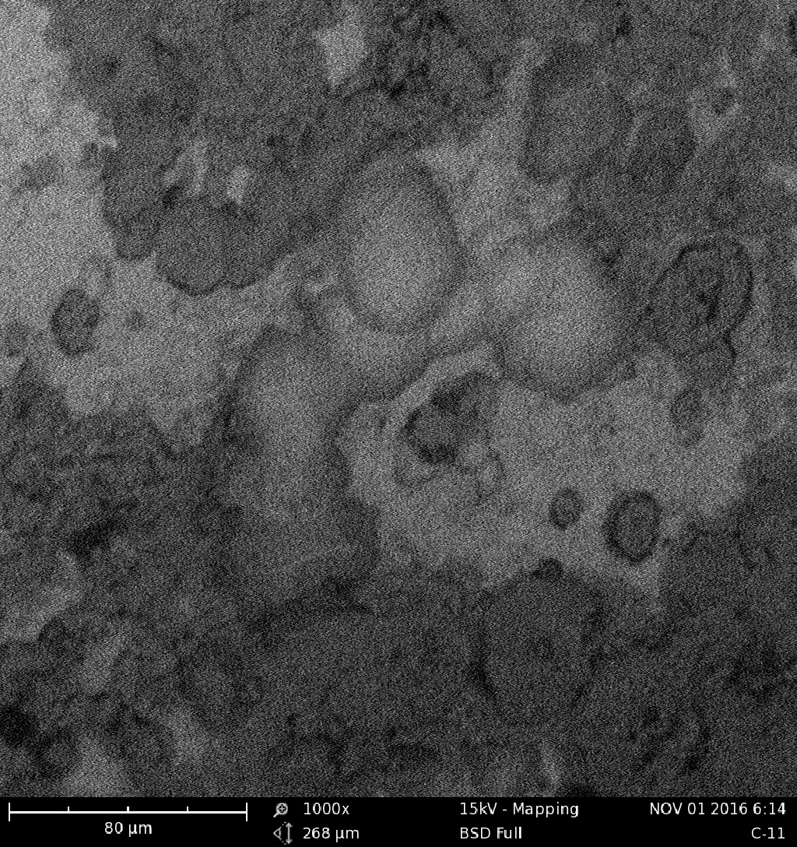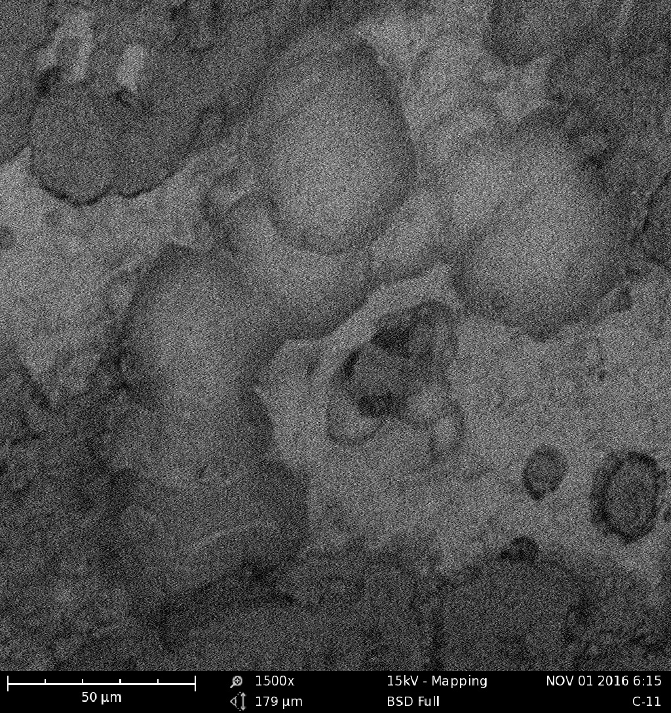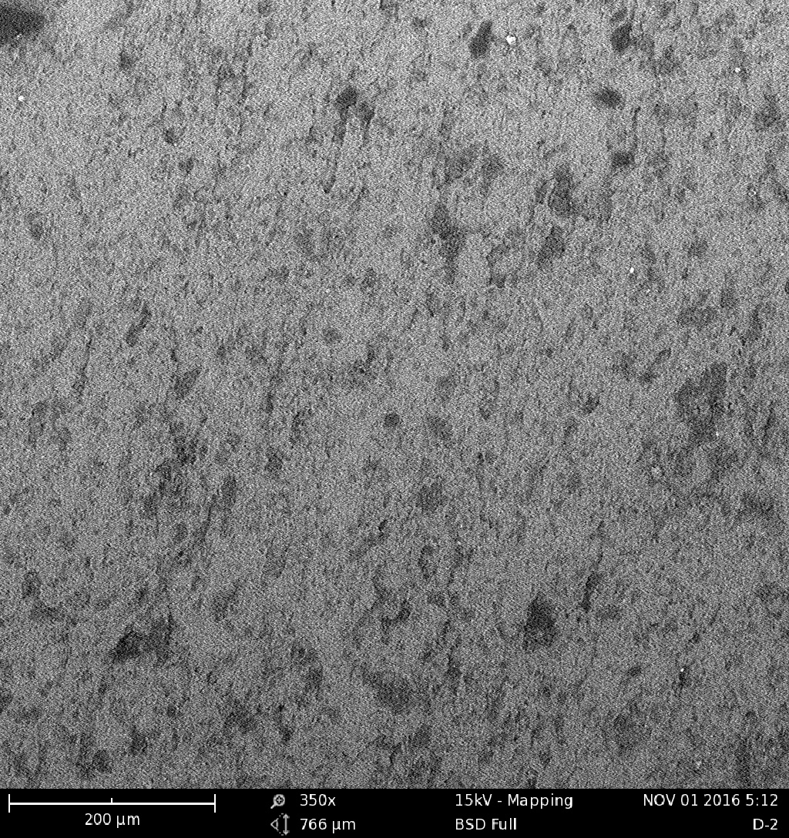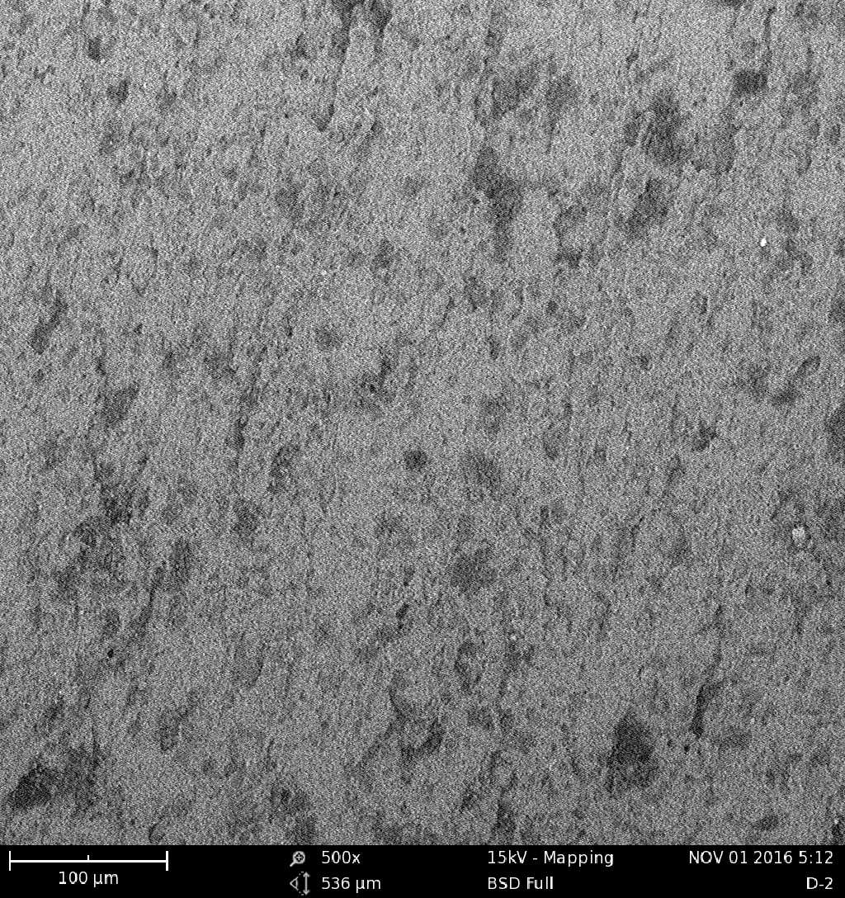
(a) (b) (c) (d) (e) (f)
Plate 2 Micrographs of corroded metal surfaces with differences in morphology:
Plate 2a Micrographs of corroded metal surfaces with differences in morphology: [SEM image for ‘a’ unexposed mild steel in 0.5 M HCl.

