Demographic and clinical variables | ALS (N = 53) | ALS mimics (N = 12) |  | HCs (N = 50) | p value
Age, mean (SD), y | 54.87 (12.41) | 47.17 (12.61) |  | 52.12 (6.78) | 0.131ª
Sex, no. (%)
Male | 28 (52.83) | 7 (58.33) |  | 22 (44.00) | 0.545^{b}
Female | 25 (47.17) | 5 (41.67) |  | 28 (56.00) | 0.545^{b}
Diagnosis by Revised EEC, no. (%)
Clinically definite ALS | 20 (37.74) | NA |  | NA | NA
Clinically probable ALS | 15 (28.30) |  |  | NA | NA
Clinically probable – LS ALS  Clinically possible ALS | 11 (20.75)  7 (13.21) |  |  | NA | NA
MGH UMNSs, mean (SD) | 27.04 (8.37) | HSP | LMN Syndrome* | NA | 0.003ª
MGH UMNSs, mean (SD) | 27.04 (8.37) | 30.50 (2.81) | 15.17 (3.37) | NA | 0.003ª
Disease duration, median (IQR), mo. | 13.00 (7.00-20.00) | 24.00 (17.25-81.00) |  | NA | 0.001^{c}
Interval between baseline and follow-up**, median (IQR), mo. | 6.00 (5.50-8.00) | 6.00 (6.00-7.00) |  | NA | 0.393^{c}
ALSFRS-R1, median (IQR) | 42.00 (39.00-44.00) | 43.00 (42.00-44.00) |  | NA | 0.174^{c}
ALSFRS-R2^{d}, median (IQR) | 37.00 (31.00-40.00) | 42.00 (39.25-43.00) |  | NA | 0.003^{c}
ΔFS^{d}, median (IQR) | 0.67 (0.50-1.16) | 0.08 (0.00-0.45) |  | NA | < 0.0001^{c}
Table S1 Demographic data and clinical data of ALS, ALS mimics and HCs
Statistical significance was defined as p < 0.05. Abbreviations: ALS, amyotrophic lateral sclerosis; HCs, healthy controls; Clinically probable – LS ALS, clinically probable laboratory–supported ALS; Revised EEC, revised El Escorial criteria; MGH UMNSs, MGH upper motor neuron scales; HSP, hereditary spastic paraplegia; LMN Syndrome, lower motor neuron syndrome; ALSFRS-R1, revised amyotrophic lateral sclerosis functional rating scale at baseline; ALSFRS-R2, revised amyotrophic lateral sclerosis functional rating scale at follow-up; ΔFS, disease progression rate, SD, standard deviation; IQR, interquartile range; NA, not available.
ª Kruskal-Wallis H test
^{b} Chi-square test
^{c} Mann-Whitney U test
^{d} Forty-one ALS patients and twelve ALS mimics were followed up.
* Include 4 chronic inflammatory demyelinating polyradiculoneuropathy (CIDP) patients, 2 multifocal motor neuropathy (MMN) patients.
** The mean follow-up interval was 6.61 months for ALS patients and 7.17 months for ALS mimics.

Table S2 Demographic and clinical data between ALS subgroups whose MBHR ≤ 54.6%
Clinical variables | Clinically definite ALS (N = 18) | Clinically probable ALS (N = 11) | Clinically probable – LS ALS (N = 6) | Clinically possible ALS (N =3)
Age, mean (SD), y | 51.78 (14.72) | 55.36 (13.08) | 50.33 (7.92) | 65.67 (9.50)
Sex, no. (%)
Male | 6 (33.33) | 7 (63.64) | 1 (16.67) | 2 (66.67)
Female | 12 (66.67) | 4 (36.36) | 5 (83.33) | 1 (33.33)
MGH UMNSs, mean (SD) | 33.00 (5.74) | 27.73 (8.26) | 27.50 (6.44) | 23.00 (11.53)
Disease duration, median (IQR), mo. | 15.00 (7.00-21.00) | 12.00 (6.00-13.00) | 11.50 (6.75-14.75) | 38.00 (7.00-NA)
ALSFRS-R1, median (IQR) | 39.00 (35.75-42.50) | 41.00 (37.00-44.00) | 44.00 (40.25-46.00) | 42.00 (42.00-NA)
ALSFRS-R2^{d}, median (IQR) | 35.00 (24.00-41.5) | 34.00 (28.50-38.25) | 38.50 (31.00-39.25) | 43.00 (43.00-43.00)
ΔFS^{d}, median (IQR) | 1.00 (0.50-1.93) | 0.81 (0.67-1.45) | 0.67 (0.53-0.98) | 0.50 (0.50-0.50)
MBHR, mean (SD) | 35.15 (13.57) | 40.16 (9.79) | 41.15 (6.65) | 52.2 (2.29)
Abbreviations: ALS, amyotrophic lateral sclerosis; MGH UMNSs, MGH upper motor neuron scales; ALSFRS-R1, revised amyotrophic lateral sclerosis functional rating scale at baseline; ALSFRS-R2, revised amyotrophic lateral sclerosis functional rating scale at follow-up; SD, standard deviation; IQR, interquartile range; MBHR, motor band hypointensity ratio; NA, not available.

Table S3 The comparison of MGH UMNSs and ALSFRS-R1 between ALS subgroups
Clinical variables | Clinically definite/probable ALS (N = 35) | Clinically probable – LS/ possible ALS (N = 18) | p value
MGH UMNSs, mean (SD) | 30.94 (6.08) | 22.83 (8.54) | 0.028ª
ALSFRS-R1, median (IQR) | 39.00 (35.50 - 43.50) | 43.00 (42.00 - 44.00) | 0.027^{b}
Statistical significance was defined as p < 0.05. Abbreviations: Clinically probable – LS ALS, clinically probable laboratory–supported ALS; MGH UMNSs, MGH upper motor neuron scales; ALSFRS-R1, revised amyotrophic lateral sclerosis functional rating scale at baseline; SD, standard deviation; IQR, interquartile range.
ª Independent-Sample T Test
^{b} Mann-Whitney U test

Table S4 Demographic and clinical data between patients who completed follow-up and those excluded
Clinical variables | ALS patients under follow-up  (N = 41) | ALS patients lost to follow-up  (N = 12) | p value
Age, mean (SD), y | 54.37 (12.20) | 56.58 (13.54) | 0.614ª
Sex, no. (%)
Male | 21 (51.20) | 7 (58.30) | 0.664^{b}
Female | 20 (48.80) | 5 (41.70) | 0.664^{b}
MGH UMNSs, mean (SD) | 25.83 (7.90) | 31.17 (8.94) | 0.936ª
Disease duration, median (IQR), mo. | 14 (7.00-24.00) | 15 (6.25-22.50) | 0.757^{c}
ALSFRS-R1, median (IQR) | 43.0 (39.50-44.00) | 42.0 (39.25-44.25) | 0.856^{c}
MBHR, mean (SD) | 48.55 (16.36) | 40.92(16.71) | 0.905ª
Statistical significance was defined as p < 0.05. Abbreviations: ALS, amyotrophic lateral sclerosis; MGH UMNSs, MGH upper motor neuron scales; ALSFRS-R1, revised amyotrophic lateral sclerosis functional rating scale at baseline; MBHR, motor band hypointensity ratio; SD, standard deviation; IQR, interquartile range.
ª Independent-Sample T Test
^{b} Chi-square test
^{c} Mann-Whitney U test

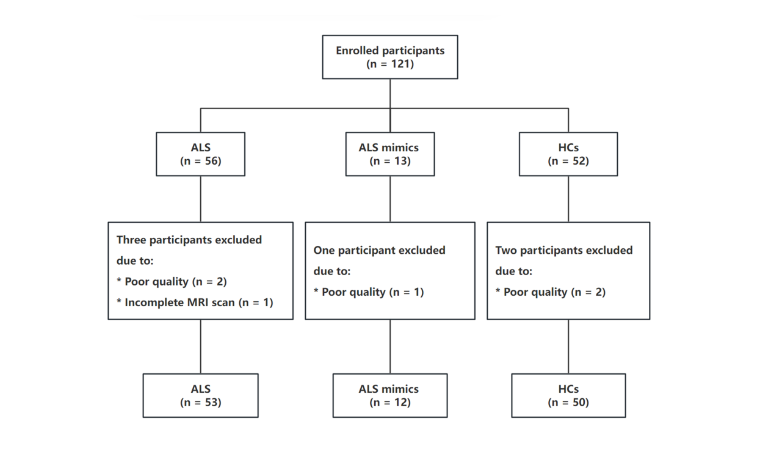

Fig. S1 Flow chart of this study
Abbreviations: ALS, amyotrophic lateral sclerosis; HCs, healthy controls; MRI, magnetic resonance imaging.

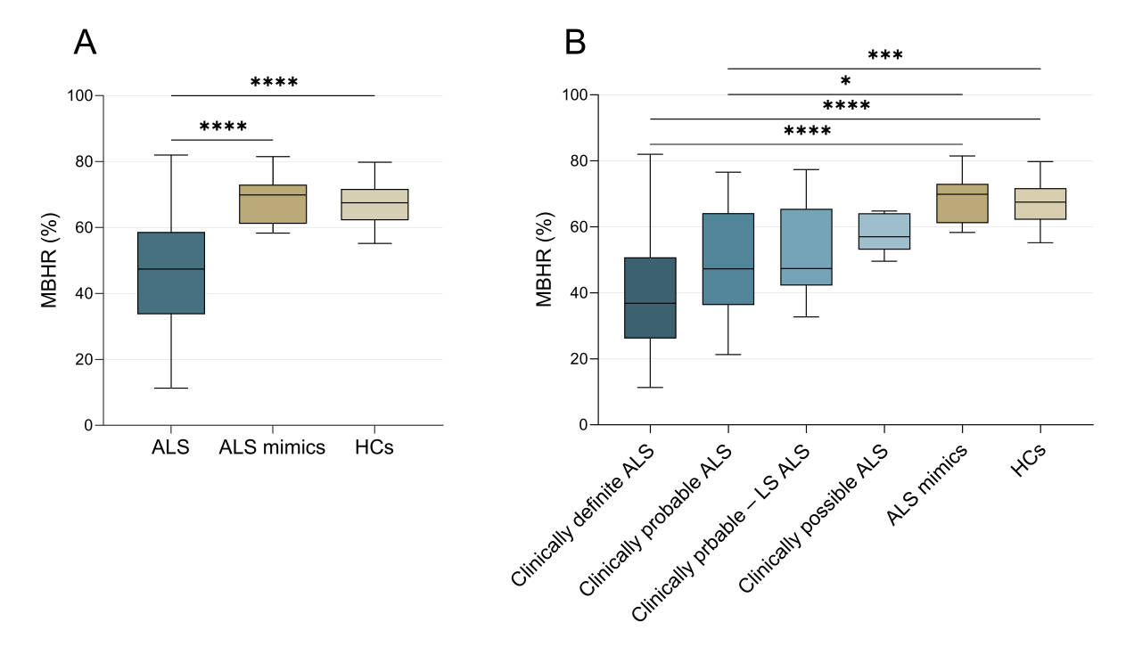
Fig. S2 Comparison of MBHR among ALS, ALS mimics, and HCs
(A) MBHR was significantly lower in ALS patients compared to both ALS mimics (p < 0.0001) and HCs (p < 0.0001). (B) Subgroup analysis revealed that MBHR reductions were particularly prominent in clinically definite ALS (vs. ALS mimics: p < 0.0001; vs. HCs: p < 0.0001) and clinically probable ALS (vs. ALS mimics: p = 0.01; vs. HCs: p = 0.0006) subgroups. However, no statistically significant differences were observed in clinically probable – LS ALS (vs. ALS mimics: p = 0.22; vs. HCs: p = 0.07) or clinically possible ALS (vs. ALS mimics: p = 0.45; vs. HCs: p = 0.28) subgroups. Abbreviations: MBHR, motor band hypointensity ratio; ALS, amyotrophic lateral sclerosis; HCs, healthy controls; clinically probable – LS ALS, clinically probable laboratory–supported ALS.
*p < 0.05 **p < 0.01 ***p < 0.001 ****p < 0.0001.

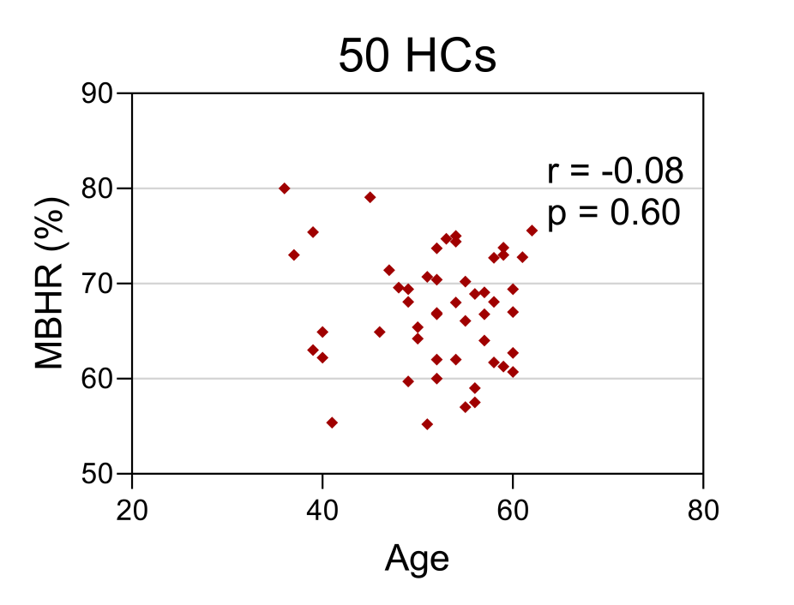
Fig. S3 Correlation analyses between MBHR and age in HCs
No correlation was observed between MBHR and age in 50 HCs (r = -0.08, p = 0.60). Abbreviations: MBHR, motor band hypointensity ratio; HCs, healthy controls.

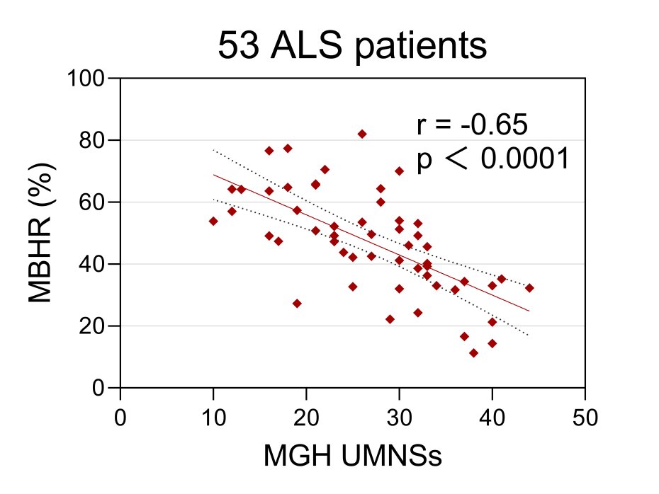

Fig. S4 Correlation analysis between MBHR and MGH UMNSs in ALS patients
A negative correlation was observed between MBHR and MGH UMNSs in 53 ALS patients (r = -0.65, p < 0.0001). Abbreviations: MBHR, motor band hypointensity ratio; MGH UMNSs, MGH upper motor neuron scales; ALS, amyotrophic lateral sclerosis.

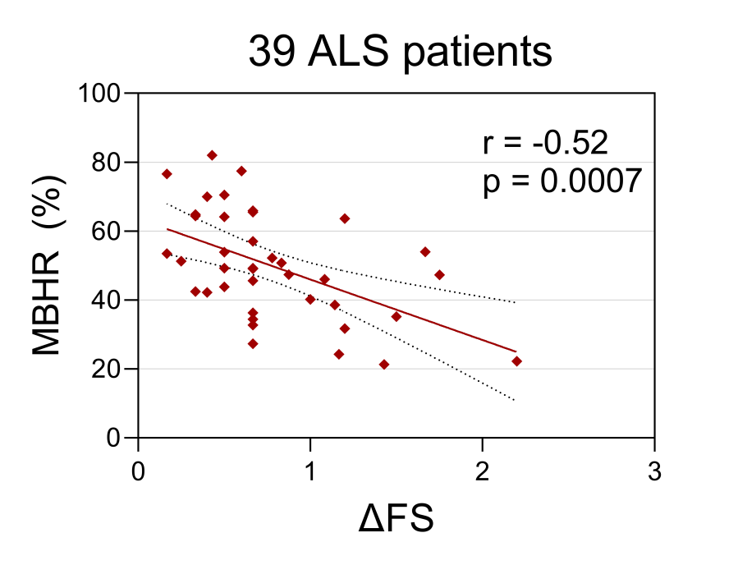

Fig. S5 Correlation analysis between MBHR and ΔFS in ALS patients, 2 outlier patients with rapid progression were excluded
A strong negative correlation between MBHR and ΔFS was observed in 39 ALS patients (r = -0.52, p = 0.0007) Abbreviations: ALS, amyotrophic lateral sclerosis; MGH UMNSs, MGH upper motor neuron scales; MBHR, motor band hypointensity ratio.

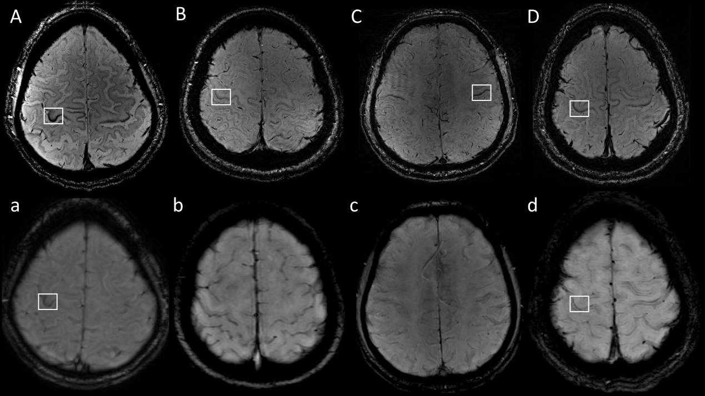
Fig. S6 7T and 3T SWI images of 4 ALS patients
Upper panels A-D display 7T SWI images from four ALS patients with post-evaluation confirmation of MBS (white boxes). Corresponding 3T SWI images (lower panels) demonstrate discernible MBS in Patients A and D.

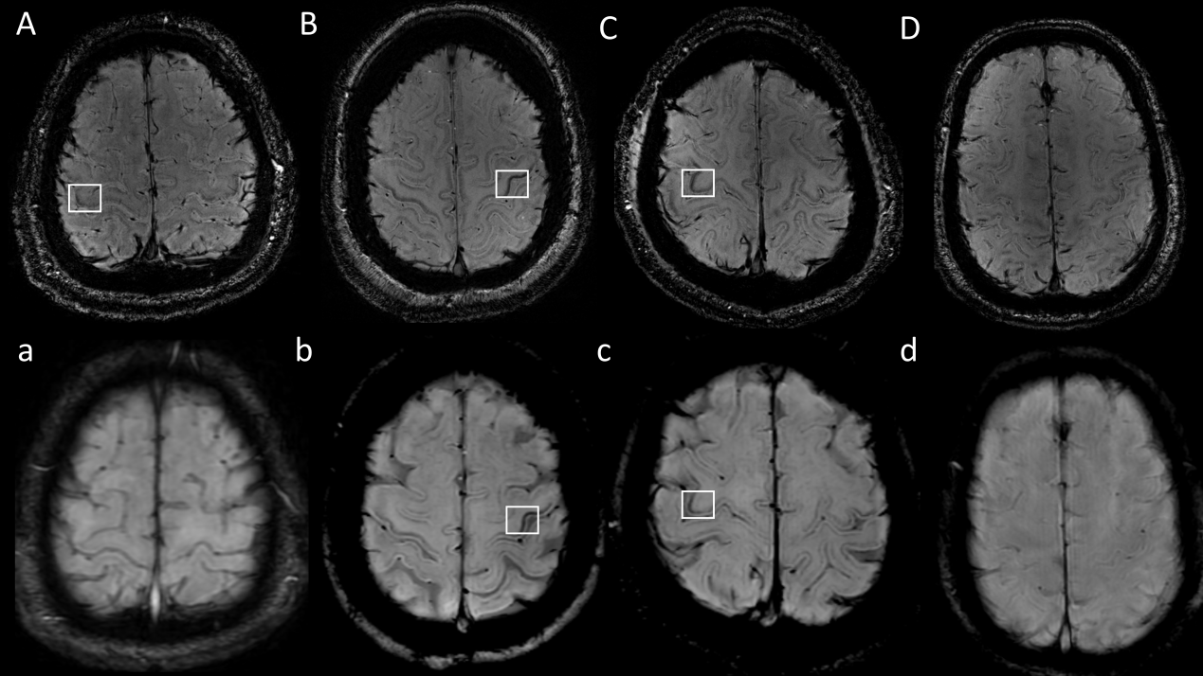
Fig. S7 7T and 3T SWI images of other 4 ALS patients
Panels A-D display 7T SWI images from four ALS patients. Post-evaluation, MBS (white boxes) were identified in Patients A-C but absent in Patient D. Corresponding 3T SWI images (lower panel) revealed discernible MBS only in Patients B and C.

Fig. S8 Motor band sign in 7T SWI (1)
(A)-(R) Clinically definite ALS patients.

Fig. S9 Motor band sign in 7T SWI (2)
(A)-(K) Clinically probable ALS patients.

Fig. S10 Motor band sign in 7T SWI (3)
(A)-(F) clinically probable laboratory–supported ALS patients; (G)-(I) Clinically possible ALS patients.

