Copper-Cobalt Bimetallic nanoparticles supported on Magnetic MOF Derived N-doped carbon as highly efficient Catalysts for the C–N coupling and one-pot multicomponent reaction
Arezoo Ahmadiª , Heshmatollah Alinezhad^{a*} , Yaghoub Sarrafiª
ª Department of Organic Chemistry, Faculty of Chemistry, University of Mazandaran, Babolsar, Iran

*Heshmatollah Alinezhad
E-mail address:
E-mail address: Heshmat@umz.ac.ir

Product Characterization Data for N-arylation Reactions
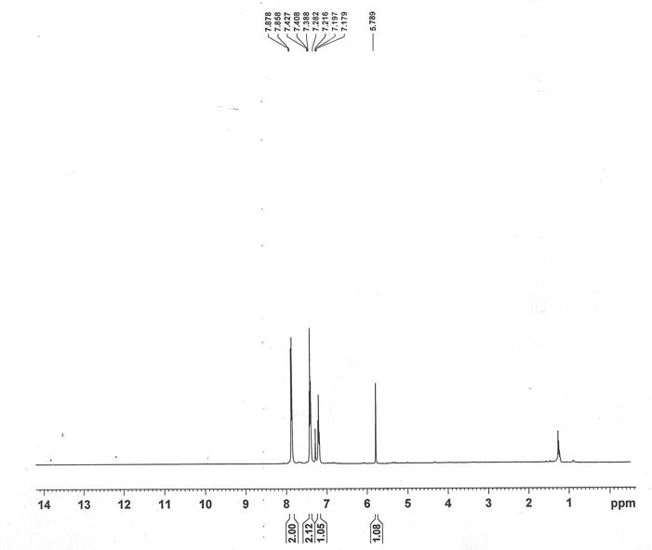
Diphenylamine (3a): Colorless solid; mp: 54-55°C (Lit. 53-54°C). ¹H NMR: (CDCl₃, 400MHZ): δ (ppm) = 7.86 (d, ³J_{HH} = 8 Hz, 2H, CH_{Ar}), 7.40 (d, ³J_{HH} = 8 Hz, 2H, CH_{Ar}), 7.19 (t, ³J_{HH} =7.2 HZ, 1H, CH_{Ar}), 5.78 (s, 1H, NH). ¹³C NMR: (100 MHZ, CDCl₃): δ (ppm) = 122.3, 132.3, 141.2, 149.0.

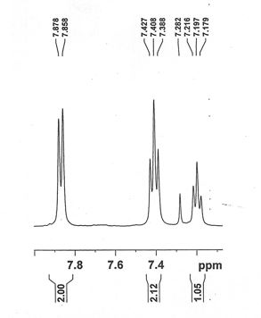

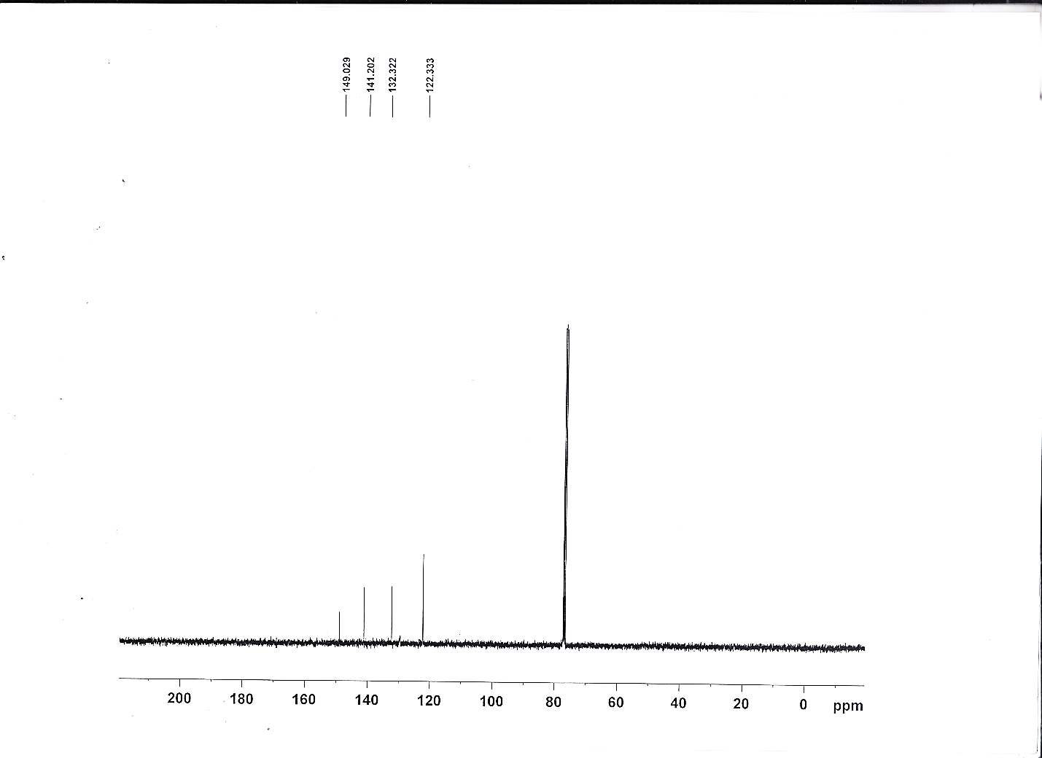
Fig.S1. ¹HNMR (400 MHz, CDCl₃), Expand ¹H NMR spectrum (400 MHz, CDCl₃), and ¹³C NMR (100 MHz, CDCl₃) spectrum of Diphenylamine (3a).

4-Nitro-N-phenylaniline (3b): Yellow solid; mp: 133-135°C (Lit. 135-137°C). ¹H NMR: (400 MHz, CDCl₃): δ (ppm) = 8.49 (d, ³J_{HH} = 8.4 Hz, 2H, CH_{Ar}), 7.96 (d, ³J_{HH} = 7.6 Hz, 2H, CH_{Ar}), 7.50 (d, ³J_{HH} =8.8 HZ, 2H, CH_{Ar}), 7.44 (t, ³J_{HH} = 7/6 Hz, 2H, CH_{Ar}), 7.34 (s, 1H, NH), 7.22 (t, ³J_{HH} =7.6 HZ, 1H, CH_{Ar}). ¹³C NMR: (100 MHz, CDCl₃): δ (ppm) =149.2, 137.2, 131.7, 130.8, 130.6, 131.7, 137.2, 149.2.

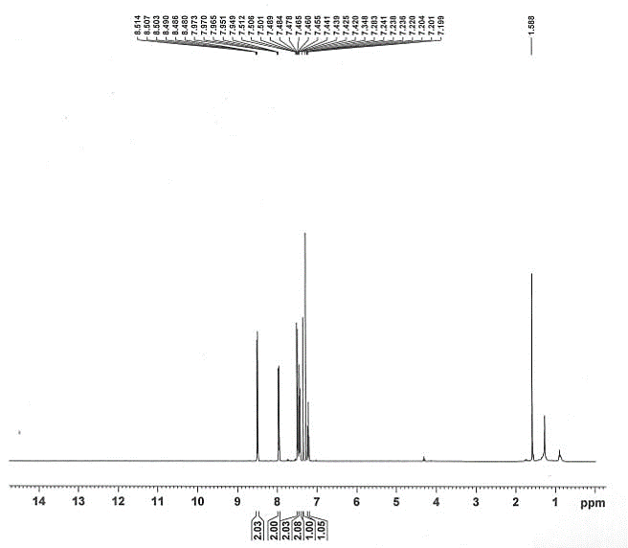

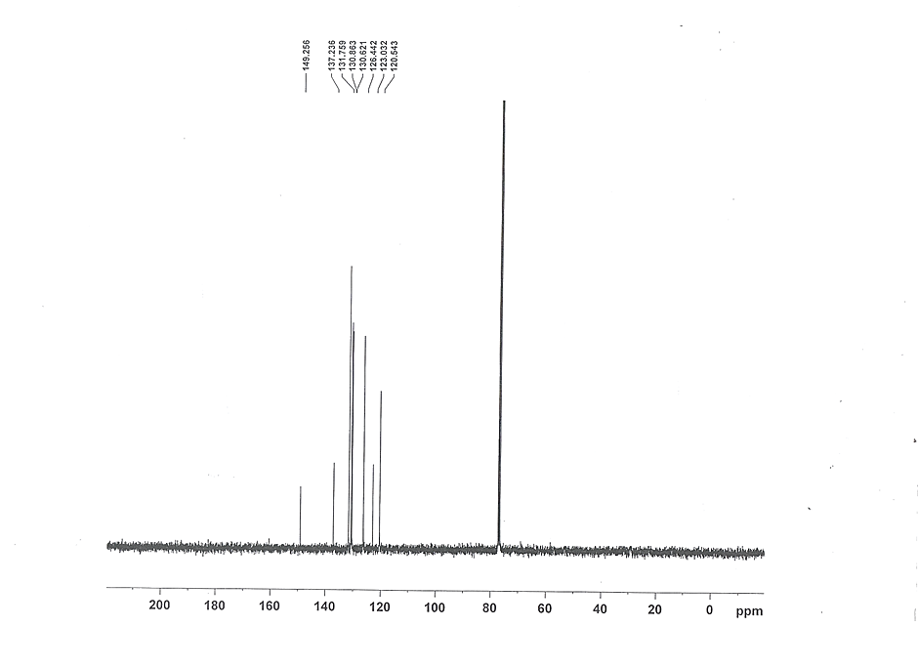

Fig. S2. ¹H NMR (400 MHz, CDCl₃), Expand ¹H NMR spectrum (400 MHz, CDCl₃), and ¹³C NMR (100 MHz, CDCl₃) spectrum of 4-Nitro-N-phenylaniline (3b).

4-Methoxy-N-phenylaniline (3c): White solid; mp: 105-107°C (Lit. 104-106°C). ¹HNMR (DMSO-d_{6,} 400 MHz), δ (ppm) = 3.73 (3H, s, OCH₃), 6.26 (1H, s, NH), 7.35 (t, ³J_{HH =}7.6 Hz, 1H, CH_{Ar}), 7.47 (t, ³J_{HH =}8.0 Hz, 2H, CH_{Ar}), 7.71 (d, ³J_{HH =}6.8 Hz, 2H, CH_{Ar}), 7.88 (t, ³J_{HH =}7.2 Hz, 2H, CH_{Ar}), 8.14 (d, ³J_{HH =}6.8 Hz, 2H, CH_{Ar}). ¹³C NMR (DMSO-d6, 100.6 MHz), δ (ppm)= 158.3, 136.6, 131.9, 131.0, 130.7, 126.6, 123.110, 121.6, 56.4.
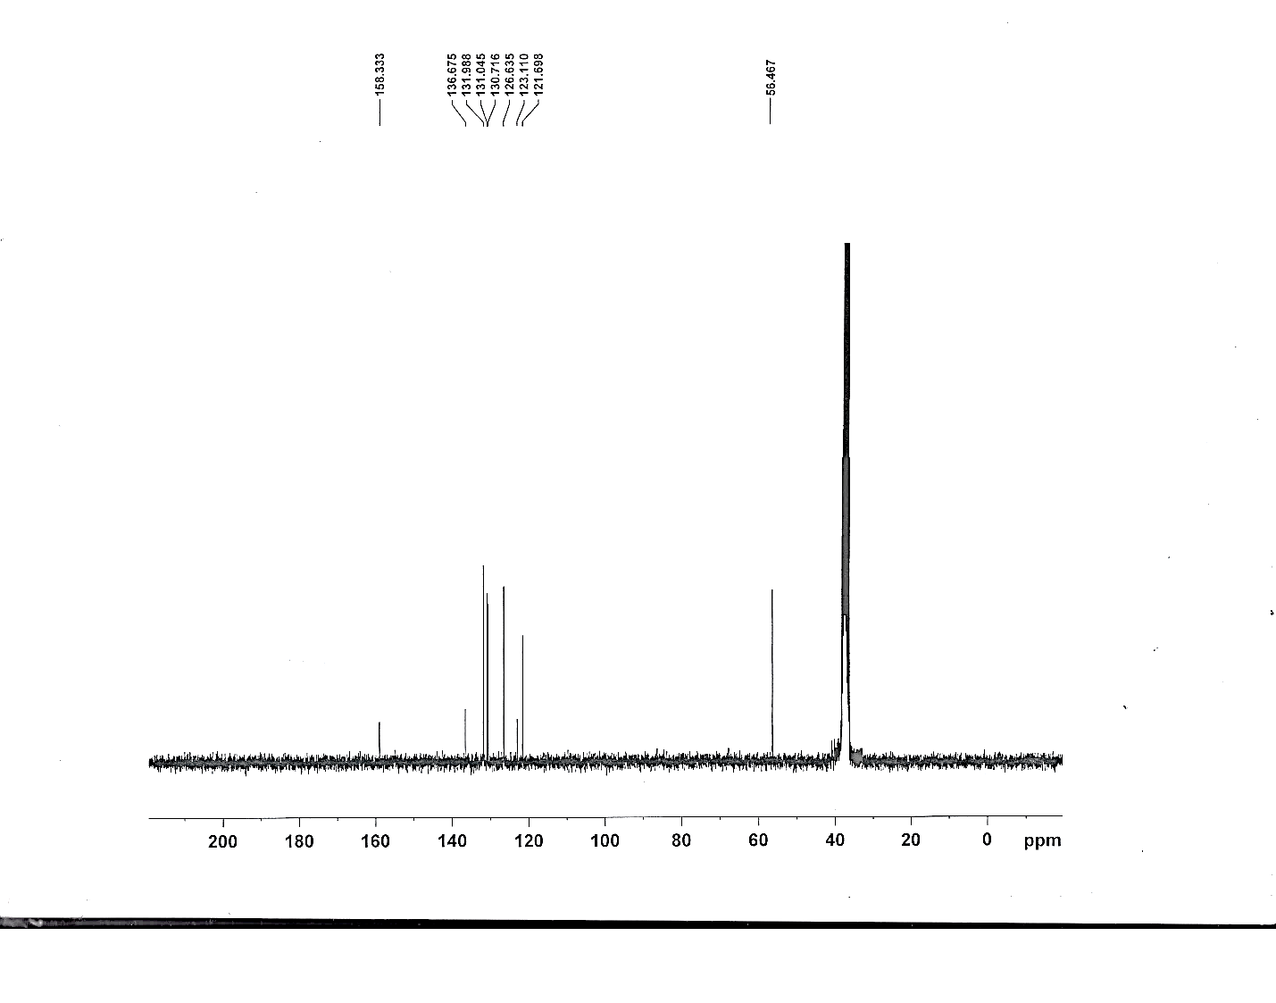
Fig. S3. ¹HNMR (DMSO-d_{6,} 400MHz), Expand ¹H NMR spectrum (400 MHz, DMSO-d₆), and ¹³C NMR (100 MHz, DMSO-d₆) spectrum of 4-Methoxy-N-phenylaniline (3c).

4-Methyl-N-phenylaniline (3d): mp: 92-94◦C. ¹H NMR: (400 MHz, CDCl₃): δ (ppm) = 7.63 (d, ³J_{HH} = 7.6 Hz, 2H, CH_{Ar}), 7.36 (t, ³J_{HH} = 8.4 Hz, 2H, CH_{Ar}), 7.31 (d, ³J_{HH} = 8.4 Hz, 2H, CH_{Ar}), 7.15 (t, ³J_{HH} = 7.6 Hz, 2H, CH_{Ar}), 7.09 (d, ³J_{HH} = 8 Hz, 1H, CH_{Ar}), 5.17 (s, 1H, NH), 2.13 (s, 3H, CH₃). ¹³C NMR: (100 MHz, CDCl₃): δ (ppm) = 139.4, 137.1, 131.3,129.0, 128.9, 126.2, 121.252, 120.3, 33.3.
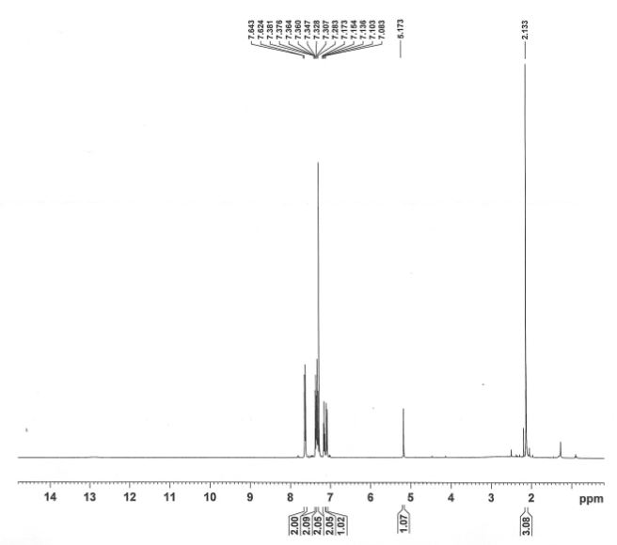

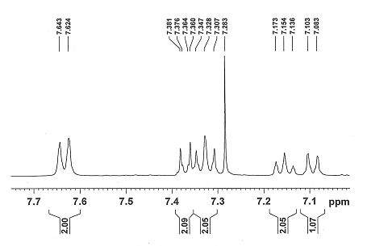

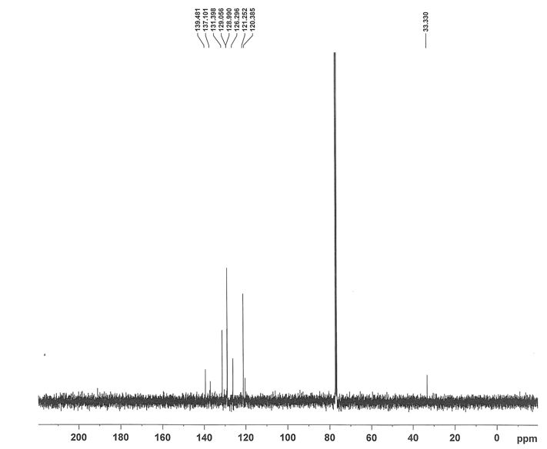
Fig. S4. ¹H NMR (400 MHz, CDCl₃), Expand ¹H NMR spectrum (400 MHz, CDCl₃), and ¹³C NMR (100 MHz, CDCl₃) spectrum of 4-Methyl-N-phenylaniline (3d).
Product Characterization Data for Biginelli Reactions
5-(Ethoxycarbonyl)-6-methyl-4-phenyl-3,4-dihydropyrimidin-2(1H)-one, (4a): White solid; mp: 204-206°C. ¹H NMR: (400 MHz, CDCl₃): δ (ppm) = 1.17 (t, ³J_{HH} = 7.6 Hz, 3H), 2.37 (s, 3H), 4.1 (q, ³J_{HH} = 7.1 Hz, 2H), 5.4 (d, ³J_{HH} = 2 Hz, 1H), 5.73 (s, 1H, NH), 7.28- 7.35 (m, 5H, CH_{Ar}), 8.06 (s,1H, NH). ¹³C NMR: (100 MHz, CDCl₃): δ (ppm) = 14.1, 18.7, 55.8, 60.0, 101.3, 126.6, 127.8, 128.7, 143.6, 146.1, 153.218, 165.7.

Fig S5. ¹HNMR (400 MHz, CDCl₃) and ¹³C NMR (100 MHz, CDCl₃) spectrum of 5-(Ethoxycarbonyl)-6-methyl-4-phenyl-3,4-dihydropyrimidin-2(1H)- one, (4a).

5-(Ethoxycarbonyl)-4-(4-chlorophenyl)-6-methyl-3,4-dihydropyrimidin-2(1H)-on, (4b): Yellow solid; mp: 213-215°C. ¹H NMR: (400 MHz, CDCl₃): δ (ppm) 1.18 (t, ³J_{HH} = 6.8 Hz ,3H), 2.36 (s, 3H), 4.10 (q, ³J_{HH} = 7.2 Hz, 2H), 5.38 (s, ³J_{HH} = 2.4, 1H), 5.89 (s, NH, 1H) ,7.27- 7.29 (m, 4H, CH_{Ar}) ,8.17 (s, NH, 1H). ¹³C NMR: (100MHz, CDCl₃): δ (ppm) = 14.2 ,18.8, 55.1, 60.2, 101.1, 128.1, 128.9, 133.8, 142.1, 146.5, 153.1, 165.4.

Fig S6. ¹H NMR (400 MHz, CDCl₃), and ¹³C NMR spectrum of 5-(Ethoxycarbonyl)-4-(4-chlorophenyl)-6-methyl-3,4- dihydropyrimidin-2(1H)-one, (4b).

5-(Ethoxycarbonyl)-4-(3-bromo phenyl)-6-methyl-3,4- dihydropyrimidin-2(1H)-one, (4c). (4c): mp: 210-212◦C. ¹H NMR: (400 MHz, CDCl₃): δ (ppm)= 1.20) t, ³J_{HH} =7.2 Hz, 3H) ,2.38 (s, 3H) ,4.06 -4.17 (m, 2H), 5. 4 (d, ³J_{HH} = 2/8, 1H), 7.21 (t, ³J_{HH} =7.6, 1H), 7.27-7.28 (m, 1H), 7.8 (m ,1H), 7.29 (s, 1H), 7.42 (³J_{HH} =7.6 Hz, ⁴J_{HH} =2 Hz, 1H), 7.47 (⁴J_{HH} =2 Hz, 1H). ¹³C NMR: (100MHz, CDCl₃): δ (ppm) = 14.1 ,19.1, 55.4, 60.2, 99.2, 122.7, 125.3, 129.8, 130.4, 131.1, 142.2, 145.7, 152.2, 165.4.

Fig S7. ¹H NMR (400 MHz, CDCl₃) and ¹³C NMR spectrum of 5-(Ethoxycarbonyl)-4-(3-bromo phenyl)-6-methyl-3,4- dihydropyrimidin-2(1H)-one, (4c).

5-(Ethoxycarbonyl)-4-(4-nitrophenyl)-6-methyl-3,4-dihydropyrimidin-2(1H)-on, (4d): mp: 204-206˚C. ¹H NMR: (400 MHz, CDCl₃): δ (ppm) = 1.21 (t, ³J_{HH} = 6.8 Hz, 3H), 2.39 (s, 3H), 4.14 (q, ³J_{HH} = 6.8 Hz, 2H), 5.54 (d, ³J_{HH} = 2 Hz, 1H), 5.72 (1H, NH, s) ,7.57 (d, 3J_{HH} = 7.2 Hz, 2H, CH_{Ar}), 8.2 (d, 3J_{HH} = 7.2 Hz, 2H, CH_{Ar}), 9.18 (s, NH, 1H). ¹³C NMR: (100 MHz, CDCl₃): δ (ppm) = 14.2, 18.1, 56.1, 60.4, 101.0, 123.9, 127.7, 135.5, 144.7, 147.3, 150.3, 165.1.

Fig S8. ¹HNMR (400 MHz, CDCl₃) and ¹³C NMR (100 MHz, CDCl₃) spectrum of 5-(Ethoxycarbonyl)-4-(4-nitrophenyl)-6-methyl-4-phenyl-3,4-dihydropyrimidin-2(1H)- one, (4d).

