Online Resource 3: Supplementary Analyses
Multivariate environmental similarity surface (MESS) analyses
Like we did for the SDMs, we created two sets of MESS analyses: one comparing the conditions of each native region with those of the invaded region, and then another one to compare the environmental conditions in the other way around. For details about the MESS analyses, refer to Elith et al. (2010).
For each MESS analysis, we used the same set of bioclimate variables selected via VIF used for each SDM. We extracted the information associated with 10000 randomly selected points from each variable, which were used as background information for each SDM, and we used those as a reference set. We then projected the reference set of environmental conditions obtained for each Native region and projected them on America (Native to Invaded region MESS; Fig. S.2.a). Therefore, for the Native to Invaded region MESS (Fig. S.2.a), we used as a reference set the environmental conditions associate to the background points for each native region and projected it to America. For the Invaded to Native MESS (Fig. S.2.b), we used the reference set of background information from America and projected to each of the native regions. We used the mess function contained in the dismo R package (Hijmans et al. 2017) for performing the MESS.
A direct comparison between the two sets of analyses was not possible because the maps generated by the MESS analyses had different scales. Therefore, to compare the results, we extracted all the MESS values and graphed their frequencies, comparing the difference between the two regions. Negative values of higher magnitude imply larger dissimilarities between the environments used as a reference set and the regions where it was projected (Elith et al. 2010).
When the MESS is calibrated in each native region as reference (Fig. S.2.a), South Africa shows more dissimilar environments in America, since there is a larger proportion of higher magnitude negative values. Most of the environments in the Mediterranean region do not differ as much, as the values are concentrated towards lower magnitude negative values. On the other hand, when America is used as a reference set (Fig. S.2.b), there is a greater overlap on the values with both South Africa and the Mediterranean regions, and the values have a lower magnitude. This shows that the set of variables selected by the VIF method for the South Africa region do not share similar conditions to America while the set of variables selected for the Mediterranean are more similar in their conditions to America. However, the set of variables selected for America is similar to those conditions for both native regions. Therefore, the predictions of the South African SDM are incurring in higher extrapolation than the Mediterranean Model, but the American SDM is not extrapolating more in either region.

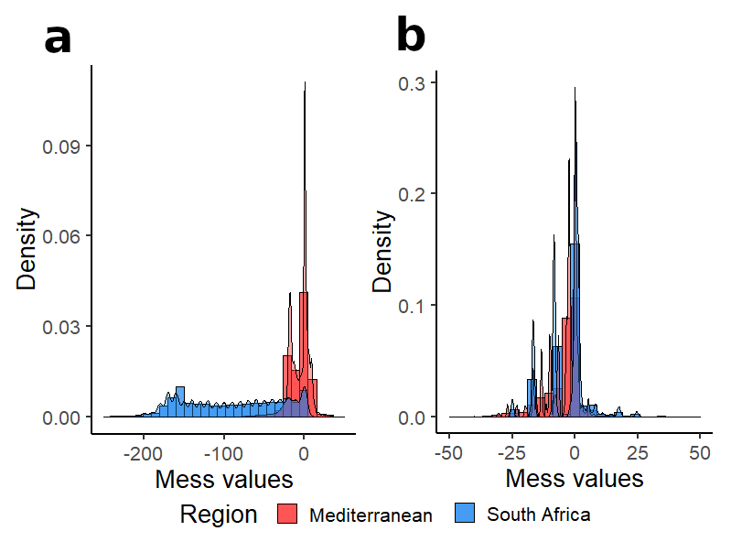
Fig. S. 2 a. Values assigned by the MESS analysis using each native region as a reference and projecting it to America. b. MESS values obtained when using America as the reference region and projecting it to each native region

Density plots for each bioclim variable
For comparing the overlap per bioclimatic variable between the three regions, we extracted all the values assigned to occurrence point in every region for all the 22 bioclimatic variables. We created density plots for each variable depicting the distribution of the values associated to each region using the R package ggplot (Wickham 2016). We observed that in most cases, the density peaks for the South African and American values are closer to each other than the peak associated with the Mediterranean.

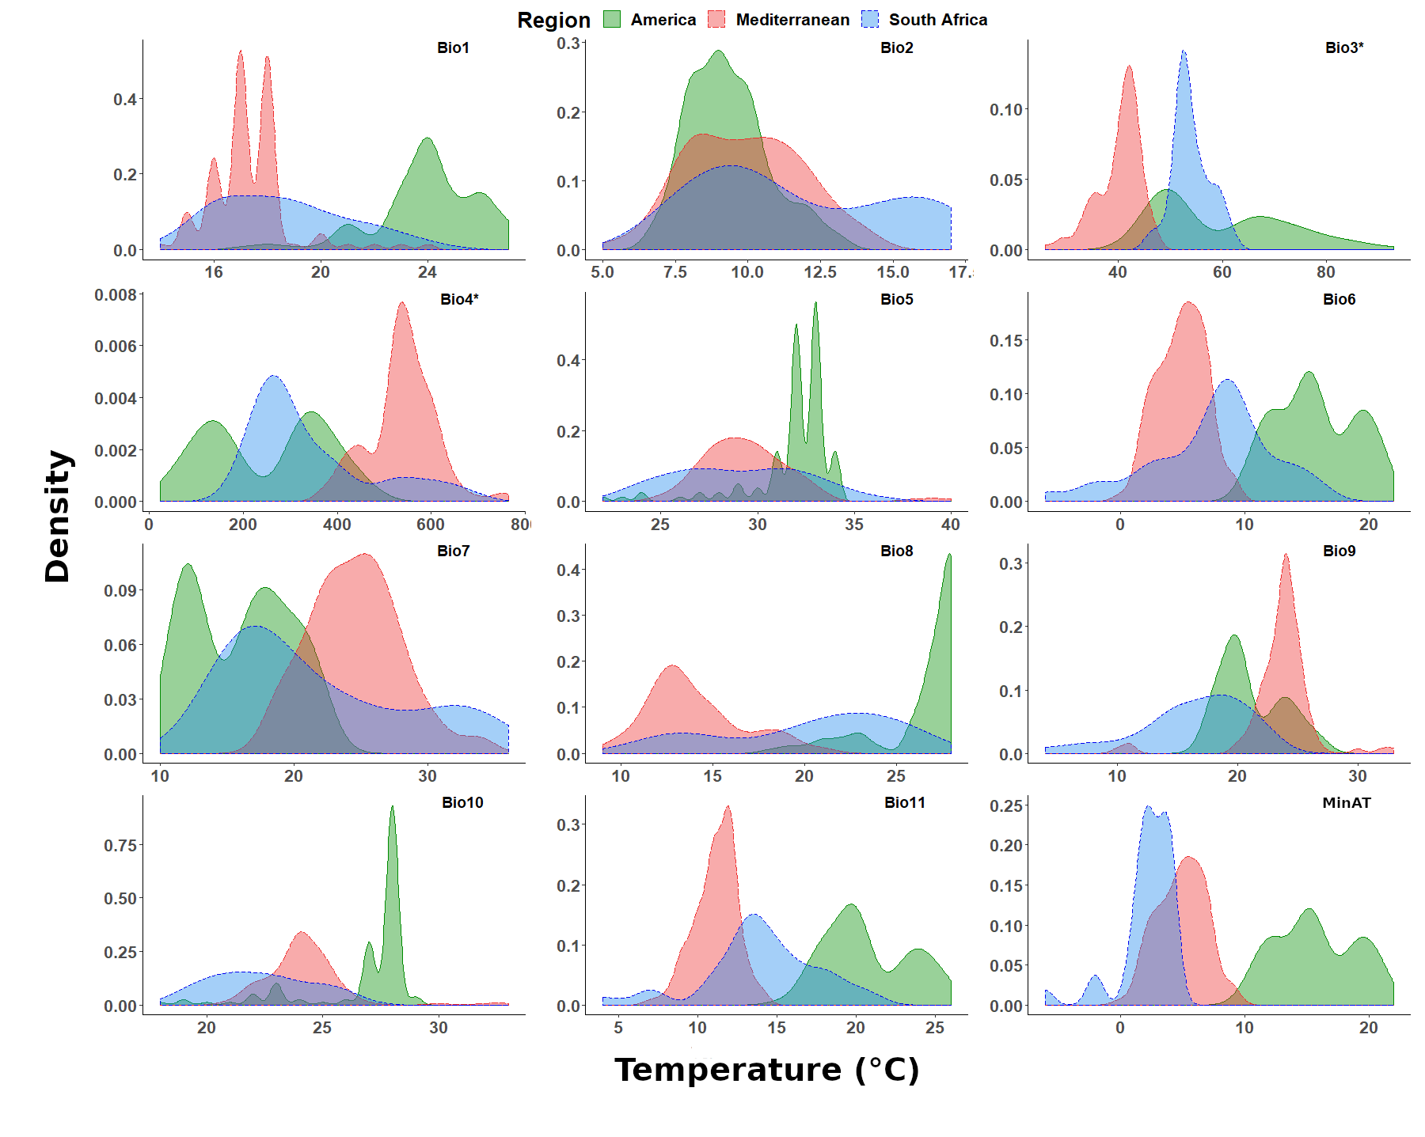
Fig. S. 3 Density plots for the bioclim variables associated with temperature. Those marked with an asterisk (*) are measured in percentage instead of Celsius

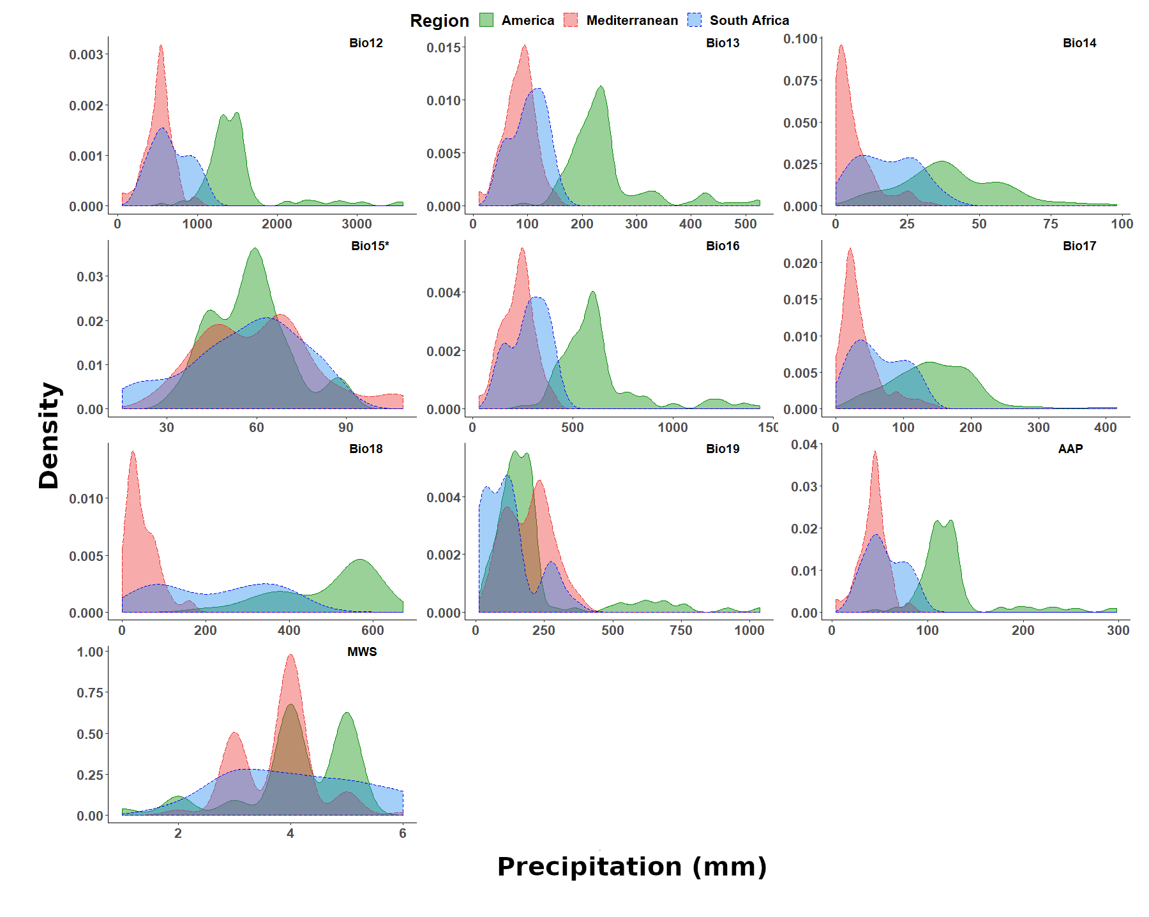
Fig. S. 4 Density plots for the variables associated to precipitation and wind. Those marked with an asterisk (*) are measured in percentage instead of millimeters

Principal component analysis
We performed a principal component analysis (PCA) to estimate the overlap between the environmental conditions of the three regions. We extracted the information associated with the 22 bioclimatic variables in 10000 randomly selected raster cells in each region - the same 10000 cells used as background reference set for the SDM. This information was used to perform a PCA (Fig S. 4). The Euclidean distance between America and South African centroids is 4.98, and between America and the Mediterranean centroids is 6.51 (Fig. S. 4. A), showing closer similarities between the South African and American environmental conditions.
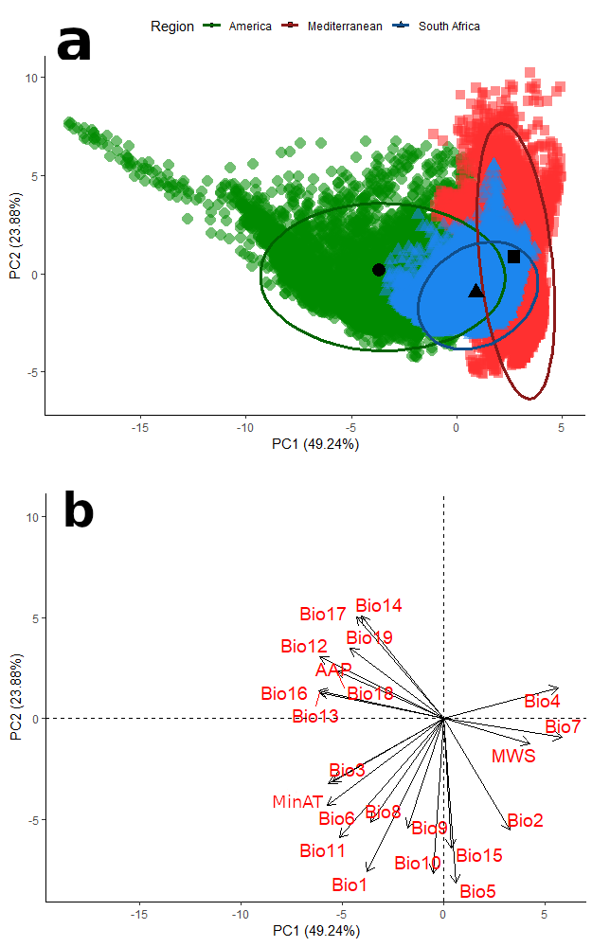
Fig S. 5 a. PCA of the 22 bioclimatic variables for the three regions. Ellipses represent the general distribution of the values for each region. Black markers represent the centroid for each region. b. Eigenvectors of each of the bioclimatic variables

References
Elith J, Kearney M, Phillips S (2010) The art of modelling range-shifting species. Methods Ecol Evol 1:330–342. https://doi.org/10.1111/j.2041-210X.2010.00036.x
Hijmans RJ, Phillips S, Leathwick J, Elith J (2017). dismo: Species Distribution Modeling. R package version 1.1-4. https://CRAN.R-project.org/package=dismo
Wickham H (2016) ggplot2: Elegant Graphics for Data Analysis. Springer-Verlag New York.

