Supplementary Information:
Global genomic population structure of wild and cultivated oat reveals signatures of chromosome rearrangements.
Wubishet A. Bekele, Raz Avni, Clayton L. Birkett, Asuka Itaya, Charlene P. Wight, Justin Bellavance, Sophie Brodführer, Francisco J. Canales, Craig H. Carlson, Anne Fiebig, Yongle Li, Steve Michel, Raja Sekhar Nandety, David J. Waring, Juan D. Arbelaez, Aaron D. Beattie, Melanie Caffe, Isabel A. del Blanco, Jason D. Fiedler, Rajeev Gupta, Lucia Gutierrez, John C. Harris, Steve A. Harrison, Matthias H. Herrmann, Yung-Fen Huang, Julio Isidro y Sanchez, Michael S. McMullen, Jennifer W. Mitchell Fetch, Kirby T. Nilsen, Isobel A. P. Parkin, YuanYing Peng, Kevin P. Smith, Tim Sutton, Weikai Yan, Pamela Zwer, Axel Diederichsen, Kathy Esvelt Klos, Yong-Bi Fu, Catherine J. Howarth, Jean-Luc Jannink, Eric N. Jellen, Tim Langdon, Peter J. Maughan, Edyta Paczos-Grzeda, Elena Prats, Taner Z. Sen, Martin Mascher, Nicholas A. Tinker
Supplementary Note S1. Species reclassification. In this study we have preserved the species identifier that was assigned by the original collector or genebank. In some cases, these names may be erroneous, or they may be affected by an evolving consensus on oat taxonomy. The project metadata in Supplementary File S1 contains a field for potential taxonomic revisions. Currently we have suggested the reclassification of 27 accessions to A. byzantina based on their membership in this genetically distinct group. We also found 11 accessions identified as A. sterilis that were classified in populations belonging mostly to A. sativa. This includes one (CN_23397) in P06, six (TL.S325, TL.S313, TL.S300, TL.S277, NAM_CAV1627, CN_20562) in P11, two (CN_20165 and CN_20161) in P12, and two (TL.S289 and CN_22599) in P21. Most of these populations contain winter oat. We have checked the phenotype of many of these accessions, and they appear to have A. sterilis seed types, but we cannot rule out that they are not feral hybrids with A. sativa (sometimes classified as A. hybrida). Further investigation of these lines may shed light on the dynamics of gene flow. In future updates of the metadata (Supplementary Data S1) on the GrainGenes archive, this field could be used for other species revisions or comments related to classification. For example, the species name A. ludoviciana¹ could be used to describe many accessions currently classified as A. sterilis² and a future botanical revision could inform us that this classification is consistent with one of the current A. sterilis populations. Our study included four accessions of A. ludoviciana. Two of these did not have adequate data to assign them to a population, but the other two were both assigned to P21. Ludoviciana appears to be a winter habit form of sterilis, which may not have been recognized as a separate category by genebanks or collectors (possibly because of the difficulty in measuring vernalization requirement), and it is possible that other species classifies as A. sterilis could fall into this category.
Supplementary Note S2. Potential for experimental bias. While these experiments followed similar protocols, all GBS experiments contain slight incidental differences that affect fragment size selection, sequencing depth, and variation among samples. Because each experiment focused on different sets of germplasm, we cannot rule out the possibility that some observed population structure is affected by experimental bias. Nevertheless, most results are consistent with previous analyses and with prior biological knowledge of the genus. Furthermore, while some populations are exclusive to specific experiments, most populations contain taxa from many experiments, indicating that population structure is generally independent of experimental bias. For example, while P09 originates almost exclusively from the CORE-Spring, POGI and Cornell experiments, the same three experiments contributed to most other populations of A. sativa.

Supplementary Table S1. Details of sequencing for experiments contributing to global genomic diversity of oat.
Project | Tissue Place | Seq. Centre | Seq. Device
Aberystwyth | IBERS, UK | IPK, Germany | Illumina NovaSeq 6000
Ancestors | AAFC, Ottawa, Canada | IBERS, UK | Illumina Hiseq 2000
Australia | University of Adelaide - Waite Campus | University of Minnesota, USA | Illumina Hiseq 2500
BioMob | AAFC Saskatoon, Canada | NRC Saskatoon, Canada | Illumina NovaSeq 6000
China | Triticeae Research Institute, Sichuan, China | AAFC Ottawa, Canada | Illumina NextSeq 500
CORE_AFRI | USDA Aberdeen, USA | NRC Saskatoon, Canada | Illumina Hiseq 2000
CORE_Spring | USDA Aberdeen, USA | NRC Saskatoon, Canada | Illumina Hiseq 2000
CORE_Winter | USDA Aberdeen, USA | NRC Saskatoon, Canada | Illumina Hiseq 2000
Cornell | Cornell University, USA | University of Minnesota, USA | Illumina Hiseq 2500
Fusarium | CBGP, UPM-INIA, Spain | Genome Quebec, Canada | Illumina Hiseq 2500
IOI | AAFC, Ottawa, Canada | NRC Saskatoon, Canada | Illumina Hiseq 2000
Jordan | AAFC Saskatoon, Canada | AAFC Saskatoon, Canada | Illumina MiSeq
KLAR | KLAR, Germany | Genome Quebec, Canada | Illumina Hiseq 2500
Mediterranean | IAS, CSIC, Spain | Genome Quebec, Canada | Illumina Hiseq 2500
NAM | IBERS, UK | Genome Quebec, Canada | Illumina Hiseq 2500
NSGC | USDA Aberdeen, USA | USDA Aberdeen, USA | Illumina Novaseq6000
POGI | USDA Fargo, ND, USA | USDA Fargo, ND, USA | Illumina NextSeq 500

Supplementary Discussion S1: Duplicated accessions in the global oat diversity panel.
Duplicated accessions are a common and complex issue in genebanks and biodiversity analyses³. We know that many genebank accessions are heterogeneous because collectors often sampled multiple plants as one accession, or single plants may have been heterozygous. Accessions also become mixed or contaminated, especially when they are grown out for multiplication. Likewise, we know that many landraces (and even cultivated varieties) contain heterogeneity. Unfortunately, heterogeneity can also arise through many types of error. It is common practice (as followed in these experiments) to sample a single seed to represent an accession. Ideally, we would perform separate analyses on multiple seeds from every accession, but at what cost? One seed from each of 9000 accessions provides much more information than nine seeds from each of 1000 accessions.
To explore duplication and heterogeneity of genebank accessions, we included a small internal experiment, in which three or four seeds were sampled from each of 99 genebank accessions (Table 1). We also included an “accidental” experiment, as some varieties and landraces were sampled multiple times due to the merging of different experiments that were planned and conducted independently by different investigators. In the latter case, an effort was required to cross-reference entries where names were identical or contained enough similarity that they could be assumed to be from the same named variety.
A summary was developed (Supplementary File S6, Sheet 1) containing 747 duplicated (or potentially duplicated) accessions among 1837 unique GBSIDs. An analysis of genomic distance among duplicated taxa (Supplementary Fig. S1) compares the average distance between pairs of subsamples from each of 99 genebank accessions vs. the average distance between pairs of samples from similarly-named accessions. The different levels of heterogeneity among genebank accessions suggests that many accessions contain substantial heterogeneity, which could be investigated further.
Surprisingly, the level of heterogeneity among named varieties was of the same frequency and magnitude as that of the genebank accessions. These differences are likely due to a variety of reasons including heterogeneous accessions, different seed sources, and mislabeling. Where duplicates exist, additional data mining is recommended prior to targeted analysis such as genome sequencing. For example, from Supplementary File S6 (Sheet 2), we note that the oat cultivar ‘Firth’ is duplicated in 6 experiments. Of the 15 possible pairwise genetic distances, the five involving Firth from the Cornell experiment (Table 1) gave an average distance of 0.21 from other Firth accessions, while the remaining distances had an average pairwise distance of 0.002. Thus, we can infer that the Firth sampled in the Cornell experiment is probably from a misidentified seed source. In contrast, nine taxa represent an historical founding landrace called ‘Red Algerian’, all with small-to-moderate genetic distances. Because this is an old landrace with no definitive origin, most of these differences likely represent heterogeneity among seed sources rather than experimental error.
While duplication introduces a small amount of uncontrolled bias, this bias is assumed to be random. No duplicates were removed from this study because the genetic similarity between duplicates followed a gradient of certainty with no obvious cutoff, and because heterogeneity among duplicates represents real data that would otherwise be lost.
Supplementary Fig. S1: Analysis of Duplicated taxa.
a

b

Average genetic distance among pairs of identically named accessions generated from pairs of potential duplicates, as shown in Supplementary File S6, Sheet 2. Each vertical bar represents the average genetic distance among all possible pairs within a single potentially duplicated accession, sorted left to right by increasing average distance (i.e., there is no scale on this axis). (a) 99 accessions sampled three to four times each from the Canadian genebank. (b) 648 named accessions duplicated across different experiments, not necessarily from the same seed source.

Supplementary Discussion S2: Robustness of SNP-based diversity analysis.
In this study, we employed a factorial analysis by MDS to provide a visualization of global diversity within hexaploid Avena species or within cultivated A. sativa. This visualization was conducted in a large SNP-based data matrix (Matrix50) having some taxa with substantial missing data. This analysis was then interpreted using a population-based analysis based on a more complete data matrix (Matrix80), in which taxa having more than 10% missing data were omitted. Thus, some taxa that appear in the MDS plots are not fully characterized by their population membership. However, it may be possible to make inferences about population membership of taxa with missing data based on genetic proximity to other taxa. In this supplement, we examine the robustness of the factorial-based visualizations, as well as the consistency of SNP calls based on two additional SNP calling methods.
Methods
SNPs called using the GS7 Reference genome: A supplementary analysis was carried out using SNPs called based on the GS7 reference genome, reported in the oat pan genome study⁴. This analysis was conducted after the reference genomes in the oat pan genome were assembled, when it was determined that the accession GS7 had one of the highest quality assemblies. Thus, we intended to compare our SNP-calling methods based on the Sang reference genome⁵ (assembled by short reads) to independently called SNPs based on the GS7 reference genome. Methods for GS7-based SNP calling and filtering are described in the companion study⁴. The use of these different methods provided an opportunity to confirm that results were not affected by bioinformatics methodology.
Haplotag analysis: A supplementary analysis was carried out using the software “Haplotag”⁶ for reference-free SNP calling. The purpose of this method was to compare results reported in the main manuscript to results that would be obtained with Haplotag, since Haplotag has been used for many previous GBS reports by the oat genomics research community. In this method, we first filtered the pre-discovered loci and tag-level haplotypes described by Bekele et al.⁷ to include only those loci where one and only-one tag-level haplotype matched perfectly to the Sang genome⁵, producing the list of physically-located 64-base loci described by Tinker et al.⁸. We then aligned all novel tags from the master tag-count file (produced by UNEAK software⁹ directly from the raw fastq read data) to the tag-level haplotype list, allowing for only one additional SNP beyond the previously-known SNP locations within each 64-base locus. We further eliminated all loci that did not provide a unique match with a novel tag-level haplotype. The resulting rebuilt ‘HTLoci’ and ‘HTalleles’ files were then used in the standard Haplotag production pipeline without further modification.
Results
Exploratory analysis by both PCA and MDS were performed using the full data set (Matrix50) as well as the filtered set (Matrix80). In addition, MDS was performed for data from the two alternate SNP calling methods. The MDS vs. PCA plots in the full data set (Supplementary Fig. S2a vs. S2b) showed a different shape and appearance. By examining taxa with the highest proportion of missing data, we determined that these lines were highly skewed toward the origin in the PCA plot, but not in the MDS plot. Most strikingly, many lines from the Jordanian experiment (circled in red) had very high proportions of missing data. In the PCA plot (Fig. S2b) these lines were oriented toward the origin relative to other lines, whereas in the MDS plot (Fig. S2a) these lines clustered together with taxa in three different regions of the MDS. In contrast, the MDS vs. PCA plots in the more complete, highly filtered data set (Supplementary Fig. S2c vs. S2d) were much more similar in structure.
The bias of PCA analysis with missing data is a well-known phenomenon, but our goals were (1) to determine if the MDS and PCA plots showed similar structure in the more complete Matrix80 data (they do) and (2) whether the MDS plot provided a better representation of lines having missing data. In the second case, we can say that the distribution of lines with missing data is more logical in the MDS plot than in the PCA plot, but we still recommend cautious interpretation of the MDS positions for lines with missing data.
We also evaluated whether the use of the Sang (A. sativa) reference genome affected the proportion of SNPs called in non-sativa species. Because of the diversity in read depth among different experiments, we filtered only those taxa having read counts between 1E6 and 3E6. This gave a similar average number of reads for taxa in each of the three major species, as summarized in Table S2. Among these three species, A. byzantina had the highest proportion of missing data while A. sterilis had the lowest. From this we conclude that the proportion of missing data (i.e. un-called SNPs) is more dependent on other factors (e.g. read quality, sequencing technology) than on how closely a genome is related to the Sang reference genome.
Supplementary Table S2. Proportion of missing data in taxa from three species
Species | Avg. N. Reads | Avg. P. Missing | Count of taxa meeting criterion
A. byzantina | 2,088,347 | 0.48 | 260
A. sativa | 2,018,485 | 0.45 | 3193
A. sterilis | 2,094,306 | 0.43 | 443

In Supplementary Figs. S2e and S2f, the full sets of taxa based on two alternate methods of SNP calling are shown using MDS. While there appear to be subtle differences between these analyses, the overall shape of the MDS plot is very similar among all three data sets. Additionally, we conducted a correlation analysis and Mantel test to compare the complete distance matrices between the SNPs called using the Sang reference (Fig. S2a) vs. those called using the GS7 reference (Fig. S2f). The Pearson correlation coefficient between these sets of distances was very high (r=0.9935) with a significance of P<0.001 based on 999 permutations.

Supplementary Fig. S2: Robustness of SNP calls and visualization methods.
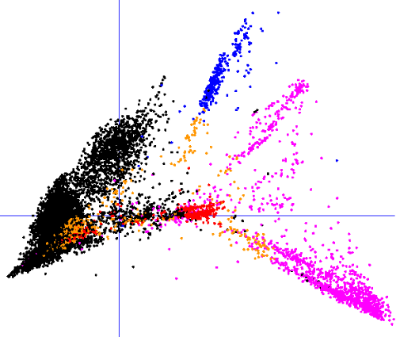
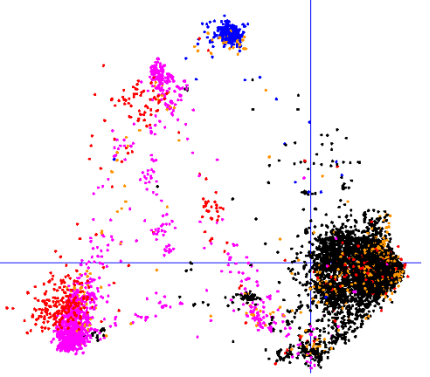
a (MDS-Matrix50) b (PCA-Matrix50)

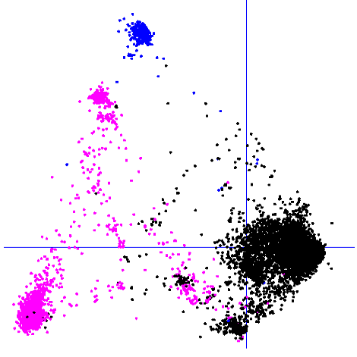
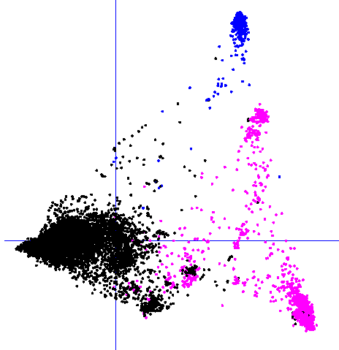
c (MDS-Matrix80) d (PCA-Matrix80)

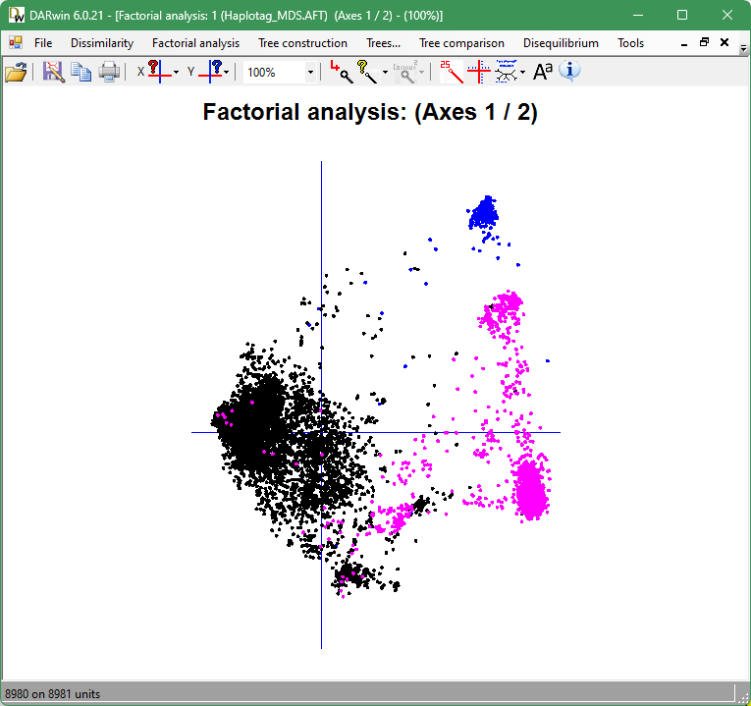
e (MDS-Haplotag) f (MDS-GS7)
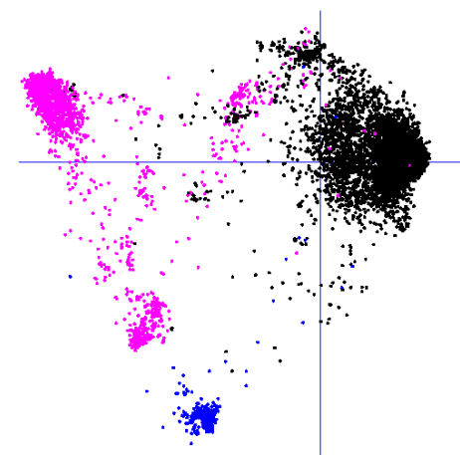

(a and b): analysis of the full SNP data set from Matrix50 by MDS (a) vs. PCA (b). Points with missing genotype data are coloured red (80-100%) or orange (60-80%). (c and d): analysis of filtered data set with imputed genotypes (Matrix80) by MDS vs. PCA, respectively. (e) analysis of SNPs called using Haplotag software by MDS. (f) analysis of SNPs called using the GS7 reference genome by MDS. In all plots, points that represent the A. byzantina cluster are coloured blue, while those representing A. sterilis lines are magenta. The axes of all plots are mirrored oriented to orient the A. byzantina cluster in the top right quadrant. Axis scales are not reported because they are arbitrary in the MDS analyses, and we are only interested in the shape of these plots for descriptive purposes.

Supplementary Fig. S3: Cross-entropy vs. cluster size.
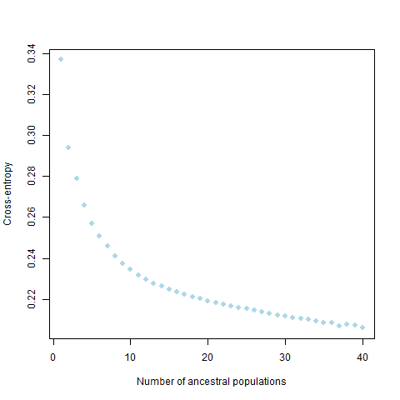

Cross-entropy vs. cluster size (K) based on five sNMF iterations per cluster (K) = 1 – 40.

Supplementary Fig. S4: Admixture plot – selected populations.
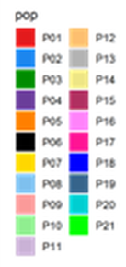

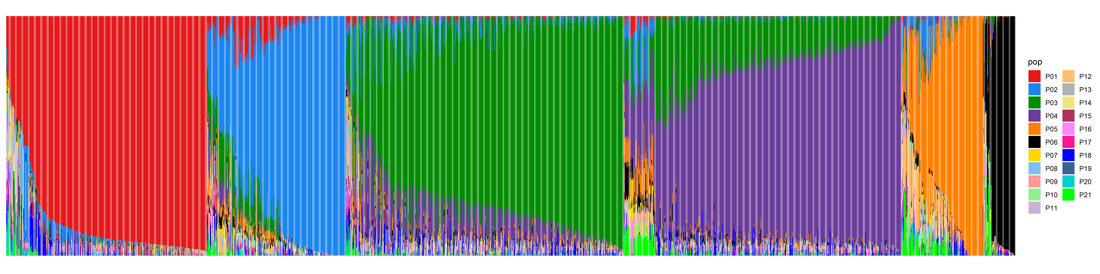

Admixture plot from K=21 showing taxa assigned to populations P01, P02, P03, P04, P05, and P06.

Supplementary Fig. S5: Admixture plot – all populations.

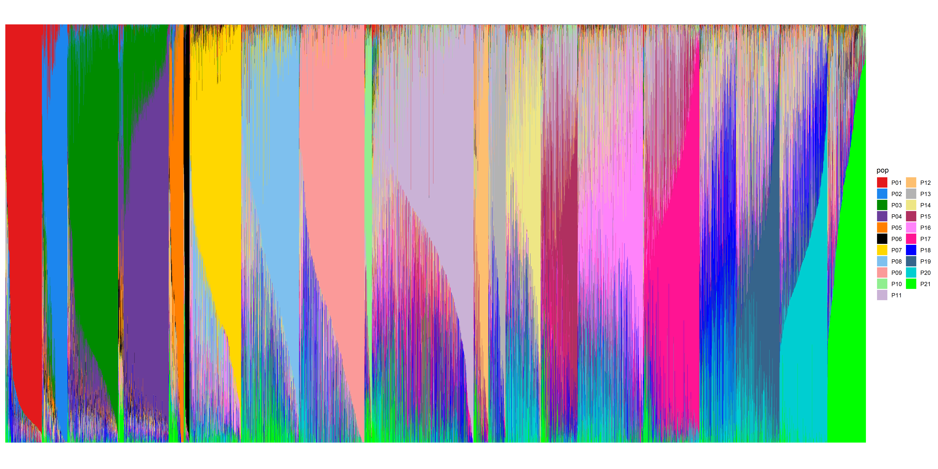

Admixture plot from K=21 showing taxa assigned to all populations.
Supplementary Fig S6: Pairwise genetic distance vs. geographical distance.
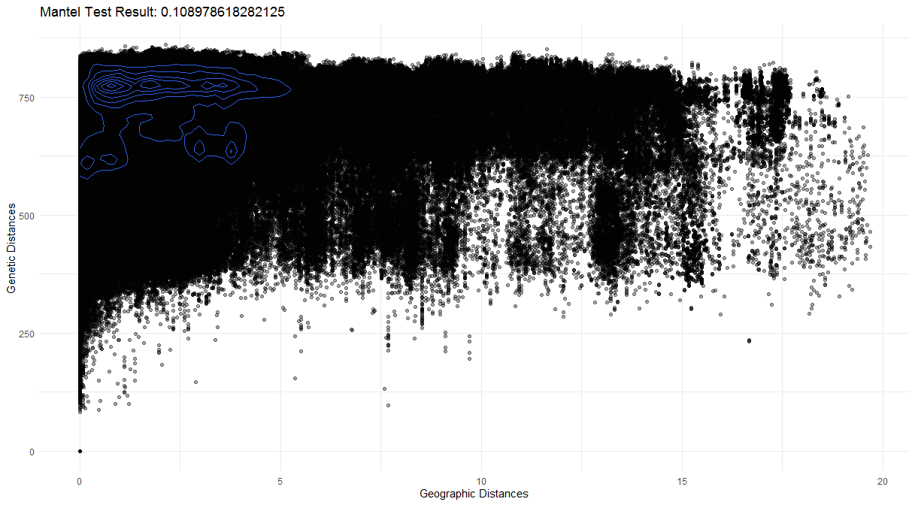

Pairwise genetic distance vs. Geographical (million meters) distance between collection sites of 2279 accessions.

Supplementary Fig. S7: MDS and map of minor species.
a
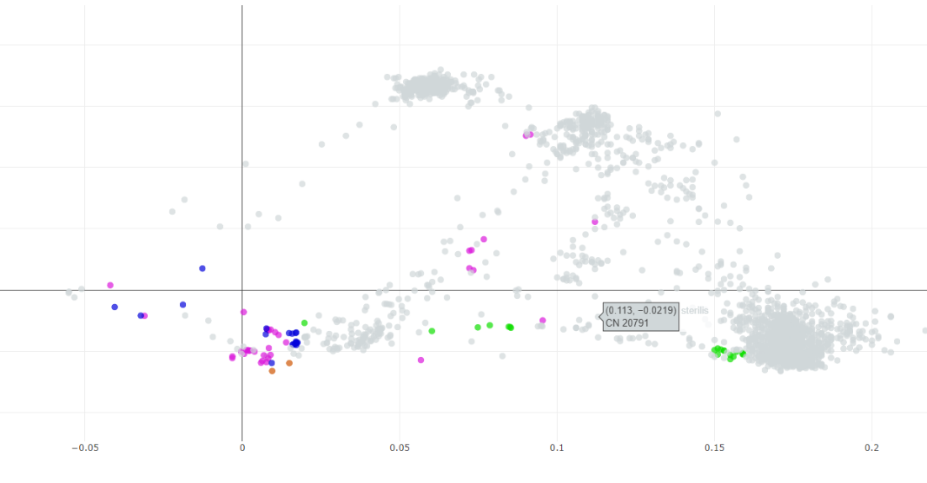

b
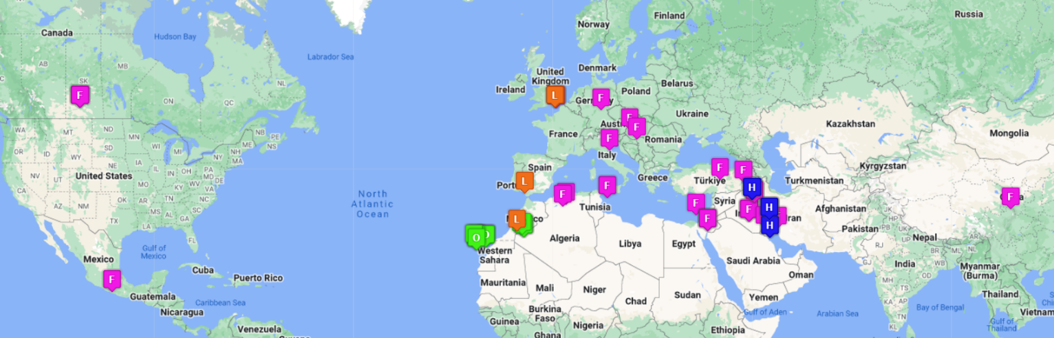

(a) Multi-dimensional scaling of n=9,111 taxa, highlighting only those accessions from species A. fatua (F, magenta), A. hybrida (H, blue), A. occidentalis (O, green) and A. ludoviciana (L, orange). Refer to Fig. 1b for comparison. The red circle shows the position of most A. sativa, which are hidden in this view. (b) Map of collection sites (when available) for taxa from the above plot.

Supplementary Fig. S8: MDS showing Chinese taxa.
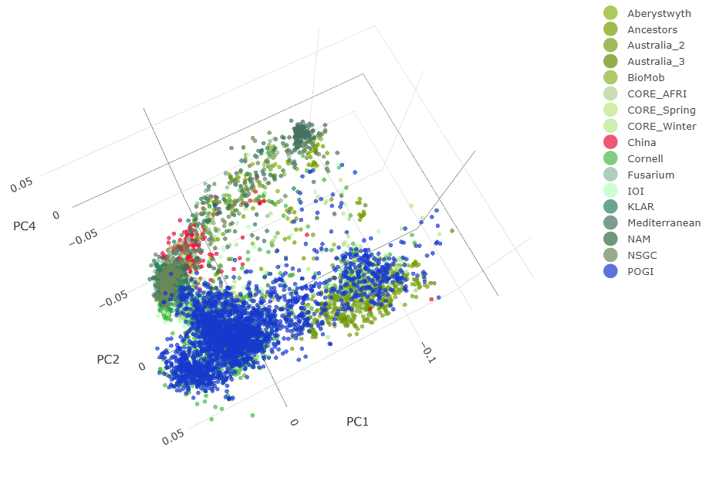

Multi-dimensional scaling of n=6,950 taxa from populations containing primarily cultivated A. sativa. Accessions from China are highlighted in red, while those from POGI (A large North American study) are in blue. Online interactive versions of these plots can be used to visualize or highlight additional populations or features: (https://graingenes.shinyapps.io/Oat_diversity/).

Supplementary Fig. S9: PCAdapt analysis.
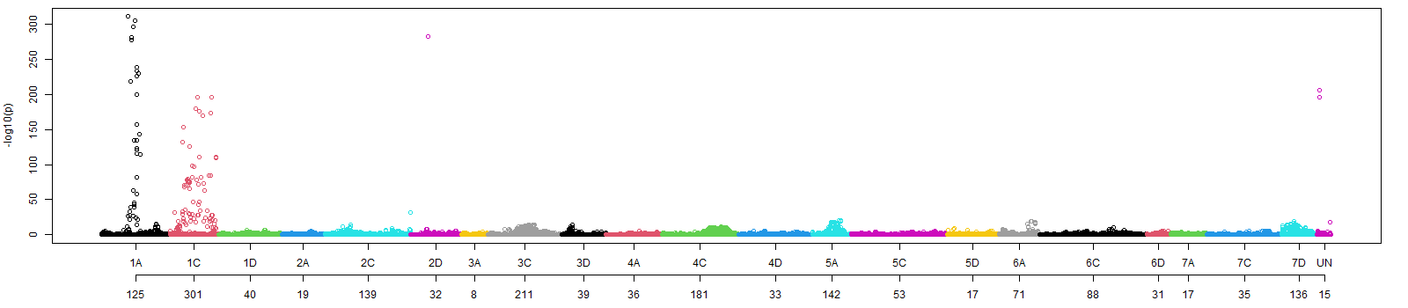
PCA-based genome-wide scans of local adaptation using PCAdapt analysis of the full set of taxa (n=8,816). The Y-axis shows the -log10(p) of the association of markers to population structure. The x-axis shows the chromosome names, and the secondary x-axis labels show the number of outlier loci associated with population structure below a threshold false discovery rate of 0.5. The table containing the PCAdapt outlier loci and summary of their chromosome distribution are in Supplementary File S8, sheets 2 and 3.

Supplementary Fig. S10: Lostruct Analysis.
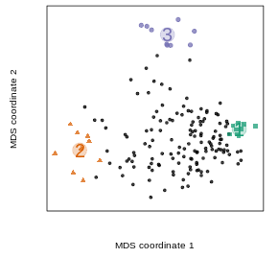
Local structure analysis identified 27 outlier windows at three corners of the left multidimensional scaling plot. The green squares, orange triangles, and purple dots represent the genomic regions with abnormal population structure due to putative chromosomal inversions. The table summarizing the 27 outlier windows is in Supplementary File S8, sheet 4.

Supplementary Fig. S11: Detailed analysis of Chromosome 7D.
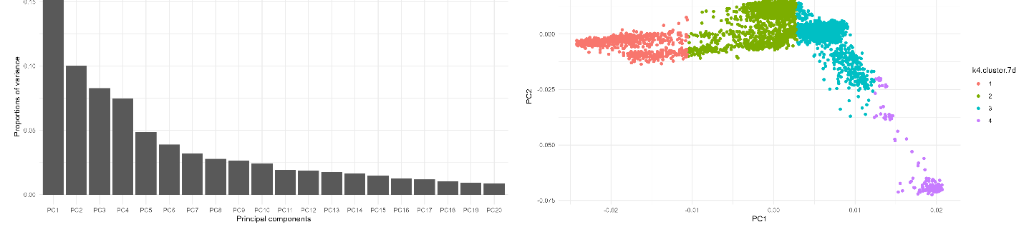

a
b

d
c
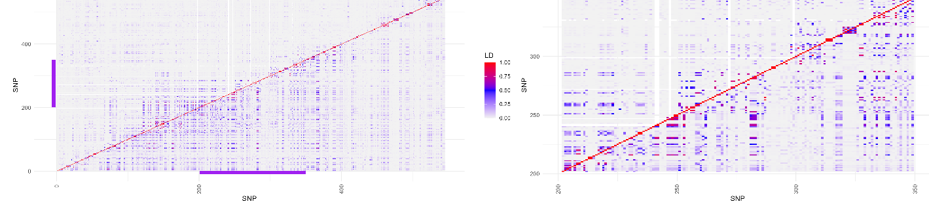

e
f
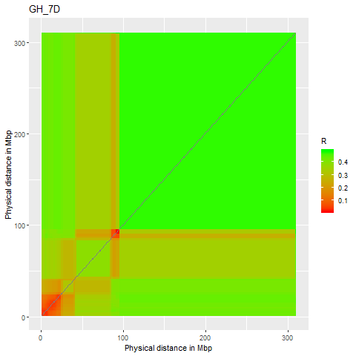
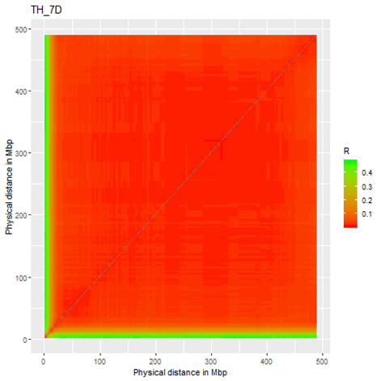

A chromosomal inversion on chromosome 7D affects linkage and recombination patterns in oat. (a) The variance explained by the first 32 eigenvectors of the PCA analysis based on 150 SNPs in a 146 Mbp outlier region detected on chromosome 7D. (b) The distribution of 8,652 accessions along PC1 (x-axis) and PC2 (y-axis). The labels and colour of the circles from left to right show the K-means clustering (K=4, sum of squares between cluster/total 0.943) based on principal component one, from which we hypothesized the existence of four haplotypes: 7D-H1 (N=1,638), 7D-H2 (N=1,983), 7D-H3 (N=4,868), and 7D-H4 (N=163). (c) The LD on chromosome 7D of accessions classified as carrying 7D-H3 (the haplotype represented by the putative inversion carriers; N=4,868) above the diagonal and all 8,652 samples below the diagonal. Purple bars show a putative 146 Mbp inversion region. (d) The LD within the putative inversion region of chromosome 7D (150 SNPs). (e and f): Recombination frequency heatmaps of chromosome 7D of (e) progenies (n=160) from a cross between parental varieties ‘Goslin’ and ‘HiFi’ (both with haplotype 7D-H3) vs. (f) progenies (n=515) from a cross between TX07CS-1948 (haplotype 7D-H1) and ‘Hidalgo’ (haplotype 7D-H3)⁸. The clusters and in silico karyotypes can be found in Supplementary File S8, sheet 5.

Supplementary Fig. S12: in-silico karyotypes of the chromosome 1A.
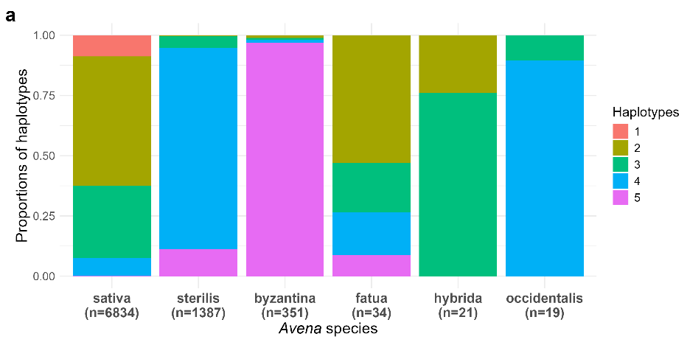

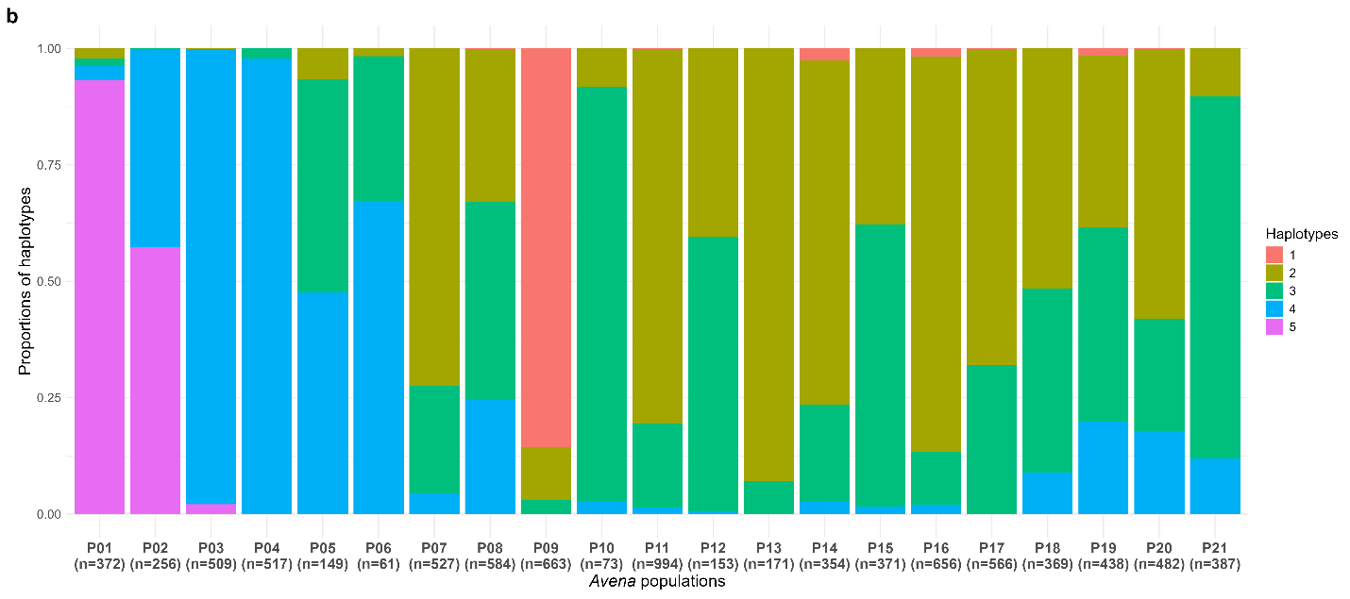
The distribution of in-silico karyotypes of the chromosome 1A translocation region in hexaploid Avena populations reveals signatures of domestication, population structure, breeding history, and agroecological adaptation. (a) The colours in the bar charts show the proportions of five haplotypes in each hexaploid species. (b) The proportion of the five haplotypes in each of the 21 Avena populations. The five haplotypes are identified in the legends by the final numeral in the following: 1AC-H1 (n=600), 1AC-H2 (n=3,706), 1AC-H3 (n=2,145), 1AC-H4 (n=1,695), and 1AC-H5 (n=506). The cross between ‘Goslin’ (having 1AC-H2) and ‘HiFi’ (having 1AC-H1) shows suppressed recombination and pseudo-linkage between 1A and 1C. In contrast, a cross between two parental lines which both have the translocated 1A/1C (‘TX07CS-1948’ (with 1AC-H3) x ‘Hidalgo’ (with 1AC-H2)) showed expected patterns of recombination (Kamal et al., Extended Data Fig. 6)⁵, as did a cross between ‘Terra’ (with 1AC-H2) x ‘Marion’ (with 1AC-H2)⁸. The clusters, in silico karyotypes, and actual karyotypes can be found in Supplementary File S8, sheet 5.

Supplementary Discussion S3: Projection of reference genomes on global oat diversity.
One of the objectives of this study was to identify diverse oat accessions for the purpose of developing a hexaploid oat pan genome⁴. When it was initiated, the oat pan genome study used reference genomes that were selected in part based on an earlier version of the current data set. That earlier data set did not include many of the taxa that were added subsequently. In particular, we later added a much larger set of A. sterilis taxa from the BioMob project, as well as most of the Australian taxa (Table 1). We then wished to identify how well this expanded hexaploid oat diversity space was represented by the accessions from oat pan genome, and to identify any gaps that might be filled in subsequent projects.
Methods
Genome positions of the SNP loci from the Matrix50 data set were identified within the pseudomolecules of the Sang genome. For each locus, a 400bp DNA fragment was extracted beginning 10bp upstream from a given SNP using the software SeqKit¹⁰. The extracted Sang sequences were formatted as a fasta query file. The remainder of the reference genomes were formatted as searchable NCBI BLAST+¹¹ databases. Each genome was then searched using the Sang query with BLAST parameters “-evalue 1e-180 -max_target_seqs 1 -max_hsps 1 -outfmt 0”. The resulting output files were parsed using a small Pascal script which identified the nucleotide matching the SNP (at the 10th base pair) in the best matching HSP for each locus. Loci were scored as ambiguous (N) if no match was found. The resulting SNP calls for each of 29 hexaploid reference genomes⁴ were merged with the GBS data in the Martix50 data file. An MDS analysis was performed using TASSEL¹² and visualized using DARWin software¹³. The associated distance matrix was parsed to identify the closest GBS-based taxa having a population-based assignment to each reference genome. A reduced data set containing only the lines from A. sativa populations was analyzed by the same methods.
Similar methods were conducted to project SNPs using the GS7 SNP calls (see Supplementary Discussion S2) as reported in our companion paper⁴.
Results
The MDS plot from the full data set resolved the positions of six reference genomes (Supplementary Fig. S3a) while the reduced analysis allowed better resolution of the remaining reference genomes (Supplementary Fig. 3b). Supplementary Table S3 shows the closest GBS taxa to each reference genome based on data from the Sang SNPs vs. data from the GS7 SNPs, as well as the population membership of the nearest genome based on either method. From Fig. S3a and the Sang projections in Table S3, it was apparent that reference genomes A-byzantina, TN4, CN25955, TN1, and FM13 fell within populations P01, P03, P04, P05 and P06, respectively, with no reference genome representing P02. From Fig. S3b and Table S3, the remaining reference genomes covered populations P07, P09, P11-P17, P20, and P21. Population membership based on the GS7 SNPs was different for four accessions (bold in Table S3), but both methods identified the same five populations without representation, including P02, P08, P10, P18, and P19.
From this we infer that conclusions about highly similar lines in adjacent populations are subject to some variability. Nevertheless, these results demonstrate that the 29 hexaploid reference taxa from the pan genome project provide a good coverage of most of the hexaploid Avena diversity space. The most notable exception is population P02. Thus, sequencing of one or more lines from population P02 should be prioritized in future efforts in order to confirm or refine our hypothesis that P02 is the progenitor of cultivated A. byzantina. Another notable exception is population P08, which contains the southern USA lines. Although the Australian lines (P07) are genetically similar to P08, we had assumed that the line Victoria would cover the Southern USA types, which it did not. Thus, this population should also be prioritized in future sequencing efforts.

Supplementary Table S3: Population membership of reference genomes.
 | Based on Sang SNP calls |  |  | Based on GS7 SNP calls
Reference | Closest GBS line | Distance | P(K=21) | Closest GBS line | Distance | P(K=21)
A. byzantina | PI 258586 | 0.0312 | P01 | PI 258586 | 0.0365 | P01
Amagalon | FABRSE | 0.1901 | P04 | CN 25974 | 0.1975 | P11
Aslak | Aslak | 0.0013 | P15 | Aslak | 0.0024 | P15
Bannister | Bannister | 0.0289 | P07 | Bannister | 0.0326 | P07
Bilby | Bilby | 0.0194 | P07 | Bilby | 0.0225 | P07
Bingo | Sang | 0.0502 | P17 | DCAs10 | 0.0519 | P15
Clintland60 | MORTON | 0.0405 | P20 | MORTON | 0.0440 | P20
CN25955 | CN 25956 | 0.0908 | P04 | CN 25956 | 0.0920 | P04
Delfin | Delfin | 0.0027 | P17 | Delfin | 0.0045 | P17
FM13 | FM13 | 0.0174 | P06 | FM13 | 0.0188 | P06
Gehl | ND160 | 0.0048 | P18 | Gehl | 0.0083 | P11
GMI423 | BGMN318 | 0.0575 | P15 | Triple Crown | 0.0648 | P11
GS7 | IL07-8721 | 0.0643 | P14 | IL07-8721 | 0.0659 | P14
Hatives | PI 573559 | 0.0162 | P11 | PI 573559 | 0.0192 | P11
HiFi | HiFi | 0.0053 | P09 | HiFi | 0.0083 | P09
Leggett | SA130278 | 0.0038 | P16 | Leggett | 0.0066 | P16
Lion | NORD 15/325 | 0.004 | P17 | NORD 15/325 | 0.0048 | P17
Morgan | AC Morgan | 0.0022 | P17 | AC Morgan | 0.0050 | P17
Nicolas | OA1331-5-0-21 | 0.0036 | P16 | OA1331-5-0-21 | 0.0074 | P16
OT3098 | SA130460 | 0.0037 | P16 | SA130460 | 0.0069 | P16
OT380 | OT380 | 0.0037 | P11 | OT380 | 0.0072 | P11
Park | CN 42524 | 0.0066 | P13 | CN 42524 | 0.0081 | P13
PI182478 | Bullion | 0.006 | P12 | Bullion | 0.0092 | P12
Rhapsody | Tardis | 0.027 | P21 | Tardis | 0.0304 | P21
Sang | Sang | 0.0001 | P11 | Sang | 0.0003 | P11
TN1 | ST0TN1 | 0.0099 | P05 | ST0TN1 | 0.0135 | P05
TN4 | CN 20957 | 0.0965 | P03 | CN 20957 | 0.0995 | P03
Victoria | Victoria | 0.0118 | P21 | Victoria | 0.0149 | P21
Williams | Williams | 0.0092 | P07 | Aus_195 | 0.0124 | P07
Reference genomes highlighted in bold differ slightly in assigned population between SNP calling methods.

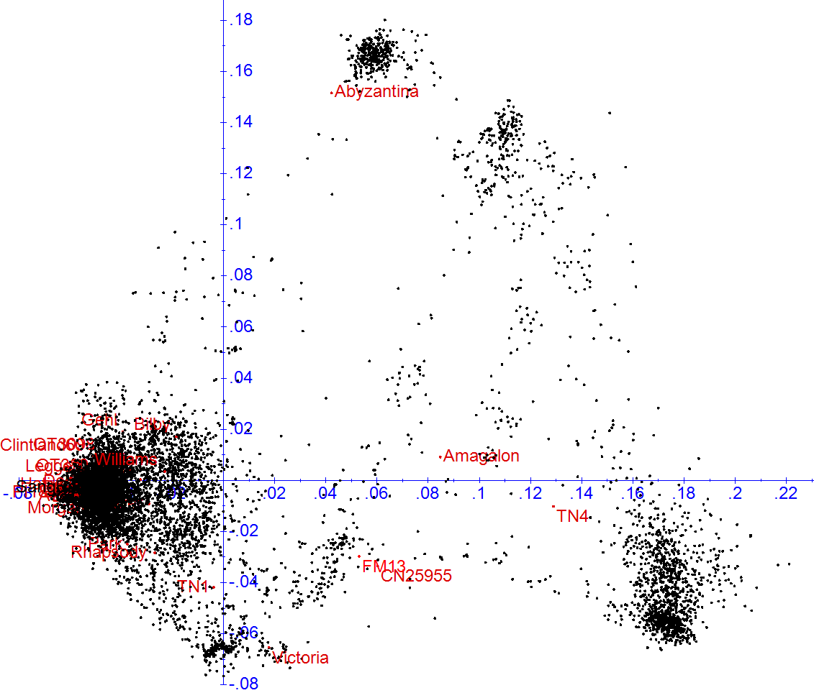
Supplementary Fig. S13: Location of reference genomes on MDS space.
a

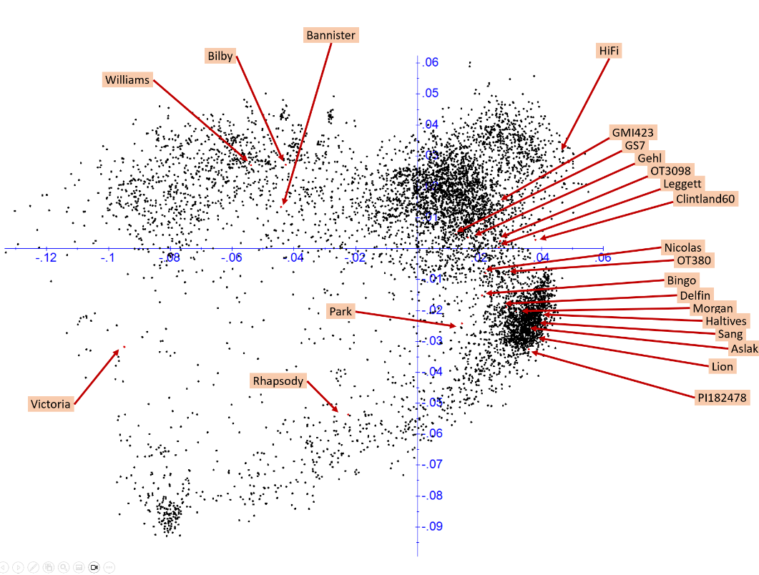

b

MDS analyses of (a) full data set (Matrix50) with the addition of reference genomes from the oat pan genome project⁴. (b) a reduced data set containing populations of A. sativa and the reference genomes that fall within this diversity space.

Literature Cited in Supplementary Information

1. Baum BR. Oats: wild and cultivated. A monograph of the genus Avena L.(Poaceae) (1977).

2. Diederichsen A. Assessments of genetic diversity within a world collection of cultivated hexaploid oat (Avena sativa L.) based on qualitative morphological characters. Genetic Resources and Crop Evolution 55, 419-440 (2008).

3. Mascher M, Schreiber M, Scholz U, Graner A, Reif JC, Stein N. Genebank genomics bridges the gap between the conservation of crop diversity and plant breeding. Nature genetics 51, 1076-1081 (2019).

4. Avni R, et al. A pangenome and pantranscriptome of hexaploid oat. bioRxiv, 2024.2010.2023.619697 (2024).

5. Kamal N, et al. The mosaic oat genome gives insights into a uniquely healthy cereal crop. Nature 606, 113-119 (2022).

6. Tinker NA, Bekele WA, Hattori J. Haplotag: software for haplotype-based genotyping-by-sequencing analysis. G3: Genes Genomes Genetics 6, 857-863 (2016).

7. Bekele WA, Wight CP, Chao S, Howarth CJ, Tinker NA. Haplotype based genotyping-by-sequencing in oat genome research. Plant Biotechnology Journal 16, 1452-1463 (2018).

8. Tinker NA, et al. Genome analysis in Avena sativa reveals hidden breeding barriers and opportunities for oat improvement. Communications Biology 5, 474 (2022).

9. Lu F, et al. Switchgrass Genomic Diversity, Ploidy, and Evolution: Novel Insights from a Network-Based SNP Discovery Protocol. PLOS Genetics 9, e1003215 (2013).

10. Shen W, Le S, Li Y, Hu F. SeqKit: a cross-platform and ultrafast toolkit for FASTA/Q file manipulation. PloS one 11, e0163962 (2016).

11. Camacho C, et al. BLAST+: architecture and applications. BMC bioinformatics 10, 1-9 (2009).

12. Bradbury PJ, Zhang Z, Kroon DE, Casstevens TM, Ramdoss Y, Buckler ES. TASSEL: software for association mapping of complex traits in diverse samples. Bioinformatics 23, 2633-2635 (2007).

13. Perrier X, Jacquemoud-Collet JP. DARwin software http://darwin.cirad.fr/darwin.) (2006).

