Supporting Information

Insights into the Formation of Covalent Organic Frameworks by Probing Interfacial Water Structure using Vibrational Sum Frequency Generation Spectroscopy

Yogesh Kumar, Srinivasa Rao Varanasi, Ravindra Pandey*

S.No. | Content | Page No.
1 | Materials | S2
2 | Instrumentation | S2
3 | Geometry Optimization of Monomer | S4
4 | NMR, IR, XRD and SFG Analysis | S5
5 | MALDI Analysis | S10
6 | Contact Angle Measurements | S11

1. Materials
All the chemicals were used as received unless stated otherwise. 1,3,5-tris(4′-aminophenyl)benzene (TAPB) and terephthaldehyde (PDA) were purchased from TCI. Solvents like mesitylene and dioxane were purchased from TCI, and glacial acetic acid was purchased from SRL. Millipore water (Merck Millipore direct-Q3, 18 MΩ cm) was used. We used a teﬂon sample cell to carry the aqueous samples for SFG measurements. The sample cell was cleaned before the experiment using a piranha solution (3:1 v/v of concentrated sulfuric acid to 30% hydrogen peroxide solution) and then rinsed thoroughly with deionized water. The same procedure was followed for cleaning all the glassware used during the experiments. All the experiments were carried out at a temperature of 22 ± 0.5 °C.
2. Instrumentation
Powder X-ray diffraction (PXRD) patterns were recorded using a Rigaku, MicroMax-007HF, using a high-intensity microfocus rotating anode X-ray generator and Cu Kα (α = 1.54 Å) radiation source with a Ni filter. Fourier-transform infrared (FT-IR) spectra were measured in the wavenumber range of 4000–500 cm^{–1} with a background correction using an FT-IR spectrophotometer manufactured by Bruker. A Bruker ultrafleXtreme-TN MALDI-TOF mass spectrometer was used to record mass spectra.
2.1. VSFG experimental details
In VSFG experiments, an overlap occurs between an infrared (IR) pulse and a visible (VIS) pulse both temporally and spatially at the surface, resulting in the generation of a sum frequency beam. A schematic diagram of a typical VSFG set-up is shown in Figure S1. When the frequency of the IR pulse aligns with the stretching vibrations of the interfacial molecule, the interaction of the two pulses leads to a significantly enhanced sum frequency field. The strength of the VSFG beam (I_{SFG}) depends on the intensities of both the visible and tunable IR pump beams (I_{VIS} and I_{IR}) and the effective second-order nonlinear susceptibility $χ_{eff}^{(2)}$, and is expressed as follows:
$$I_{SFG}∝ {\left|P_{SF}^{\left(2\right)}= ε_{0}χ_{eff}^{(2)}I_{vis}I_{IR}\right|}^{2}$$
The VSFG spectroscopy output is comprised of two components: a non-resonant portion and a resonant portion stemming from the resonant excitation of vibrational modes within the interfacial molecules because
$$χ_{eff}^{\left(2\right)}=χ_{NR}^{\left(2\right)}+ \sum_{n}{χ_{R,n}^{\left(2\right)}}$$
and
$$χ_{R}^{\left(2\right)}=\sum_{n}{\frac{A_{n}}{{(ω}_{n}-ω_{sum}-iΓ_{n})}}$$
In the above equations, $χ_{NR}^{\left(2\right)}$ and $χ_{R,n}^{\left(2\right)}$ denote the nonresonant and resonant contribution, respectively, $A_{n}$ is the amplitude of the resonant mode n, $Γ_{n}$ is the damping constant that represents the full width at half maximum of the Lorentzian line shape. The resonant part is directly proportional to the orientational macroscopic average of the molecular hyperpolarizability (⟨β⟩) and the total number of molecules that contribute to the generation of the VSFG signals ($N_{s}$).
$$χ_{R}^{\left(2\right)}=\frac{N_{s}}{ε_{0}}⟨β⟩$$
Therefore, the shapes of the vibrational bands of the molecules, described by Lorentzian curves, are influenced by factors such as the density of the molecules and the average orientation of the hyperpolarizabilities of molecules active in VSFG. Consequently, the intensity of VSFG increases with higher surface coverage and greater molecular organization of the interfacial molecules.
In our SFG set-up a focused femtosecond laser beam, operating at approximately 800 nm produced by Ti:sapphire regenerative amplifier (Astrella, Coherent), with 35 fs pulse duration. It generated a pulse energy of 5 mJ with a repetition rate of 1 kHz. The 2.5 mJ of laser output was passed through a Fabry-Perot etalon (SLS Optics Ltd.) to generate pulses of 15 cm⁻¹ FWHM. Another 2.5 mJ laser output was used to pump an optical parametric amplifier with the DFG stage (TOPAS, Light Conversion) to generate broad-band IR pulses. Both the beams were focused with the lens and overlapped (in space and time) at the sample surface to generate the VSFG pulse. The incidence angles of the IR and visible beams with respect to the surface normal were approximately 36° and 41° respectively. The resulting sum frequency signal was focused onto a lens, filtering out residual visible light which was collimated and focused onto a spectrograph (Kymera 328i A, Andor Instruments) and detected with an electron-multiplied charge-coupled device (Newton 970, Andor Instruments). All sum frequency generation (SFG) spectra were recorded in SSP (S-SFG, S-Visible, P-IR beam) polarization. Background correction of the spectra was achieved by subtracting the measured spectra from those recorded without an IR beam. This background subtraction eliminates the potential contamination of the resultant SFG signal by room or stray light, particularly induced by the visible beam, and gives the resultant changes in the spectra only due to the IR transition of the molecules. The z-cut quartz was used to normalize the data after background subtraction to account for the non-resonant signal. The sample trough was properly cleaned first with piranha solution and then with chloroform, methanol, and then water several times before recording the VSFG spectra. All the parameters like fixing the polarization to SSP, maintaining constant laser power throughout the experiment, background subtraction, and normalization of the spectra with respect to the quartz help to mitigate possible sources of error throughout the experiment.

Figure S1. Schematic diagram of VSFG experimental setup.
3. Geometry Optimization of Monomer
Table S1. Optimized geometry of the monomer, using the B3LYP/6-311G (d, p) method.
Monomer | Structure | Top View | Side View | Torsional Angle
TAPB | 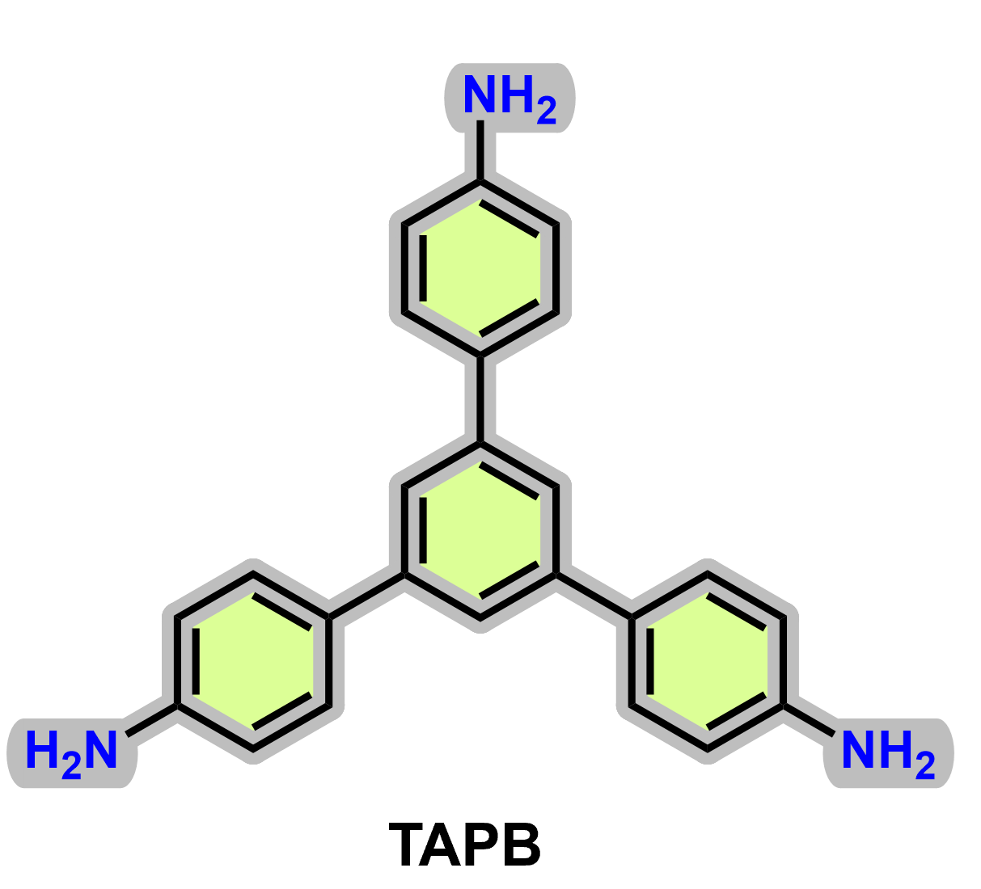 | 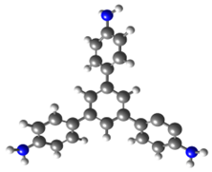 | 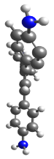 | 38.0°

4. NMR, IR,XRD and SFG analysis
4.1. NMR of model compound MC-TAPB-PDA

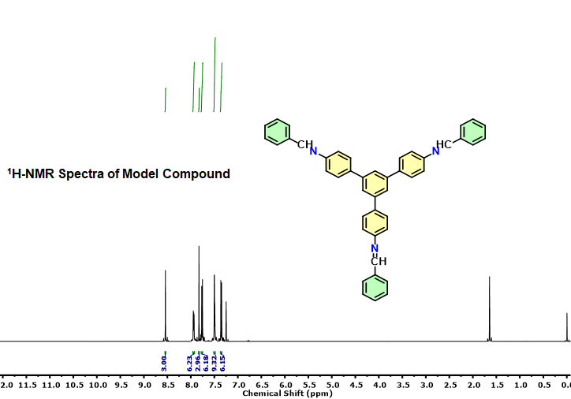
Figure S2. ¹H NMR spectra of model compound MC-TAPB-PDA.
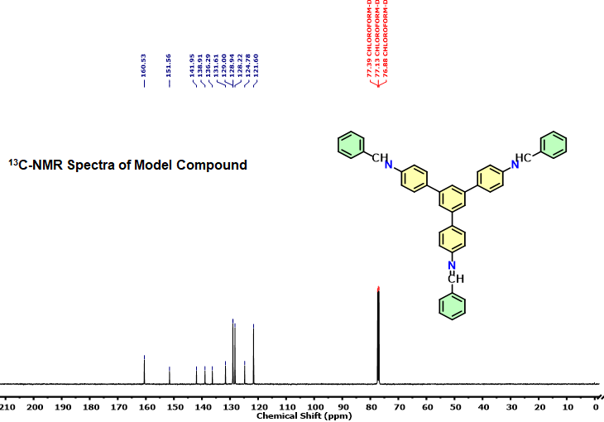
Figure S3. ¹³C NMR spectra of model compound MC-TAPB-PDA.
4.2. IR and XRD Analysis of TAPB-PDA Polymer
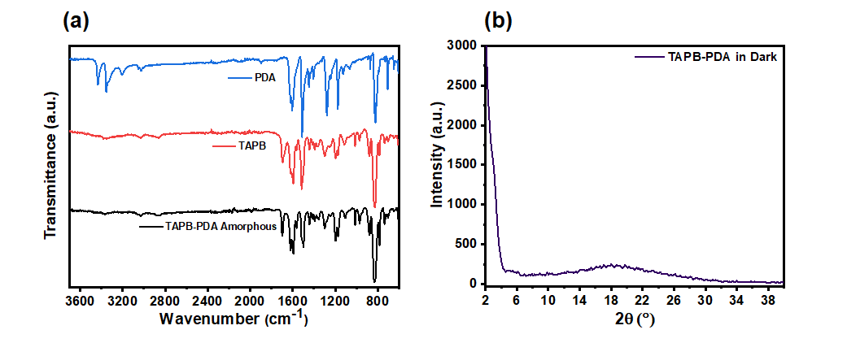
Figure S4. (a) FT-IR spectra of TAPB-PDA polymer synthesized in the dark compared with the linkers isotherm, (b) PXRD spectra of the TAPB-PDA polymer synthesized in dark.

4.3. SFG Analysis
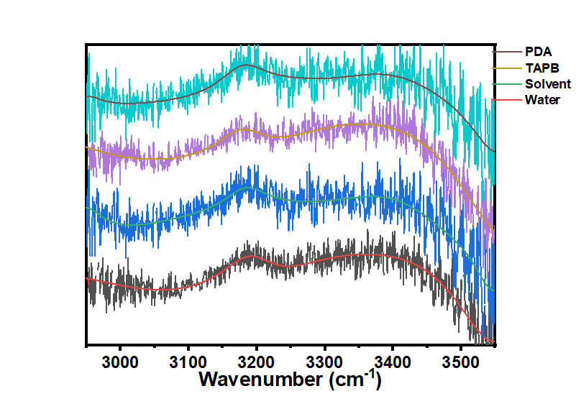
Figure S5. SFG spectra of pure water compared with the SFG spectra after adding solvent and monomers.

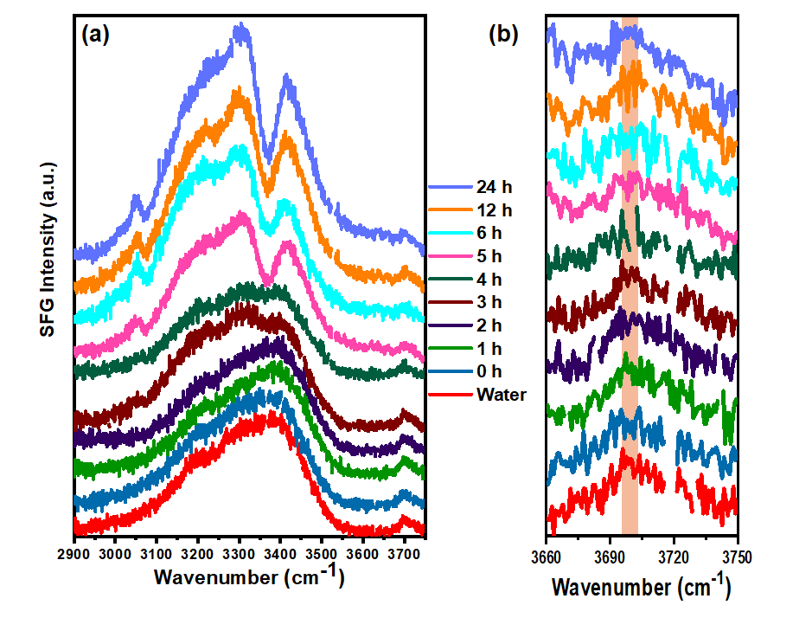Figure S6. SFG spectra of 10 μL TAPB-PDA precursor without catalyst in free O-H region at different times.
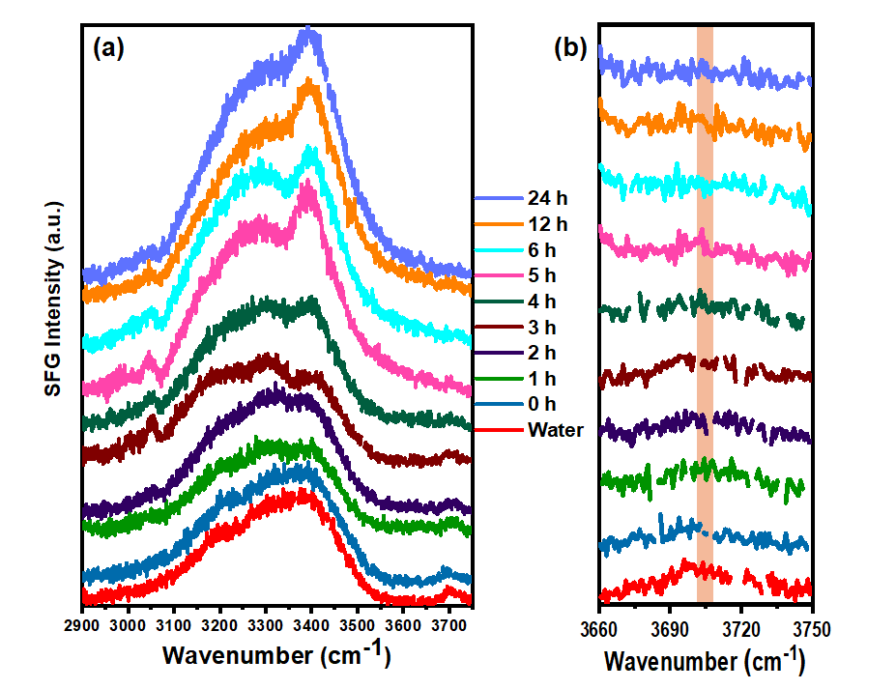
Figure S7. SFG spectra of 20 μL of TAPB-PDA precursor without catalyst in free O-H region at different times.
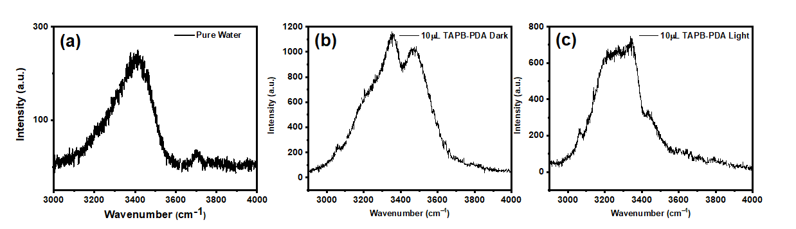
Figure S8. SFG spectra in the free O-H region of (a) Pure water; (b) after the addition of 10 μL of TAPB-PDA precursor with a catalyst in the dark; (c) after the addition of 10 μL TAPB-PDA precursor solution with irradiation of light.

5. MALDI-TOF analysis
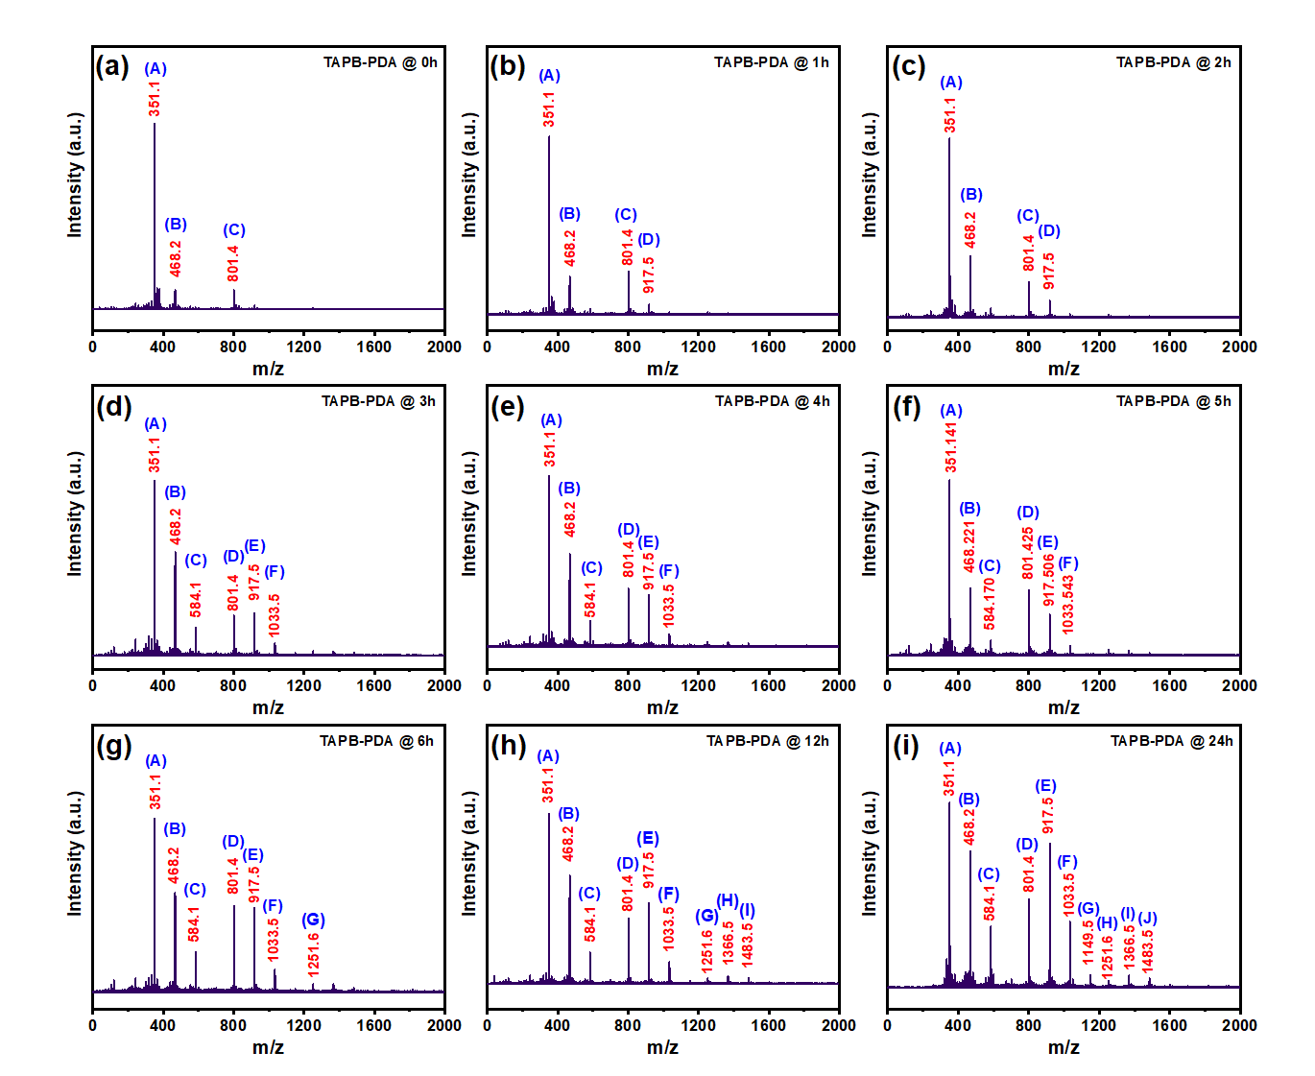
Figure S9. MALDI-TOF mass spectra of the TAPB-PDA precursor solution for analysis of the progress of reaction between TAPB and PDA without catalyst at different time intervals.
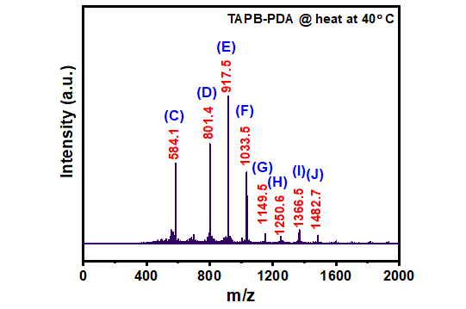
Figure S10. MALDI-TOF mass spectra of the TAPB-PDA precursor solution without catalyst after heating for 5 min at 40°C.
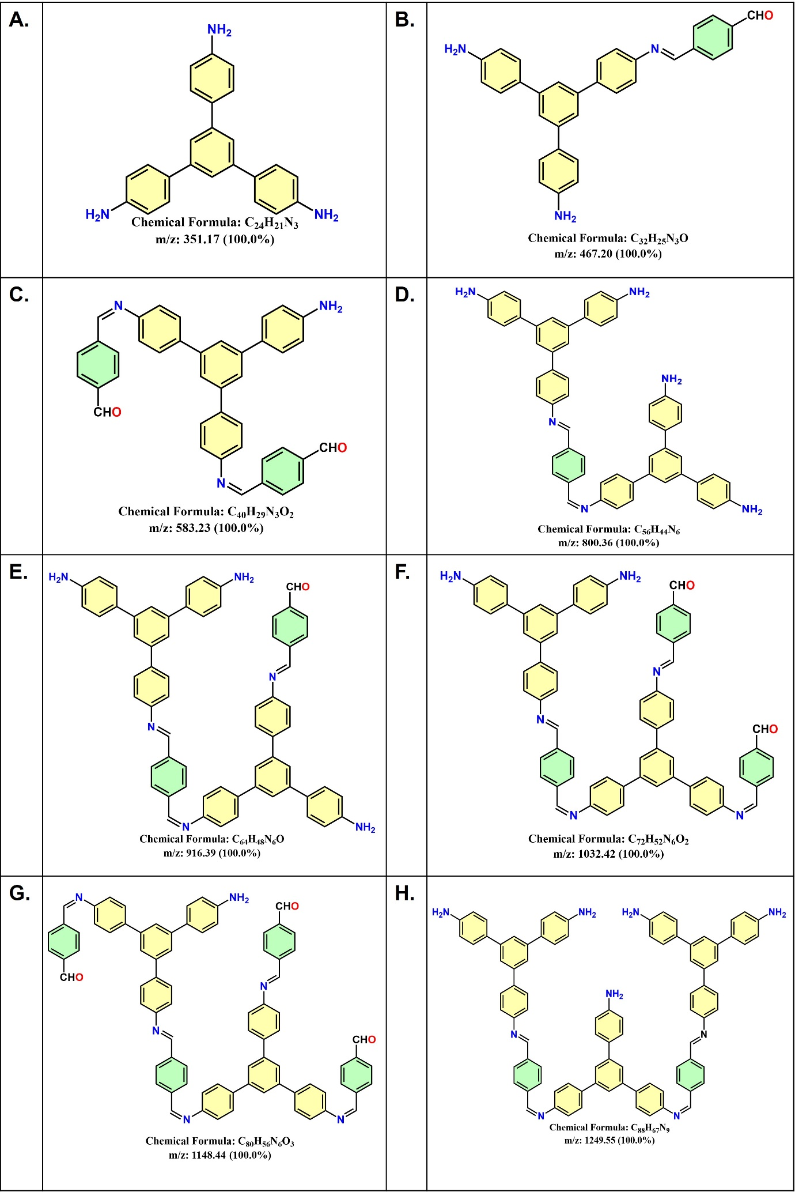Continue……..
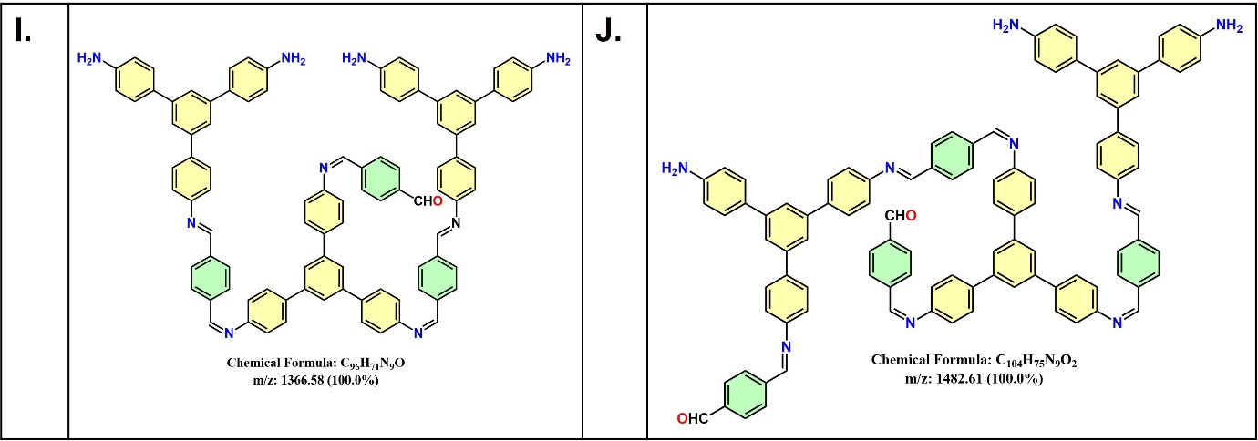
Figure S11. Possible macromolecules (A-J) formed during reaction between TAPB and PDA monomers without a catalyst in the precursor solution.
6. Contact Angle Measurements
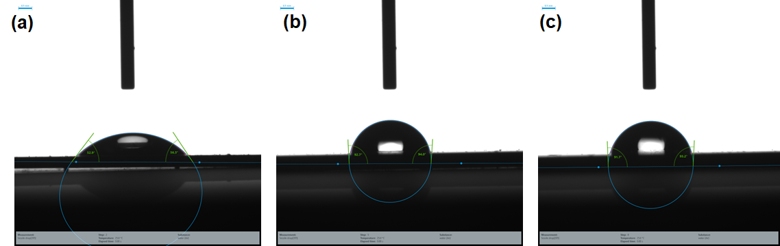
Figure S12. Contact angle measurements of (a) bare silicon wafer; (b) after the deposition of TAPB-PDA polymer; (c) after the deposition of TAPB-PDA COF.

