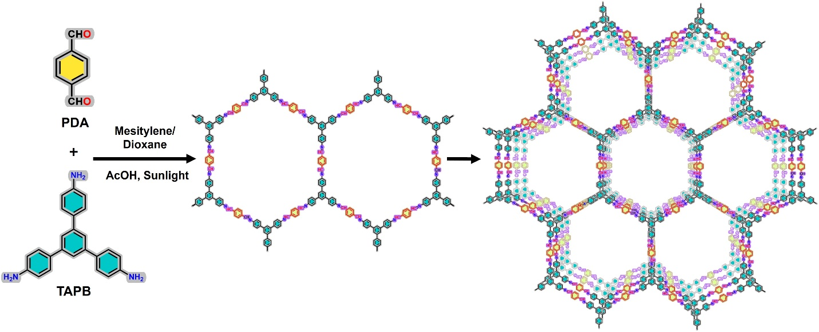Scheme 1. Schematic strategy for the synthesis of TAPB-PDA COF

