Supplementary materials
- The adsorption effect of different concentrations of pyrite on methyl orange
Fig. S1 Adsorption effect of different concentrations of pyrite on methyl orange
([MO]=0.1 mmol/L)
- The degradation effect of different concentrations of persulfate activated by pyrite on the degradation of methyl orange
Fig. S2 The degradation effect of different concentrations of persulfate activated by pyrite on the degradation of methyl orange ([MO]=0.1 mmol/L, [FeS₂]=1.6 g/L)
- The degradation of methyl orange after 2.5 hours of activation with different concentrations of pyrite and persulfate
Fig. S3 The degradation of methyl orange after 2.5 hours of activation with different concentrations of pyrite and persulfate (JMP response surface method)
([MO]=0.1 mmol/L)
It was known that Fe(Ⅱ) could stimulate PS to degrade organic pollutants. Analogous to the FeS₂/PS system might also have a good degradation effect on organic pollutants. Therefore, the response surface method was used to optimize the degradation of methyl orange by different concentrations of FeS₂ and different concentrations of PS (Fig. S3), the FeS₂ concentration was set to 0.2-2.0 g/L, and the PS concentration was set to 0.2-1.0 mmol/L, according to JMP software after setting the experimental plan, the optimization experiment was carried out, and the experimental data obtained was visualized and analyzed. The analysis result was shown in Fig. 1, and Fig. S3 showed the degradation effect of methyl orange after 2.5 hours of reaction. The degradation rate of methyl orange increased with the increase of FeS₂ and PS concentrations. This result was consistent with the FeS₂/PS system. Based on the analysis of the results in Fig. 1, the optimal conditions for the degradation of methyl orange by the FeS₂/PS system are: [PS]=1.0 mM and [FeS₂]=1.6 g/L.
- Pore diameter distribution of the pyrite
Fig. S4 Pore diameter distribution of the pyrite
- pH at different reaction time points
Fig. S5 pH at different reaction time points
([MO]=0.1 mmol/L，[FeS₂]=1.6 g/L，[PS]=1.0 mmol/L)
- UV spectra of methyl orange degradation by persulfate activated by pyrite
Fig. S6 UV spectra of methyl orange degradation by persulfate activated by pyrite
- Interface effect verification
Fig. S7 Interface effect verification
([MO]=0.1 mmol/L，[FeS₂]=1.6 g/L，[Fe(II)]=4 mg/L, [PS]=1.0 mmol/L)
- The pH before and after the reaction of different anions
Table S1 After adding different concentrations of Cl⁻, HCO₃⁻, H₂PO₄⁻, the FeS₂/PS system degrades the pH before and after the methyl orange reaction
([MO]=0.1 mmol/L, [FeS₂]=1.6 g/L, [PS]=1.0 mmol/L)
Anion/MO | Cl⁻ |  | HCO₃⁻ |  | H₂PO₄⁻
Reaction | Before | After | Before | After | Before | After
0 | 6.08 | 2.87 | 6.08 | 2.87 | 6.08 | 2.87
0.1 | 6.04 | 3.04 | 6.63 | 2.88 | 6.53 | 3.67
1 | 5.86 | 2.84 | 6.79 | 2.87 | 6.52 | 4.87
10 | 5.70 | 2.83 | 7.68 | 6.71 | 6.14 | 5.50
100 | 5.65 | 2.93 | 7.97 | 7.41 | 5.39 | 4.67
- The kobs and t_{1/2} of methyl orange were obtained by FeS₂/PS system under different concentrations of Cl⁻, HCO₃⁻ and H₂PO₄⁻
Table S2 The kobs and t_{1/2} of methyl orange were obtained by FeS₂/PS system under different concentrations of Cl⁻, HCO₃⁻ and H₂PO₄⁻
([MO]=0.1 mmol/L，[FeS₂]=1.6 g/L，[PS]=1.0 mmol/L)
Anion: C | Cl⁻ |  |  | HCO₃⁻ |  |  | H₂PO₄⁻
Anion: C | k_{obs}(min⁻¹) | R² | t_{1/2}(min) | k_{obs}(min⁻¹) | R² | t_{1/2}(min) | k_{obs}(min⁻¹) | R² | t_{1/2}(min)
0: 1 | 0.0180 | 0.9941 | 38.51 | 0.0180 | 0.9941 | 38.51 | 0.0180 | 0.9941 | 38.51
0.1: 1 | 0.0128 | 0.9855 | 54.15 | 0.0133 | 0.9987 | 52.12 | 0.0029 | 0.9901 | 239.02
1: 1 | 0.0146 | 0.9950 | 47.48 | 0.0125 | 0.9880 | 55.45 | 0.0007 | 0.9947 | 990.21
10: 1 | 0.0143 | 0.9923 | 48.47 | 0.0019 | 0.9833 | 364.81 | 0.0011 | 0.9730 | 630.13
100: 1 | 0.0113 | 0.9948 | 61.34 | 0.0014 | 0.9973 | 495.11 | 0.0021 | 0.9821 | 330.07
- Basic physical and chemical properties of different water substrates
Table S3 Physical and chemical properties of different water substrates
Physicochemical property | Tap water | River water
Water temperature | 18.3ºC | 19.6ºC
pH | 7.69 | 7.97
Electrical conductivity | 535 μS/cm | 655 μS/cm
TOC | 8.17 mg/L | 13.62 mg/L
Na⁺ | 14.13 μg/L | 11.51 μg/L
K⁺ | 1.95 μg/L | 3.70 μg/L
Ca²⁺ | 18.04 mg/L | 12.02 mg/L
Mg²⁺ | 74.13 mg/L | 55.90 mg/L
Cl⁻⁻ | 53.18 mg/L | 39.88 mg/L
HCO₃⁻ | 292.88 mg/L | 289.83 mg/L
SO₄²⁻ | 214.20 mg/L | 406.32 mg/L
Note: The river water was taken from the Wuma River, Taigu, Jinzhong City, Shanxi Province on November 26, 2020 ( 37°27’11’’ N, 112°33’18” E )
- SEM and EDS spectra of fresh and used pyrite
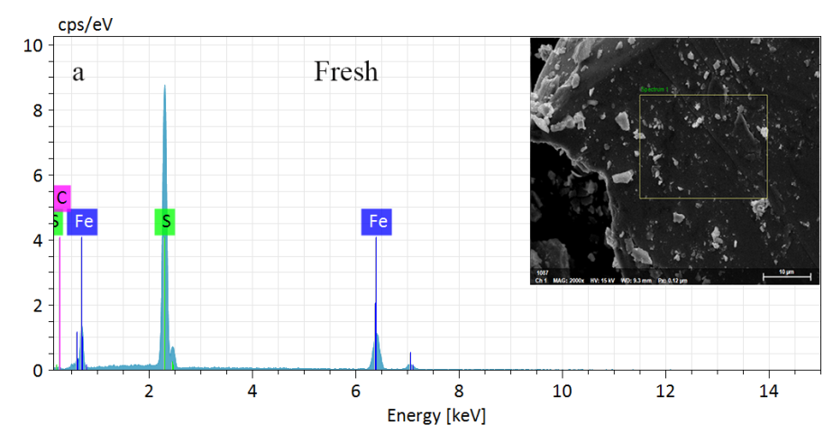
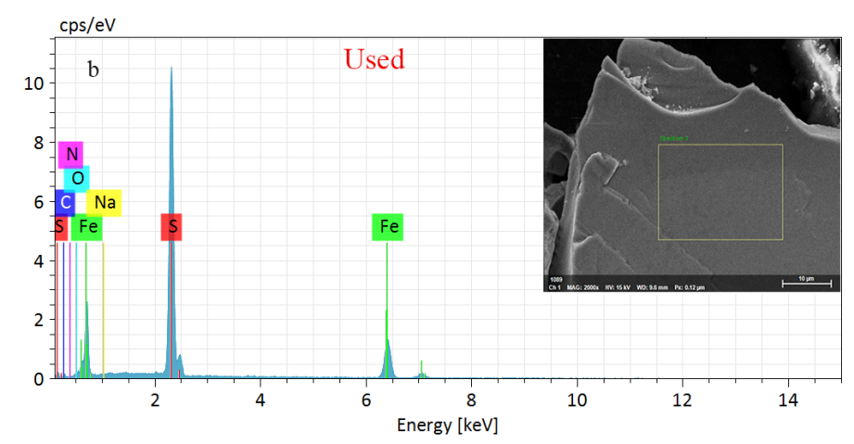
Fig. S8 SEM and EDS spectra of fresh and used pyrite
- FTIR spectra of fresh and used pyrite
Fig. S9 FTIR spectra of fresh and used pyrite
- Exploration of biological toxicity
Fig. S10 Exploration of biological toxicity
([MO]=0.1 mmol/L, [FeS₂]=1.6 g/L, [PS]=1.0 mmol/L)
- Analysis results of LC-MS (ESI-) degradation products
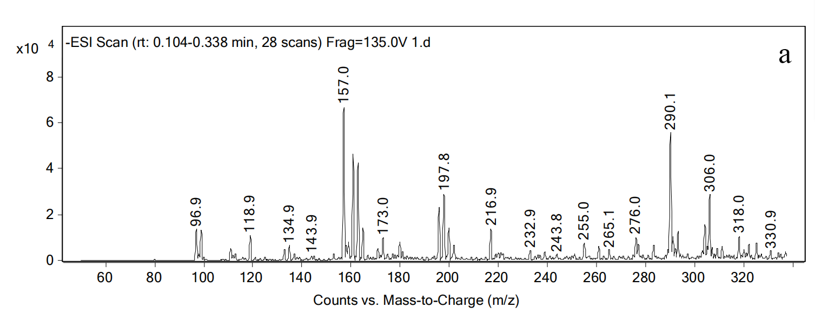
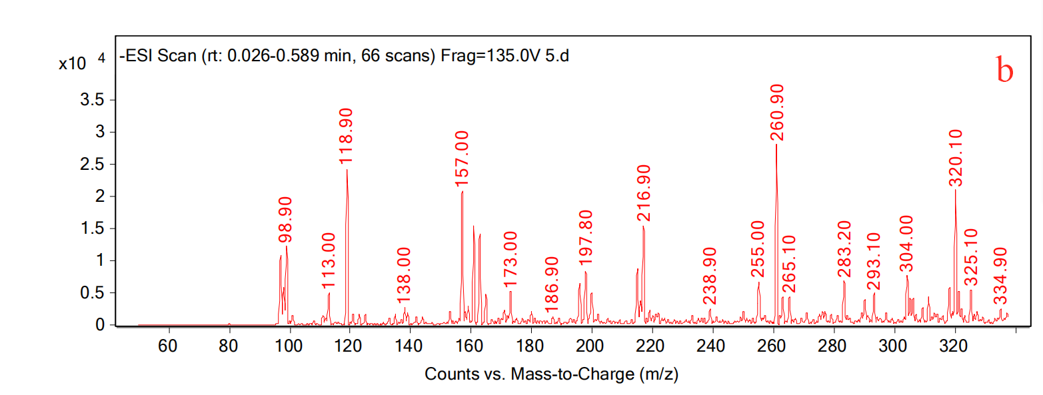
Fig.S11 Analysis results of LC-MS(ESI-) degradation products

- FeS₂/PS system degrades methyl orange intermediates
Table S4 FeS₂/PS system degrades methyl orange intermediates
Products | m/z | Structural formula
MO | 327.33 | 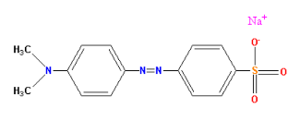
P1 | 304.34 | 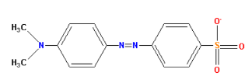
P2 | 290.32 | 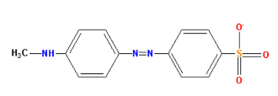
P3 | 276.29 | 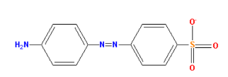
P4 | 261.28 | 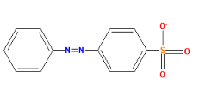
P5 | 172.18 | 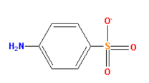
P6 | 157.17 | 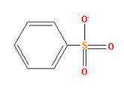
P7 | 306.36 | 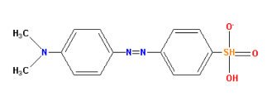
P8 | 197.24 | 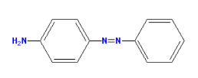
P9 | 199.24 | 