Supplementary Tables
Table S1. TORCH test results of proband’s mother at 13 weeks of gestation.
Pathogen | IgM | IgG
Toxoplasmosis | Negative | Negative
Rubella | Negative | Negative
Cytomegalovirus | Negative | Positive
Herpes simplex | Negative | Positive

Table S2. Maternal dietary intakes of nutrients at 14 weeks of gestation.
Nutrients | Intake | RNI/AIª | AMDR^{b}
Macronutrient, fiber
Energy (Kcal/d) | 1062 | 2100-2700
Protein (g/d) | 31.2 | 70
Fat (%/d) | 13.2 |  | 20-30
Carbohydrate (%/d) | 75.6 |  | 50-65
Vitamin
VA (μg REA/d) | 701.3 | 770
VE (mg α-TE/d) | 24.9 | 14
VB1 (mg/d) | 0.63 | 1.4
VB2 (mg/d) | 0.66 | 1.4
VC (mg/d) | 288.4 | 115
Folic acid (μg DEF/d) | 318.2 | 600
Nicotinic acid (mg NE/d) | 9.4 | 12
Mineral
Selenium, Se (μg/d) | 25.5 | 65
Calcium, Ca (mg/d) | 454.9 | 1000
Iron, Fe (mg/d) | 15.9 | 24
Magnesium, Mg (mg/d) | 289.5 | 370
Phosphorus, P (mg/d) | 651 | 720
Potassium, K (mg/d) | 2556.4 | 2000
Sodium, Na (mg/d) | 2712.8 | 1500
Zinc, Zn (mg/d) | 6.9 | 9.5
Copper, Cu (mg/d) | 2.3 | 0.9
Manganese, Mn (mg/d) | 4.7 | 4.9
Iodine, I (μg/d) | 435.8 | 230
ªRNI: recommended nutrient intake; AI: adequate intake (Chinese Dietary Reference Intakes [DRIs], 2013);
^{b}AMDR: acceptable macronutrient distribution ranges (Chinese Dietary Reference Intakes [DRIs], 2013)
Table S3. Non-invasive prenatal testing at 14 weeks of gestation.
Trisomy | Value | Reference | Risk
21 | -1.076 | -3 to 3 | low risk
18 | -2.280 | -3 to 3 | low risk
13 | -1.087 | -3 to 3 | low risk

Table S4. Thyroid function tests and urinary iodine level at 17 weeks of gestation.
Item | Value | Reference
Serum free Triiodothyronine, fT3 (pg/mL) | 2.75 | 2.50-3.90
Free Thyroxine, fT4 (ng/dL) | 0.82 | 0.61-1.12
Thyroid-stimulating hormone, TSH (μIU/mL) | 0.12 | 0.34-5.10
Urinary iodine (μg/L) | 383.86 | 150-250

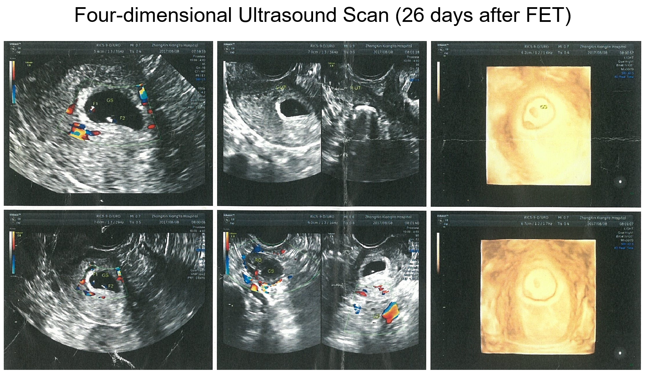
Fig. S1. Pictures of four-dimensional ultrasound scan of the infants at 26 days after FET. The monochorionic diamniotic (MCDA) twins were diagnosed.
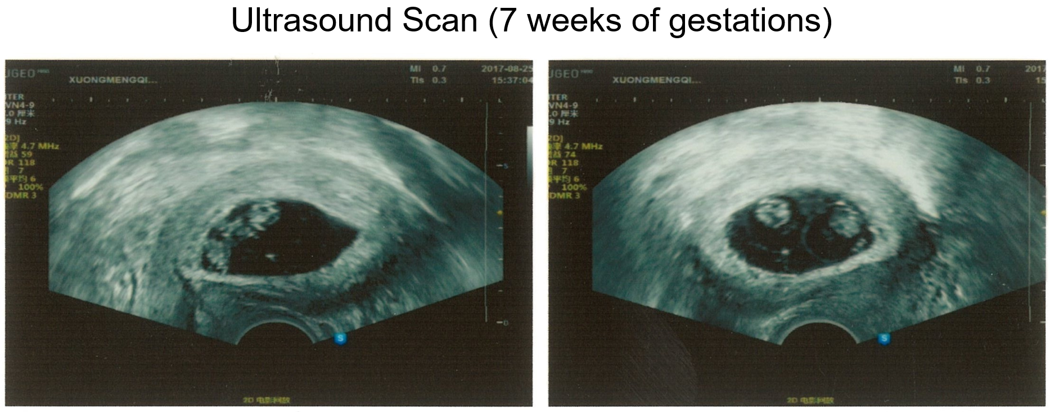
Fig. S2. Pictures of ultrasound scan of the infants at 7 weeks of gestations. Two yolk sacs and two embryos with heart beats were detected.
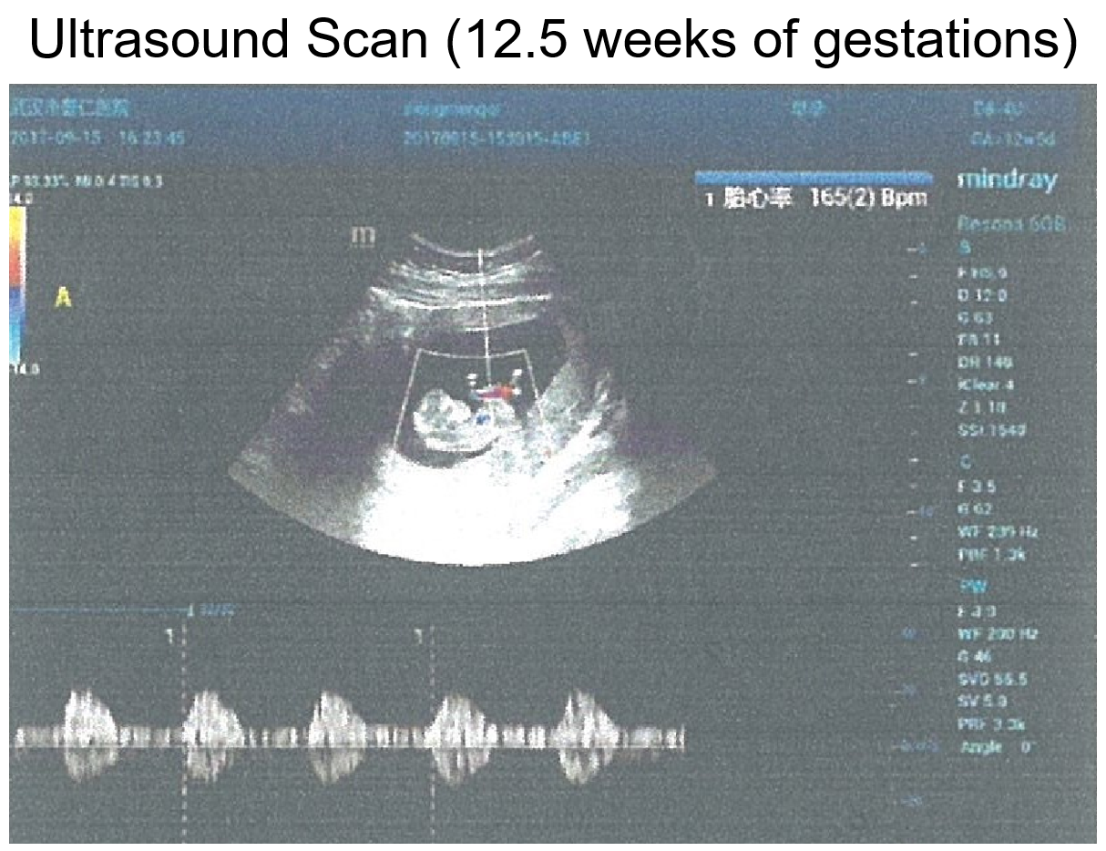
Fig. S3. Pictures of ultrasound scan of the infants at 12.5 weeks of gestations.

