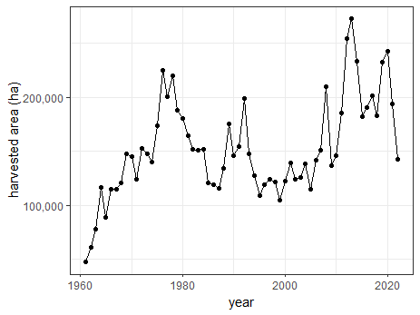
(A)
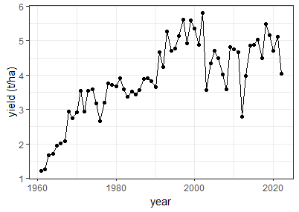
(B)
Figure S1. Time series of sorghum harvested area (A) and yield (B) in Europe (1961-2022). Europe includes Turkey and all 44 European countries except Iceland and Russia Source: FAO (2023).
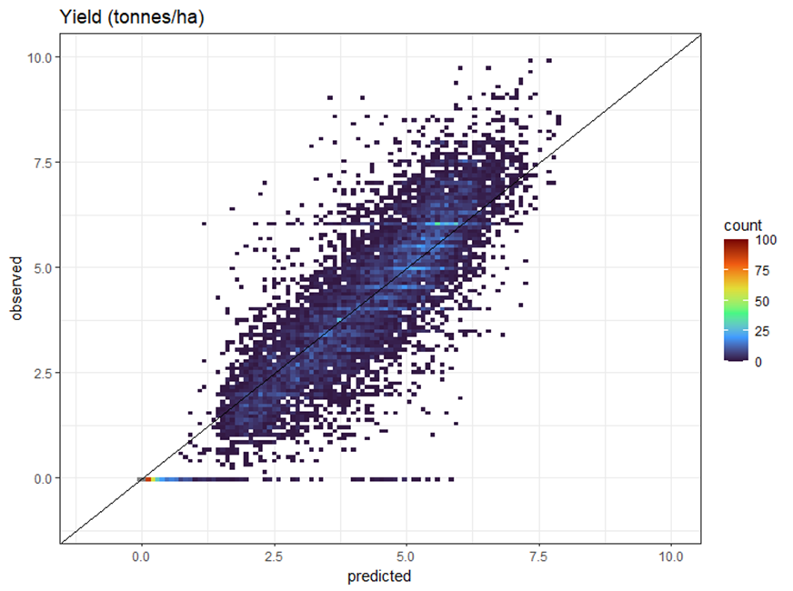
Figure S2. Comparison of predicted and observed sorghum yields (t ha⁻¹). Predictions were produced for the 2000 to 2020 period by a random forest algorithm using five-fold cross-validation (R2=83%, RMSE=0.94 t ha⁻¹).

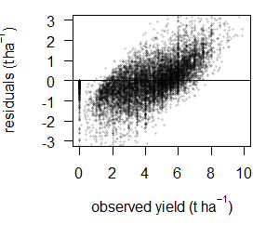
(A)
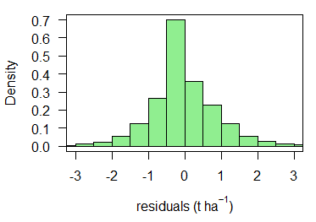
(B)
Figure S3. Analysis of the residuals of the yield predictions (Obs.-Pred.). (A) Residuals as a function of the observed sorghum yield. (B) Histogram of the residuals.
(A)
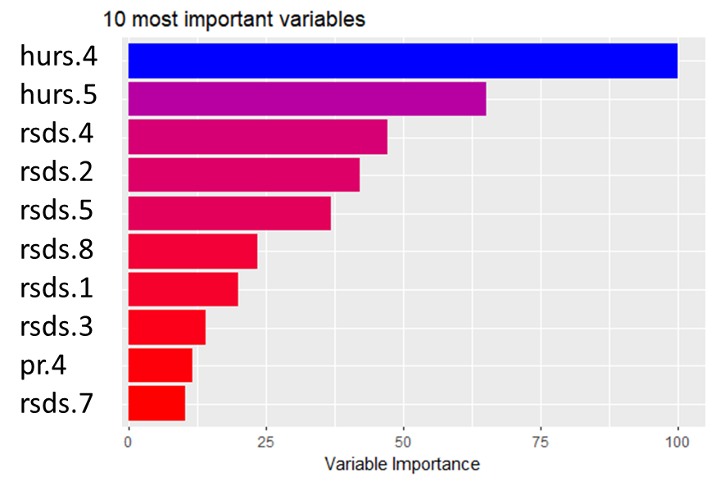
(B)
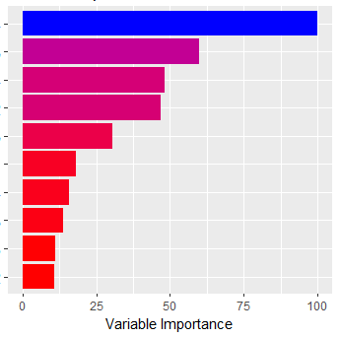
VPD.4
VPD.5
rsds.4
rsds.2
rsds.5
rsds.1
pr.4
rsds.3
rsds.8
VPD.2

Figure S4. Top 10 most important climate variables of the model with relative humidity (A) and the model with vapor pressure deficit (VPD) (B). We used the mean decrease in impurity (Gini importance) to compare the variable importance of climate variables. Gini importance evaluates the feature's contribution to reducing impurity in decision trees, indicating its significance in splitting nodes to improve model performance. Variables are sorted by decreasing order. The color palette in the figure follows a blue-to-red gradient, with blue representing the most important parameters and progressively transitioning to red for the least important parameters. pr: monthly total precipitation (mm month⁻¹), rsds: monthly mean daily total solar radiation (MJ m⁻² d⁻¹), and hurs: monthly mean relative humidity (%). The numerical suffix refers to the month of the sorghum growing season (from 1 to 8). To maintain consistency with future parameters used in the ISIMIP database, relative humidity (RH) was used instead of VPD. Despite this change, our model showed the same performance (VPD vs RH). That is why we used the model with RH.

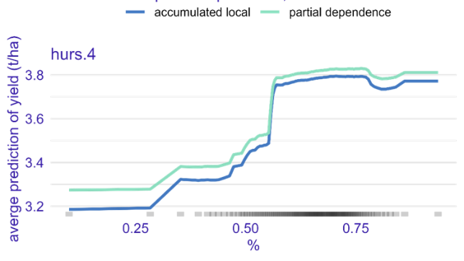  (A)  (C)  (A)  (C) | 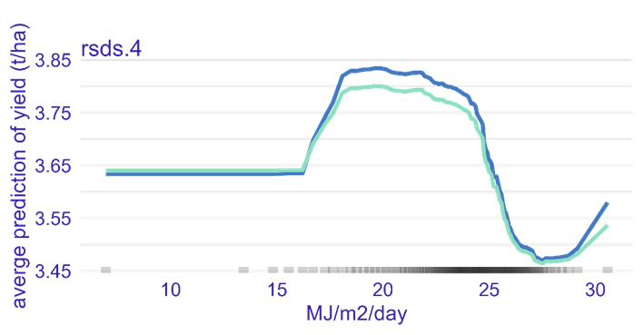  (B)
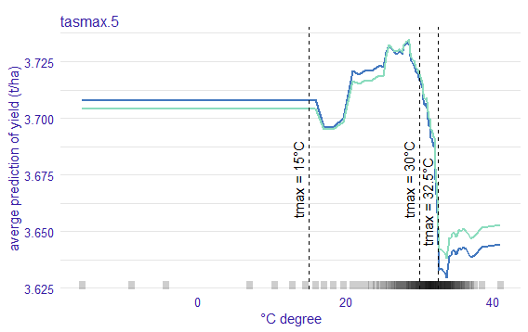  (E) | 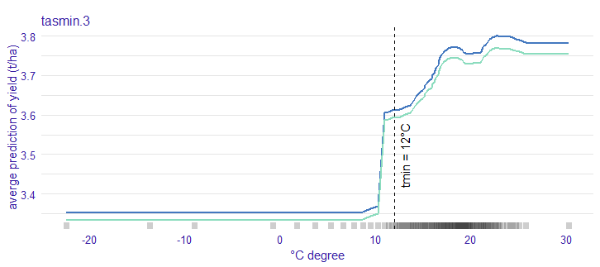  (D)  (F)
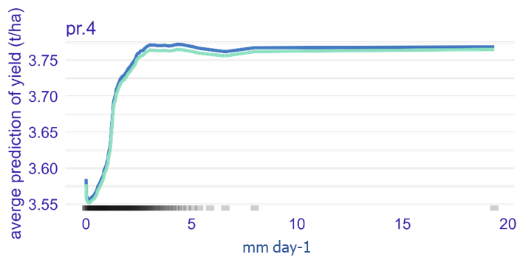  (G) | 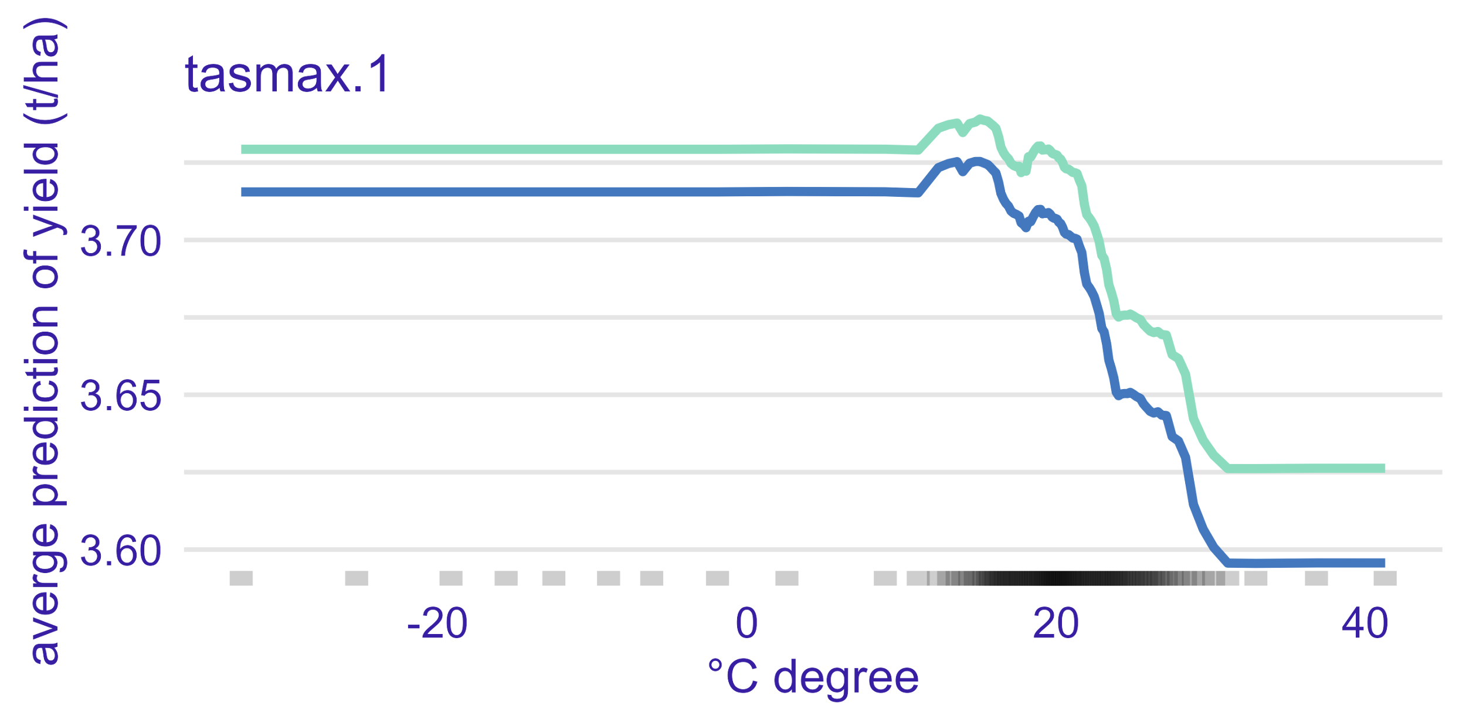  (H)
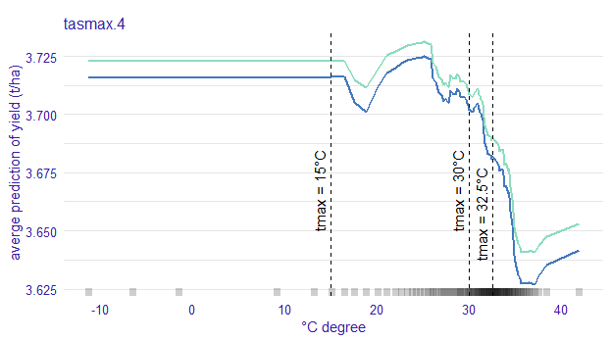 | 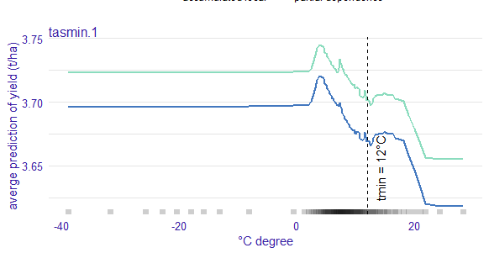
Figure S5. Partial dependence plots and Accumulated Local Effects for selected climate variables. (A) monthly average of daily relative humidity in the fourth month of the sorghum growing season (hurs.4). (B) monthly average of daily solar radiation in the fourth month of the sorghum growing season (April-November) (rsds.4). (C) monthly average of daily maximum temperature in the fifth month of the sorghum growing season (tasmax.5). (D) monthly average of daily minimum temperature in the third month of the sorghum growing season (tasmin.3). (E) monthly average of daily precipitation in the fourth month of the sorghum growing season (pr.4). (F) monthly average of daily maximum temperature in the first month of the sorghum growing season (tasmax.1). (G) monthly average of daily maximum temperature in the fourth month of the sorghum growing season (tasmax.4). (H) monthly average of daily minimum temperature in the first month of the sorghum growing season (tasmin.1). We found that the optimum growing temperature as well as critical minimum and maximum temperatures estimated by our model are consistent with results reported in experimental studies (Emendack et al., 2021; Hoffman et al., 2020; Tack et al., 2017, Prasad et al., 2015). Specifically, these studies demonstrated that during the main growth phase, sorghum has an optimum range of daily maximum temperatures between 27°C to 30°C (dotted line tmax= 30°C, G and C). They also showed that sorghum needs a minimum temperature of 15 °C (dotted line tmin= 15°C, D) for growth, while its yields decrease rapidly when the daily maximum temperature exceeds 32.5 °C (dotted line tmax= 32.5°C, G and C). These findings suggest that our model simulations are consistent with the current understanding of sorghum physiology.
(A)
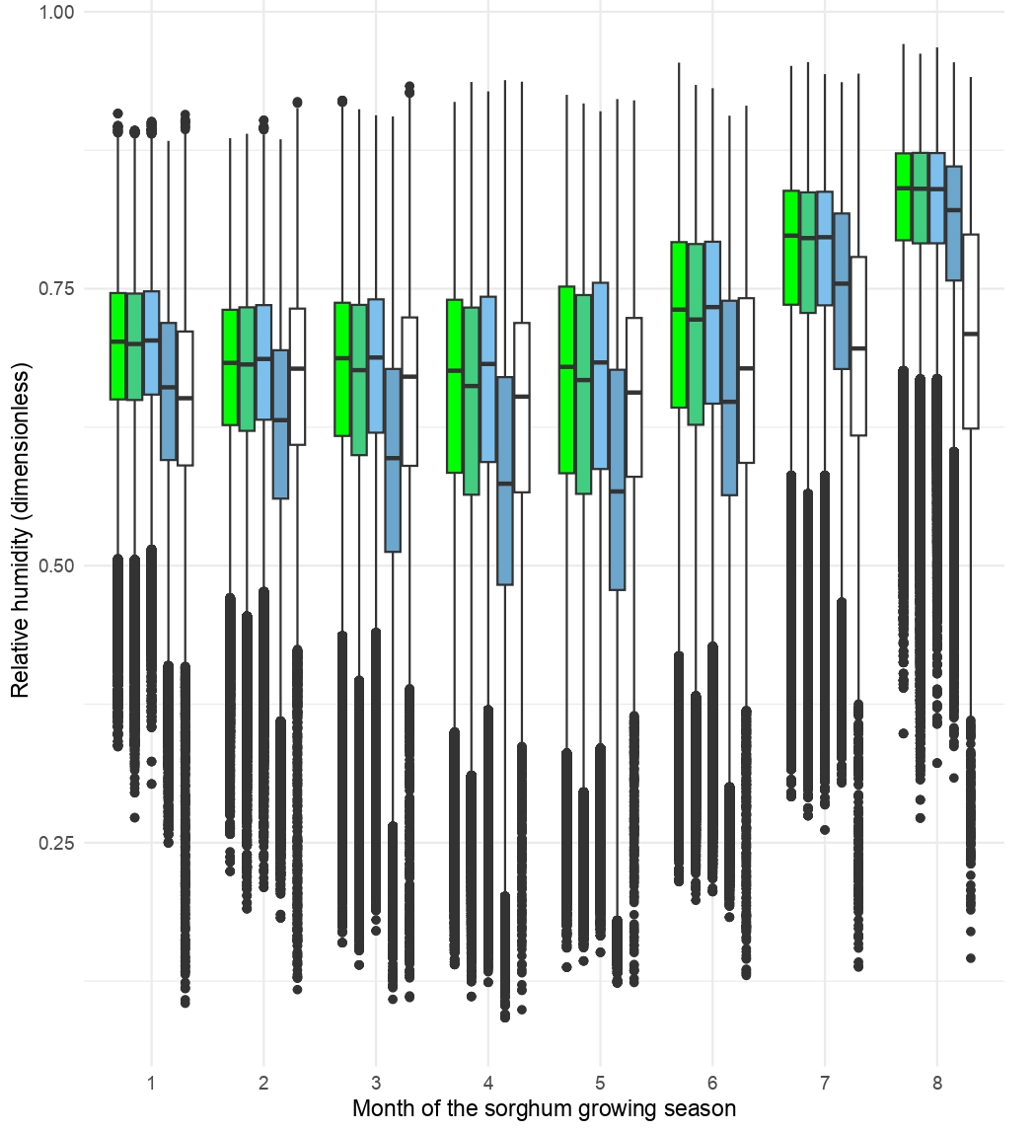
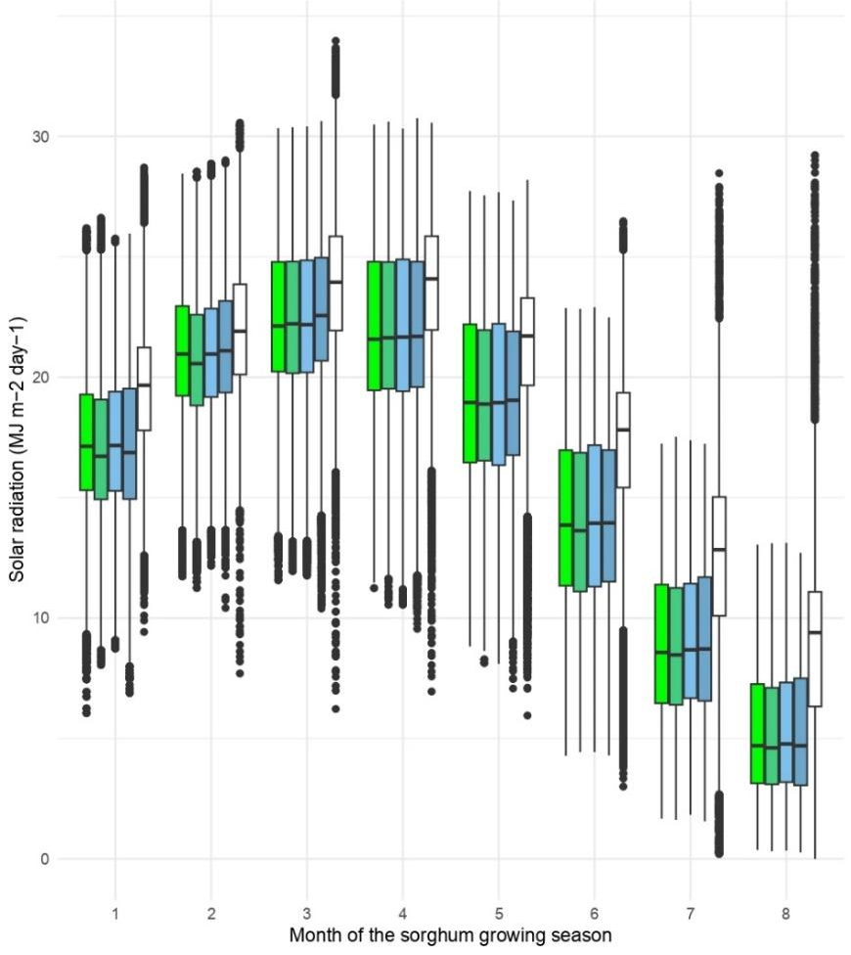
(B)
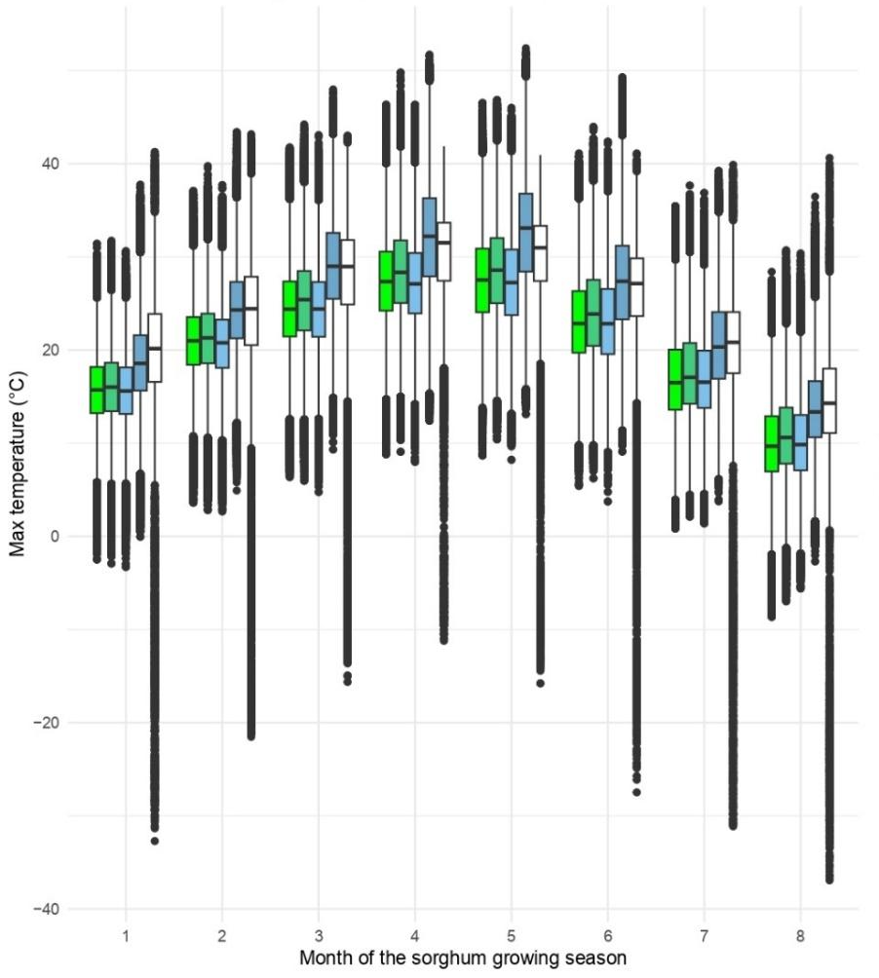
(C)
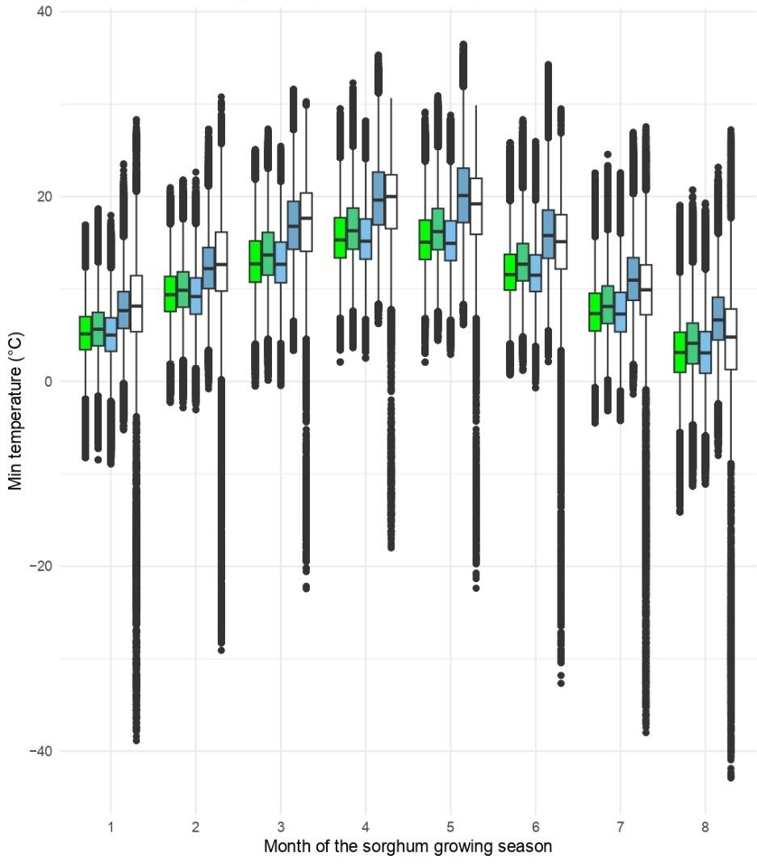
(D)
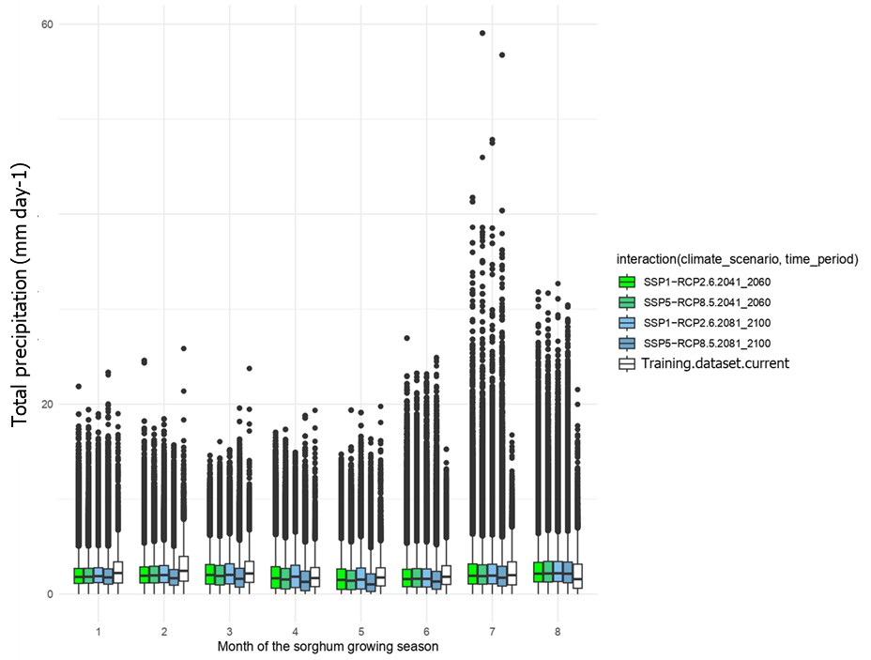
(E)
Figure S6. Comparison of observed ranges of climate variables in the dataset used for training the random forest model and the datasets used to make sorghum yield projections in Europe under current (Erra5) and future climate scenarios. (A) relative humidity (hurs). (B) solar radiation (rsds). (C) Monthly average of daily maximum temperature (tasmax). (D) Monthly average of daily minimum temperature (tasmin). (E) total precipitation (pr). The Erra5-land dataset is used for model training (“training dataset” in the color key) and to make projections of sorghum yield in Europe under current climate (2000-2020) (“current” in the color key). The five global climate models (Eyring et al., 2016) for future climate scenarios between mid-century (2041-2060), end-‎century (2081-2100)‎ under SSP1-RCP2.6 and SSP5-RCP8.5‎.
(A)

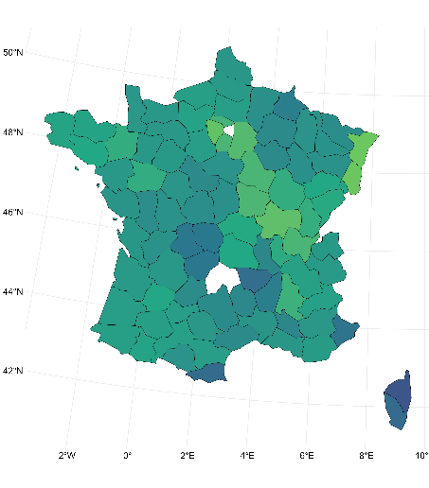  France | Italy  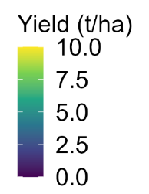  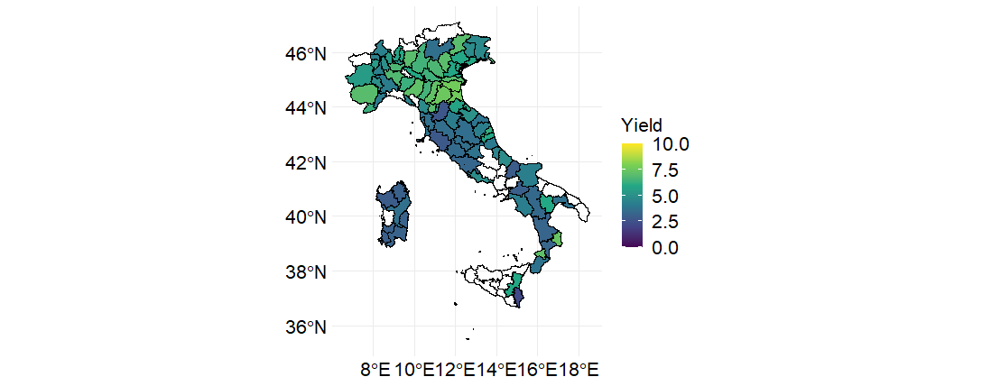
The USA  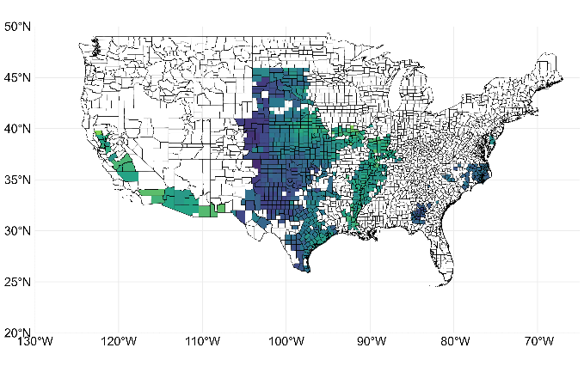 | Spain  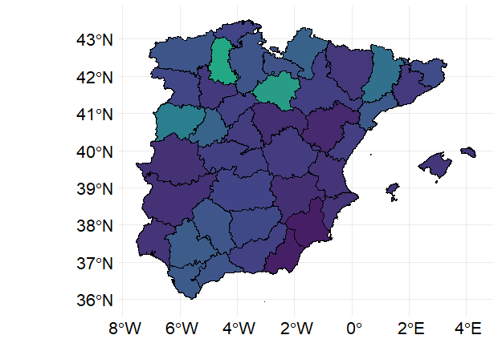
Figure S7. Maps of average sorghum yield across subnational ‎administrative levels for different countries ‎during the years 2000-2020‎.‎ For Italy‎, sorghum data is available from 2006

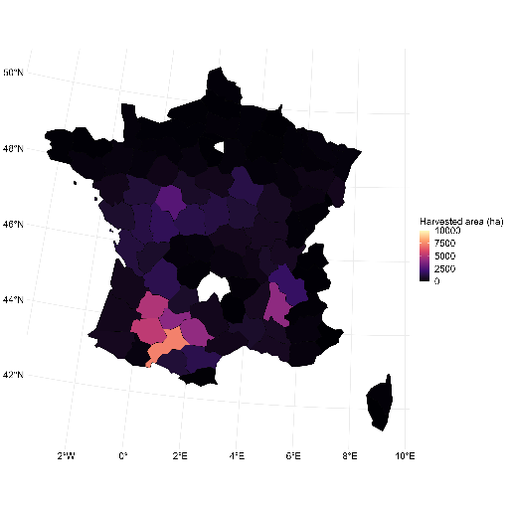  France | Italy  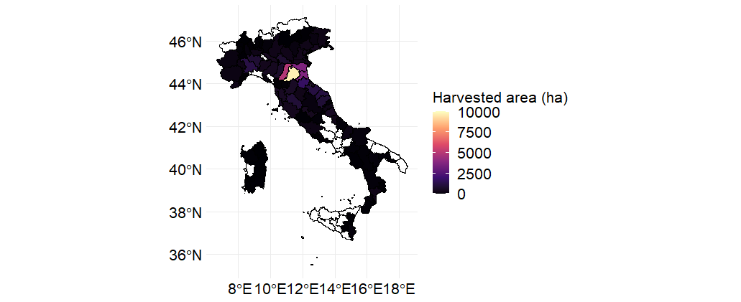
The USA  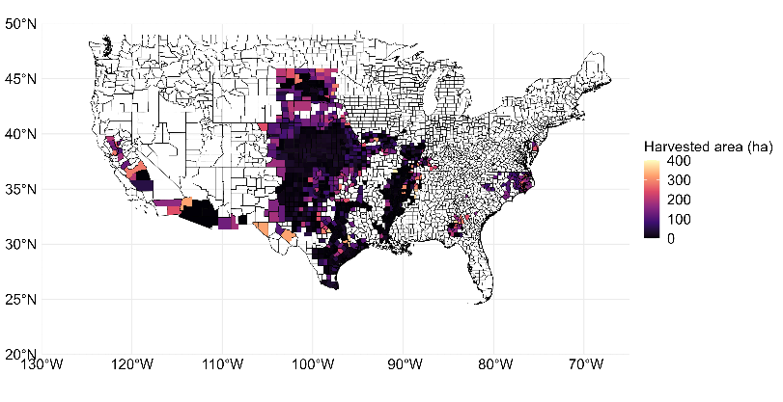 | Spain  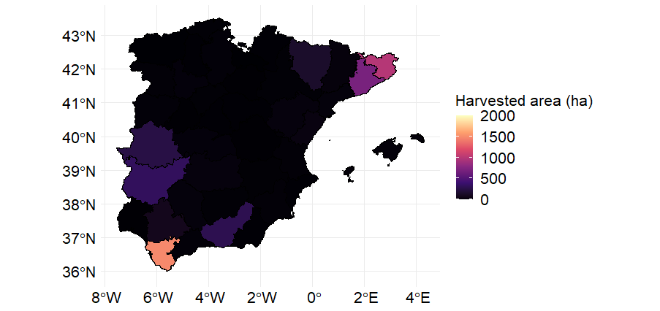

Figure S8. Maps of average sorghum harvested area across subnational ‎administrative levels for different countries ‎during the years 2000-2020‎.‎ For Italy‎, sorghum data is available from 2006.
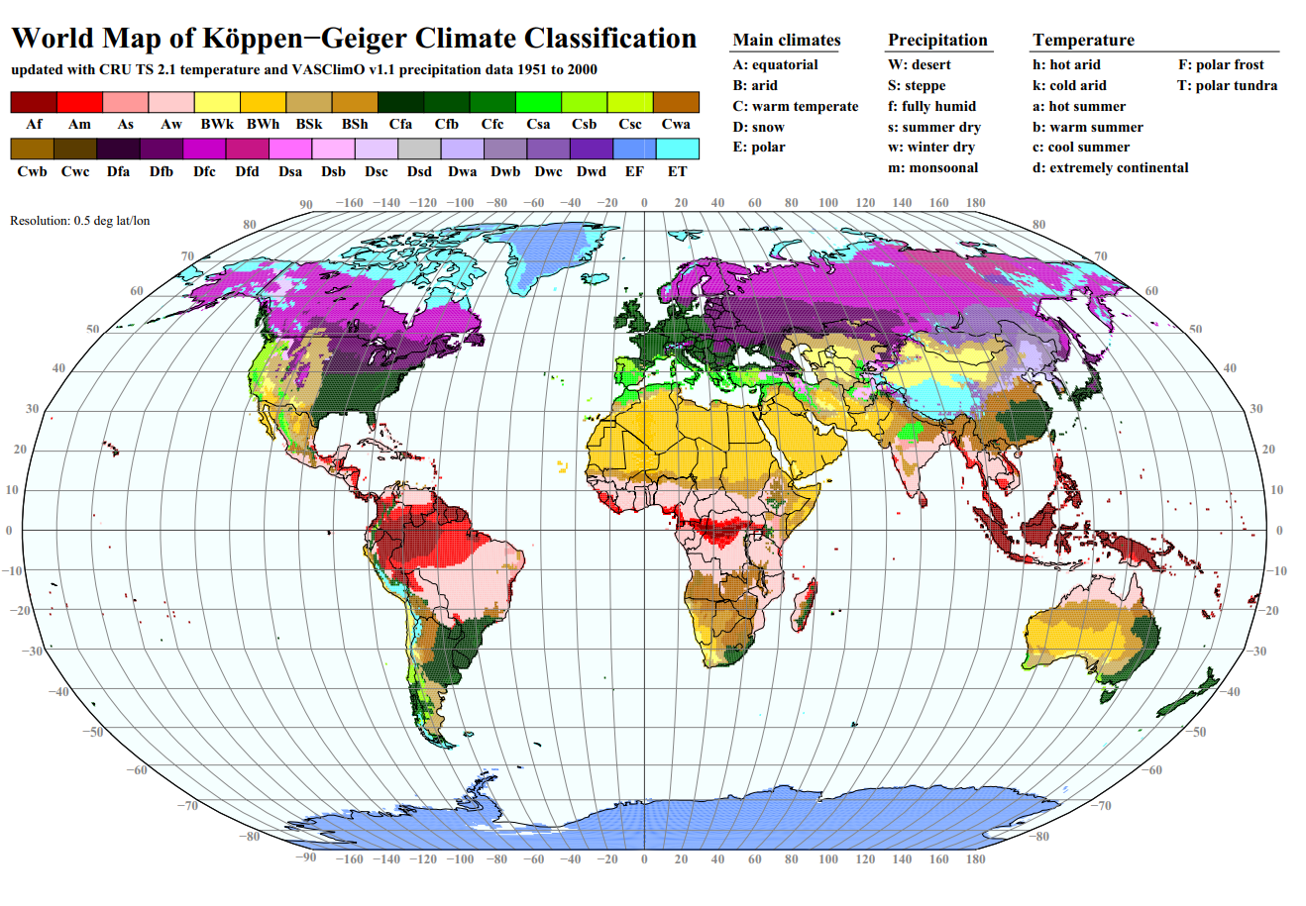
Figure S9. Köppen–Geiger climate zone classification (Kottek et al., 2006).

Table S1. Temporal cross validation of the random forest model. NRMSE: normalized root-mean-square error. NSE: Nash–Sutcliffe model efficiency. R2: R-squared of test data
Year of data test | NRMSE (%) | NSE | R2 (%)
2000 | 32 | 0.677 | 68
2001 | 27 | 0.781 | 79
2002 | 44 | 0.504 | 70
2003 | 39 | 0.591 | 67
2004 | 37 | 0.621 | 63
2005 | 30 | 0.719 | 72
2006 | 36 | 0.680 | 68
2007 | 32 | 0.651 | 68
2008 | 30 | 0.754 | 77
2009 | 32 | 0.764 | 78
2010 | 31 | 0.727 | 74
2011 | 38 | 0.712 | 74
2012 | 41 | 0.664 | 67
2013 | 33 | 0.744 | 75
2014 | 32 | 0.726 | 76
2015 | 31 | 0.749 | 76
2016 | 31 | 0.763 | 77
2017 | 33 | 0.754 | 79
2018 | 34 | 0.785 | 79
2019 | 32 | 0.800 | 81
2020 | 35 | 0.708 | 73

Table S2. Spatial cross-validation of the random forest model. ‎NRMSE: normalized root-mean-square error, NSE: Nash–Sutcliffe model efficiency. R2: R-squared of test data. NRMSE, NSE, and R2 values are the average over 30 NRMSE, NSE, and R2 ‎values (10 departments × 3 European countries).
Transferability in space | NRMSE (%) | NSE | R2(%)
100 km | 26 | 0.26 | 36
200 km | 29 | 0.26 | 30
400 km | 35 | 0.14 | 28
600 km | 35 | 0.14 | 26
800 km | 42 | -0.41 | 14
1000 km | 48 | -0.88 | 11

‎Table S3. ‎ Percentage of climate data used for sorghum yield projections that fall outside of the observed range of climate data used for model training. hurs: relative humidity. rsds: solar radiation. tasmax: monthly average of daily maximum ‎temperature. tasmin: monthly average of daily minimum temperature. pr: total ‎precipitation.
climate scenario | time period | month* | hurs | pr | rsds | tasmax | tasmin
SSP1-RCP2.6 | 2041_2060 | 1 | 0.00 | 0.05 | 0.05 | 0.00 | 0.00
SSP1-RCP2.6 | 2041_2060 | 2 | 0.00 | 0.13 | 0.00 | 0.00 | 0.00
SSP1-RCP2.6 | 2041_2060 | 3 | 0.00 | 0.65 | 0.00 | 0.00 | 0.00
SSP1-RCP2.6 | 2041_2060 | 4 | 0.00 | 2.28 | 0.00 | 0.15 | 0.00
SSP1-RCP2.6 | 2041_2060 | 5 | 0.00 | 1.85 | 0.00 | 0.34 | 0.00
SSP1-RCP2.6 | 2041_2060 | 6 | 0.02 | 0.67 | 0.00 | 0.00 | 0.00
SSP1-RCP2.6 | 2041_2060 | 7 | 0.00 | 0.17 | 0.00 | 0.00 | 0.00
SSP1-RCP2.6 | 2041_2060 | 8 | 0.10 | 0.16 | 0.00 | 0.00 | 0.00
SSP1-RCP2.6 | 2081_2100 | 1 | 0.00 | 0.03 | 0.02 | 0.00 | 0.00
SSP1-RCP2.6 | 2081_2100 | 2 | 0.00 | 0.17 | 0.00 | 0.00 | 0.00
SSP1-RCP2.6 | 2081_2100 | 3 | 0.00 | 0.73 | 0.00 | 0.00 | 0.00
SSP1-RCP2.6 | 2081_2100 | 4 | 0.00 | 2.52 | 0.00 | 0.19 | 0.00
SSP1-RCP2.6 | 2081_2100 | 5 | 0.00 | 2.03 | 0.00 | 0.33 | 0.00
SSP1-RCP2.6 | 2081_2100 | 6 | 0.00 | 0.95 | 0.00 | 0.00 | 0.00
SSP1-RCP2.6 | 2081_2100 | 7 | 0.00 | 0.20 | 0.00 | 0.00 | 0.00
SSP1-RCP2.6 | 2081_2100 | 8 | 0.14 | 0.12 | 0.00 | 0.00 | 0.00
SSP5-RCP8.5 | 2041_2060 | 1 | 0.00 | 0.04 | 0.04 | 0.00 | 0.00
SSP5-RCP8.5 | 2041_2060 | 2 | 0.00 | 0.14 | 0.00 | 0.00 | 0.00
SSP5-RCP8.5 | 2041_2060 | 3 | 0.00 | 0.81 | 0.00 | 0.00 | 0.00
SSP5-RCP8.5 | 2041_2060 | 4 | 0.00 | 2.51 | 0.00 | 0.45 | 0.00
SSP5-RCP8.5 | 2041_2060 | 5 | 0.00 | 2.11 | 0.00 | 0.67 | 0.00
SSP5-RCP8.5 | 2041_2060 | 6 | 0.03 | 1.14 | 0.00 | 0.01 | 0.00
SSP5-RCP8.5 | 2041_2060 | 7 | 0.01 | 0.36 | 0.00 | 0.00 | 0.00
SSP5-RCP8.5 | 2041_2060 | 8 | 0.12 | 0.23 | 0.00 | 0.00 | 0.00
SSP5-RCP8.5 | 2081_2100 | 1 | 0.00 | 0.10 | 0.09 | 0.00 | 0.00
SSP5-RCP8.5 | 2081_2100 | 2 | 0.00 | 0.29 | 0.00 | 0.00 | 0.00
SSP5-RCP8.5 | 2081_2100 | 3 | 0.00 | 1.22 | 0.00 | 0.22 | 0.01
SSP5-RCP8.5 | 2081_2100 | 4 | 0.00 | 3.92 | 0.00 | 3.44 | 0.39
SSP5-RCP8.5 | 2081_2100 | 5 | 0.00 | 3.18 | 0.00 | 6.57 | 0.99
SSP5-RCP8.5 | 2081_2100 | 6 | 0.00 | 1.62 | 0.00 | 0.48 | 0.17
SSP5-RCP8.5 | 2081_2100 | 7 | 0.00 | 0.48 | 0.00 | 0.00 | 0.00
SSP5-RCP8.5 | 2081_2100 | 8 | 0.04 | 0.25 | 0.00 | 0.00 | 0.00
*Month of the sorghum growing season (April to November in Europe)
Table S4. Total production of Sorghum in Europe in future scenarios for different sorghum frequency in crop rotations: one year out of three, four, five, and six years equivalent to 33%, 25%, 20%, and 17% of cropland area in a grid-cell under sorghum, respectively.
Time period | Scenario | Frequency in crop rotations  (Fraction of cropland in grid-cell) | Production  (Mton)
Mid-century | SSP1-RCP2.6‎ | 0.17 | 39.7
(2041-2060) |  | 0.20 | 47.6
 |  | 0.25 | 59.5
 |  | 0.33 | 79.3
 | SSP5-RCP8.5‎‎ | 0.17 | 47.3
 |  | 0.20 | 56.8
 |  | 0.25 | 71.0
 |  | 0.33 | 94.7
End-century | SSP1-RCP2.6‎ | 0.17 | 49.2
(2081-2100) |  | 0.20 | 59.1
 |  | 0.25 | 73.8
 |  | 0.33 | 98.5
 | SSP5-RCP8.5‎‎ | 0.17 | 55.6
 |  | 0.20 | 66.7
 |  | 0.25 | 83.3
 |  | 0.33 | 111.1

climate scenario | time period | wheat | maize | barley | sunflower
SSP1-RCP2.6‎ | 2041-2060 | 11.7 | 7.3 | 3.3 | 2.9
SSP5-RCP8.5‎‎ | 2041-2060 | 14.3 | 8.9 | 3.9 | 3.9
SSP1-RCP2.6‎ | 2081-2100 | 19.2 | 9.4 | 3.9 | 3.7
SSP5-RCP8.5‎‎ | 2081-2100 | 17.9 | 8.1 | 6.1 | 4.2
Table S5. Harvested area (Mha) of wheat, barley, maize, and sunflower within the suitable area obtained in each scenario based on Figure 4 (with high and stable sorghum yield (an average inter-annual yield higher than 4 t ha-1 (the average sorghum yield in Europe in the last 20 years) and an inter-annual yield standard variation less than 0.5 t ha-1. While the standard variation criterion was consistently applied across all models, we retained only those grid cells that met the average yield threshold in at least 4 out of 5 models).
Table S6. Description of sorghum data in each country.‎
Country | Duration of time series | Number of data points | Administrative level | Average sorghum yield | Average area (km²) | Reference
France | 2000-2020 | 1445 | Nuts3 | 5.56 | 5961 | https://agreste.agriculture.gouv.fr/agreste-web/disaron/SAANR_DEVELOPPE_2/detail/
‎Italy ‎ | 2006-2020 | 1098 | Nuts3 | 6.38 | 2663 | https://www.istat.it/en/agriculture?data-and-indicators
Spain | 2000-2020 | 391 | Nuts3 | 2.41 | 11264 | https://www.mapa.gob.es/es/estadistica/temas/estadisticas-agrarias/agricultura/esyrce/
USA | 2000-2020 | 6747 | County level | 4.50 | 2320 | https://www.nass.usda.gov/Data_and_Statistics/

