Table S1: Differentiating attributes between 101C5 and publically available other Thermococcus genomes
Organism | 101C5 | Thermococcus sp. PK | Thermococcus sp. EP1 | Thermococcus litoralis DSM 5473 | Thermococcus litoralis_oil
Accession no. | WHIZ00000000 | AKID00000000.1 | JXCG00000000.1 | CP006670.1 | FJMQ00000000.1
Isolation source | Produced water form high temperature oil reservoir | -- | Deep-sea hydrothermal vent sediment sample | Shallow submarine hot spring | Formation fluid from deep sub-surface oil reservoir.
Growth temp | 80 – 101 ℃ | -- | 80 ℃ | 83 ℃ | --
Size (Mb) | 1.92 | 2.18 | 1.82 | 2.22 | 2.17
Contigs | 119 | 132 | 43 | 1 | 207
G+C (%) | 44 | 44 | 39.3 | 43.1 | 43.2
No. of RNAs | 46 | 52 | 47 | 52 | 51
No. of subsystem | 146 | 150 | 142 | 159 | 150
Coding sequences | 2258 | 2459 | 1997 | 2448 | 2399

Table S2: Putative genes involved in stress tolerance detected in 101C5 genome
Genes detected in 101C5 genome | Predicted function
1. Prefoldin subunit alpha and beta  2. Archaeal heat shock regulator, ArsR family  3. Heat shock protein 60 family chaperone GroEL @ Thermosome subunit  4. Small heat shock protein HSP16.5  5. FKBP-type peptidyl-prolyl cis-trans isomerase SlyD (EC 5.2.1.8) and MJ0825  6. Clp  7. Spermidine synthase  8. Polyamine ABC transporters | Thermo-tolerance
- Superoxide reductase  - Rubrerythrin  - NADH oxidase of the flavin-dependent disulfide reductase family, MJ0649  - Peroxiredoxin, Bcp-type  - Thioredoxin reductase | Tolerance to oxidative stress
- Kef-type K+ transport systems (NAD-binding component fused to domain related to exopolyphosphatase)  - Trk potassium uptake system protein TrkA, TrkH  - Sarcosine oxidase alpha and beta subunit (Choline and Betaine Uptake and Betaine Biosynthesis) | Osmoadaptation
- GroEL  - Clp | Pressure tolerance

Table S3: Putative genes involved in MEOR detected in 101C5 genome
Genes detected in 101C5 genome | Subunit/ Component | Predicted function
- [NiFe] hydrogenase nickel incorporation protein | HypA  HypC  HypD  HypE  HypF | Hydrogen production
- Hydrogenase maturation protease |  | Hydrogen production
- AIR Synthase, TMP kinase, hydrogenase maturation protein HypE superfamily |  | Hydrogen production
- Membrane bound hydrogenase | MbhA  MbhB  MbhC  MbhD  MbhE  MbhF  MbhG  MbhH  MbhI  MbhM | Hydrogen production
- Membrane bound hydrogenase, 4Fe-4S cluster-binding subunit MbhN |  | Hydrogen production
- Membrane bound hydrogenase, NiFe-hydrogenase | MbhL (large)  MbhK  MbJ (small) | Hydrogen production
- Hydrogenase-4 | component B  component D  component G  component H  component I | Hydrogen production
- Hydrogenase expression/formation protein |  | Hydrogen production
- pmm-pgm; phosphomannomutase / phosphoglucomutase  - algA; mannose-1-phosphate guanylyltransferase / mannose-6-phosphate isomerase  - mannosyl-3-phosphoglycerate phosphatase  - mannosyl-3-phosphoglycerate synthase  - mannose-1-phosphate guanylyltransferase / phosphomannomutase |  | Exopolysaccharide / Bioemulsifier production
- Pyruvate: Ferredoxin oxidoreductase (POR)  - Glyceraldehyde-3-phosphate: ferredoxin oxidoreductase (GAPOR)  - ADP-dependent glucokinase  - ADP-dependent phosphofructokinase  - Phosphoenolpyruvate synthase  - Acetyl-CoA synthetase (ADP-forming) (ACS) |  | Organic acid production (Acetate)

Table S4: Putative genes involved in crude oil degradation detected in 101C5 genome
 | Genes detected in 101C5 genome |  | Predicted function
 | - 4-oxalocrotonate tautomerase [EC:5.3.2.6]  - acetyl-CoA C-acetyltransferase [EC:2.3.1.9]  - acylphosphatase [EC:3.6.1.7]  - flavin prenyltransferase [EC:2.5.1.129]  - 4-nitrophenyl phosphatase [EC:3.1.3.41]  - Putative dioxygenase  - Fumarylacetoacetate hydrolase family protein, putative |  | (Benzoate and aminobenzoate degradation)
- 2-haloacid dehalogenase [EC:3.8.1.2]  - alcohol dehydrogenase [EC:1.1.1.1] |  | Chloroalkane and chloroalkene degradation
- Rubredoxin  - Dehydrogenase |  | Alkane degradation

Figure legends
Fig S1 Scanning electron micrograph of Thermococcus sp. 101C5
Fig S2 Circular genome map of 101C5
Fig S3 BRIG image highlighting differences between 101C5 and other Thermococcus genomes

Fig S1

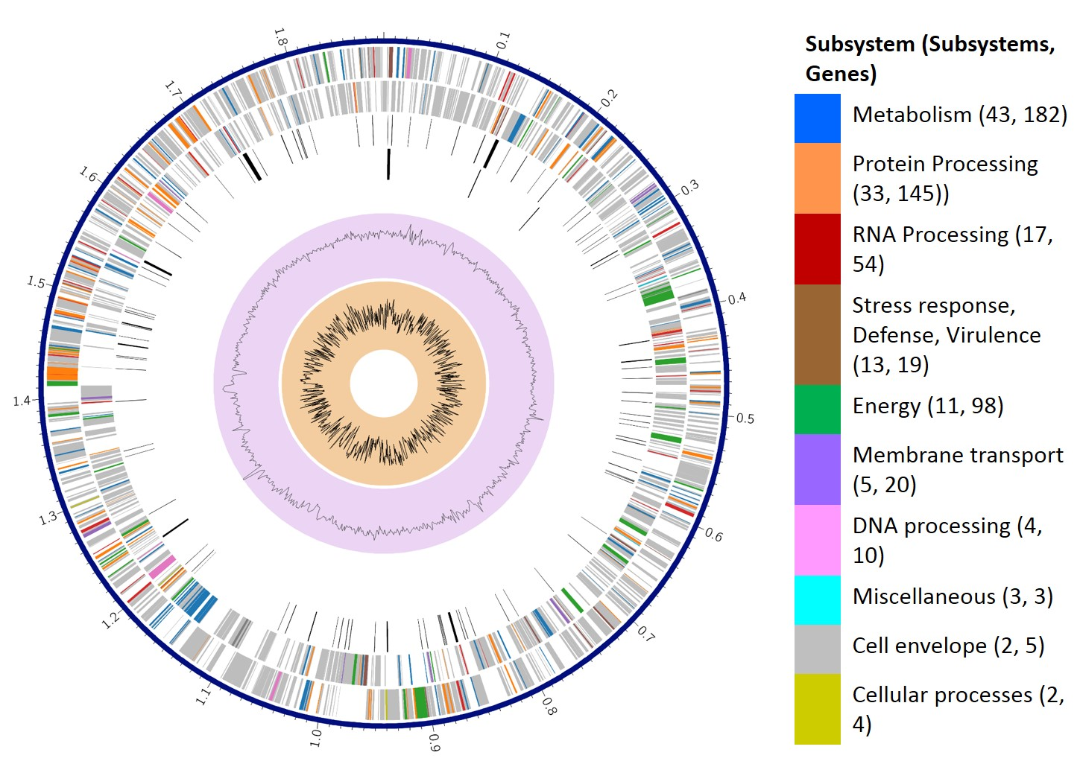

Fig S2

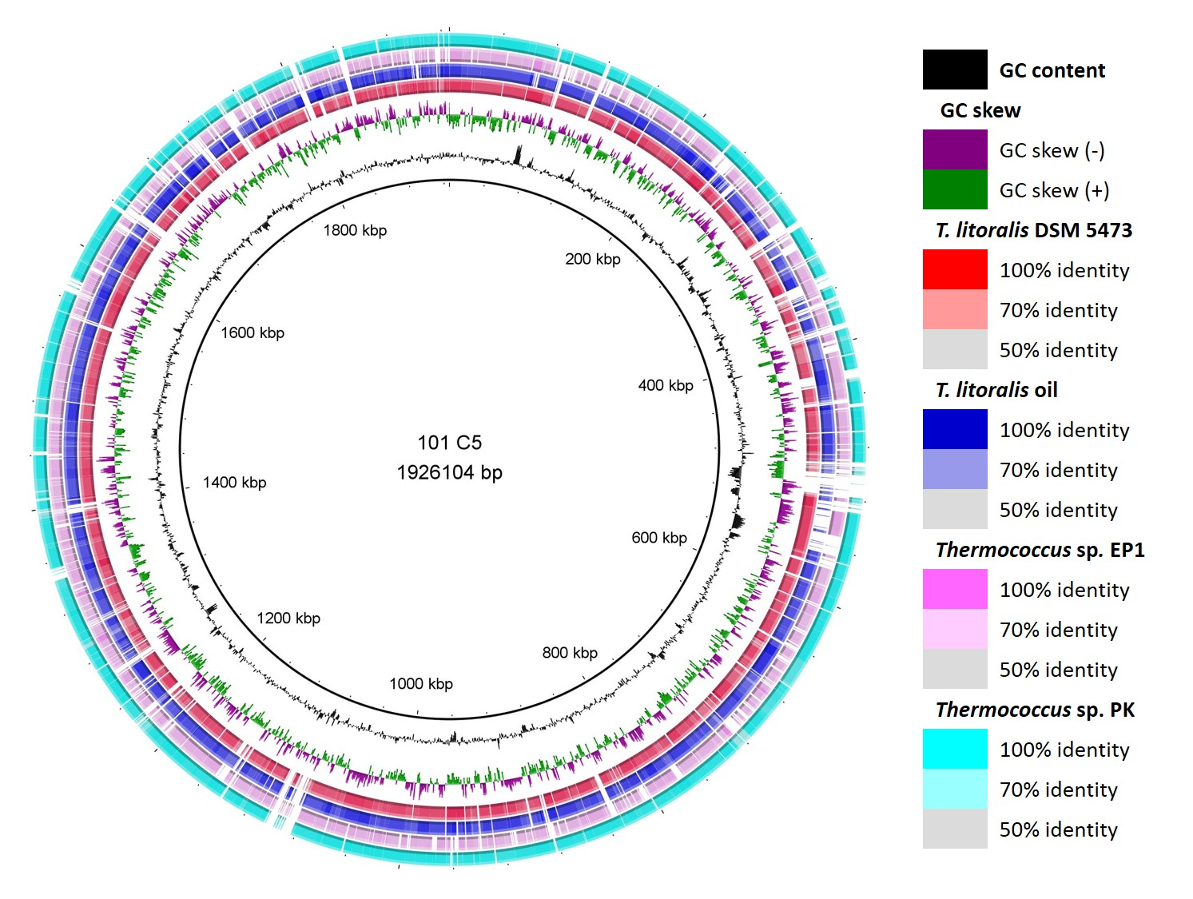
Fig S3

