Table 1.1: Test name and apparatus.

SL. | Test Name | Apparatus Name & Model | Picture of the Apparatus
1 | pH | pHep® HI 96107 Pocket-Sized pH Meter | 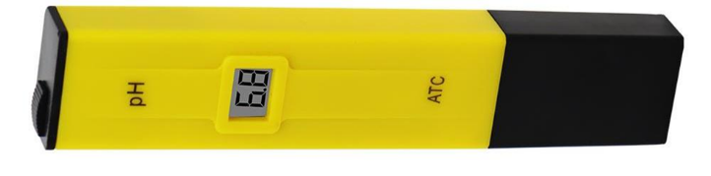
2 | Turbidity | Turbidity Meter-Lutron TU - 2016 | 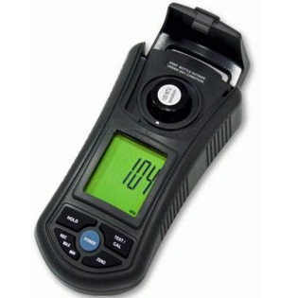
3 | Chlorine | HI 3831T Total Chlorine Test Kit. | 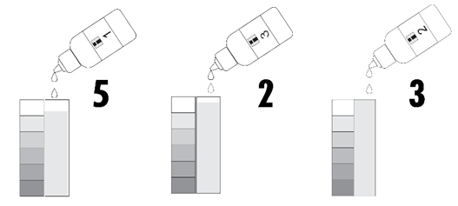
4 | Phosphorus | RAEL Phosphorus (v) Test Kit | 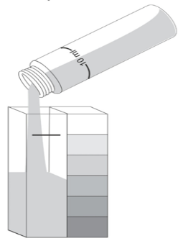
5 | Iron | HI 3834 Iron Test Kit. | 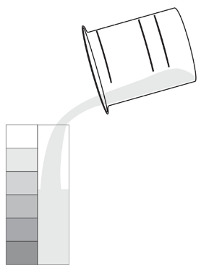
6 | Color | HI727 Checker®HC (Handheld Colorimeter) | 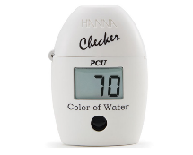
7 | Nitrate | HI 3874 Nitrate Test Kit. | 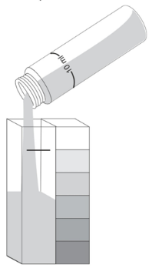
8 | CO₂ | HI 3818 Carbon Dioxide Test Kit | 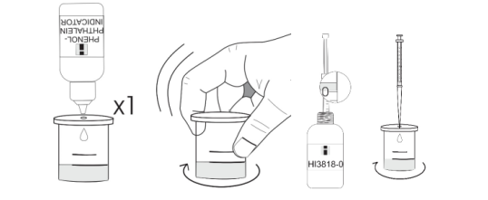
9 | TDS, TSS, & TS | Hanna HI98301 DiST-1 | 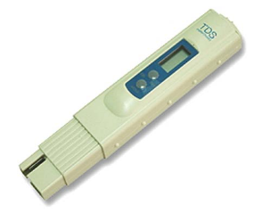  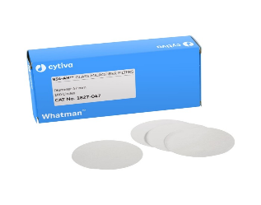
10 | DO and BOD | HI 3810 Dissolved Oxygen Test Kit. | 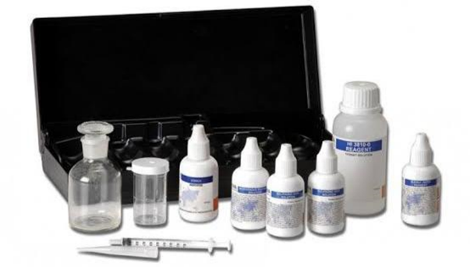

Table 1.4: Water quality index (NSF method)

 | Unit | Demra Ghat | Q- Value | Weight factor,W | Wx Q | Dhitpur Bazar | Q- Value | Weight factor,W | Wx Q | Nolchata | Q- Value | Weight factor,W | Wx Q | Balurpar School | Q- Value | Weight factor,W | Wx Q | Eiderkandi | Q- Value | Weight factor,W | Wx Q
pH | - | 6.7 | 84.5 | 0.18 | 15.21 | 6.6 | 88 | 0.18 | 15.84 | 6.4 | 74 | 0.18 | 13.32 | 6.5 | 77.5 | 0.18 | 13.95 | 6.4 | 74 | 0.18 | 13.32
Turbidly | NTU | 1.07 | 94 | 0.12 | 11.28 | 1.31 | 93 | 0.12 | 11.16 | 2.27 | 92 | 0.12 | 11.04 | 2.26 | 92 | 0.12 | 11.04 | 1.1 | 94 | 0.12 | 11.28
Phosphate | mg/L | 0 | 100 | 0.16 | 16 | 0 | 100 | 0.16 | 16 | 0 | 100 | 0.16 | 16 | 0 | 100 | 0.16 | 16 | 0 | 100 | 0.16 | 16
TDS | mg/L | 267 | 75 | 0.11 | 8.25 | 296 | 76 | 0.11 | 8.36 | 342 | 57 | 0.11 | 6.27 | 349 | 55 | 0.11 | 6.05 | 311 | 78 | 0.11 | 8.58
DO | mg/L | 7.2 | 3 | 0.25 | 0.75 | 2.3 | 1 | 0.25 | 0.25 | 0.4 | 0.1 | 0.25 | 0.025 | 0.8 | 0.2 | 0.25 | 0.05 | 2 | 1 | 0.25 | 0.25
BOD | mg/L | 6.5 | 50 | 0.18 | 9 | 1.8 | 95 | 0.18 | 17.1 | 0.1 | 98 | 0.18 | 17.64 | 0 | 100 | 0.18 | 18 | 1.2 | 94 | 0.18 | 16.92
Sum |  |  |  | 1 | 60.49 |  |  |  | 68.71 |  |  |  | 64.30 |  |  |  | 65.09 |  |  |  | 66.35

