Table 3. Antidiabetic target identification of phytoconstituents from docking study.
S. No | Molecule | Molecular targets (PDB ID)  (LibDock)
 |  | 2OQV | 1B2Y | 1T49 | 3W37 | 5Y2F | 3D4N | 3HB5
1 | 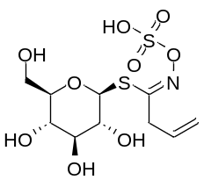  Sinigrin | 106.942 | 126.196 | 130.083 | 96.9104 | 118.218 | 121.38 | 155.46
2 | 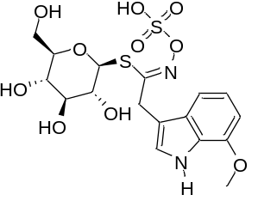  7-Methoxy brassicin | 145.831 | 128.973 | 134.454 | 117.828 | 123.66 | 117.556 | 151.947
3 | 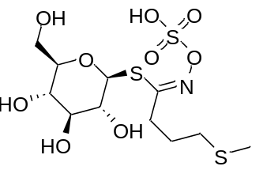  Glucoebeverin | 91.1238 | 105.143 | 113.048 | 88.0638 | 101.884 | 98.238 | 127.035
4 | 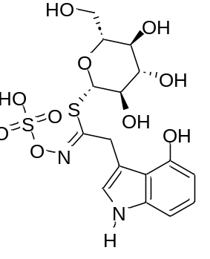  4-Hydroxy glucobrassicin | 143.075 | 125.302 | 133.129 | 112.67 | 118.969 | 123.431 | 154.624
5 | 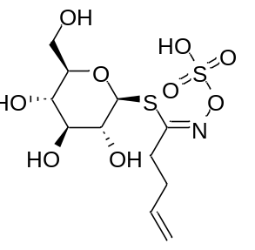  Gluconapin | 91.7767 | 107.295 | 113.705 | 93.988 | 97.782 | 96.1036 | 123.987
6 | 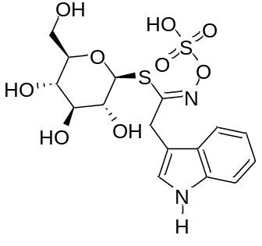  Glucobrassicin | - | 119.017 | 132.024 | 116.482 | 110.15 | 116.733 | 137.049
7 | 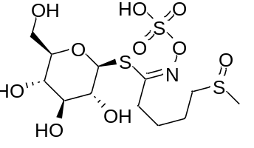  Glucoraphanin | 105.603 | 113.458 | 118.644 | 94.538 | 105.332 | 103.356 | 138.253
8 | 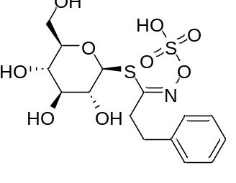  Gluconasturtina | 109.853 | 122.827 | 119.605 | 107.251 | 117.688 | 113.209 | 144.595
9 | 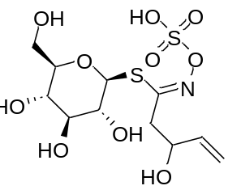  Progoitrin | 94.675 | 108.997 | 116.922 | 91.3158 | 101.812 | 107.01 | 124.316
10 | 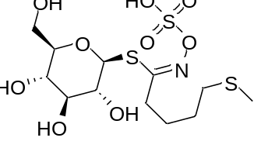  Glucoerucina | 98.595 | 111.725 | 120.83 | 97.7411 | 104.934 | 101.75 | 136.222
11 | 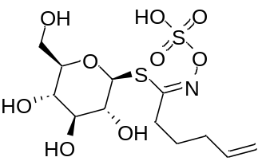  Glucobrassicanapin | 99.603 | 111.488 | 115.073 | 94.329 | 105.89 | 101.959 | 128.678
12 | Internal ligand | 91.127 | 170.312 | 149.357 | 128.458 | 104.839 | 125.201 | 155.167

