Supplementary Materials to “Simulating the spatial distribution of pollutant loads from pig farming using an agent-based modeling approach”
An The Ngo ^{1,}*, Giang Thi Huong Nguyen ¹, Duong Huu Nong¹ and Linda See ^{2,} *
¹ Faculty of Environment, Vietnam National University of Agriculture; ntan@vnua.edu.vn
² International Institute for Applied Systems Analysis (IIASA); see@iiasa.ac.at
* Correspondence: ntan@vnua.edu.vn; Tel.: +84-9122-54886 (T.A.N.) and see@iiasa.ac.at; Tel.: +34-2236-807-423 (L.S.)

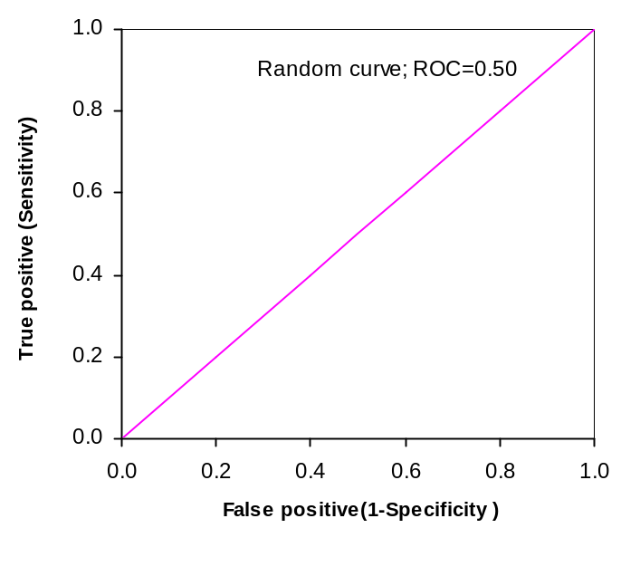
Fig. S1: A basic ROC curve (adapted from Fawcett, 2004).

References

FAWCETT, T. 2004. ROC Graphs: Notes and Practical Considerations for Researchers. HP Labs Tech Report.

Table S1: Characteristics of pig production households
No. | Characteristics | Unit | Mean | SD
1 | Age of farm owners | (Year) | 49.1 | 8.1
2 | Education level | (class) | 8.5 | 2.8
3 | Labor availability | (person) | 2.6 | 0.9
4 | Social membership | (% of total) | 28 | -
5 | Pig farming experiences | (year) | 18.6 | 10.1
6 | Land area | (m2) | 1525.0 | 2099.3
7 | Hogs | (head) | 61.4 | 139.6
8 | Sows | (head) | 11.4 | 10.0
9 | Number of pigs | (head) | 72.9 | 140.9
10 | Distance to the nearest farm | (m) | 48.6 | 72.7
11 | The manure recycling status of the neighboring farms (1=yes) | % | 71.2 | -
12 | A higher waste discharge rate compared to neighbors (1=higher) | % | 18.4 | -
13 | Technical support (1=yes) | % | 30.4 | -
14 | Financial support (1=yes) | % | 54.4 | -
15 | Biogas digester (1=yes) | % | 68.8 | -
16 | Household income | (1= below 60 million VND) | 39.2 | -
16 | Household income | (2=60-90 million VND) | 32.0 | -
16 | Household income | (3=90-120 million VND) | 25.6 | -
16 | Household income | (4=above 120 million VND) | 3.2 | -

The data in Table S1 were used to assign characteristics to agents in the ABM.

Implementation of the ABM for predicting pollutant discharge load from pig farming
In this study, NetLogo version 6.2.0 was used to develop the model. The model structure includes the following modules:
- GIS-DATA and initial parameter setup:
- Import and manage GIS data, convert GIS data format into NetLogo: Sub-basins map, land use map with residential areas, administrative map (commune), surveyed households (125 selected households for the survey)
- Create households (agent)
- Setup global parameters
- Assign of properties for households and land patches.
- CALCULATE POLLUTANT LOAD AND PREDICT BEHAVIOR:
- Calculate pollutant load based on emission coefficients issued by regulation 154/QD-TCMT (VEA, 2019).
- Calculate the manure reuse through behavioral prediction model
- Calculation of manure treatment rate (biogas).
- Calculating discharge load into the sub-basins.
- UPDATE:
- Update parameters related to feedbacks r₁ and r₂ (Fig. 5). Where r₁ is the distance and density between agents; r₂ is the higher waste discharge rate compared to neighbors.
- MODEL VALIDATION:
- Sensitivity analysis
- Validate the response of agents with ROC statistic
- Model output validation.
- MAP LEGEND AND GRAPH:
- Calculate color tones and brightness for pollutant load variation representation on the map and graph.
- Model interface was designed as in Fig. S1.
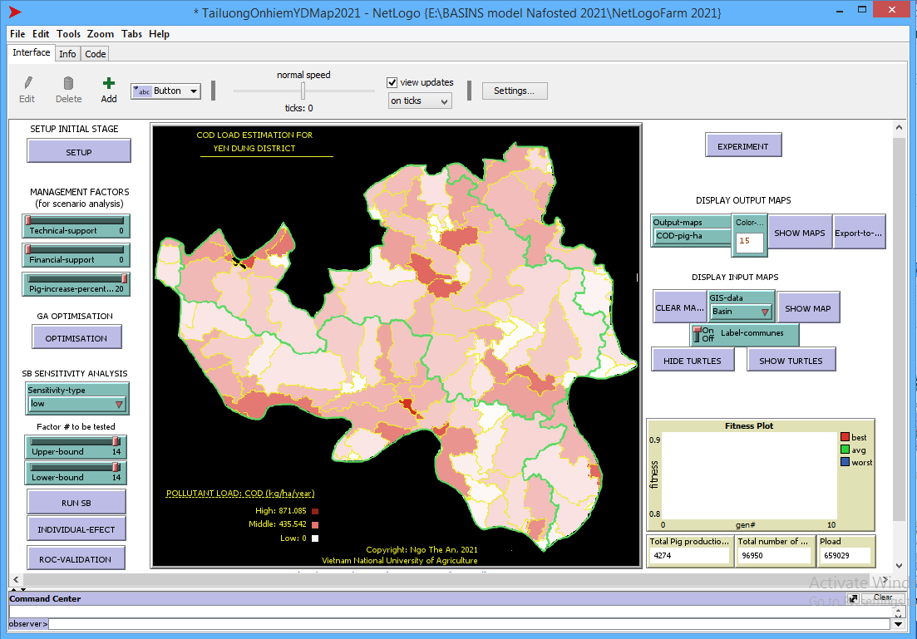
Fig. S2 Model interface for simulating spatial pollutant loads from pig farming in NetLogo

The model interface includes some tabs and slider bars for user interactions. The setup tab is used to import GIS data and assign other input variables. The main part of the model interface is where the maps (e.g., pollution loads, locations of discharge points, boundaries of sub-basins and communes, etc.) are shown. In addition, the interface also has an option to display output results according to different input scenarios.

