Supplementary Figures for

GeneBag: training a cell foundation model for broad-spectrum cancer diagnosis and prognosis with bulk RNA-seq data

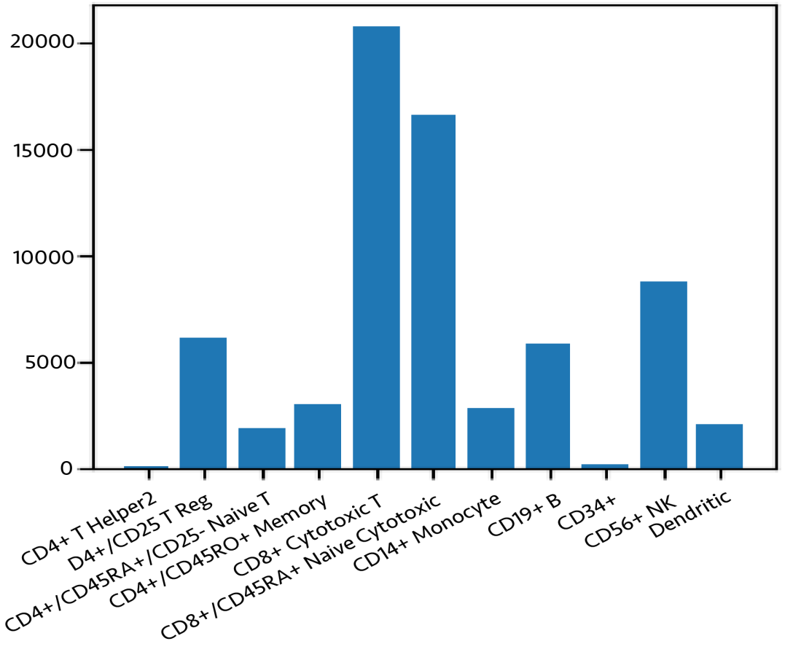

Figure S1 The number of each cell type in the Zheng68K. The dataset consists of 11 cell types, totaling 68,450 cells.
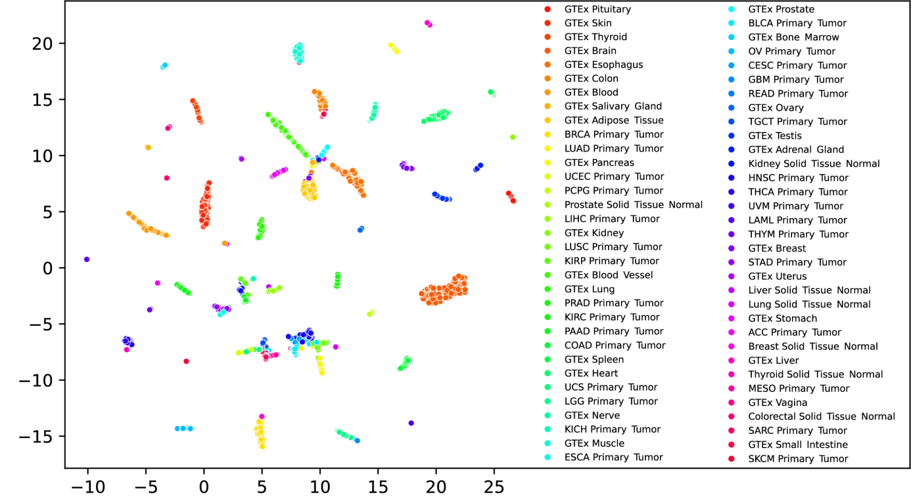
Figure S2 Tissue classification. Inference on normal and tumor samples (GTEx and TCGA database) was done with a classifier. The last layer of the classifier was used for producing UMAP. Colors represent the ground truth of the sample types.

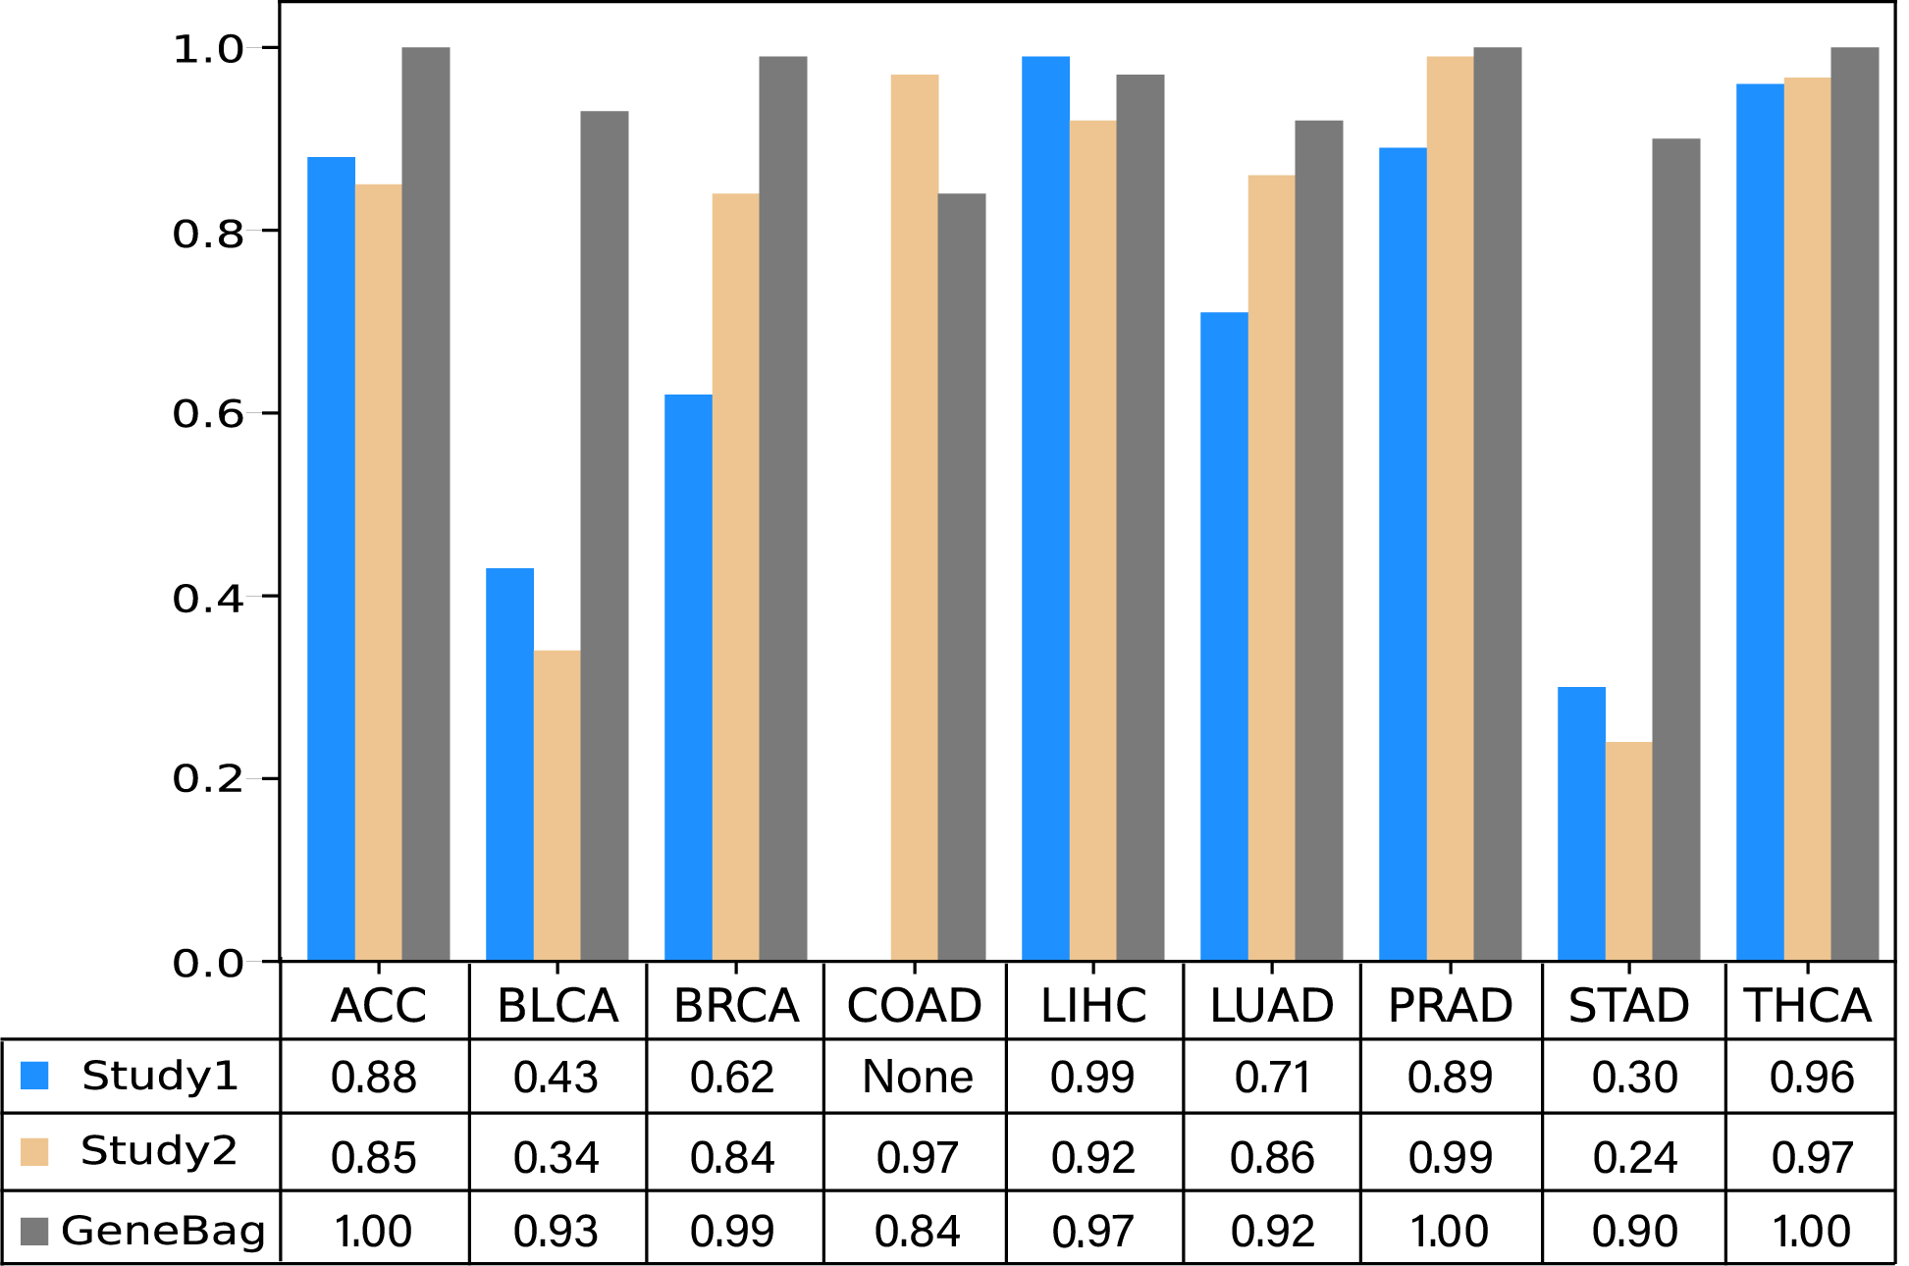
Figure S3 Comparison of identification accuracy of selected tumor types. Nine tumor types shared by our model and two previous studies are selected fo comparison.
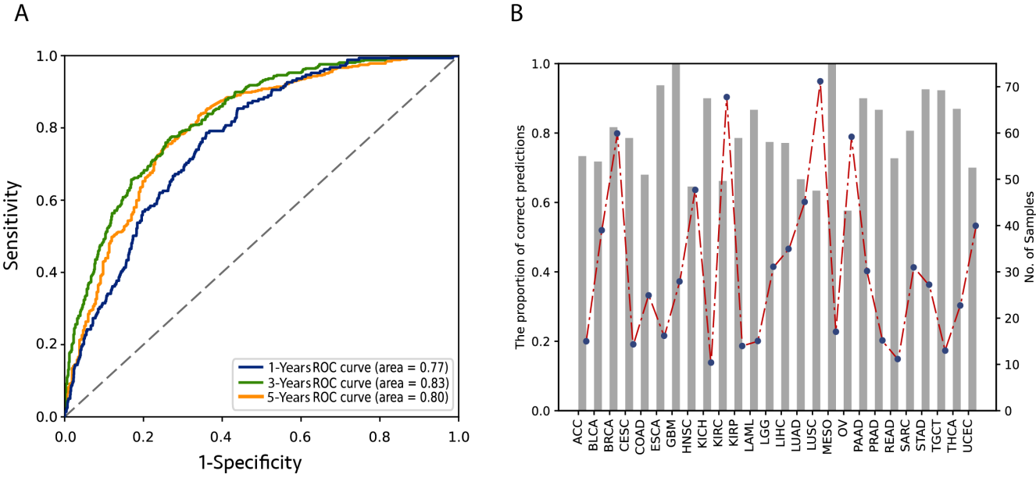
Figure S4 Survival prediction of cancer patients. A. Blue, green and orange represent the ROC curves of the GeneBag model’s survival predictions at 1, 3 and 5 years, respectively. B. 5-year survival predictions for various tumor types. Bar-plot shows the predicted accuracy of each tumor type, dash-line shows the sample number of each tumor type.

